HVAC Optimization for Greenhouses

Sandeep Polavarapu Venkata Naga

# **Introduction**

Food consumption has gradually increased in recent years. The need to increase food production has driven us all to develop innovative strategies for growing crops with higher yields while using fewer resources. Greenhouse farming techniques are one such breakthrough.

There is also a rising concern for environmental issues. Greenhouses are a major source of CO2 emissions. It has become an important problem to solve for cheaper and sustainable farming methods.

This project is designed to optimize the cost of HVAC systems generated due to the combined costs of heating, cooling, humidification, dehumidification, and CO2 generation.

The process of regulating costs involves regulating the setpoint temperature and relative humidity (The temperature and humidity levels to be maintained inside the greenhouse) and the HVAC parameters described above.

Environmental factors such as outside temperature and relative humidity are the factors that dictate how much energy is required to obtain the set point values within the greenhouse.

The major challenge here was to understand the laws of conservation of energy in three domains: heat flow, humidity, and CO2 (Ventilation). A slight knowledge of horticulture to figure out plant transpiration rate and CO2 absorption were required.

The incorporation of many variables like soil moisture, multiple/special crops etc have been ignored here to simplify the problem statement.

# **Formulation**

## *Mathematical model*

**External Environment Variables:**

*T_outside*: Temperature outside the greenhouse

*RH_outside*: Relative humidity outside the greenhouse

**Optimization function**

The cost of an HVAC system is the total sum of heating, cooling, humidification, dehumidification, and CO2 emission. The total cost is a product of cost per unit and energy rate consumed by each of the above functionalities.

*Heating_Rate, Cooling_Rate, CO2_Generation_Rate, Humidification_Rate, Dehumidification_Rate* - The rate of energy required by each of the functionalities.

*Heating_Cost,Cooling_Cost,CO2_Generation_Cost,Humidification_Cost,Dehumidification_Cost* - The cost (in $) per unit energy consumed for the above functionalities.

**Constraints**:

There are three components of constraints for this problem.

1. **Inequality HVAC System Constraints**:

The variables defining the rate of energy consumed must be greater than 0

*Heating_Rate>=0, Cooling_Rate>=0, CO2_Generation_Rate>=0, Humidification_Rate>=0, Dehumidification_Rate>=0.*

1. **Bounding Inequality Plant growth constraints**: The setpoint Temperature(*T*), Relative Humidity (*RH*), and *CO2* levels define the values that should be maintained within the greenhouse facility. These should be within general growth conditions required for a plant (These can be further specified based on the kind and number of plants).

*70F < T < 80F* and *50% < RH < 80%.*

1. **Equality Constraints for Law of Conservation of Energy**: The inflow energy and internal energy should be balanced with the outflow energy. Outflow Energy flow - Internal Energy flow - Inflow Energy flow = 0. These energies can be defined in three terms: **Heat transfer**, **Humidity or Moisture flow,** and **CO2 or Ventilation flow**. (Defined below)

**Heat transfer:**

*Internal Heat Energy:*

* The heat from Lighting *(Heat_From_Lights*)
* + HVAC Heating Rate (*Heating_Rate*)
* - HVAC Cooling Rate (*Cooling_Rate*)
* - HVAC Cooling due to Moisture : Latent Heat of Vaporization * Total Moisture (This is a combination of the Amount of water released by the plants into the air *Plant_Humidity_Release* + *Humidification_Rate* - *Dehumidification_Rate)*
* + HVAC Heat due to CO2 emission: Amount of CO2 generated by the HVAC per second *CO2_VolumeGenerated_rate* * *CO2_Generation_Rate*
* + Heat generated due to heat conduction by the greenhouse roofs and walls. *Material_Conductivit*y * *Area_of_Conduction* * Difference in temperature from outside to the greenhouse *T_outside - T*

*Inflow Heat Energy:*

Heat transfer from outside to the greenhouse

*Air_Density*\**Air_Heat_Capacity*\**T_outside*\*Rate of airflow from the HVAC (*Ventilation_Rate)*

*Outflow Heat Energy:*

Heat transfer from the greenhouse to outside

*Air_Density*\**Air_Heat_Capacity*\**T*\**Ventilation_Rate*

**Heat Flow =** Air_Density*Air_Heat_Capacity*T*Ventilation_Rate- Air_Density*Air_Heat_Capacity*T_outside*Ventilation_Rate - ( Heat_From_Lights + Heating_Rate - Cooling_Rate - Latent_Heat_of_Vaporization*(

Humidification_Rate

+ Plant_Humidity_Release

- Dehumidification_Rate

)

+ CO2_VolumeGenerated_rate *CO2_Generation_Rate

+ Material_Conductivity*Area_of_Conduction*(T_outside-T)

)

**Moisture Flow:**

*Internal Moisture Energy:*

Total Moisture (This is a combination of the Amount of water released by the plants into the air *Plant_Humidity_Release* + *Humidification_Rate* - *Dehumidification_Rate)*

*Inflow Moisture Energy:*

Water_holding_capacity * Internal Relative Humidity *RH_inside* * Ventilation Rate

Water_holding_capacity: Percentage/amount of moisture that air can hold at a given temperature:

0.7278*(T*9/5 - 459.67) - 32.189

Dew Point temperature (*T_dewpoint*): Temperature the air needs to be cooled to achieve a relative humidity (RH) of 100% : ((T_outside-273.15) - ((100 - RH_outside)/5))

Internal Relative Humidity(*RH_inside*): The proportion of Relative humidity present in the greenhouse based on the dewpoint temperature: (5*((T_dewpoint) - (T-273.15)) + 100)

*Outflow Moisture Energy*

Water_holding_capacity * RH/100 * Ventilation Rate

**Moisture Flow =**

((0.7278*(T*9/5 - 459.67)-32.189)*RH/100*Ventilation_Rate)

-((0.7278*(T*9/5-459.67)-32.189)*(5*(((T_outside-273.15)-((100-RH_outside)/5))-(T-273.15))+100)/100*Ventilation_Rate) -(Plant_Humidity_Release+Humidification_Rate- Dehumidification_Rate)

**CO2 Flow:**

*Internal CO2 Energy:*

*CO2_Generation_Rate* - Amount of CO2 absorbed by the plants for photosynthesis *Plant_CO2_Absorption*

In this case Outflow_CO2_Energy = Inflow_CO2_Energy due to constant CO2 levels being maintained with respect to the environment. This also ensures net zero CO2 emission.

**CO2 Flow** = CO2_Generation_Rate - Plant_CO2_Absorption

## *Optimization formulation*

**Minimize**:

Heating_Rate * Heating Cost +

Cooling_Rate * Cooling_Cost +

CO2_Generation_Rate * CO2_Generation_Cost +

Humidification_Rate * *Humidification_Cost +*

Dehumidification_Rate * *Dehumidification_Cost*

***Subject to:***

Heating_Rate>=0,

Cooling_Rate>=0,

CO2_Generation_Rate>=0,

Humidification_Rate>=0,

Dehumidification_Rate>=0,

70F < T < 80F,

50% < RH < 80%,

Heat Flow = 0, Moisture Flow = 0, CO2 Flow = 0,

# **Results and Insights**

It can be noted that at a fairly average te

(60F) and relative humidity (50%), the setpoint temperature is around 70 F and most of the costs are for ventilation and adding humidity.

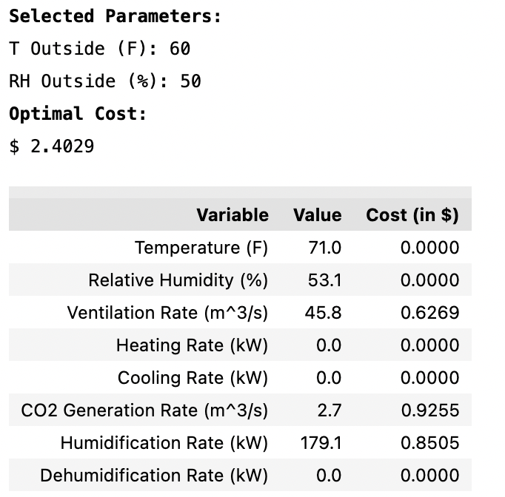

It can also be noted that once the outside temperature crosses around 75 F (with constant RH_outside = 50%), the costs start increasing significantly, this is because the cooling system starts to contribute to the total cost.

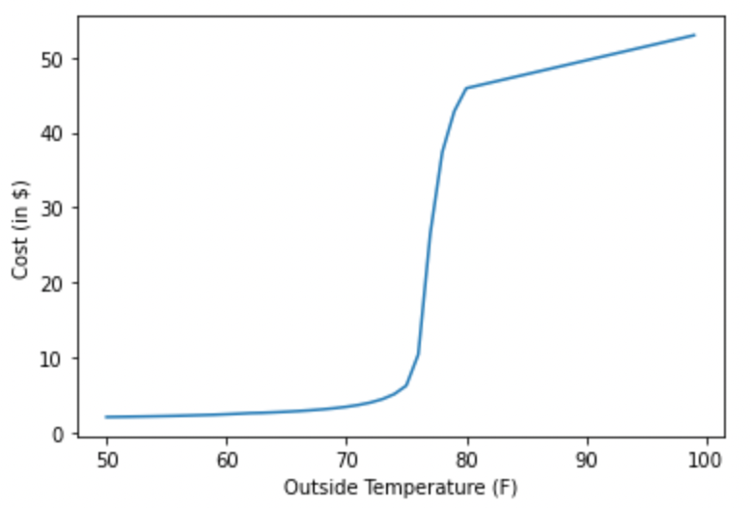

Based on the weather reports of the region where the greenhouse is located, the HVAC system parameters can be tweaked to best suit the needs in the most economical way.

# **Future directions**

The aim of this project was to minimize the cost of operating an HVAC system based on multiple parameters. Multiple assumptions like ignoring the horticultural sciences of the plants, soil moisture, human livable constraints, etc. have been made. Future work would be to take into account these parameters.

Additionally, there are more advanced farming techniques like vertical farming and smart farming. The concept of HVAC optimization can be extended from greenhouses to these techniques as well.

##### **Acknowledgment**

I would like to express my profound gratitude to Prof.Richard J. La of the University of Maryland, College Park for his mentorship and guidance throughout the design and implementation of this project.

##### **References**

1. https://hvactraining101.com/learning/hvac-formulas/
2. https://journals.ametsoc.org/view/journals/bams/86/2/bams-86-2-225.xml
3. https://www.engproguides.com/hvac-heat-transfer.html
4. Many of the constant values were obtained by interacting with a subject matter expert