The first step is to take the images of the apple as input, convert them too their appropriate matrices. The code begins with three variables one each for Red, Green and Blue. These are initially zero. They represent the overall RGB values for the variables 'apple'.

The images are specifically named such as to make the input part easier and more flexible. The names of the file are stored in an array 'str' (10 images in our case). The function 'imread' does the above mentioned job for us.

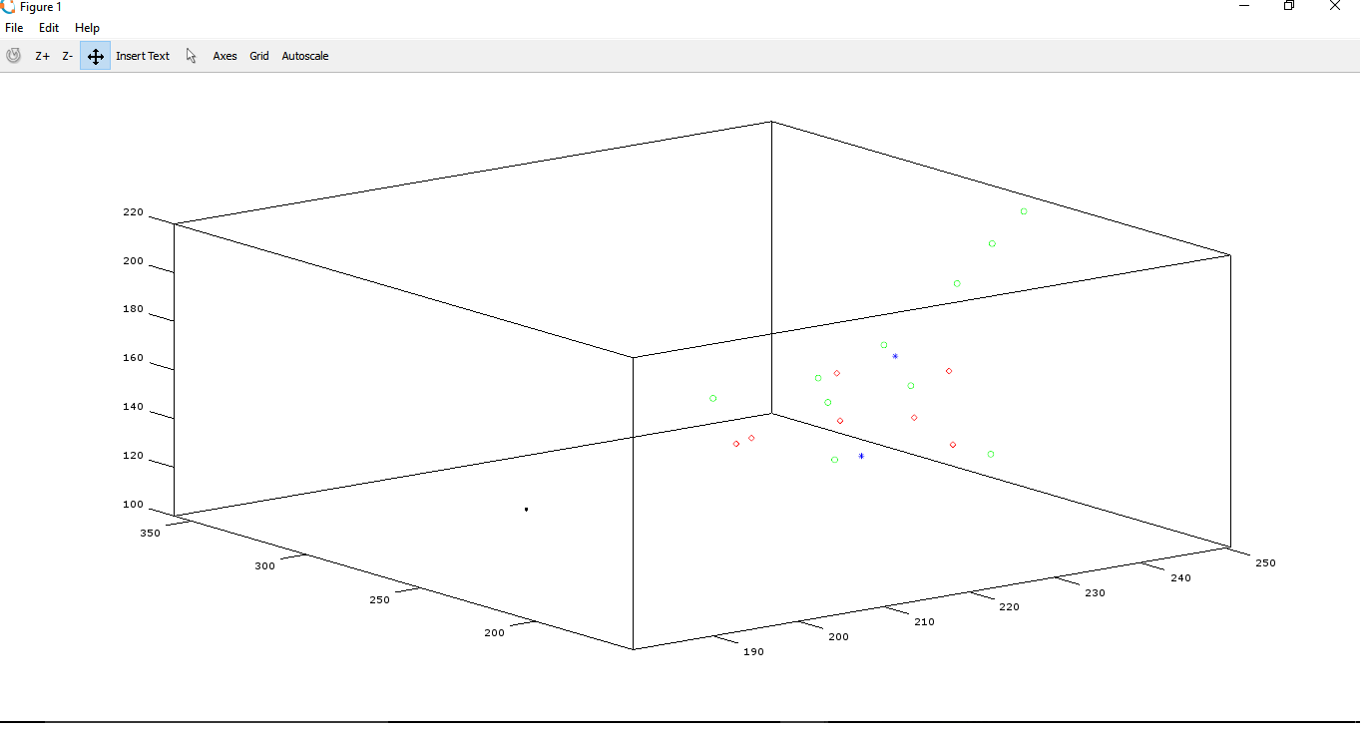

For every image, its respective RGB values are stored in variables with respective names and hence their means are found. This values are plotted then on the graph as seen above. Now these new mean values are added to the respective RGB class values for apple retaining the previous value.
(This step is repeated for all the images in the array ‘str’)

We get the final value of the RGB components of the apple class by dividing the each value by the no. of images the mean is taken over (10 in our case).

Now getting to the calculations part we have,

Let A be original reference vector of Apple class.
Let A' denote its transpose.
A contains the mean RGB components of the apple class.

∴ A = [class_apple_red class_apple_green class_apple_blue];

The value of the vector A can be defined as, 'norm' of A.

i.e., ||A||^ 2 = A'A

Thus, ||A|| = √ (A'A)

Now we have to repeat for the images of the banana as input, convert them too their appropriate matrices. The code begins with three classes one each for Red, Green and Blue. These are initially zero. They represent the overall RGB values for the class 'banana'.

The images are specifically named such as to make the input part easier and more flexible. The names of the file are stored in an array 'str' (10 images in our case). The function 'imread' does the above mentioned job for us.

For every image, its respective RGB values are stored in variables with respective names and hence their means are found. This values are plotted then on the graph as seen above .Now these new mean values are added to the respective RGB class values for banana retaining the previous value.
(This step is repeated for all the images in the array ‘str’)

We get the final value of the RGB components of the banana class by dividing the each value by the no. of images the mean is taken over (10 in our case).

Now getting to the calculations part we have,

Let B be original reference vector of Banana class.
Let B' denote its transpose.
A contains the mean RGB components of the Banana class.

∴ A = [class_banana_red class_banana_green class_banana_blue];

The value of the vector A can be defined as, 'norm' of B.

i.e., ||B||^ 2 = B'B

Thus, ||B|| = √ (B'B)

Now take in the test image T using 'imread' function. Save its RGB value matrix separately and find the mean for the same. Since we got only a single image this time, no extra calculations are needed to be done.

Now getting to the calculations part we have,

Let T be the Test image vector containing the mean RGB components in it.
Let T' denote its transpose.

||T|| = √ (T'T)

Let EA represent error vector b/w T and A.

Similarly, let EB represent error vector b/w T and B.

⇾ ⇾ ⇾
∴ EA = T-A

⇾ ⇾ ⇾
And, EB = T-B

Now, ||EA|| = ||T-A||
= √ (||T|| + ||A|| – 2.||T||.||A||.cost)

Where cosθ = Angle b/w T and A

i.e., cosθ = T'.A
||T|| ||A||

Thus on substitution,
||EA|| = √ (||T|| + ||A|| – 2.T'.A)

Similarly for EB,
||EB|| = √ (||T|| + ||B|| – 2.T'.B)

The above is the final equation that would be used for further calculations.

The only thing left is to compare the errors and validate the lesser error image.

Thus,

If (||EA|| < ||EB||)
“The image is an apple”
Else
“The image is a banana”

