PLC Open Client FB Test Automation
Design Specifications

Table of Contents
1. Revision History: 3
2. Reference Documents/Links: 3
3. Introduction: 3
3.1 Acronyms, Definitions, Terms: 5
4. Technology Choices: 5
5. Block Diagram: 6
6. Test Grouping based upon Test cases and Sequence Diagrams: 6
7. Configuration Details for Test Execution – DeviceConfig_LLM.xls: 10
8. Class Diagram: 13
Test_OpcUa_LLM Class: 14
Lib_OpcUa_LLM Class: 14
LLM_PLC Class: 15
9. Report.xls Format: 17
10. Design Limitations: 18

Revision History:

Version No. | Date | Changes Made | Author | Reviewers
0.1 | 8/12/2025 | Initial draft | Sandeep Raina | Sachin Patole

Reference Documents/Links:

Document Name/Link | Source
https://lenze.atlassian.net/projects/SYST?selectedItem=com.atlassian.plugins.atlassian-connect-plugin%3Acom.xpandit.plugins.xray__testing-board&atlOrigin=eyJpIjoiYzExNmZiYjVkNTBlNDIwNDkxMTNkMDdlYWI2MmQ0ZDYiLCJwIjoiaiJ9#!page=test-repository&selectedFolder=650fb9a932166a1b272a7c1f | Detailed Test cases from System Team

Introduction:
This document describes the design for automation of PLC Open Client FB Test.
Aim of the automation is to run all the tests in automation, without any manual intervention and generate reports in the approved format.
This document will reference detailed JIRA test cases for the implementation of automation for test cases.
The scope of this test involves testing PLC Open Client Function Block.

3.1 Acronyms, Definitions, Terms:

Acronyms / Definitions / Terms | Description
PyTeF | Python Test Framework
GUI | Graphical User Interface
XML | Extensible Markup Language
PLCD | PLC Designer

Technology Choices:
- Automated test development shall be done using Python programming language. PyTeF is developed in python and provides rich set of functionalities for test automation. We can use Python Environment of PyTeF for development.
- PyWinAuto Python Library is used for GUI automation of PLC Designer tool.
- PyWinAuto version used is 0.6.0 and PyTeF version is v01.03
- XML file is generated using PyTeF for results which are also posted to Spira.
- Configuration file (DeviceConfig_PLC_Open_Client_FB.xls) is used to store user test run configuration data.
- Test Run or Execution Report is generated in .xlsx format. Approved Template report will be provided by System test team.

Block Diagram:

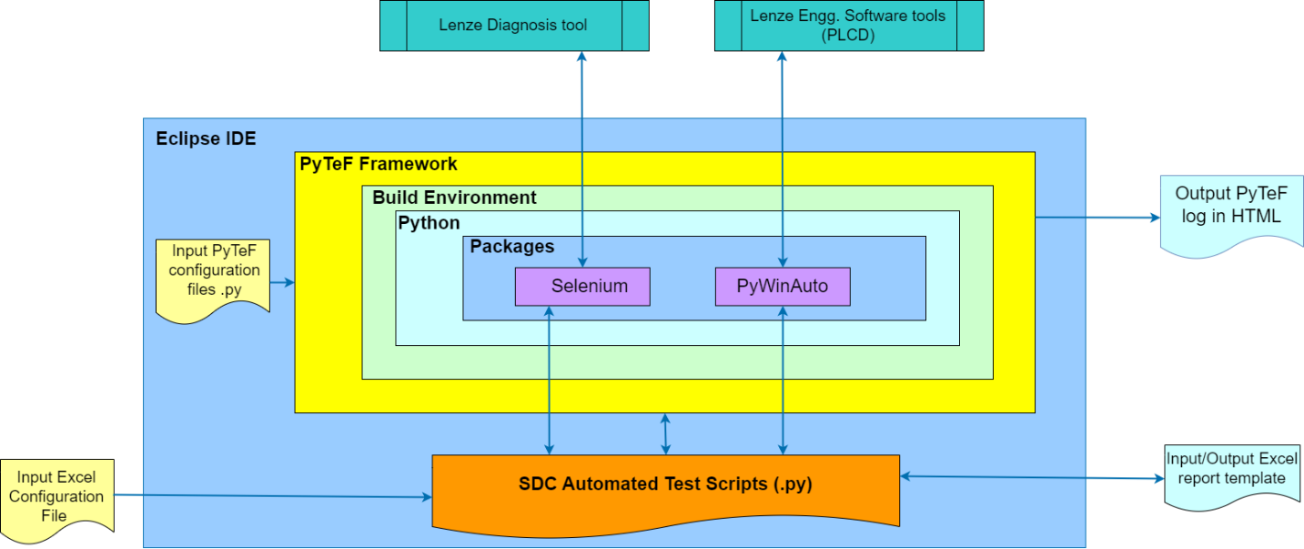

Test Grouping based upon Test cases and Sequence Diagrams:

  - Test Group1: Variable data from c430 Internal Server

  - Test Group2: Variable data from c550 External Server

  - Test Group3: Variable data from c520 External Server

  - Test Group4: Variable data from 3rd party controller External Server

  - Test Group5: Variable data from Multiple Servers

Configuration Details for Test Execution – DeviceConfig_PLC_Open_Client_FB.xls:

Common Settings: -
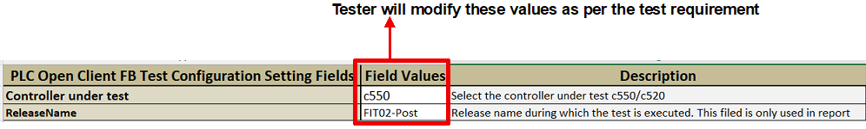

Test case selection sheet:
Test case selection table consists of following columns:
Sr No. | Column Name | Column details
 | Test Group Name | Similar testcases are grouped together. This column denotes the name of the test group
 | Test case Name | This column denotes Test case name inside a test group.
 | Spira Id | This column contains JIRA ID for each testcase.
 | Execute Flag | Using this column, Tester can choose if specific testcase is to be executed or not.
 | Testcase description | This column contains test description for each testcase.

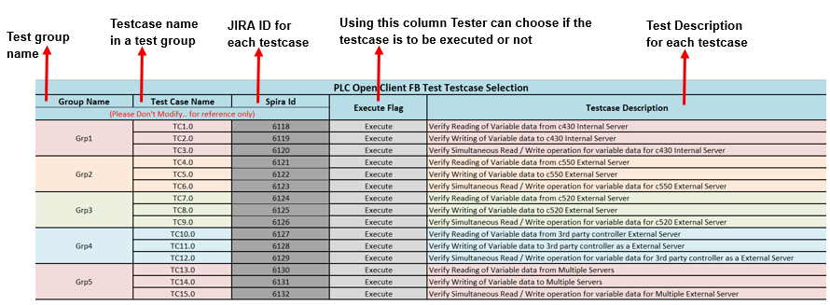

Class Diagram:

Class details –
Existing class for PLCD will be used “C:\Workspace-SV-devel\ODC-Tests\tests\common\testlib\lib_pywinauto”. Following are new classes which will be implemented as a part of this.

Test_PLC_Open_Client_FB Class:
Test_PLC_Open_Client_FB | This is a test class for PLC Open Client FB Test.
__init__ | Constructor for Main PLC Open Client FB Test Script
setUpClass() | Setup call to initialize Library
Tc_Grp1() | These are testcase methods of PLC Open Client FB test
Tc_Grp2()
Tc_Grp3()
Tc_Grp4()
Tc_Grp5()

Lib_PLC_Open_Client_FB Class:
Lib_PLC_Open_Client_FB | This class is a library for PLC Open Client FB Test
__init__ | Constructor for Main Test Library
createTests | Creates testcases based upon the selection done in Config.xls
setUpClass() | Setup call to initialize Library
grp_01_tc_01() | These methods are used to execute individual testcase for PLC Open Client FB Test
grp_02_tc_01()
grp_03_tc_01()
grp_04_tc_01()

Report.xls Format:
For Reporting of the results for PLC Open Client FB Testcases, a report template is used. After execution of each testcase this report gets updated with result (“Pass” or “Fail”). If any testcase is not executed or skipped for some reason, then the result cell for that testcase is not updated (remains Not Executed).
Report table consists of following columns:
Sr no. | Column Name | Column Details
 | Spira Id | This column contains JIRA IDs for each testcase.
 | Test Group | Similar testcases are grouped together. These test groups are mentioned in this column.
 | Test Description | This column contains test description for each testcase.
 | Results | Depending on testcase result, this column is updated with either “Pass” or “Fail” or is left “Not executed”.

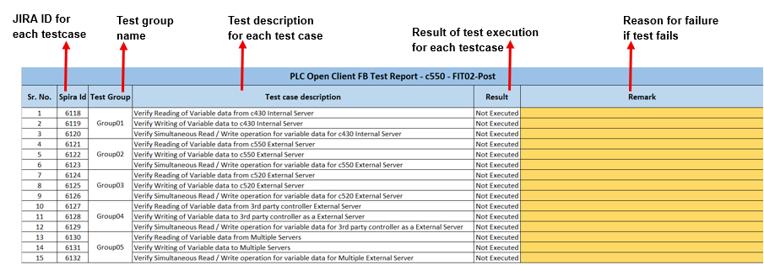

Design Limitations:
- Design for PyWinAuto script is based on PLC Designer GUI and PyWinAuto libraries.
- Changes in PyWinAuto version could impact the GUI object detection during execution.
- PyWinAuto version used for test automation is 0.6.0
- PyTeF version used is 1.3. Changes in PyTeF will require respective changes for tests.

