**Assignment-3**

Create a hello world fastapi application. Create a Docker file for your fastapi hello world application. Build Docker image using Docker file. Run Docker image built in previous step. Push your Docker image to Docker hub.

**1.Created a hello world fastapi application using python**.

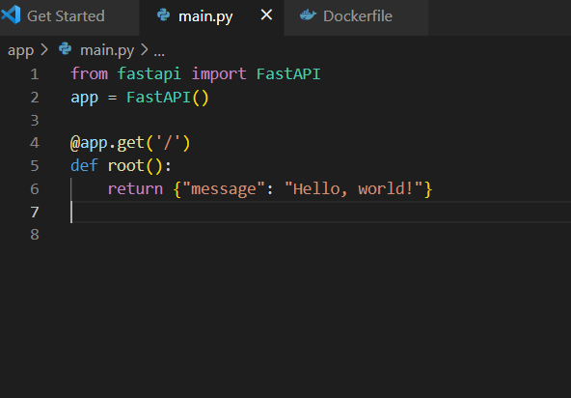

**2.Created a Docker file for fastapi app.**

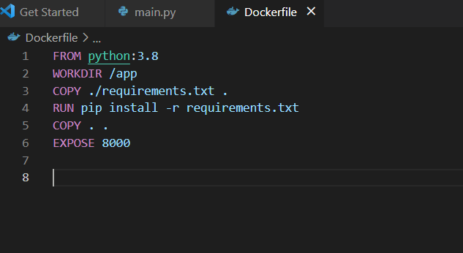

**3. After Building docker image(fast-app) using docker file and running docker image(fast-app).**



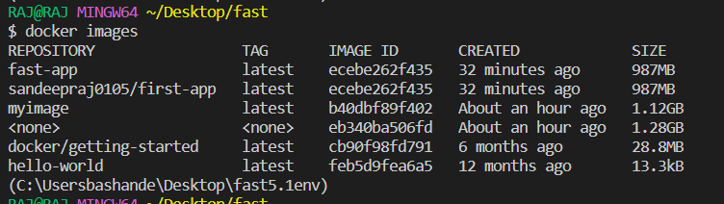

**4. After running docker image checking the localhost.**

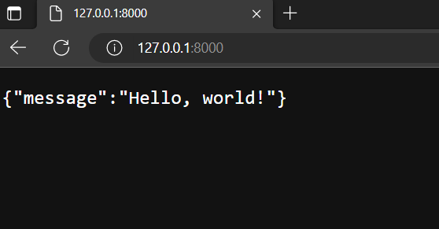

**5. using docker push command to push docker image**

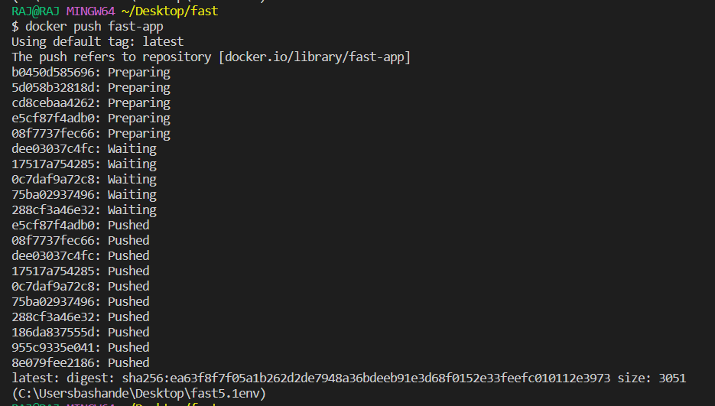

**6. Finally checking the pushed docker image in docker hub**

