Assignment-4

Automate assignment

Build docker image

Push docker image to docker hub using git hub actions.

**1.Created a new repository(dockerimage-automate) in github.**

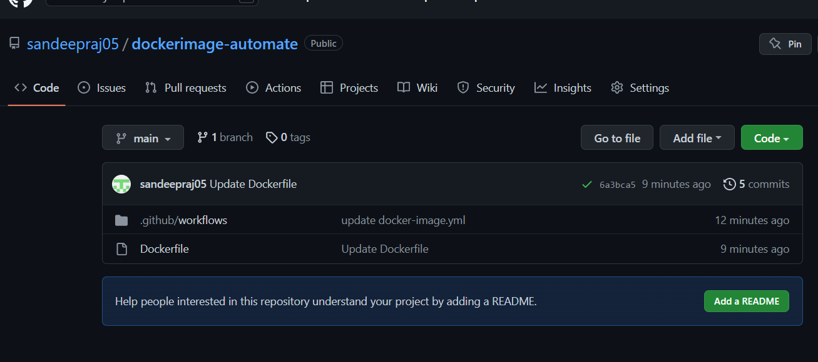

**2. created docker file in repository.**

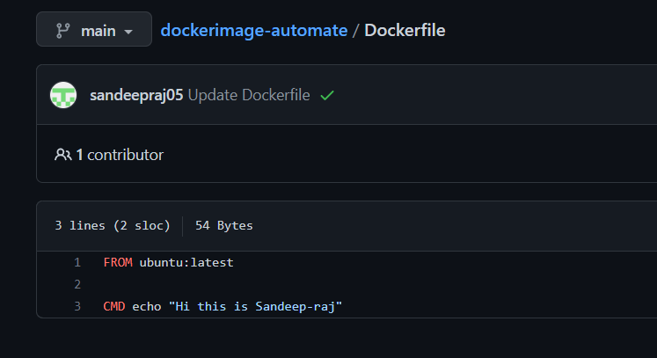

**3. And then created docker image through github actions.**

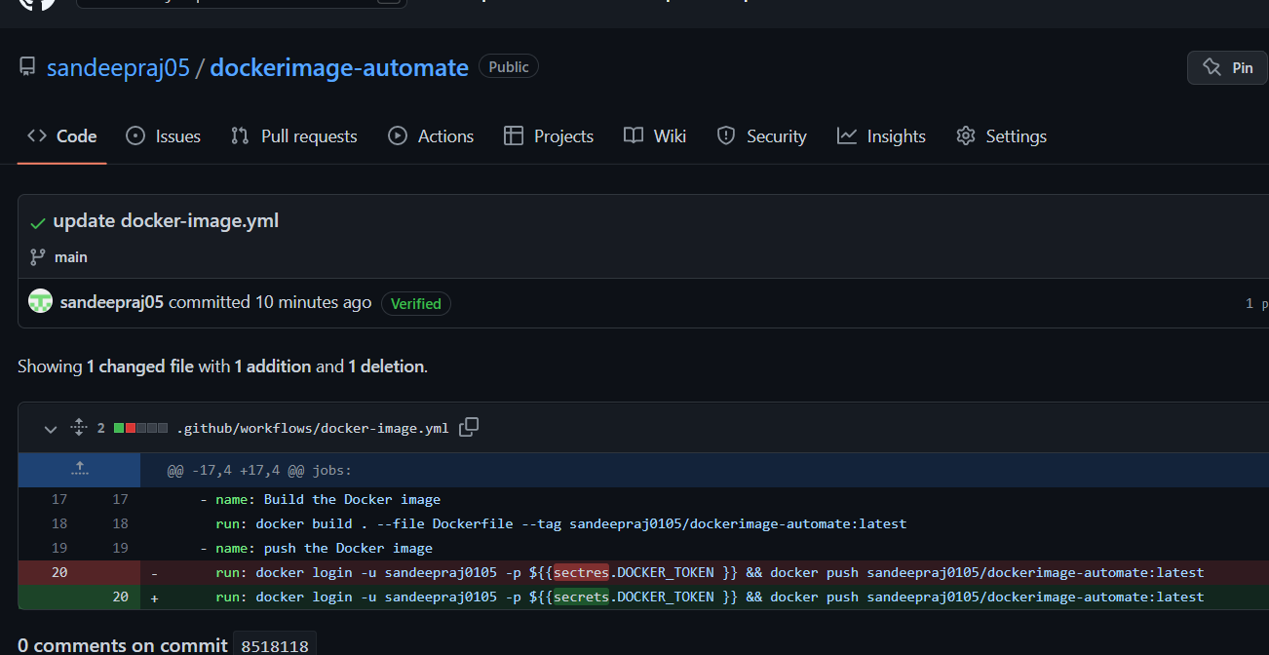

**4. built and pushed docker image to docker hub.**

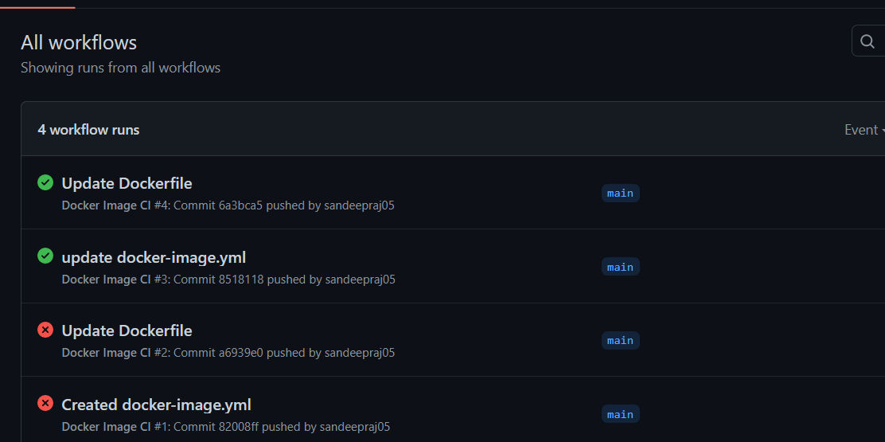

**5.Docker image is pushed to docker hub using github actions.**

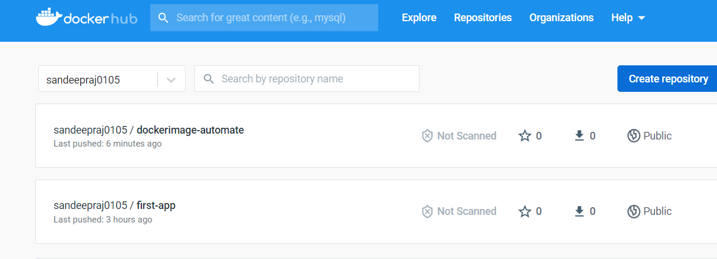

**6. checking the docker image(dockerimage-automate) by pulling from hub to local.**

**And running the docker image.**

