ASSIGNMENT – 2

**Run Hello World Docker Image Locally.**

**1.Pulling hello world docker image from hub to local.**

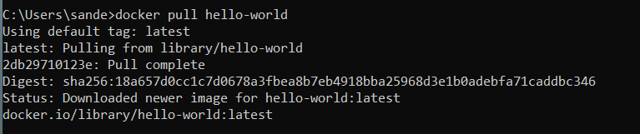

**2.After pulling completed, checking docker images.**

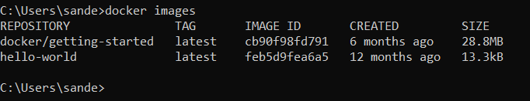

**3.Next using run command running the hello world docker image**

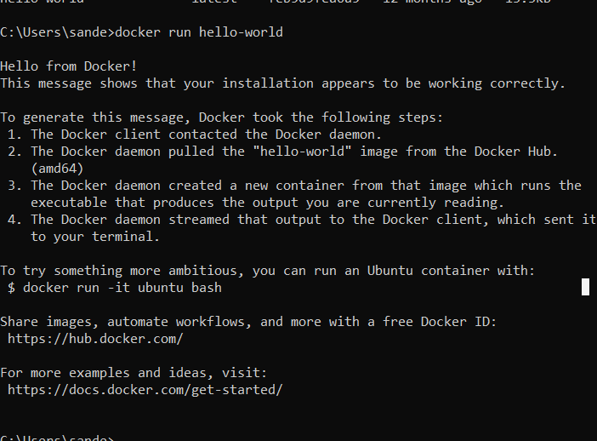

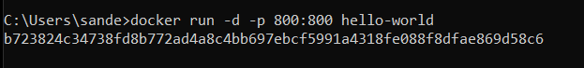

**4.docker image and container from docker desktop**

