CenturyLink Coding Challenge

I have Written a shell Script that will basically ask for a ligin_id input and produce three level deep follower login's of a given GitHub user.

Step 1: Download the Code file and navigate to the folder where it is located. Run the shell Script file attached on a Bash.

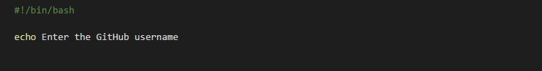

Enter a Login details of a GitHub User through command prompt.

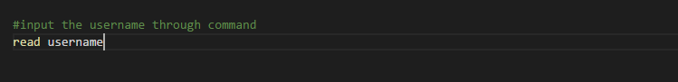

The following Curl command gives the followers of given user in JSON format.

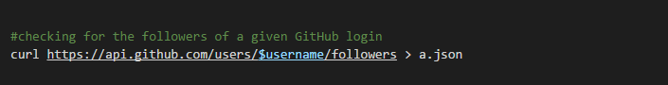

Then the following line of code will filter 5 follower logins from the complete list.

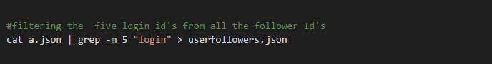

Download and Install Jq on your local system to execute the code without errors. You can find the exe here <https://stedolan.github.io/jq/download/> .

Sample Output:



Note: There is a possibility that a user or a follower might not have a minimum of 5 users. In such a case we will have loop up one layer to look for a different follower. Having a busy schedule couldn’t spend much time on this.