Smart India Hackathon - 2019

**APPLICATION TO REPORT AND FIX AIR,WATER AND SOUND POLLUTION.**

**Category** : Sustainable Environment

**Problem:**

Every day we come across several sources of pollution, polluting the very basics of our lives- Rivers, Land, Air and Noise. We know nothing about who/where to report it and how. We suggest an Innovative way to identify the sources of pollution in your area, get it prioritised through people votes, escalate it to the concerned authorities, keep a track of the progress and get notified of the actions taken. It will provide an End-2-End tool to battle pollution democratically partnering with Govt.

**Complexity** : complex.

**Problem code :**

**College code :**

**Authors :**

|  |  |
| --- | --- |
| NAME | E-MAIL |
| C RAGHU VARDHAN(team leader) | [vardhanraghu95@gmail.com](mailto:vardhanraghu95@gmail.com) |
| SAI SUJITH BEZAWADA | [saisujith63@gmail.com](mailto:saisujith63@gmail.com) |
| NIKHIL REDDY E | [nikhilreddy3599@gmail.com](mailto:nikhilreddy3599@gmail.com) |
| SANDEEP P | [sandeep.reddy2075@gmail.com](mailto:sandeep.reddy2075@gmail.com) |
| PRANEETH VARMA D | [vpraneeth9919@gmail.com](mailto:vpraneeth9919@gmail.com) |
|  |  |

**Abstract :**

**Pollution** in India has become a major problem these days. It’s not always possible to the authorities to have an eye on each and every pollution causing area and problem. Effective participation of residents in reporting, helps in solving the pollution problem. People have chaos on who to report .Our app aims at linking the local residents of a city to the corresponding authorities, which will help them to overcome many difficulties and allow them to report a problem with ease.

The application has two interfaces:

**Interface for residents :**

1. It includes simple and easy to use login portal.
2. After registering the user can now upload the picture, video that causing the problem(pollutant)
3. The uploaded multimedia can be upvoted by the other users who are facing with the same problem.
4. The interface provides the option to share the problem on other social media platforms.
5. It also provides the user with toll-free number for queries.
6. Dedicated section to suggest the user with tips to reduce pollution.

**Interface at the authority end:**

1. The authority gets notified with the problem and the location of the problem.
2. It will suggest the authorities with the nearest GHMC or other problem related agency details.
3. The multimedia file received can be deleted with public upvote after solving the issue .

**Technology stack:**

1. App development: Android Development Studio 3.1.0
2. Programming interface: Java JDK 1.8.0
3. Server and Database management: Google firebase v 11.0.1
4. An Android phone with minimum of 1GB RAM and android version 4.4(API 20).

**Register :**

1. Mobile number.
2. Email (optional).

**Use case diagram :**

For registration:

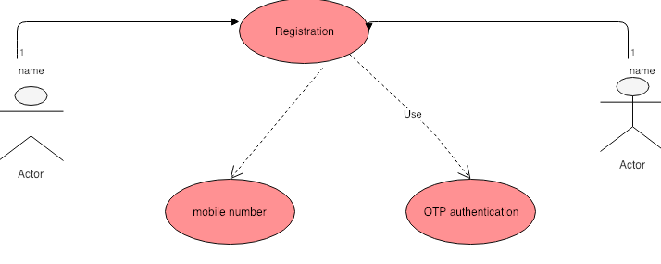

For registered users:

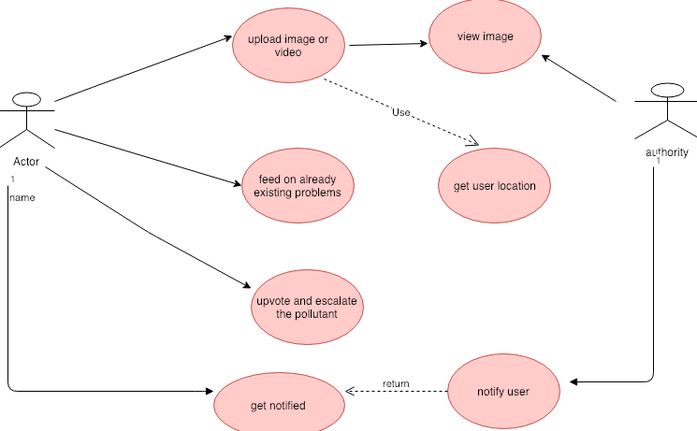

**Diagram description :**

The user logins into the application using his mobile number, which is authenticated using an OTP.

User can now send the pollutant image or video using the application after logging in. He can even upvote the problems that are in the feeds, if he suffered from any. The sent problem is received at the server end by authority like **CENTRAL POLLUTION CONTROL BOARD.** The user will be notified after the problem is resolved.

**Pseudo code :**

(User)

Step 1: Login using mobile number with OTP as authentication.

Step 2: Feed with multimedia files representing the problem.

Step 3: He/She can now upload a picture or video that’s causing pollution. Advance Android concepts are used to start camera intent to capture a picture and record a video.

Step 4: Upload this using the firebase server. The location of the sender is collected and sent using google maps API.

Step 5: Dedicated section to suggest the user with tips to reduce pollution. Basic layouts in android studio to illustrate pictures is used.

(Authority)

Step 6: Check for new queries/images/videos in the firebase.

Step 7: If new queries are found, then add it to list of recycle view array adapter.

Step 8: On clicking an item of Recycle view, a Floating window is opened. The Authority user can see the requests in the Floating window.

Step 9: It will suggest the authorities with the nearest GHMC or other problem related agency details. The Authority will help the User based on his request.

Step 14: Authority will update the User account after satisfying his request and can now delete the multimedia file.

**Example :**

If Mr.X has a problem with a bus that is releasing way more black smoke than usual, he may now capture an image or record a video of the bus emitting the smoke and can report it. He can also get upvotes with other residents who have encountered the same issue. The user can share the multimedia file with other social media apps like WhatsApp, twitter etc. Mr.X can also get suggestions to reduce pollution in illustrated pictures.

The reported problem now is sent to the authority (like Central Pollution Control Board) with the location of Mr.X. The authority is suggested with nearest GHMC or other agency that can handle the issue.

**Advantages:**

1. Aid for the people by reducing the pollution in possible ways.
2. Elimination of difficulties in reporting a pollution causing issue.
3. Manages to increase the active participation of people.
4. Promoting government schemes like swach-bharat.

**Dependencies :**

1. Require help from GHMC and other agencies .

2. The authority should also provide a Toll-free number so that the users can contact them.

3. Using Google Firebase to send notifications and sync data.

4. Using Google Maps API to get the location of user.