Experiment 17: VoteOnline
Aim
To develop a VoteOnline website using HTML, CSS, and JavaScript for online voting, voter verification, candidate management, and election result display.
Algorithm
- Start.
- Admin creates elections, candidates, voter lists, and wards.
- Voters log in using their Voter ID.
- Verify the voter using a demo OTP.
- Display candidates and allow the voter to select one.
- Submit the vote and display confirmation.
- Admin views election results and updates voter details.
- Stop.
HTML Code

<!DOCTYPE html>
<html>
<head>
<title>VoteOnline</title>
<style>
body{font-family:Arial;background:#eef2f7;margin:0}
header{background:#123b65;color:white;text-align:center;padding:20px}
nav{text-align:center;background:#092b4c;padding:12px}
button{padding:10px;margin:5px;background:#1473b9;color:white;border:0;cursor:pointer}
section{background:white;margin:20px auto;padding:20px;max-width:650px;border-radius:8px}
input,select{display:block;width:95%;padding:10px;margin:10px 0}
.item{padding:12px;border:1px solid #ccc;margin:10px 0}
</style>
</head>
<body>
<header>
<h1>VoteOnline</h1>
<p>Online Voting Management System</p>
</header>

<nav>
<button onclick="show('voter')">Voter</button>
<button onclick="show('admin')">Admin</button>
</nav>

<section id="voter">
<h2>Voter Login</h2>
<input id="voterId" placeholder="Enter Voter ID">
<button onclick="sendOTP()">Get OTP</button>
<p id="otpMsg"></p>
<input id="otp" placeholder="Enter OTP">
<button onclick="verifyOTP()">Verify OTP</button>
<p id="loginMsg"></p>

<div id="voting" hidden>
<h2>Select Candidate</h2>
<div id="candidates"></div>
<button onclick="submitVote()">Submit Vote</button>
<p id="voteMsg"></p>
</div>
</section>

<section id="admin" hidden>
<h2>Admin Login</h2>
<input id="adminName" placeholder="Username">
<input id="adminPass" type="password" placeholder="Password">
<button onclick="adminLogin()">Login</button>
<p id="adminMsg"></p>

<div id="adminPanel" hidden>
<h3>Create Candidate</h3>
<input id="candidateName" placeholder="Candidate Name">
<input id="candidateWard" placeholder="Election Ward">
<button onclick="addCandidate()">Add Candidate</button>

<h3>Voter List</h3>
<input id="newVoter" placeholder="Voter ID">
<button onclick="addVoter()">Add Voter</button>
<div id="voterList"></div>

<h3>Election Results</h3>
<button onclick="showResults()">View Results</button>
<div id="results"></div>
</div>
</section>

<script>
let candidates=[
{name:"Candidate A",ward:"Ward 1",votes:0},
{name:"Candidate B",ward:"Ward 1",votes:0}
];
let voters=["VOTER001","VOTER002","VOTER003"];
let voted=[];
let currentVoter="";
let generatedOTP="";
let verified=false;
let admin=false;

function show(id){
document.getElementById("voter").hidden=id!=="voter";
document.getElementById("admin").hidden=id!=="admin";
}

function sendOTP(){
let id=document.getElementById("voterId").value.trim();
if(!voters.includes(id)){alert("Voter ID not found");return;}
if(voted.includes(id)){alert("This voter has already voted");return;}
currentVoter=id;
generatedOTP=String(Math.floor(100000+Math.random()*900000));
document.getElementById("otpMsg").innerText=
"Demo OTP: "+generatedOTP+" (real OTP delivery needs a backend)";
}

function verifyOTP(){
if(!currentVoter){alert("Request OTP first");return;}
if(document.getElementById("otp").value!==generatedOTP){
document.getElementById("loginMsg").innerText="Invalid OTP";
return;
}
verified=true;
document.getElementById("loginMsg").innerText="Verification successful";
document.getElementById("voting").hidden=false;
renderCandidates();
}

function renderCandidates(){
document.getElementById("candidates").innerHTML=candidates.map((c,i)=>
`<div class="item">
<label><input type="radio" name="candidate" value="${i}" style="display:inline;width:auto">
<b>${c.name}</b> - ${c.ward}</label>
</div>`).join("")||"No candidates available";
}

function submitVote(){
if(!verified||!currentVoter){alert("Verify your voter ID first");return;}
if(voted.includes(currentVoter)){alert("Vote already submitted");return;}
let choice=document.querySelector('input[name="candidate"]:checked');
if(!choice){alert("Select a candidate");return;}
candidates[Number(choice.value)].votes++;
voted.push(currentVoter);
document.getElementById("voteMsg").innerText=
"Vote submitted successfully! Confirmation ID: V"+Date.now();
document.getElementById("voting").hidden=true;
verified=false;
}

function adminLogin(){
admin=document.getElementById("adminName").value==="admin"&&
document.getElementById("adminPass").value==="admin123";
document.getElementById("adminMsg").innerText=admin?
"Admin login successful":"Invalid credentials";
document.getElementById("adminPanel").hidden=!admin;
}

function addCandidate(){
if(!admin)return;
let name=document.getElementById("candidateName").value.trim();
let ward=document.getElementById("candidateWard").value.trim();
if(!name||!ward){alert("Enter candidate name and ward");return;}
candidates.push({name,ward,votes:0});
document.getElementById("candidateName").value="";
document.getElementById("candidateWard").value="";
alert("Candidate added");
}

function addVoter(){
if(!admin)return;
let id=document.getElementById("newVoter").value.trim();
if(!id)return alert("Enter voter ID");
if(voters.includes(id))return alert("Voter already exists");
voters.push(id);
document.getElementById("newVoter").value="";
renderVoters();
}

function renderVoters(){
document.getElementById("voterList").innerHTML=voters.map(v=>
`<div class="item">${v} <button onclick="removeVoter('${v}')">Delete</button></div>`
).join("");
}

function removeVoter(id){
if(!admin)return;
voters=voters.filter(v=>v!==id);
renderVoters();
}

function showResults(){
if(!admin)return;
document.getElementById("results").innerHTML=candidates.map(c=>
`<div class="item">${c.name} (${c.ward}): ${c.votes} vote(s)</div>`
).join("");
}
renderVoters();
</script>
</body>
</html>

Output:
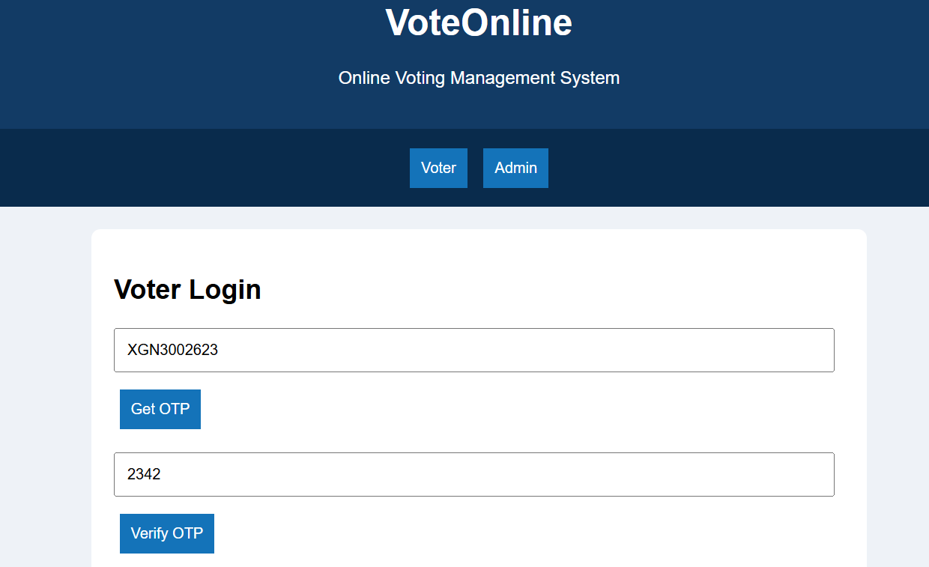
Result
Thus, the VoteOnline website was developed with voter verification, candidate selection, vote submission, voter management, and election result display.

