Experiment 18: AgriMart
Aim
To develop an AgriMart online shopping website using HTML, CSS, and JavaScript for agricultural product sales, cart management, orders, and shipping status tracking.
Algorithm
- Start.
- Allow farmers and customers to register and log in.
- Display agricultural products with search and filtering options.
- Allow customers to manage their cart, wallet, and shipping address.
- Enable customers to place orders and track shipping status.
- Allow farmers to add, edit, and delete products and manage sales.
- Display order details and status.
- Stop.
HTML Code

<!DOCTYPE html>
<html>
<head>
<title>AgriMart</title>
<style>
body{font-family:Arial;margin:0;background:#f0f7ed;color:#263528}
header{background:#28743b;color:white;text-align:center;padding:20px}
nav{background:#194e2b;text-align:center;padding:12px}
button{padding:9px 13px;margin:4px;border:0;border-radius:4px;background:#39884a;color:white;cursor:pointer}
section{background:white;max-width:850px;margin:20px auto;padding:20px;border-radius:8px}
input,select,textarea{display:block;width:95%;padding:10px;margin:9px 0;border:1px solid #ccc}
.item{border:1px solid #ddd;padding:12px;margin:10px 0;border-radius:6px}
img{max-width:120px;display:block}
</style>
</head>
<body>
<header>
<h1>🌱 AgriMart</h1>
<p>Your Online Agricultural Store</p>
</header>
<nav>
<button onclick="show('shop')">Shop</button>
<button onclick="show('account')">My Account</button>
<button onclick="show('cart')">My Cart</button>
<button onclick="show('orders')">My Orders</button>
<button onclick="show('farmer')">Farmer Panel</button>
</nav>

<section id="shop">
<h2>Register / Login</h2>
<input id="username" placeholder="Enter your name">
<input id="email" placeholder="Email">
<input id="password" type="password" placeholder="Password">
<button onclick="login()">Register / Login</button>
<p id="welcome"></p>

<h2>Agricultural Products</h2>
<input id="search" placeholder="Search products..." oninput="renderProducts()">
<select id="category" onchange="renderProducts()">
<option value="">All Categories</option>
<option>Seeds</option><option>Fertilizers</option>
<option>Pesticides</option><option>Equipment</option>
</select>
<div id="products"></div>
</section>

<section id="account" hidden>
<h2>My Account & Wallet</h2>
<p id="accountInfo">Please log in first.</p>
<h3>Wallet Balance: ₹<span id="balance">1000</span></h3>
<input id="amount" type="number" placeholder="Amount to add">
<button onclick="addMoney()">Add Wallet Money</button>
<h3>Shipping Address</h3>
<textarea id="address" placeholder="Enter delivery address"></textarea>
<button onclick="saveAddress()">Save Address</button>
<p id="addressMsg"></p>
</section>

<section id="cart" hidden>
<h2>Shopping Cart</h2>
<div id="cartItems"></div>
<p>Total: ₹<span id="total">0</span></p>
<button onclick="checkout()">Place Order</button>
</section>

<section id="orders" hidden>
<h2>My Orders</h2>
<div id="orderItems"></div>
</section>

<section id="farmer" hidden>
<h2>Farmer Login</h2>
<input id="farmerId" placeholder="Farmer ID">
<input id="farmerPass" type="password" placeholder="Password">
<button onclick="farmerLogin()">Login</button>
<p id="farmerMsg"></p>
<div id="farmerPanel" hidden>
<h3>Add / Update Product</h3>
<input id="pname" placeholder="Product Name">
<select id="pcategory">
<option>Seeds</option><option>Fertilizers</option>
<option>Pesticides</option><option>Equipment</option>
</select>
<input id="price" type="number" placeholder="Price">
<input id="image" type="text" placeholder="Image URL (optional)">
<button onclick="addProduct()">Add Product</button>
<h3>Manage Products</h3>
<div id="farmerProducts"></div>
<h3>My Sales / Orders</h3>
<div id="farmerOrders"></div>
</div>
</section>

<script>
let products=[
{id:1,name:"Tomato Seeds",category:"Seeds",price:120,image:""},
{id:2,name:"Organic Fertilizer",category:"Fertilizers",price:350,image:""},
{id:3,name:"Crop Protection Spray",category:"Pesticides",price:250,image:""},
{id:4,name:"Garden Sprayer",category:"Equipment",price:600,image:""}
];
let cart=[];
let orders=[];
let balance=1000;
let currentUser="";
let shippingAddress="";
let farmer=false;
let editId=null;

function show(id){
["shop","account","cart","orders","farmer"].forEach(s=>
document.getElementById(s).hidden=s!==id);
renderProducts();renderCart();renderOrders();renderFarmer();
}

function login(){
let name=username.value.trim(),mail=email.value.trim();
if(!name||!mail||!password.value){alert("Enter all login details");return;}
currentUser=mail;
welcome.innerText="Welcome, "+name+"! Demo login successful.";
accountInfo.innerText="Logged in as "+mail;
}

function renderProducts(){
let q=search.value.toLowerCase(),cat=category.value;
productsDiv=document.getElementById("products");
productsDiv.innerHTML=products.filter(p=>
p.name.toLowerCase().includes(q)&&(!cat||p.category===cat))
.map(p=>`<div class="item">
${p.image?`<img src="${p.image}" alt="${p.name}">`:""}
<h3>${p.name}</h3><p>${p.category}</p><b>₹${p.price}</b><br>
<button onclick="addCart(${p.id})">Add to Cart</button>
</div>`).join("")||"No products found.";
}

function addCart(id){
let p=products.find(x=>x.id===id);
let existing=cart.find(x=>x.id===id);
if(existing)existing.qty++;
else cart.push({...p,qty:1});
renderCart();alert("Product added to cart");
}

function renderCart(){
cartItems.innerHTML=cart.map(p=>`<div class="item">
${p.name} - ₹${p.price}
<input type="number" min="1" value="${p.qty}" onchange="changeQty(${p.id},this.value)">
<button onclick="removeCart(${p.id})">Delete</button>
</div>`).join("")||"Your cart is empty.";
total.innerText=cart.reduce((s,p)=>s+p.price*p.qty,0);
}

function changeQty(id,qty){
let p=cart.find(x=>x.id===id);
if(p)p.qty=Math.max(1,Number(qty)||1);
renderCart();
}

function removeCart(id){
cart=cart.filter(p=>p.id!==id);renderCart();
}

function addMoney(){
let amountValue=Number(amount.value);
if(amountValue<=0)return alert("Enter a valid amount");
balance+=amountValue;balanceSpan();
amount.value="";
}

function balanceSpan(){
document.getElementById("balance").innerText=balance;
}

function saveAddress(){
shippingAddress=address.value.trim();
addressMsg.innerText=shippingAddress?"Address saved successfully":"Enter an address";
}

function checkout(){
if(!currentUser)return alert("Please register or log in first");
if(!cart.length)return alert("Your cart is empty");
if(!shippingAddress)return alert("Please save your shipping address first");
let cost=cart.reduce((s,p)=>s+p.price*p.qty,0);
if(cost>balance)return alert("Insufficient wallet balance");
balance-=cost;balanceSpan();
orders.push({id:orders.length+1,user:currentUser,items:cart.map(p=>({...p})),
total:cost,status:"Order Placed",shipping:"Processing"});
cart=[];renderCart();renderOrders();
alert("Order placed successfully!");
}

function renderOrders(){
orderItems.innerHTML=orders.filter(o=>!currentUser||o.user===currentUser)
.map(o=>`<div class="item"><b>Order #${o.id}</b>
<p>Total: ₹${o.total}</p><p>Status: ${o.status}</p>
<p>Shipping: ${o.shipping}</p></div>`).join("")||"No orders yet.";
}

function farmerLogin(){
farmer=farmerId.value==="farmer"&&farmerPass.value==="1234";
farmerMsg.innerText=farmer?"Farmer login successful":"Invalid farmer credentials";
farmerPanel.hidden=!farmer;
renderFarmer();
}

function addProduct(){
if(!farmer)return;
let name=pname.value.trim(),priceValue=Number(price.value);
if(!name||priceValue<=0)return alert("Enter product name and valid price");
if(editId!==null){
let p=products.find(x=>x.id===editId);
Object.assign(p,{name,category:pcategory.value,price:priceValue,image:image.value});
editId=null;
}else{
products.push({id:Date.now(),name,category:pcategory.value,
price:priceValue,image:image.value});
}
pname.value="";price.value="";image.value="";
renderProducts();renderFarmer();
}

function editProduct(id){
let p=products.find(x=>x.id===id);
pname.value=p.name;pcategory.value=p.category;
price.value=p.price;image.value=p.image;editId=id;
}

function deleteProduct(id){
products=products.filter(p=>p.id!==id);
renderProducts();renderFarmer();
}

function updateOrder(id,status){
let o=orders.find(x=>x.id===id);
o.shipping=status;renderFarmer();renderOrders();
}

function renderFarmer(){
if(!farmer)return;
farmerProducts.innerHTML=products.map(p=>`<div class="item">
${p.name} - ₹${p.price}
<button onclick="editProduct(${p.id})">Edit</button>
<button onclick="deleteProduct(${p.id})">Delete</button>
</div>`).join("");
farmerOrders.innerHTML=orders.map(o=>`<div class="item">
Order #${o.id} - ₹${o.total}
<select onchange="updateOrder(${o.id},this.value)">
<option>${o.shipping}</option><option>Shipped</option><option>Delivered</option>
</select></div>`).join("")||"No sales yet.";
}
renderProducts();
renderCart();
renderOrders();
</script>
</body>
</html>
Output:
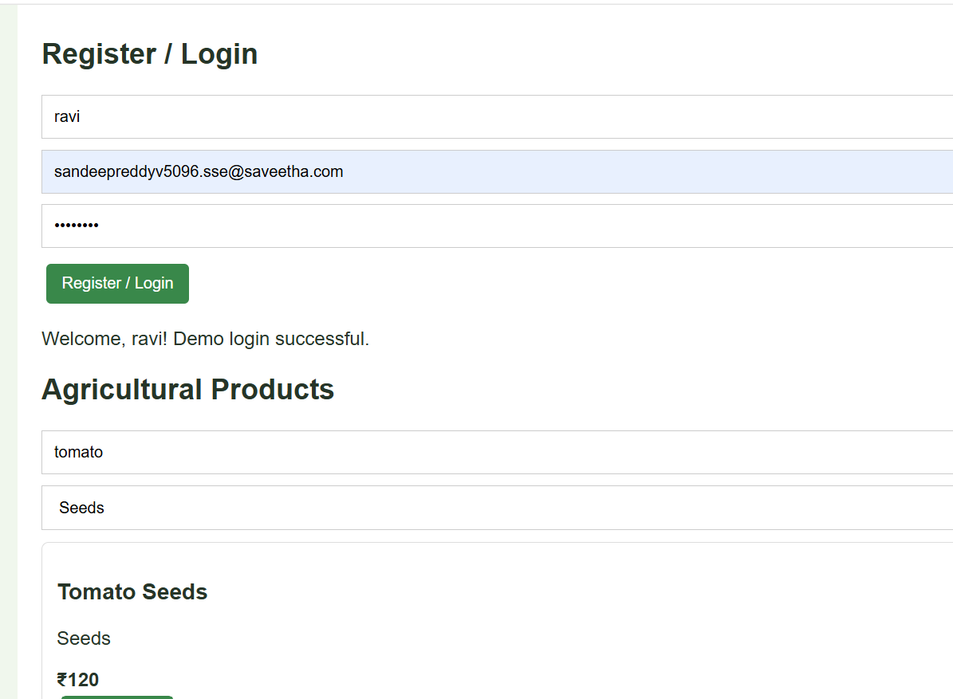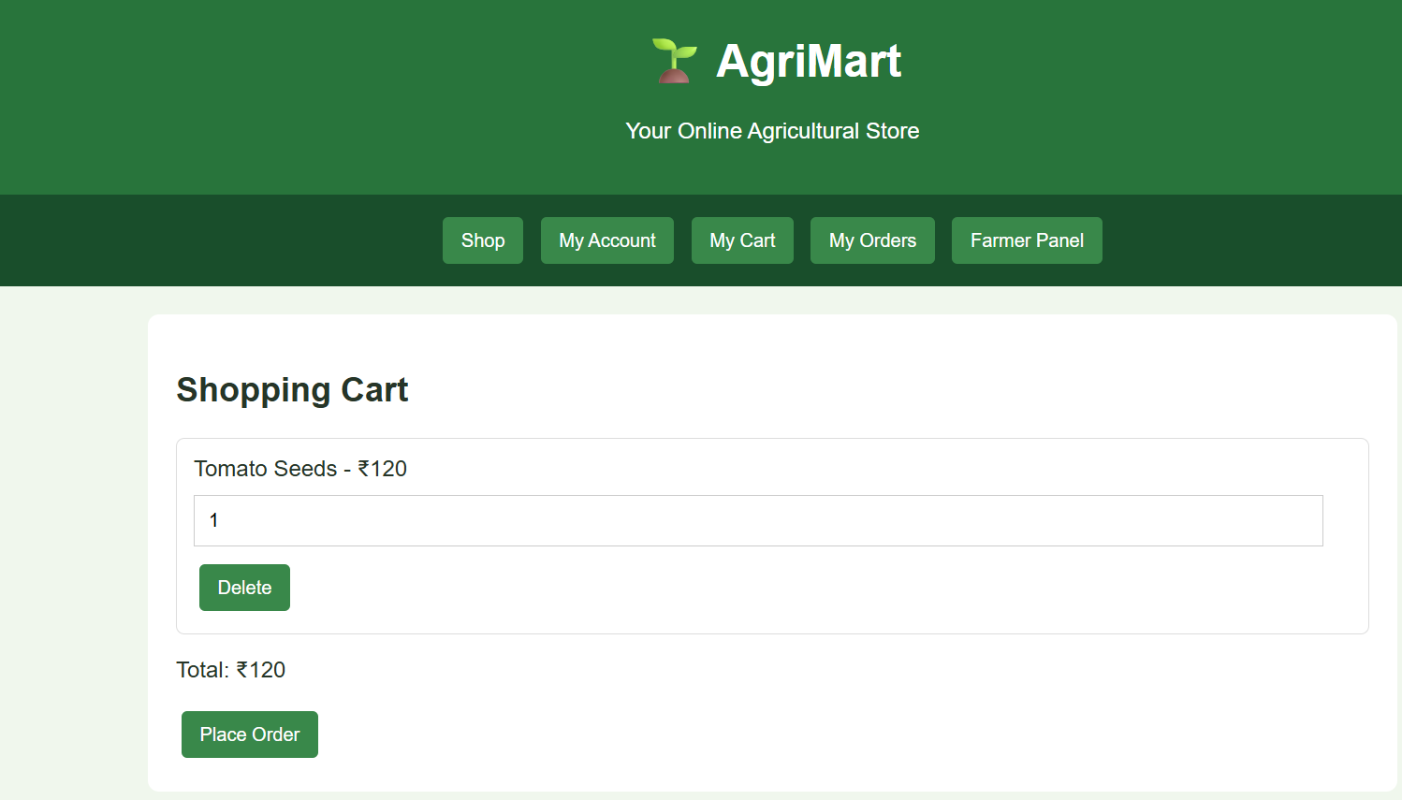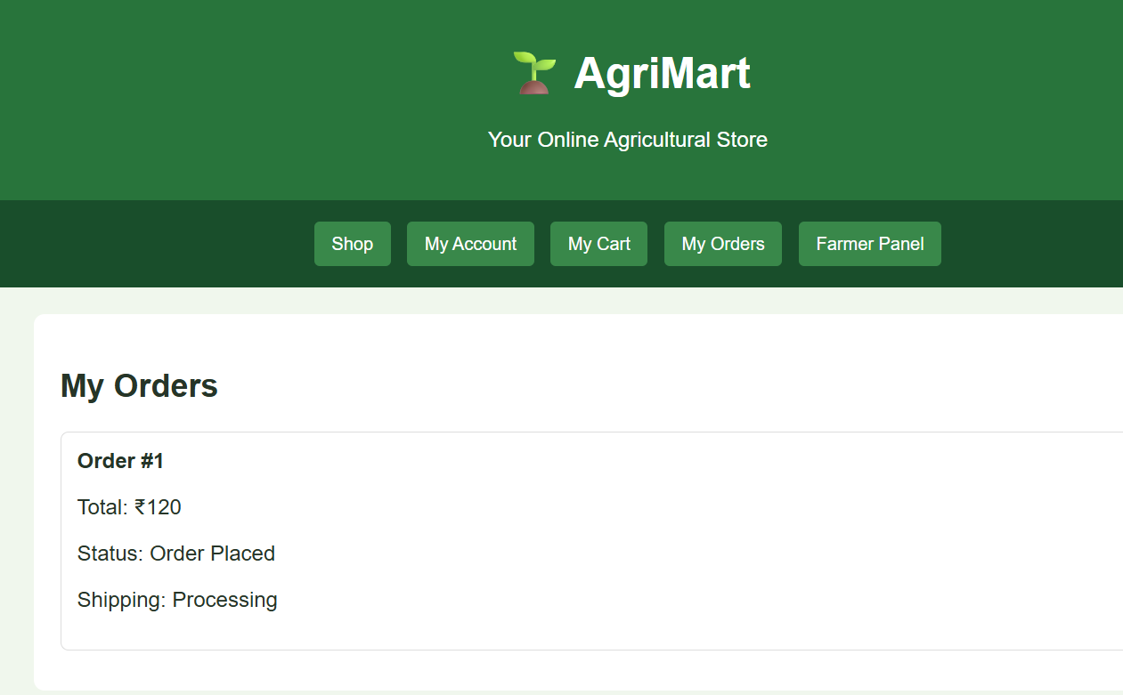
Result
Thus, the AgriMart website was developed successfully with product search, cart management, wallet balance, order placement, and farmer product and shipping management features.

