Experiment 19: VetCure – Online Veterinary Consultation System
Aim
To develop a VetCure website using HTML, CSS, and JavaScript for online veterinary consultation, complaint management, doctor solutions, payments, and animal disease information.
Algorithm
- Start.
- Allow farmers and doctors to register and log in.
- Farmers submit animal symptoms using text, images, audio, or video.
- Doctors view complaints and provide solutions.
- Display doctor details, veterinary news, and disease information.
- Allow farmers to make payments and submit feedback.
- Generate disease reports and display complaint status.
- Stop.
HTML Code

<!DOCTYPE html>
<html>
<head>
<title>VetCure</title>
<style>
body{font-family:Arial;margin:0;background:#eef5f0;color:#243b2c}
header{background:#247443;color:white;text-align:center;padding:20px}
nav{background:#164d2d;text-align:center;padding:12px}
button{padding:10px;margin:4px;background:#29864b;color:white;border:0;cursor:pointer}
section{background:white;max-width:800px;margin:20px auto;padding:20px;border-radius:8px}
input,textarea,select{display:block;width:95%;padding:10px;margin:10px 0}
.item{border:1px solid #ccc;padding:12px;margin:10px 0;border-radius:5px}
</style>
</head>
<body>
<header>
<h1>VetCure 🐄</h1>
<p>Online Veterinary Consultation System</p>
</header>

<nav>
<button onclick="show('farmer')">Farmer</button>
<button onclick="show('doctor')">Doctor</button>
<button onclick="show('news')">News & Cures</button>
<button onclick="show('report')">Reports</button>
</nav>

<section id="farmer">
<h2>Farmer Register / Login</h2>
<input id="fname" placeholder="Farmer Name">
<input id="femail" type="email" placeholder="Email">
<input id="fpass" type="password" placeholder="Password">
<button onclick="farmerLogin()">Register / Login</button>
<p id="fmsg"></p>

<h2>Submit Animal Complaint</h2>
<form onsubmit="postComplaint(event)">
<input id="animal" placeholder="Animal Name (e.g. Cow)" required>
<textarea id="symptoms" placeholder="Describe symptoms" required></textarea>
<label>Upload Image, Audio, or Video</label>
<input id="media" type="file" accept="image/*,audio/*,video/*">
<button type="submit">Submit Complaint</button>
</form>

<h2>My Complaint Status</h2>
<div id="myComplaints"></div>

<h2>View Doctors</h2>
<div id="doctors"></div>

<h2>Payment</h2>
<select id="payment">
<option>Bank Transfer</option>
<option>EasyPaisa</option>
</select>
<button onclick="pay()">Make Demo Payment</button>
<p id="paymsg"></p>

<h2>Feedback</h2>
<textarea id="feedback" placeholder="Enter feedback"></textarea>
<button onclick="sendFeedback()">Submit Feedback</button>
<p id="fbmsg"></p>

<h2>My Profile</h2>
<p id="profile">Please log in first.</p>
</section>

<section id="doctor" hidden>
<h2>Doctor Register / Login</h2>
<input id="dname" placeholder="Doctor Name">
<input id="demail" placeholder="Email">
<input id="dpass" type="password" placeholder="Password">
<select id="clinic">
<option>Government Veterinary Hospital</option>
<option>Private Clinic</option>
</select>
<input id="fee" type="number" placeholder="Consultation Fee">
<input id="bank" placeholder="Bank / EasyPaisa Details">
<button onclick="doctorLogin()">Register / Login</button>
<p id="dmsg"></p>

<h2>Manage Complaints</h2>
<div id="doctorComplaints"></div>

<h2>Manage Animal Cures</h2>
<input id="disease" placeholder="Disease Name">
<textarea id="solution" placeholder="General solution or advice"></textarea>
<button onclick="addCure()">Add Cure</button>
</section>

<section id="news" hidden>
<h2>Veterinary News</h2>
<div id="newsList"></div>
<h2>Animal Diseases and Cures</h2>
<div id="cures"></div>
</section>

<section id="report" hidden>
<h2>Disease Report</h2>
<button onclick="makeReport()">Generate Report</button>
<div id="reportData"></div>
</section>

<script>
let complaints=[];
let doctors=[];
let cures=[
{disease:"Foot-and-mouth disease",solution:"Seek veterinary examination and isolate affected animals."},
{disease:"Mastitis",solution:"Contact a veterinarian for diagnosis and appropriate treatment."},
{disease:"Animal fever",solution:"Monitor symptoms and consult a veterinarian promptly."}
];
let currentFarmer="";
let currentDoctor=-1;

function show(id){
["farmer","doctor","news","report"].forEach(x=>
document.getElementById(x).hidden=x!==id);
render();
}

function farmerLogin(){
if(!fname.value.trim()||!femail.value.trim()||!fpass.value){
alert("Enter all farmer details");return;
}
currentFarmer=femail.value;
fmsg.innerText="Welcome "+fname.value;
profile.innerText="Farmer: "+fname.value+" | Email: "+femail.value;
}

function postComplaint(e){
e.preventDefault();
if(!currentFarmer){alert("Please register or log in first");return;}
let file=media.files[0];
complaints.push({
id:complaints.length+1,farmer:currentFarmer,
animal:animal.value,symptoms:symptoms.value,
file:file?file.name:"No file uploaded",
status:"Pending",solution:""
});
e.target.reset();
render();
alert("Complaint submitted successfully");
}

function doctorLogin(){
if(!dname.value.trim()||!demail.value.trim()||!dpass.value){
alert("Enter doctor details");return;
}
let index=doctors.findIndex(d=>d.email===demail.value);
if(index<0){
doctors.push({name:dname.value,email:demail.value,
clinic:clinic.value,fee:Number(fee.value)||0,bank:bank.value});
index=doctors.length-1;
}
currentDoctor=index;
dmsg.innerText="Doctor login successful";
render();
}

function render(){
myComplaints.innerHTML=complaints.filter(c=>c.farmer===currentFarmer)
.map(c=>`<div class="item"><b>Complaint #${c.id}</b>
<p>Animal: ${c.animal}</p><p>Symptoms: ${c.symptoms}</p>
<p>File: ${c.file}</p><p>Status: ${c.status}</p>
<p>Doctor's solution: ${c.solution||"Awaiting response"}</p></div>`)
.join("")||"No complaints submitted.";

doctorsDiv=document.getElementById("doctors");
doctorsDiv.innerHTML=doctors.map(d=>`<div class="item">
<b>${d.name}</b><p>${d.clinic}</p>
<p>Consultation fee: ₹${d.fee}</p></div>`).join("")||"No doctors registered.";

doctorComplaints.innerHTML=currentDoctor<0?"Please log in as a doctor.":
complaints.map(c=>`<div class="item"><b>Complaint #${c.id}</b>
<p>Animal: ${c.animal}</p><p>Symptoms: ${c.symptoms}</p>
<textarea id="sol${c.id}" placeholder="Enter solution">${c.solution}</textarea>
<select id="st${c.id}"><option>Pending</option><option>In Progress</option><option>Resolved</option></select>
<button onclick="updateComplaint(${c.id})">Send Solution</button></div>`).join("")||"No complaints.";

curesDiv=document.getElementById("cures");
curesDiv.innerHTML=cures.map(c=>`<div class="item"><b>${c.disease}</b><p>${c.solution}</p></div>`).join("");

newsList.innerHTML="<div class='item'>Vaccination: Follow your local veterinarian's vaccination schedule.</div><div class='item'>Animal care: Provide clean water, proper nutrition, and regular veterinary checkups.</div>";
}

function updateComplaint(id){
if(currentDoctor<0){alert("Doctor login required");return;}
let c=complaints.find(x=>x.id===id);
c.solution=document.getElementById("sol"+id).value;
c.status=document.getElementById("st"+id).value;
render();
alert("Complaint updated");
}

function addCure(){
if(currentDoctor<0){alert("Doctor login required");return;}
if(!disease.value.trim()||!solution.value.trim())return alert("Enter disease and solution");
cures.push({disease:disease.value,solution:solution.value});
disease.value="";solution.value="";
render();
alert("Cure information added");
}

function pay(){
if(!currentFarmer)return alert("Please log in first");
paymsg.innerText="Demo payment selected: "+payment.value+
". No real money was transferred.";
}

function sendFeedback(){
if(!currentFarmer)return alert("Please log in first");
if(!feedback.value.trim())return alert("Enter feedback");
fbmsg.innerText="Feedback submitted successfully";
feedback.value="";
}

function makeReport(){
let counts={};
complaints.forEach(c=>counts[c.animal]=(counts[c.animal]||0)+1);
reportData.innerHTML="<h3>Complaints by Animal</h3>"+
(Object.keys(counts).map(a=>`<p>${a}: ${counts[a]} complaint(s)</p>`).join("")||"No data available");
}
render();
</script>
</body>
</html>

Output:
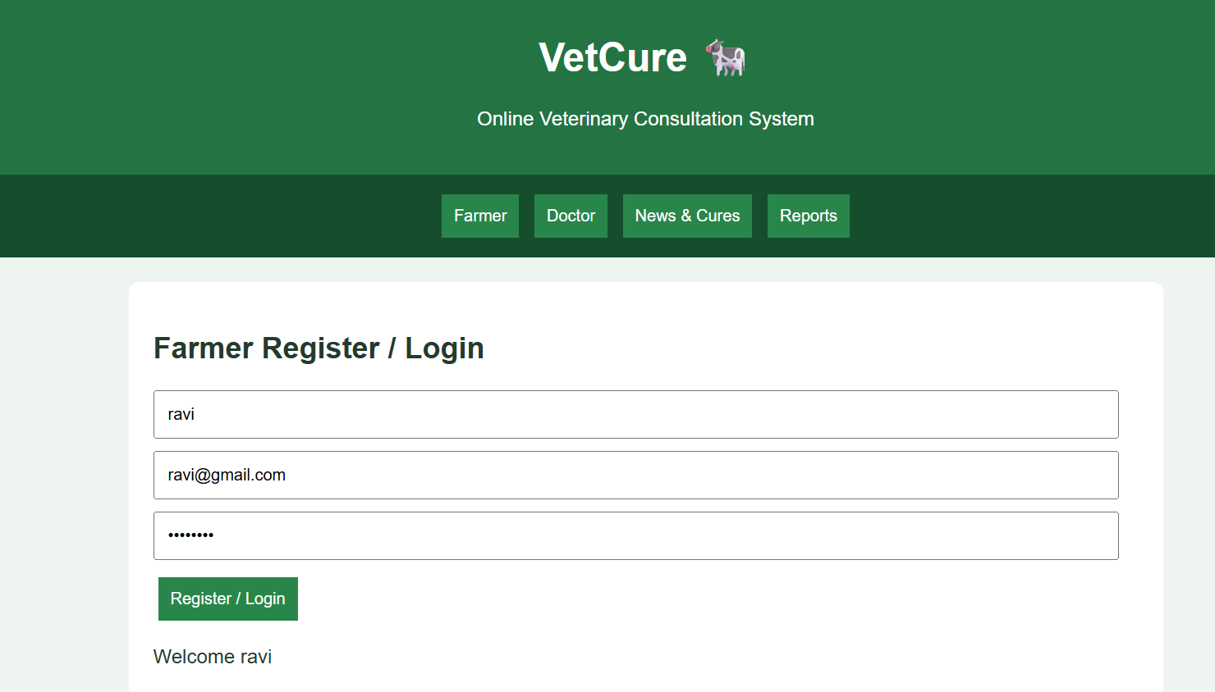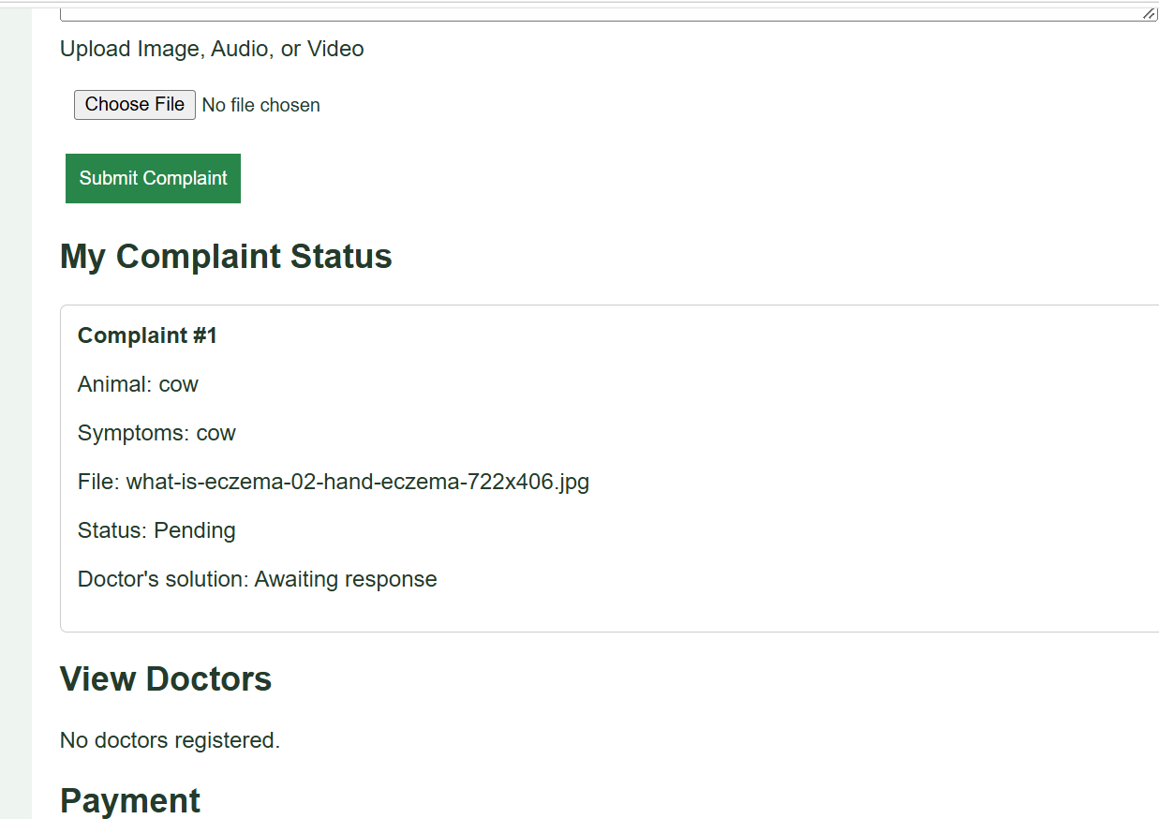
Result
Thus, the VetCure website was developed with farmer complaint submission, doctor responses, animal disease information, demo payments, feedback, and disease reporting.

