Experiment 20: RentRide – Online Vehicle Rental System
Aim
To develop a RentRide website using HTML, CSS, and JavaScript for vehicle searching, booking, reservation management, and vehicle administration.
Algorithm
- Start.
- Allow users to register and log in.
- Display vehicles with type, price, and location filters.
- Allow users to select a vehicle and submit booking details.
- Display booking status and rental history.
- Allow admins to add vehicles and manage vehicle details.
- Allow admins to approve or reject bookings.
- Stop.
HTML Code

<!DOCTYPE html>
<html>
<head>
<title>RentRide</title>
<style>
body{font-family:Arial;margin:0;background:#eef2f7;color:#243247}
header{background:#17416b;color:white;text-align:center;padding:20px}
nav{background:#0d2c4b;text-align:center;padding:12px}
button{padding:10px;margin:4px;background:#1673b9;color:white;border:0;border-radius:4px;cursor:pointer}
section{background:white;max-width:800px;margin:20px auto;padding:20px;border-radius:8px}
input,select,textarea{display:block;width:95%;padding:10px;margin:10px 0;box-sizing:border-box}
.item{border:1px solid #ccc;padding:12px;margin:10px 0;border-radius:5px}
</style>
</head>
<body>

<header>
<h1>🚗 RentRide</h1>
<p>Your Journey, Your Ride</p>
</header>

<nav>
<button onclick="show('user')">User</button>
<button onclick="show('bookings')">My Bookings</button>
<button onclick="show('admin')">Admin</button>
</nav>

<section id="user">
<h2>User Registration / Login</h2>
<input id="uname" placeholder="Full Name">
<input id="email" type="email" placeholder="Email">
<input id="password" type="password" placeholder="Password">
<button onclick="login()">Register / Login</button>
<p id="msg"></p>

<h2>Search Vehicles</h2>
<input id="search" placeholder="Search by vehicle or location" oninput="renderVehicles()">
<select id="type" onchange="renderVehicles()">
<option value="">All Vehicle Types</option>
<option>Car</option><option>SUV</option><option>Truck</option>
</select>

<div id="vehicles"></div>

<h2>Book a Vehicle</h2>
<form onsubmit="bookVehicle(event)">
<select id="vehicleSelect" required>
<option value="">Select Vehicle</option>
</select>
<input id="customer" placeholder="Customer Name" required>
<input id="phone" placeholder="Customer Number" required>
<textarea id="address" placeholder="Address" required></textarea>
<label>Rental Start Date</label>
<input id="start" type="date" required>
<label>Rental End Date</label>
<input id="end" type="date" required>
<button type="submit">Submit Booking</button>
</form>
<p id="bookMsg"></p>

<h2>Check-in Form</h2>
<input id="checkId" placeholder="Booking ID">
<button onclick="checkIn()">Submit Check-in</button>
<p id="checkMsg"></p>

<h2>Reviews</h2>
<textarea id="review" placeholder="Write your review"></textarea>
<button onclick="submitReview()">Submit Review</button>
<div id="reviews"></div>
</section>

<section id="bookings" hidden>
<h2>My Bookings / Rental History</h2>
<div id="bookingList"></div>
</section>

<section id="admin" hidden>
<h2>Admin Login</h2>
<input id="adminUser" placeholder="Username">
<input id="adminPass" type="password" placeholder="Password">
<button onclick="adminLogin()">Login</button>
<p id="adminMsg"></p>

<div id="adminPanel" hidden>
<h2>Add Vehicle</h2>
<input id="vname" placeholder="Vehicle Name">
<select id="vtype">
<option>Car</option><option>SUV</option><option>Truck</option>
</select>
<input id="vprice" type="number" placeholder="Price per day">
<input id="vlocation" placeholder="Vehicle Location">
<button onclick="addVehicle()">Add Vehicle</button>

<h2>Manage Vehicles</h2>
<div id="adminVehicles"></div>

<h2>Manage Bookings</h2>
<div id="adminBookings"></div>
</div>
</section>

<script>
let vehicles=[
{id:1,name:"Swift Dzire",type:"Car",price:1800,location:"Chennai"},
{id:2,name:"Toyota Innova",type:"SUV",price:3000,location:"Bengaluru"},
{id:3,name:"Mahindra Pickup",type:"Truck",price:2500,location:"Chennai"}
];
let bookings=[];
let reviews=[];
let currentUser="";
let admin=false;

function show(id){
["user","bookings","admin"].forEach(x=>
document.getElementById(x).hidden=x!==id);
renderVehicles();renderBookings();renderAdmin();
}

function login(){
if(!uname.value.trim()||!email.value.trim()||!password.value){
alert("Enter all login details");return;
}
currentUser=email.value;
msg.innerText="Welcome, "+uname.value+"!";
}

function renderVehicles(){
let q=search.value.toLowerCase(),t=type.value;
vehiclesDiv=document.getElementById("vehicles");
vehiclesDiv.innerHTML=vehicles.filter(v=>
(v.name+" "+v.location).toLowerCase().includes(q)&&(!t||v.type===t))
.map(v=>`<div class="item">
<h3>${v.name}</h3>
<p>Type: ${v.type}</p>
<p>Location: ${v.location}</p>
<p>Price: ₹${v.price} per day</p>
<button onclick="selectVehicle(${v.id})">Book Vehicle</button>
<button onclick="deleteVehicle(${v.id})" ${admin?"":"hidden"}>Delete</button>
</div>`).join("")||"No vehicles found.";

vehicleSelect.innerHTML='<option value="">Select Vehicle</option>'+
vehicles.map(v=>`<option value="${v.id}">${v.name} - ₹${v.price}/day</option>`).join("");
}

function selectVehicle(id){
vehicleSelect.value=id;
document.getElementById("customer").scrollIntoView({behavior:"smooth"});
}

function bookVehicle(e){
e.preventDefault();
if(!currentUser)return alert("Please register or log in first");
let s=new Date(start.value),en=new Date(end.value);
if(en<s||isNaN(s.getTime()))return alert("Select valid rental dates");
let v=vehicles.find(x=>x.id===Number(vehicleSelect.value));
if(!v)return alert("Select a vehicle");
let days=Math.max(1,Math.ceil((en-s)/86400000)+1);
bookings.push({
id:bookings.length+1001,user:currentUser,vehicle:v.name,
customer:customer.value,phone:phone.value,address:address.value,
start:start.value,end:end.value,total:days*v.price,
status:"Pending",checkin:"Not checked in"
});
bookMsg.innerText="Booking submitted successfully!";
e.target.reset();renderBookings();renderAdmin();
}

function renderBookings(){
bookingList.innerHTML=bookings.filter(b=>!currentUser||b.user===currentUser)
.map(b=>`<div class="item">
<b>Booking ID: ${b.id}</b><p>Vehicle: ${b.vehicle}</p>
<p>Dates: ${b.start} to ${b.end}</p>
<p>Total: ₹${b.total}</p><p>Status: ${b.status}</p>
<p>Check-in: ${b.checkin}</p>
</div>`).join("")||"No bookings yet.";
}

function checkIn(){
let b=bookings.find(x=>x.id===Number(checkId.value)&&x.user===currentUser);
if(!b){checkMsg.innerText="Booking not found";return;}
b.checkin="Check-in submitted";
checkMsg.innerText="Check-in form submitted successfully";
renderBookings();renderAdmin();
}

function adminLogin(){
admin=adminUser.value==="admin"&&adminPass.value==="admin123";
adminMsg.innerText=admin?"Admin login successful":"Invalid credentials";
adminPanel.hidden=!admin;
renderAdmin();renderVehicles();
}

function addVehicle(){
if(!admin)return;
if(!vname.value.trim()||Number(vprice.value)<=0||!vlocation.value.trim())
return alert("Enter valid vehicle details");
vehicles.push({id:Date.now(),name:vname.value,type:vtype.value,
price:Number(vprice.value),location:vlocation.value});
vname.value="";vprice.value="";vlocation.value="";
renderVehicles();renderAdmin();
}

function deleteVehicle(id){
if(!admin)return;
vehicles=vehicles.filter(v=>v.id!==id);
renderVehicles();renderAdmin();
}

function updateBooking(id,status){
if(!admin)return;
let b=bookings.find(x=>x.id===id);
b.status=status;
renderBookings();renderAdmin();
}

function renderAdmin(){
if(!admin)return;
adminVehicles.innerHTML=vehicles.map(v=>`<div class="item">
${v.name} - ${v.type} - ₹${v.price}/day
<button onclick="deleteVehicle(${v.id})">Delete</button></div>`).join("");
adminBookings.innerHTML=bookings.map(b=>`<div class="item">
<b>Booking #${b.id}</b><p>${b.customer} - ${b.vehicle}</p>
<p>${b.start} to ${b.end} | ₹${b.total}</p>
<select onchange="updateBooking(${b.id},this.value)">
<option ${b.status==="Pending"?"selected":""}>Pending</option>
<option ${b.status==="Approved"?"selected":""}>Approved</option>
<option ${b.status==="Rejected"?"selected":""}>Rejected</option>
</select></div>`).join("")||"No bookings.";
}

function submitReview(){
if(!currentUser)return alert("Please log in first");
if(!review.value.trim())return alert("Enter a review");
reviews.push(review.value);
document.getElementById("reviews").innerHTML=reviews.map(r=>
`<div class="item">${r}</div>`).join("");
review.value="";
}
renderVehicles();renderBookings();
</script>
</body>
</html>
Output:
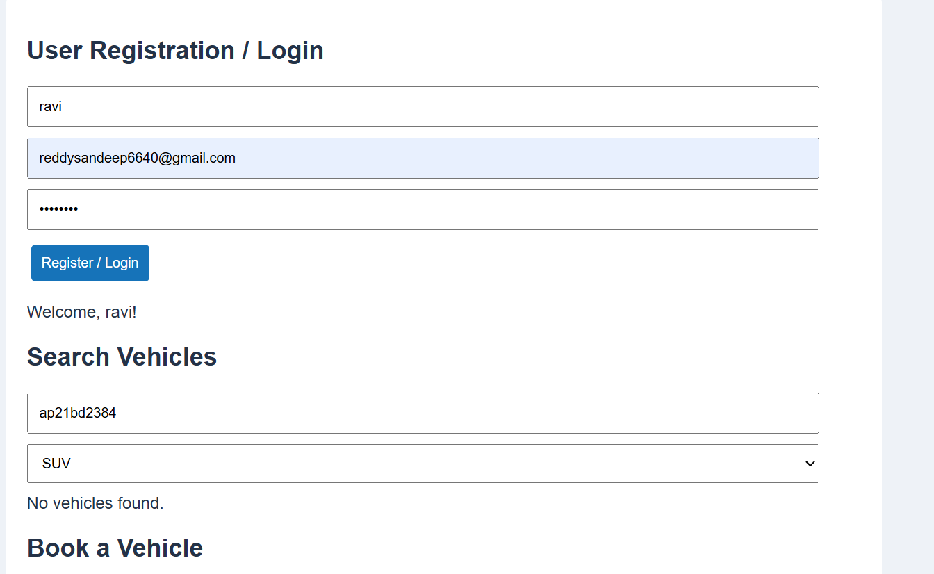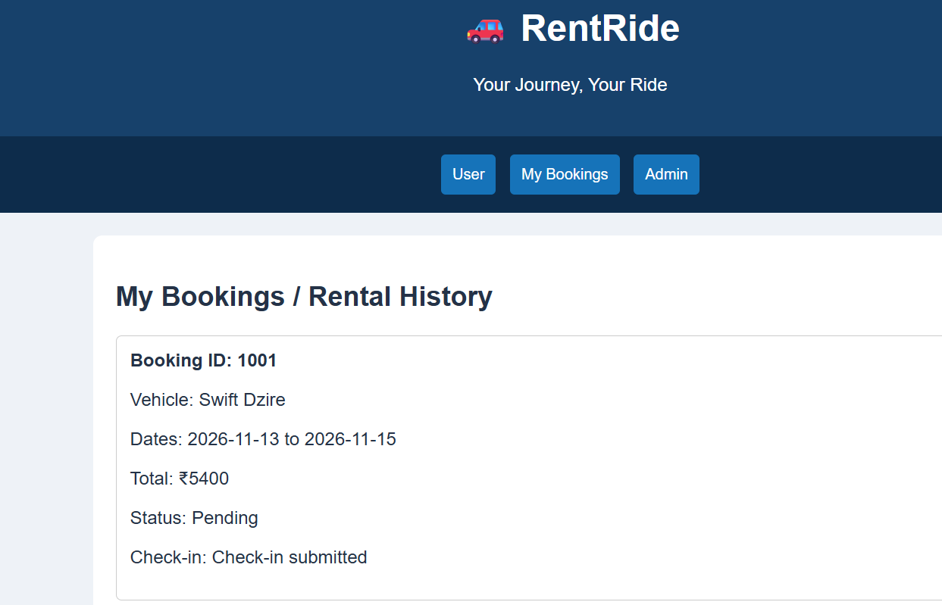
Result
Thus, the RentRide website was developed successfully with vehicle search, booking, check-in, reviews, booking status tracking, and admin vehicle management.

