Experiment 11: Home Finder – Online Real Estate Website
Aim
To design and develop a user-friendly real estate website using HTML, CSS, and JavaScript to search properties based on location, price, and type.
Algorithm
- Start the program.
- Display available houses, lands, and commercial properties.
- Allow users to search properties by location and budget.
- Display property details and prices.
- Allow users to save favorite properties.
- Provide agent contact details and property location.
- Allow users to add and manage property listings.
- Display the search results and stop the program.
HTML Code

<!DOCTYPE html>
<html>
<head>
<title>Home Finder</title>
<style>
body {
font-family: Arial;
margin: 0;
background: #f1f6f5;
}
header {
background: #176b60;
color: white;
text-align: center;
padding: 20px;
}
nav {
background: #222;
padding: 12px;
text-align: center;
}
nav a {
color: white;
margin: 15px;
text-decoration: none;
}
.container { padding: 20px; }
.search, .card {
background: white;
padding: 15px;
margin: 10px 0;
border-radius: 8px;
box-shadow: 0 2px 5px #ccc;
}
.properties {
display: flex;
flex-wrap: wrap;
gap: 15px;
}
.card { width: 230px; }
button {
background: #176b60;
color: white;
padding: 9px;
border: none;
cursor: pointer;
margin: 4px;
}
input, select {
padding: 9px;
margin: 5px;
}
</style>
</head>
<body>

<header>
<h1>Home Finder</h1>
<p>Find Your Dream Property</p>
</header>

<nav>
<a href="#home">Home</a>
<a href="#properties">Properties</a>
<a href="#saved">Favorites</a>
<a href="#admin">Add Property</a>
</nav>

<div class="container" id="home">
<h2>Search Properties</h2>

<div class="search">
<input id="location" placeholder="Enter location">

<select id="type">
<option value="">All Types</option>
<option>House</option>
<option>Land</option>
<option>Apartment</option>
<option>Commercial</option>
</select>

<input id="budget" type="number"
placeholder="Maximum budget">

<button onclick="searchProperties()">Search</button>
<button onclick="resetSearch()">Reset</button>
</div>

<h2 id="properties">Available Properties</h2>
<div class="properties" id="propertyList"></div>

<h2 id="saved">Favorite Properties</h2>
<div id="favorites">No favorites saved.</div>

<h2>Property Location</h2>
<p id="mapInfo">Select a property to view its location.</p>
<a id="mapLink" href="https://maps.google.com/"
target="_blank">Open Google Maps</a>

<h2 id="admin">Add Property</h2>
<input id="pname" placeholder="Property name">
<input id="plocation" placeholder="Location">
<input id="pprice" type="number" placeholder="Price">
<select id="ptype">
<option>House</option>
<option>Land</option>
<option>Apartment</option>
<option>Commercial</option>
</select>
<input id="agent" placeholder="Agent contact">
<button onclick="addProperty()">Add Property</button>
</div>

<script>
let properties = [
{name:"Modern House", location:"Chennai",
price:4500000, type:"House", agent:"9876543210"},
{name:"Residential Land", location:"Bengaluru",
price:2500000, type:"Land", agent:"9876543211"},
{name:"City Apartment", location:"Hyderabad",
price:3500000, type:"Apartment", agent:"9876543212"},
{name:"Office Space", location:"Chennai",
price:6000000, type:"Commercial", agent:"9876543213"}
];

let favorites = [];

function displayProperties(list = properties) {
let output = document.getElementById("propertyList");
output.innerHTML = "";

list.forEach(p => {
let i = properties.indexOf(p);
output.innerHTML += `
<div class="card">
<h3>${p.name}</h3>
<p>Location: ${p.location}</p>
<p>Type: ${p.type}</p>
<h4>Price: ₹${p.price.toLocaleString("en-IN")}</h4>
<p>Agent: ${p.agent}</p>
<button onclick="saveFavorite(${i})">
Save Favorite
</button>
<button onclick="showLocation(${i})">
View Location
</button>
<button onclick="deleteProperty(${i})">
Delete
</button>
</div>`;
});

if (list.length === 0)
output.innerHTML = "No matching properties found.";
}

function searchProperties() {
let location = document.getElementById("location")
.value.toLowerCase();
let type = document.getElementById("type").value;
let budget = Number(document.getElementById("budget").value);

let result = properties.filter(p =>
p.location.toLowerCase().includes(location) &&
(!type || p.type === type) &&
(!budget || p.price <= budget)
);

displayProperties(result);
}

function resetSearch() {
document.getElementById("location").value = "";
document.getElementById("type").value = "";
document.getElementById("budget").value = "";
displayProperties();
}

function saveFavorite(i) {
if (!favorites.includes(properties[i])) {
favorites.push(properties[i]);
}
displayFavorites();
}

function displayFavorites() {
document.getElementById("favorites").innerHTML =
favorites.map(p =>
p.name + " - " + p.location +
" - ₹" + p.price.toLocaleString("en-IN")
).join("<br>") || "No favorites saved.";
}

function showLocation(i) {
let p = properties[i];
document.getElementById("mapInfo").innerText =
p.name + " is located in " + p.location;
document.getElementById("mapLink").href =
"https://www.google.com/maps/search/?api=1&query=" +
encodeURIComponent(p.location);
}

function addProperty() {
let name = document.getElementById("pname").value.trim();
let location = document.getElementById("plocation").value.trim();
let price = Number(document.getElementById("pprice").value);
let type = document.getElementById("ptype").value;
let agent = document.getElementById("agent").value.trim();

if (!name || !location || price <= 0 || !agent) {
alert("Enter valid property details.");
return;
}

properties.push({name, location, price, type, agent});
displayProperties();
alert("Property added successfully!");
}

function deleteProperty(i) {
if (confirm("Delete this property?")) {
favorites = favorites.filter(p => p !== properties[i]);
properties.splice(i, 1);
displayProperties();
displayFavorites();
}
}

displayProperties();
</script>

</body>
</html>

Output:
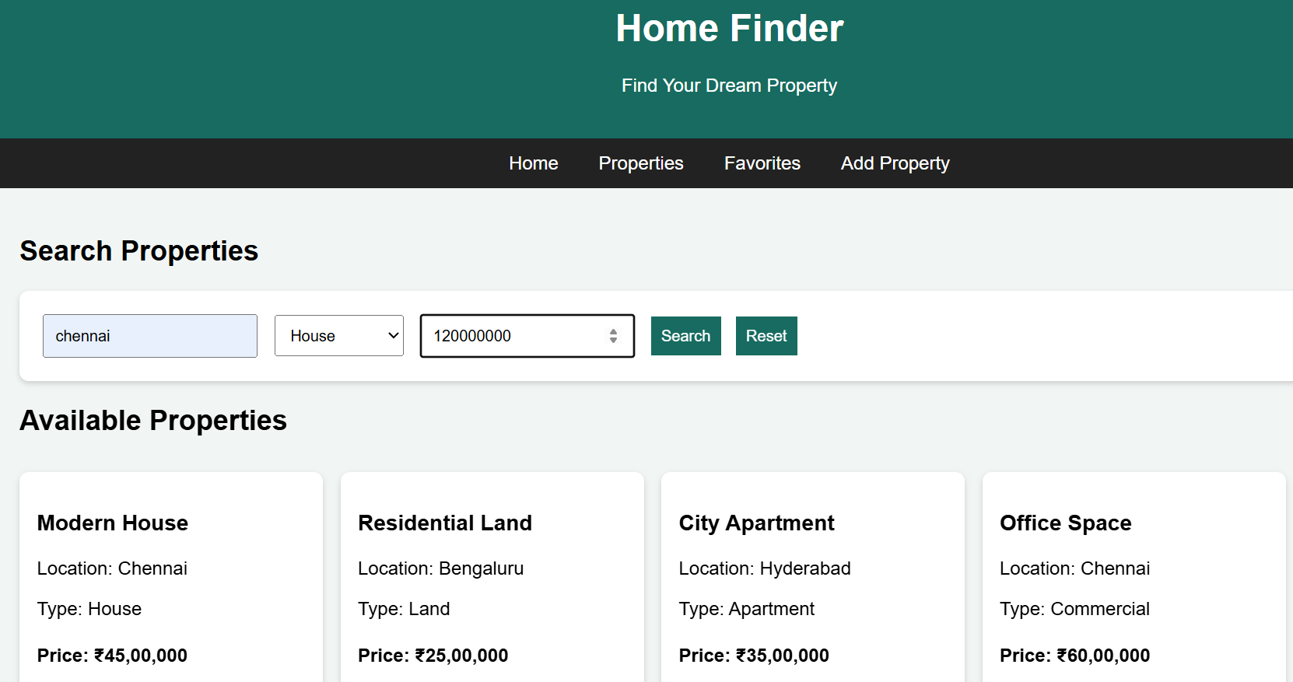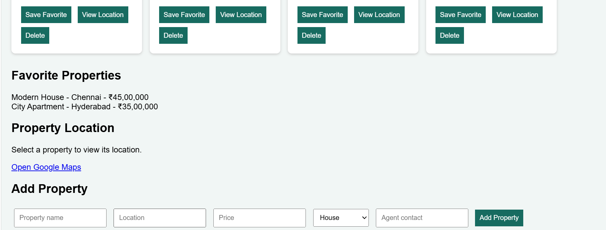
Result
Thus, the Home Finder real estate website was successfully developed with property searching, budget filtering, favorite listings, agent details, Google Maps links, and basic property management.

