Experiment 12: InsureEasy – Online Insurance Management System
Aim
To develop an online insurance management website using HTML, CSS, and JavaScript to manage agents, customers, insurance policies, and premium due-date reminders.
Algorithm
- Start the program.
- Display the InsureEasy home page.
- Provide login and registration options for agents and users.
- Allow the admin to approve agents and view agent details.
- Allow agents to add customers and manage policy details.
- Display policy information and premium due dates to users.
- Provide reminders for upcoming premium payments.
- Stop the program.
HTML Code

<!DOCTYPE html>
<html>
<head>
<title>InsureEasy Insurance Management</title>
<style>
body {
font-family: Arial;
margin: 0;
background: #f1f5f9;
}
header {
background: #164e63;
color: white;
text-align: center;
padding: 20px;
}
nav {
background: #222;
padding: 12px;
text-align: center;
}
nav a {
color: white;
margin: 12px;
text-decoration: none;
}
.container { padding: 20px; }
.card {
background: white;
padding: 15px;
margin: 12px 0;
border-radius: 8px;
box-shadow: 0 2px 5px #ccc;
}
button {
background: #087f8c;
color: white;
border: none;
padding: 9px;
margin: 5px;
cursor: pointer;
}
input, select {
padding: 9px;
margin: 5px;
}
</style>
</head>
<body>

<header>
<h1>InsureEasy</h1>
<p>Simple and Smart Insurance Management</p>
</header>

<nav>
<a href="#home">Home</a>
<a href="#login">Login</a>
<a href="#policies">Policies</a>
<a href="#agent">Agent</a>
<a href="#admin">Admin</a>
</nav>

<div class="container" id="home">
<h2>Welcome to InsureEasy</h2>
<p>Manage insurance policies and premium reminders easily.</p>

<h2 id="login">User / Agent Login</h2>
<input id="username" placeholder="Username">
<input id="password" type="password" placeholder="Password">
<select id="role">
<option>User</option>
<option>Agent</option>
<option>Admin</option>
</select>
<button onclick="login()">Login</button>
<p id="message"></p>

<h2 id="policies">Insurance Policies</h2>
<div id="policyList"></div>

<h2 id="agent">Agent - Add Customer Policy</h2>
<input id="customer" placeholder="Customer name">
<input id="policyName" placeholder="Policy name">
<input id="premium" type="number" placeholder="Premium amount">
<input id="dueDate" type="date">
<button onclick="addPolicy()">Add Policy</button>

<h2>Customer Policy Details</h2>
<div id="customerList"></div>

<h2 id="admin">Admin - Agent Management</h2>
<input id="agentName" placeholder="Agent name">
<button onclick="registerAgent()">Register Agent</button>
<div id="agentList"></div>
</div>

<script>
let policies = [
{customer:"Ravi", name:"Health Insurance",
premium:5000, due:"2026-11-15"},
{customer:"Priya", name:"Vehicle Insurance",
premium:3000, due:"2026-11-20"},
{customer:"Kiran", name:"Home Insurance",
premium:4000, due:"2026-12-01"}
];

let agents = [];
let currentRole = "";

function login() {
let user = document.getElementById("username").value.trim();
let pass = document.getElementById("password").value;

if (!user || !pass) {
alert("Enter username and password.");
return;
}

currentRole = document.getElementById("role").value;
document.getElementById("message").innerText =
"Demo login successful as " + currentRole + ".";
alert("Welcome to InsureEasy!");
displayPolicies();
}

function displayPolicies() {
document.getElementById("policyList").innerHTML =
policies.map(p => `
<div class="card">
<h3>${p.name}</h3>
<p>Premium: ₹${p.premium}</p>
<p>Due Date: ${p.due}</p>
</div>`).join("");

document.getElementById("customerList").innerHTML =
policies.map(p => `
<div class="card">
Customer: ${p.customer}<br>
Policy: ${p.name}<br>
Premium: ₹${p.premium}<br>
Due Date: ${p.due}
<button onclick="sendReminder('${p.customer}')">
Send Reminder
</button>
</div>`).join("");
}

function addPolicy() {
if (currentRole !== "Agent" && currentRole !== "Admin") {
alert("Please select Agent or Admin and log in first.");
return;
}

let customer = document.getElementById("customer").value.trim();
let name = document.getElementById("policyName").value.trim();
let premium = Number(document.getElementById("premium").value);
let due = document.getElementById("dueDate").value;

if (!customer || !name || premium <= 0 || !due) {
alert("Enter valid policy details.");
return;
}

policies.push({customer, name, premium, due});
displayPolicies();
alert("Policy added successfully!");
}

function registerAgent() {
if (currentRole !== "Admin") {
alert("Please log in as Admin.");
return;
}

let name = document.getElementById("agentName").value.trim();
if (!name) {
alert("Enter agent name.");
return;
}

agents.push({name, approved:false});
displayAgents();
}

function displayAgents() {
document.getElementById("agentList").innerHTML =
agents.map((a, i) => `
<div class="card">
${a.name} - ${a.approved ? "Approved" : "Pending"}
<button onclick="approveAgent(${i})">
Approve Agent
</button>
</div>`).join("");
}

function approveAgent(i) {
if (currentRole !== "Admin") {
alert("Only admin can approve agents.");
return;
}

agents[i].approved = true;
displayAgents();
}

function sendReminder(customer) {
alert("Premium payment reminder for " + customer +
". Please check your due date.");
}

displayPolicies();
</script>

</body>
</html>
Output:
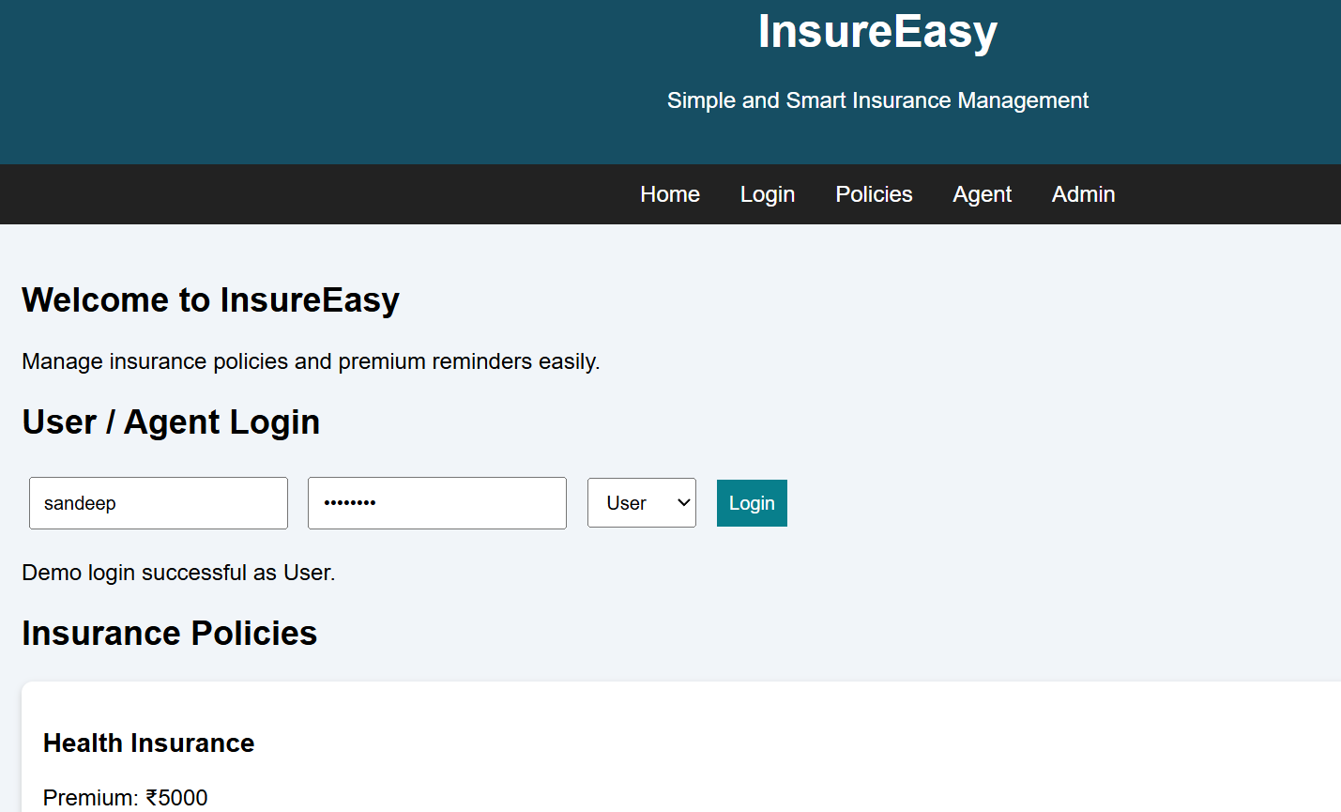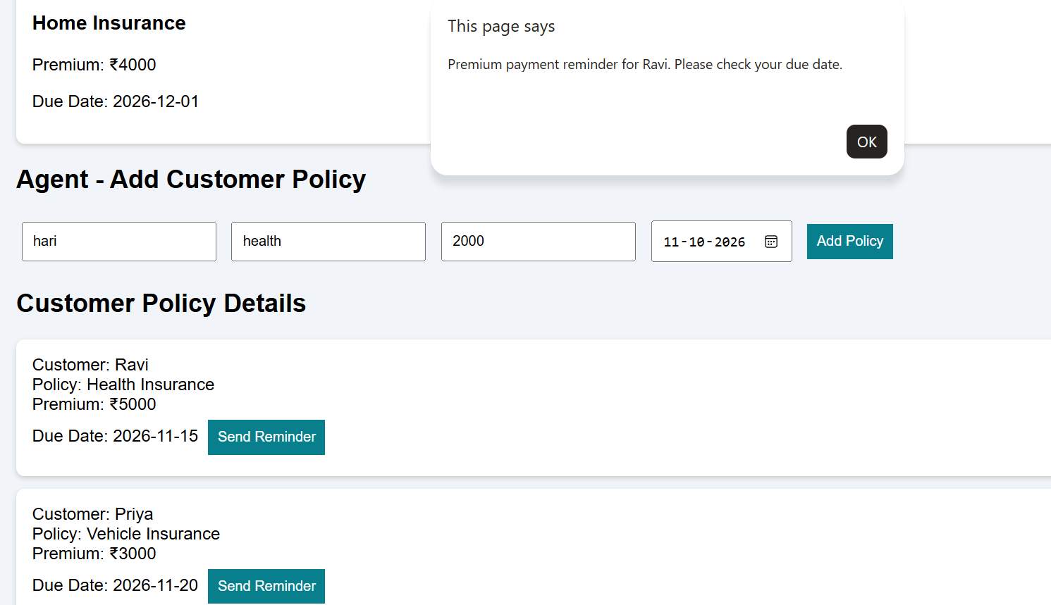
Result
Thus, the InsureEasy insurance management website was developed with demo login, agent approval, customer policy management, premium details, and payment reminders.

