Experiment 13: BlossomGifts – Online Flowers and Gifts Shopping Website
Aim
To develop an online flower and gift shopping website using HTML, CSS, and JavaScript to browse products, manage a shopping cart, place orders, and maintain inventory.
Algorithm
- Start the program.
- Display flower and gift categories on the home page.
- Allow users to search and view product details.
- Add, edit, or remove products from the shopping cart.
- Calculate the total price and checkout.
- Display order confirmation and status.
- Allow the admin to add, update, and delete products.
- Stop the program.
HTML Code

<!DOCTYPE html>
<html>
<head>
<title>BlossomGifts</title>
<style>
body {
font-family: Arial;
margin: 0;
background: #fff0f5;
}
header {
background: #c2185b;
color: white;
text-align: center;
padding: 20px;
}
nav {
background: #333;
padding: 12px;
text-align: center;
}
nav a {
color: white;
margin: 12px;
text-decoration: none;
}
.container { padding: 20px; }
.products {
display: flex;
flex-wrap: wrap;
gap: 15px;
}
.card {
background: white;
width: 200px;
padding: 15px;
border-radius: 8px;
box-shadow: 0 2px 5px #ccc;
}
button {
background: #c2185b;
color: white;
border: none;
padding: 9px;
margin: 4px;
cursor: pointer;
}
input {
padding: 9px;
margin: 5px;
}
</style>
</head>
<body>

<header>
<h1>BlossomGifts</h1>
<p>Make Every Occasion Special!</p>
</header>

<nav>
<a href="#home">Home</a>
<a href="#products">Products</a>
<a href="#cart">Cart</a>
<a href="#admin">Admin</a>
</nav>

<div class="container" id="home">
<h2>Gift Categories</h2>
<p>Flowers | Birthday Gifts | Gift Baskets | Chocolates</p>

<input id="search" placeholder="Search gifts..."
oninput="displayProducts()">

<h2 id="products">Available Gifts</h2>
<div class="products" id="productList"></div>

<h2 id="cart">Shopping Cart</h2>
<div id="cartItems">Cart is empty.</div>
<h3 id="total">Total: ₹0</h3>

<label>Delivery Date:</label>
<input type="date" id="deliveryDate">
<button onclick="checkout()">Checkout</button>
<p id="status"></p>

<h2 id="admin">Admin - Add Gift</h2>
<input id="name" placeholder="Gift name">
<input id="price" type="number" placeholder="Price">
<input id="category" placeholder="Category">
<button onclick="addProduct()">Add Gift</button>
</div>

<script>
let products = [
{name:"Rose Bouquet", price:599, category:"Flowers"},
{name:"Birthday Cake", price:799, category:"Birthday Gifts"},
{name:"Chocolate Basket", price:999, category:"Gift Baskets"},
{name:"Teddy Bear", price:499, category:"Personalized Gifts"}
];

let cart = [];

function displayProducts() {
let search = document.getElementById("search")
.value.toLowerCase();
let list = document.getElementById("productList");
list.innerHTML = "";

products.forEach((p, i) => {
if ((p.name + p.category).toLowerCase().includes(search)) {
list.innerHTML += `
<div class="card">
<h3>${p.name}</h3>
<p>Category: ${p.category}</p>
<h4>Price: ₹${p.price}</h4>
<button onclick="addToCart(${i})">Add to Cart</button>
<button onclick="editProduct(${i})">Edit</button>
<button onclick="deleteProduct(${i})">Delete</button>
</div>`;
}
});
}

function addToCart(i) {
let item = cart.find(p => p.name === products[i].name);
if (item) item.qty++;
else cart.push({...products[i], qty:1});
displayCart();
}

function displayCart() {
let total = 0;
let output = "";

cart.forEach((p, i) => {
total += p.price * p.qty;
output += `${p.name} - ₹${p.price}
<button onclick="changeQty(${i},-1)">-</button>
${p.qty}
<button onclick="changeQty(${i},1)">+</button>
<button onclick="removeItem(${i})">Remove</button>
<br><br>`;
});

document.getElementById("cartItems").innerHTML =
output || "Cart is empty.";
document.getElementById("total").innerText =
"Total: ₹" + total;
}

function changeQty(i, n) {
cart[i].qty += n;
if (cart[i].qty <= 0) cart.splice(i, 1);
displayCart();
}

function removeItem(i) {
cart.splice(i, 1);
displayCart();
}

function checkout() {
if (cart.length === 0) {
alert("Please add gifts to the cart.");
return;
}

let date = document.getElementById("deliveryDate").value;
if (!date) {
alert("Please select a delivery date.");
return;
}

document.getElementById("status").innerText =
"Order placed successfully! Delivery date: " + date;

cart = [];
displayCart();
}

function addProduct() {
let name = document.getElementById("name").value.trim();
let price = Number(document.getElementById("price").value);
let category = document.getElementById("category").value.trim();

if (!name || price <= 0 || !category) {
alert("Enter valid gift details.");
return;
}

products.push({name, price, category});
displayProducts();
alert("Gift added successfully!");
}

function editProduct(i) {
let price = prompt("Enter new price:", products[i].price);
if (price === null || price.trim() === "" ||
!Number.isFinite(Number(price)) || Number(price) <= 0)
return;

products[i].price = Number(price);
displayProducts();
}

function deleteProduct(i) {
if (confirm("Delete this gift?")) {
let name = products[i].name;
products.splice(i, 1);
cart = cart.filter(p => p.name !== name);
displayProducts();
displayCart();
}
}

displayProducts();
displayCart();
</script>

</body>
</html>
Output:
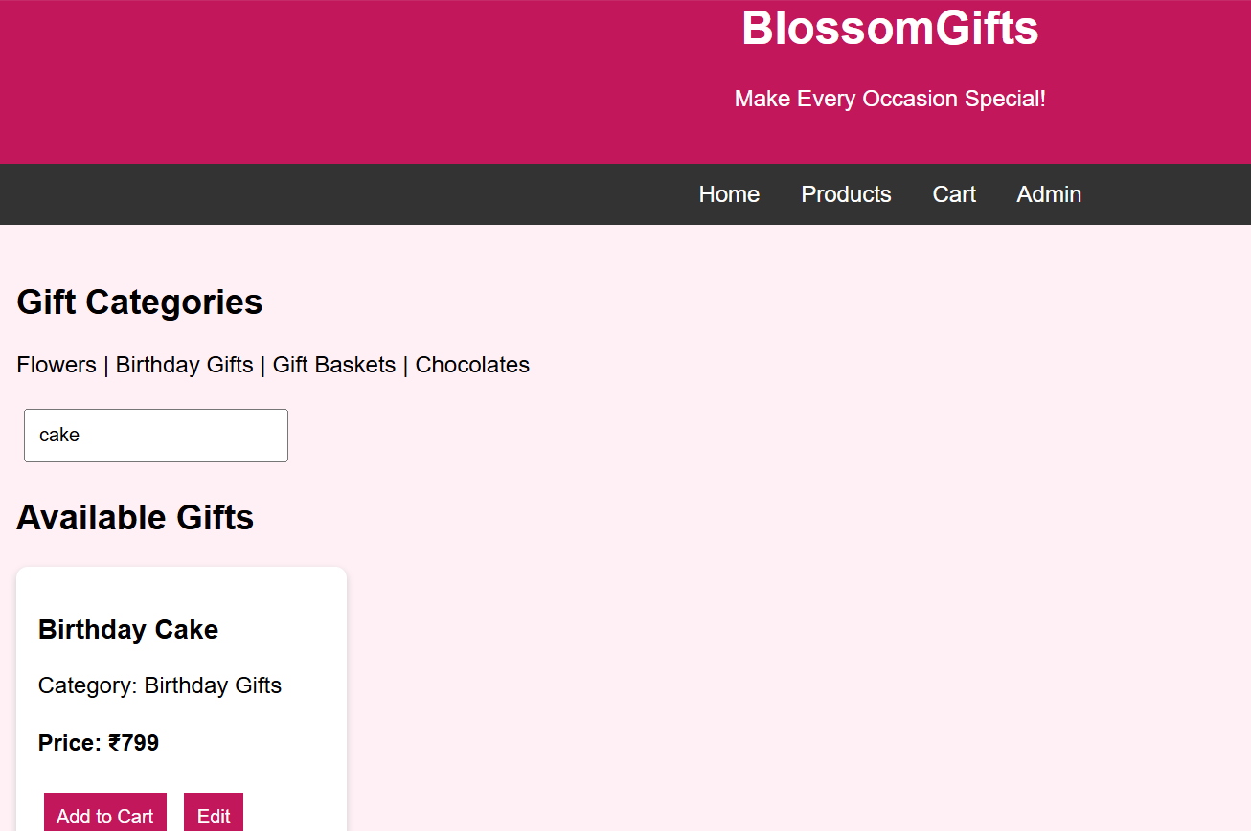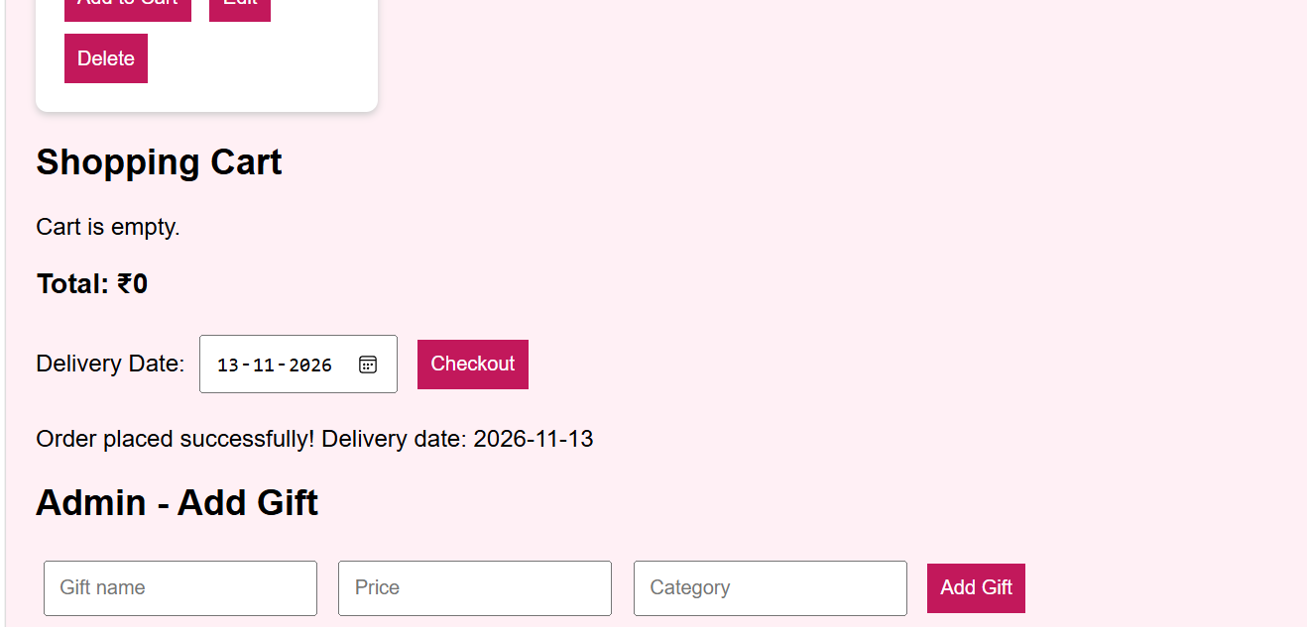
Result
Thus, the BlossomGifts website was successfully developed with product searching, shopping cart management, delivery date selection, checkout confirmation, and basic inventory management.

