Aim
To develop an online second-hand goods marketplace using HTML, CSS, and JavaScript for managing users, product categories, items, and orders.
Algorithm
- Start the program.
- Display second-hand products by category.
- Allow users to search and view items.
- Allow sellers to add, edit, and delete products.
- Allow the admin to manage users and categories.
- Update order status as Shipped or Received.
- Stop the program.
HTML Code

<!DOCTYPE html>
<html>
<head>
<title>ReNewMarket</title>
<style>
body {
font-family: Arial;
margin: 0;
background: #f2f7f2;
}
header {
background: #287a4b;
color: white;
text-align: center;
padding: 20px;
}
nav {
background: #222;
padding: 12px;
text-align: center;
}
nav a {
color: white;
margin: 12px;
text-decoration: none;
}
.container { padding: 20px; }
.products {
display: flex;
flex-wrap: wrap;
gap: 15px;
}
.card {
background: white;
padding: 15px;
width: 200px;
border-radius: 8px;
box-shadow: 0 2px 5px #ccc;
}
button {
background: #287a4b;
color: white;
border: none;
padding: 8px;
margin: 4px;
cursor: pointer;
}
input, select {
padding: 8px;
margin: 5px;
}
</style>
</head>
<body>

<header>
<h1>ReNewMarket</h1>
<p>Buy, Sell and Reuse Second-Hand Products</p>
</header>

<nav>
<a href="#home">Home</a>
<a href="#products">Products</a>
<a href="#admin">Admin</a>
<a href="#orders">Orders</a>
</nav>

<div class="container" id="home">
<h2>Product Categories</h2>
<p>Electronics | Furniture | Clothing | Collectibles</p>

<input id="search" placeholder="Search products..."
oninput="displayProducts()">

<h2 id="products">Available Products</h2>
<div class="products" id="productList"></div>

<h2 id="admin">Admin - Add Product</h2>
<input id="name" placeholder="Product name">
<input id="price" type="number" placeholder="Price">
<input id="category" placeholder="Category">
<button onclick="addProduct()">Add Product</button>

<h2 id="orders">Order Management</h2>
<div id="orderList">No orders available.</div>
</div>

<script>
let products = [
{name:"Used Laptop", price:15000,
category:"Electronics"},
{name:"Wooden Chair", price:1200,
category:"Furniture"},
{name:"Denim Jacket", price:500,
category:"Clothing"},
{name:"Old Watch", price:800,
category:"Collectibles"}
];

let orders = [];

function displayProducts() {
let search = document.getElementById("search")
.value.toLowerCase();
let list = document.getElementById("productList");
list.innerHTML = "";

products.forEach((p, i) => {
if ((p.name + p.category).toLowerCase()
.includes(search)) {
list.innerHTML += `
<div class="card">
<h3>${p.name}</h3>
<p>Category: ${p.category}</p>
<h4>Price: ₹${p.price}</h4>
<button onclick="buyProduct(${i})">
Buy Item
</button>
<button onclick="editProduct(${i})">
Edit
</button>
<button onclick="deleteProduct(${i})">
Delete
</button>
</div>`;
}
});
}

function addProduct() {
let name = document.getElementById("name").value.trim();
let price = Number(document.getElementById("price").value);
let category = document.getElementById("category").value.trim();

if (!name || price <= 0 || !category) {
alert("Enter valid product details.");
return;
}

products.push({name, price, category});
displayProducts();
alert("Product added successfully!");
}

function editProduct(i) {
let price = prompt("Enter new price:", products[i].price);

if (price === null || price.trim() === "" ||
!Number.isFinite(Number(price)) || Number(price) <= 0)
return;

products[i].price = Number(price);
displayProducts();
}

function deleteProduct(i) {
if (confirm("Delete this product?")) {
products.splice(i, 1);
displayProducts();
}
}

function buyProduct(i) {
let p = products[i];
orders.push({
name: p.name,
price: p.price,
status: "Shipped"
});
displayOrders();
alert("Order placed successfully!");
}

function displayOrders() {
document.getElementById("orderList").innerHTML =
orders.map((o, i) => `
<div class="card">
<p>Product: ${o.name}</p>
<p>Price: ₹${o.price}</p>
<p>Status: ${o.status}</p>
<button onclick="updateOrder(${i})">
Update Status
</button>
<button onclick="deleteOrder(${i})">
Delete Order
</button>
</div>`).join("") || "No orders available.";
}

function updateOrder(i) {
orders[i].status =
orders[i].status === "Shipped" ? "Received" : "Shipped";
displayOrders();
}

function deleteOrder(i) {
orders.splice(i, 1);
displayOrders();
}

displayProducts();
displayOrders();
</script>

</body>
</html>
Output:
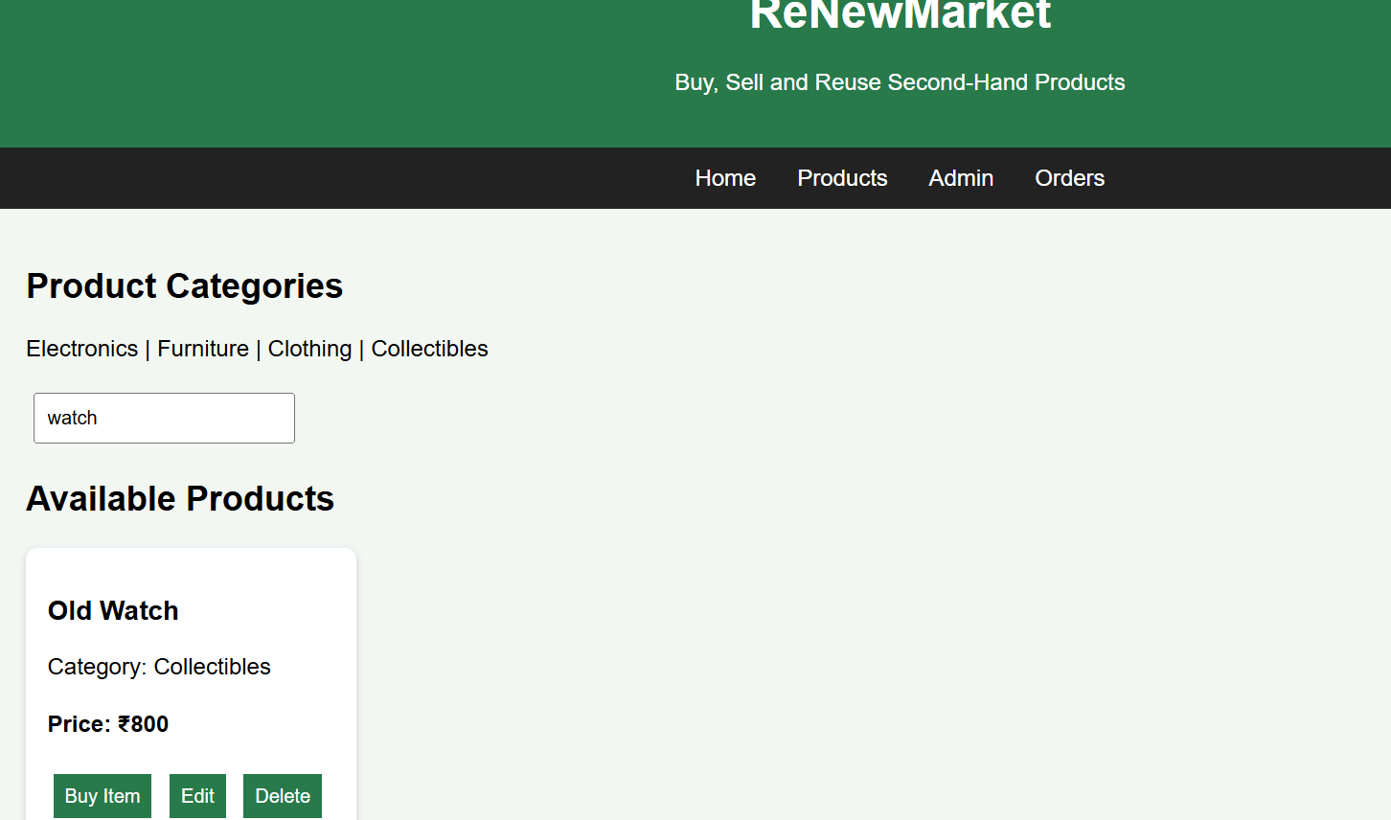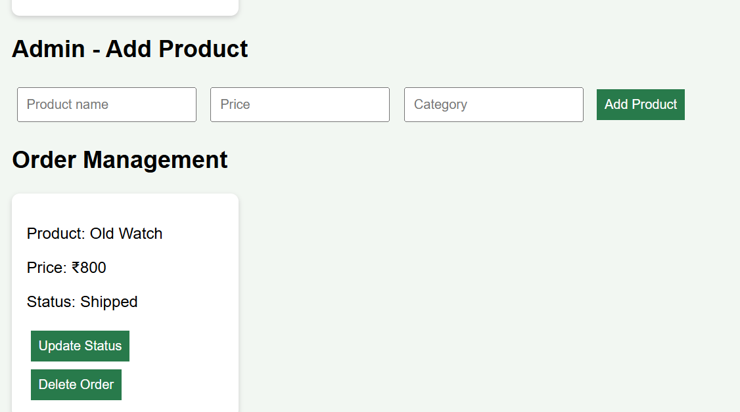
Result
Thus, the ReNewMarket website was successfully designed to manage second-hand products, users, categories, and orders.

