Experiment 15: EasyToll – Online Toll Payment System
Aim
To develop an online toll payment website using HTML, CSS, and JavaScript to manage users, toll passes, e-tickets, wallet balance, and toll payments.
Algorithm
- Start the program.
- Display the EasyToll home page.
- Allow users to register and log in.
- Allow users to add money to their wallet and buy toll tickets.
- Provide toll pass application and renewal options.
- Allow the admin to manage users, toll details, and approve passes.
- Allow toll gate users to verify ticket and pass details.
- Display payment status and stop the program.
HTML Code

<!DOCTYPE html>
<html>
<head>
<title>EasyToll Payment System</title>
<style>
body {
font-family: Arial;
margin: 0;
background: #f1f5f9;
}
header {
background: #075985;
color: white;
text-align: center;
padding: 20px;
}
nav {
background: #222;
padding: 12px;
text-align: center;
}
nav a {
color: white;
margin: 12px;
text-decoration: none;
}
.container { padding: 20px; }
.card {
background: white;
padding: 15px;
margin: 12px 0;
border-radius: 8px;
box-shadow: 0 2px 5px #ccc;
}
button {
background: #075985;
color: white;
padding: 9px;
border: none;
cursor: pointer;
margin: 5px;
}
input, select {
padding: 9px;
margin: 5px;
}
</style>
</head>
<body>

<header>
<h1>EasyToll</h1>
<p>Pay Toll Online and Travel Easily</p>
</header>

<nav>
<a href="#home">Home</a>
<a href="#user">User</a>
<a href="#pass">Toll Pass</a>
<a href="#gate">Toll Gate</a>
<a href="#admin">Admin</a>
</nav>

<div class="container" id="home">
<h2>Welcome to EasyToll</h2>
<p>Manage toll payments and passes online.</p>

<h2 id="user">User Login / Register</h2>
<input id="username" placeholder="Username">
<input id="password" type="password" placeholder="Password">
<button onclick="login()">Login</button>
<button onclick="registerUser()">Register</button>
<p id="message"></p>

<h3>eWallet</h3>
<p id="balance">Wallet Balance: ₹0</p>
<input id="amount" type="number" placeholder="Amount">
<button onclick="addMoney()">Add Money</button>

<h2 id="pass">Toll Pass and e-Ticket</h2>
<input id="vehicle" placeholder="Vehicle Number">
<input id="location" placeholder="Toll Gate Location">
<button onclick="buyTicket()">Buy Toll e-Ticket</button>
<button onclick="applyPass()">Apply / Renew Toll Pass</button>
<div id="ticket"></div>

<h2 id="gate">Toll Gate Verification</h2>
<input id="verifyId" placeholder="Enter Ticket / Pass ID">
<button onclick="verifyTicket()">Verify Ticket</button>
<p id="verification"></p>

<h2 id="admin">Admin Management</h2>
<input id="tollName" placeholder="Toll Gate Name">
<input id="tollFee" type="number" placeholder="Toll Fee">
<button onclick="addToll()">Add Toll Details</button>
<div id="tollList"></div>
</div>

<script>
let wallet = 0;
let ticketNumber = 1000;
let tickets = [];
let tolls = [];

function login() {
let user = document.getElementById("username").value.trim();
let pass = document.getElementById("password").value;

if (!user || !pass) {
alert("Enter username and password.");
return;
}

document.getElementById("message").innerText =
"Demo login successful. Welcome " + user + "!";
}

function registerUser() {
let user = document.getElementById("username").value.trim();
let pass = document.getElementById("password").value;

if (!user || !pass) {
alert("Enter username and password.");
return;
}

document.getElementById("message").innerText =
"Registration successful (demo).";
}

function addMoney() {
let amount = Number(document.getElementById("amount").value);

if (amount <= 0) {
alert("Enter a valid amount.");
return;
}

wallet += amount;
document.getElementById("balance").innerText =
"Wallet Balance: ₹" + wallet;
}

function buyTicket() {
let vehicle = document.getElementById("vehicle").value.trim();
let location = document.getElementById("location").value.trim();
let fee = 100;

if (!vehicle || !location) {
alert("Enter vehicle number and toll location.");
return;
}

if (wallet < fee) {
alert("Insufficient wallet balance. Add ₹" + fee + " or more.");
return;
}

wallet -= fee;
document.getElementById("balance").innerText =
"Wallet Balance: ₹" + wallet;

let ticket = {
id: "ET" + ticketNumber++,
vehicle: vehicle,
location: location,
status: "Valid"
};

tickets.push(ticket);

document.getElementById("ticket").innerHTML =
`<div class="card">
<h3>Toll e-Ticket</h3>
Ticket ID: ${ticket.id}<br>
Vehicle: ${ticket.vehicle}<br>
Location: ${ticket.location}<br>
Status: ${ticket.status}
</div>`;
}

function applyPass() {
let vehicle = document.getElementById("vehicle").value.trim();

if (!vehicle) {
alert("Enter vehicle number.");
return;
}

let id = "PASS" + ticketNumber++;
tickets.push({
id: id,
vehicle: vehicle,
location: "All configured tolls",
status: "Pending Approval"
});

document.getElementById("ticket").innerHTML =
`<div class="card">
Toll pass application submitted.<br>
Pass ID: ${id}<br>
Status: Pending Approval
</div>`;
}

function verifyTicket() {
let id = document.getElementById("verifyId").value.trim();
let ticket = tickets.find(t => t.id === id);

document.getElementById("verification").innerText =
ticket
? "ID: " + ticket.id + " | Vehicle: " +
ticket.vehicle + " | Status: " + ticket.status
: "Invalid ticket or pass ID.";
}

function addToll() {
let name = document.getElementById("tollName").value.trim();
let fee = Number(document.getElementById("tollFee").value);

if (!name || fee <= 0) {
alert("Enter valid toll details.");
return;
}

tolls.push({name, fee});
document.getElementById("tollList").innerHTML =
tolls.map(t =>
`<div class="card">${t.name} - ₹${t.fee}</div>`
).join("");

alert("Toll details added successfully!");
}
</script>

</body>
</html>
Output:
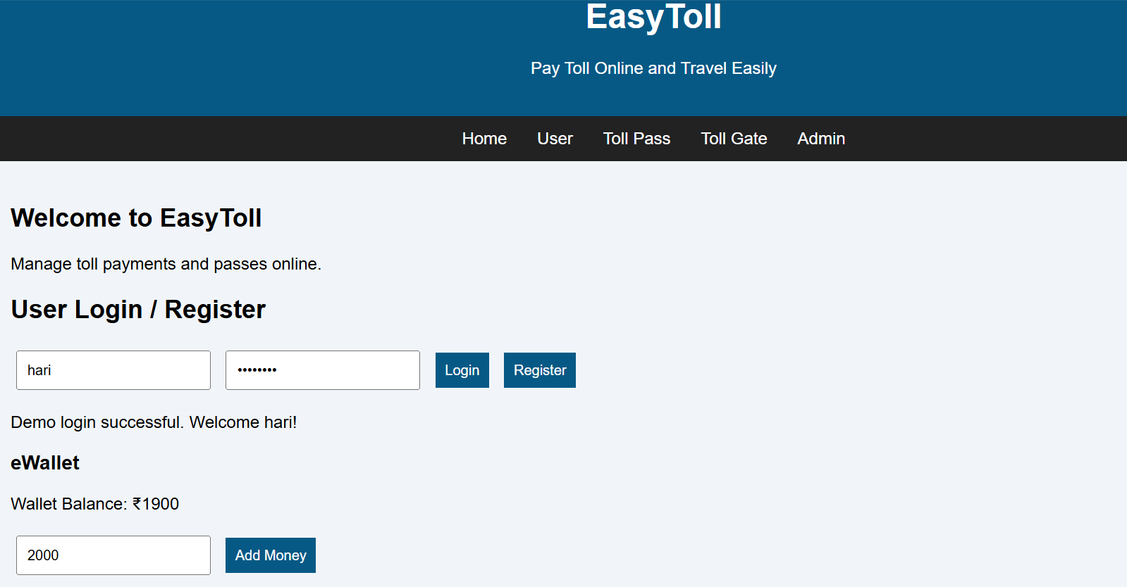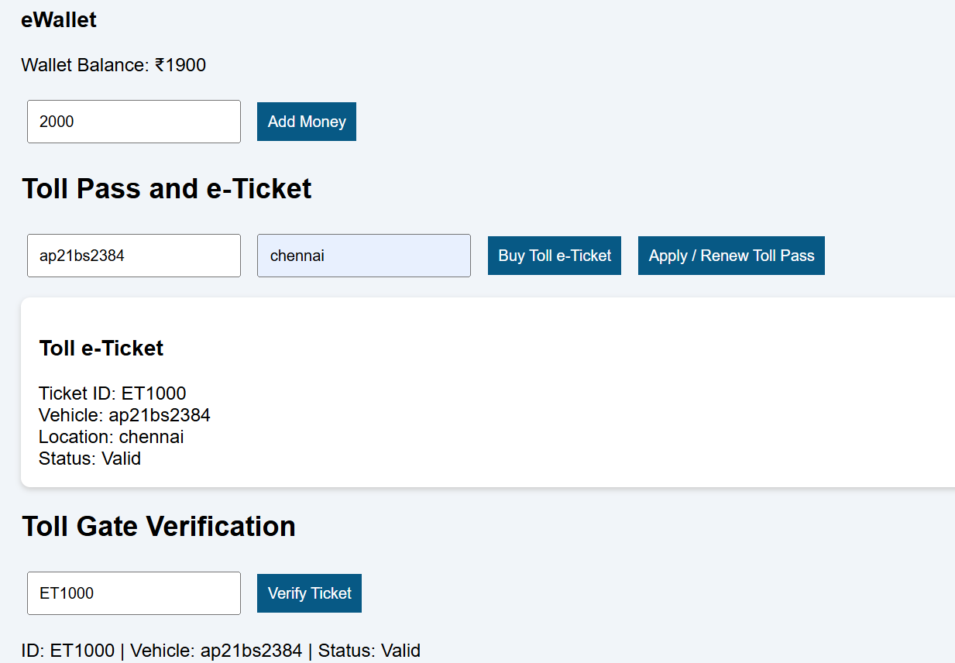
Result
Thus, the EasyToll website was developed with demo registration, wallet management, toll ticket booking, pass applications, toll details, and ticket verification.

