Experiment 16: ComplainEase
Aim
To develop a ComplainEase website using HTML, CSS, and JavaScript for complaint registration, tracking, and management.
Algorithm
- Start.
- Create a website with User, Officer, and Admin sections.
- Allow users to register, log in, and post complaints with location.
- Allow users to track complaint status and submit feedback.
- Allow officers to view complaints and update status with proof of work.
- Allow admins to manage user and officer accounts.
- Display complaint details and location using Google Maps.
- Stop.
HTML Code

<!DOCTYPE html>
<html>
<head>
<title>ComplainEase</title>
<style>
body{font-family:Arial;background:#eef2f7;margin:0}
header{background:#123b65;color:white;text-align:center;padding:20px}
nav{text-align:center;background:#092b4c;padding:12px}
nav button,button{padding:10px;margin:5px;background:#1473b9;color:white;border:0;cursor:pointer}
section{background:white;margin:20px auto;padding:20px;max-width:650px;border-radius:8px}
input,textarea,select{display:block;width:95%;padding:10px;margin:10px 0}
.item{border:1px solid #ccc;padding:10px;margin:10px 0}
</style>
</head>
<body>
<header>
<h1>ComplainEase</h1>
<p>Online Complaint Management System</p>
</header>

<nav>
<button onclick="show('user')">User</button>
<button onclick="show('officer')">Officer</button>
<button onclick="show('admin')">Admin</button>
</nav>

<section id="user">
<h2>User Registration / Login</h2>
<input id="name" placeholder="Your Name">
<input id="email" placeholder="Email">
<button onclick="login()">Register / Login</button>
<p id="welcome"></p>

<h2>Post Complaint</h2>
<form onsubmit="postComplaint(event)">
<input id="category" placeholder="Complaint Category" required>
<textarea id="description" placeholder="Complaint Description" required></textarea>
<input id="location" placeholder="Complaint Location" required>
<input id="proof" type="file">
<button type="submit">Submit Complaint</button>
</form>

<h2>Complaint Status</h2>
<div id="myList"></div>

<h2>Feedback</h2>
<textarea id="feedback" placeholder="Enter feedback"></textarea>
<button onclick="sendFeedback()">Submit Feedback</button>
<p id="feedbackMsg"></p>

<h3>Admin Contact</h3>
<p>Email: admin@complainease.com</p>
<p>Phone: 9876543210</p>
</section>

<section id="officer" hidden>
<h2>Officer Login</h2>
<input id="oid" placeholder="Officer ID">
<input id="opass" type="password" placeholder="Password">
<button onclick="officerLogin()">Login</button>
<p id="omsg"></p>
<div id="officerList"></div>
</section>

<section id="admin" hidden>
<h2>Admin Login</h2>
<input id="aid" placeholder="Username">
<input id="apass" type="password" placeholder="Password">
<button onclick="adminLogin()">Login</button>
<p id="amsg"></p>
<div id="adminPanel" hidden>
<h3>Create Officer Account</h3>
<input id="newid" placeholder="Officer ID">
<input id="newpass" placeholder="Password">
<button onclick="createOfficer()">Create Officer</button>
<h3>All Complaints</h3>
<div id="adminList"></div>
</div>
</section>

<script>
let complaints=[];
let currentUser="";
let officers=[{id:"OFF001",pass:"off123"}];

function show(id){
["user","officer","admin"].forEach(x=>
document.getElementById(x).hidden=x!==id);
}

function login(){
let name=document.getElementById("name").value;
let email=document.getElementById("email").value;
if(!name||!email){alert("Enter name and email");return;}
currentUser=email;
document.getElementById("welcome").innerText="Welcome "+name;
}

function postComplaint(e){
e.preventDefault();
complaints.push({
id:complaints.length+1,
user:currentUser,
category:category.value,
description:description.value,
location:location.value,
status:"Pending",
proof:""
});
e.target.reset();
render();
alert("Complaint submitted successfully");
}

function render(){
let html=complaints.map(c=>`
<div class="item">
<b>Complaint ID: ${c.id}</b>
<p>${c.category}: ${c.description}</p>
<p>Status: ${c.status}</p>
<p>Proof of work: ${c.proof||"Not provided"}</p>
<a target="_blank" href="https://www.google.com/maps/search/?api=1&query=${encodeURIComponent(c.location)}">View Location</a>
</div>`).join("")||"No complaints available";
myList.innerHTML=complaints.filter(c=>!currentUser||c.user===currentUser).map(c=>
`<div class="item">ID: ${c.id} | ${c.category} | Status: ${c.status}
<a target="_blank" href="https://www.google.com/maps/search/?api=1&query=${encodeURIComponent(c.location)}">View Map</a></div>`).join("")||"No complaints submitted";
if(!document.getElementById("adminPanel").hidden)adminList.innerHTML=html;
if(officerLogged)officerList.innerHTML=complaints.map(c=>`
<div class="item">ID: ${c.id} - ${c.category}
<p>${c.description}</p>
<select id="s${c.id}"><option>Pending</option><option>In Progress</option><option>Resolved</option></select>
<input id="p${c.id}" placeholder="Proof of work">
<button onclick="updateStatus(${c.id})">Update</button></div>`).join("");
}

let officerLogged=false;
function officerLogin(){
officerLogged=officers.some(o=>o.id===oid.value&&o.pass===opass.value);
omsg.innerText=officerLogged?"Login successful":"Invalid login";
render();
}

function updateStatus(id){
let c=complaints.find(x=>x.id===id);
c.status=document.getElementById("s"+id).value;
c.proof=document.getElementById("p"+id).value;
render();
}

function adminLogin(){
let ok=aid.value==="admin"&&apass.value==="admin123";
amsg.innerText=ok?"Admin login successful":"Invalid login";
adminPanel.hidden=!ok;
render();
}

function createOfficer(){
if(!newid.value||!newpass.value)return alert("Enter officer details");
officers.push({id:newid.value,pass:newpass.value});
alert("Officer account created");
newid.value="";newpass.value="";
}

function sendFeedback(){
if(!currentUser)return alert("Please register or log in first");
feedbackMsg.innerText="Feedback submitted successfully";
feedback.value="";
}
</script>
</body>
</html>
Output:
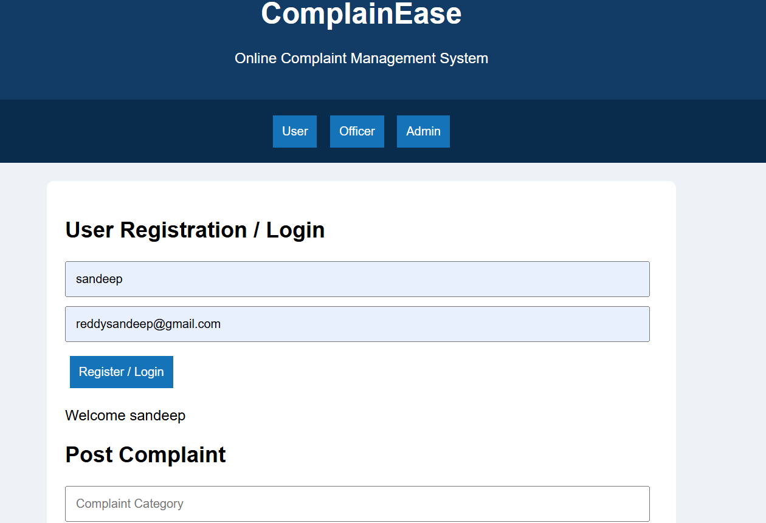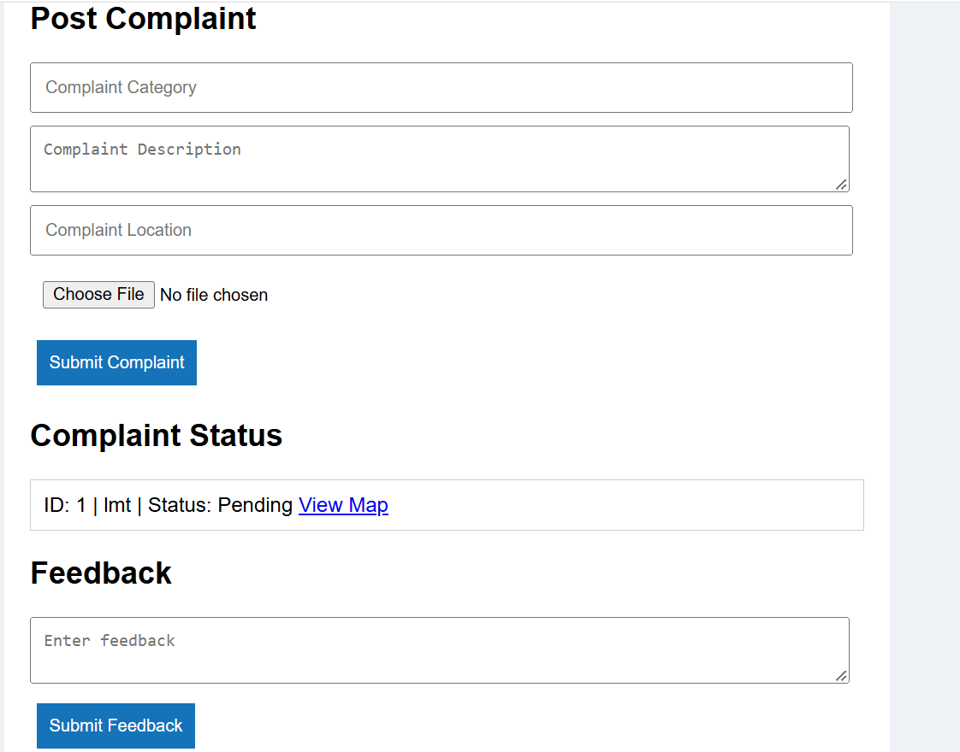
Result
Thus, the ComplainEase website was created successfully with complaint registration, location mapping, status tracking, officer updates, and admin management features.

