Title: Online Cake Ordering System
Aim
To develop a web-based Cake Ordering System that allows users to search cakes, filter by category and price, add cakes to the cart, place orders, and track delivery status. Admins can manage cake products, images, orders, and shipping details.
Algorithm
- Start the application.
- Allow users to register and log in.
- Display cakes with categories, descriptions, and prices.
- Allow users to search, filter, and add cakes to the cart.
- Enter shipping details and place an order.
- Allow users to view orders and track delivery.
- Admin manages cake products and updates order status.
- Stop the application.
HTML Code

<!DOCTYPE html>
<html lang="en">
<head>
<meta charset="UTF-8">
<meta name="viewport" content="width=device-width, initial-scale=1.0">
<title>Online Cake Ordering</title>
<style>
body { font-family: Arial; margin: 0; background: #fff5f5; }
header { background: #a83250; color: white; text-align: center; padding: 20px; }
main { max-width: 700px; margin: 20px auto; padding: 15px; }
.cake { background: white; padding: 15px; margin: 12px 0; border-radius: 8px; }
input, select, button { padding: 10px; margin: 6px 0; }
input, select { max-width: 100%; }
button { background: #a83250; color: white; border: none; cursor: pointer; }
footer { text-align: center; padding: 15px; }
</style>
</head>
<body>

<header>
<h1>Sweet Treats Cake Shop</h1>
<p>Order Your Favourite Cake Online!</p>
</header>

<main>
<h2>Search Cakes</h2>
<input id="search" placeholder="Search cake name">

<select id="category">
<option value="All">All Categories</option>
<option value="Chocolate">Chocolate</option>
<option value="Fruit">Fruit</option>
<option value="Birthday">Birthday</option>
</select>

<select id="price">
<option value="all">All Prices</option>
<option value="500">Below ₹500</option>
<option value="1000">Below ₹1000</option>
</select>

<button onclick="showCakes()">Search</button>

<h2>Available Cakes</h2>
<div id="cakes"></div>

<h2>My Cart</h2>
<p id="cart">No cakes added.</p>

<h2>Shipping Details</h2>
<input id="customer" placeholder="Your Name">
<input id="address" placeholder="Delivery Address">
<button onclick="placeOrder()">Place Order</button>
<p id="message"></p>

<h2>Admin</h2>
<p>Admin can manage cake products and update order status.</p>
<button onclick="showStatus()">View Order Status</button>
<p id="status"></p>
</main>

<footer>
<p>&copy; 2026 Sweet Treats Cake Shop</p>
</footer>

<script>
const cakes = [
{name: "Chocolate Cake", category: "Chocolate", price: 450},
{name: "Fruit Cake", category: "Fruit", price: 350},
{name: "Birthday Cake", category: "Birthday", price: 800},
{name: "Chocolate Truffle", category: "Chocolate", price: 650}
];

let cart = [];
let ordered = false;

function showCakes() {
let search = document.getElementById("search").value.toLowerCase();
let category = document.getElementById("category").value;
let price = document.getElementById("price").value;
let list = document.getElementById("cakes");

list.replaceChildren();

cakes.filter(c =>
c.name.toLowerCase().includes(search) &&
(category === "All" || c.category === category) &&
(price === "all" || c.price < Number(price))
).forEach(c => {
let item = document.createElement("div");
item.className = "cake";

let name = document.createElement("h3");
name.textContent = c.name;

let details = document.createElement("p");
details.textContent = c.category + " Cake - ₹" + c.price;

let button = document.createElement("button");
button.textContent = "Add to Cart";
button.onclick = () => {
cart.push(c);
updateCart();
};

item.append(name, details, button);
list.appendChild(item);
});
}

function updateCart() {
document.getElementById("cart").textContent =
cart.length
? cart.map(c => c.name).join(", ") +
" | Total: ₹" + cart.reduce((sum, c) => sum + c.price, 0)
: "No cakes added.";
}

function placeOrder() {
let name = document.getElementById("customer").value.trim();
let address = document.getElementById("address").value.trim();

if (!name || !address || cart.length === 0) {
document.getElementById("message").textContent =
"Enter your name, address, and add a cake.";
return;
}

ordered = true;
document.getElementById("message").textContent =
"Order placed successfully! Total: ₹" +
cart.reduce((sum, c) => sum + c.price, 0) +
". Demo order only.";
}

function showStatus() {
document.getElementById("status").textContent =
ordered ? "Order Status: Received (Demo)" : "No orders placed yet.";
}

showCakes();
</script>

</body>
</html>
Output:
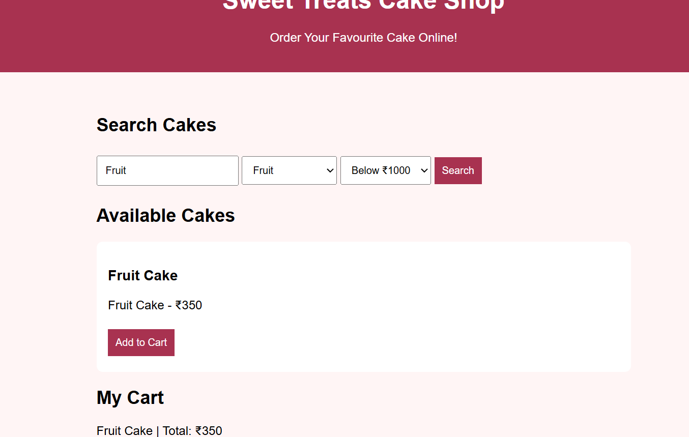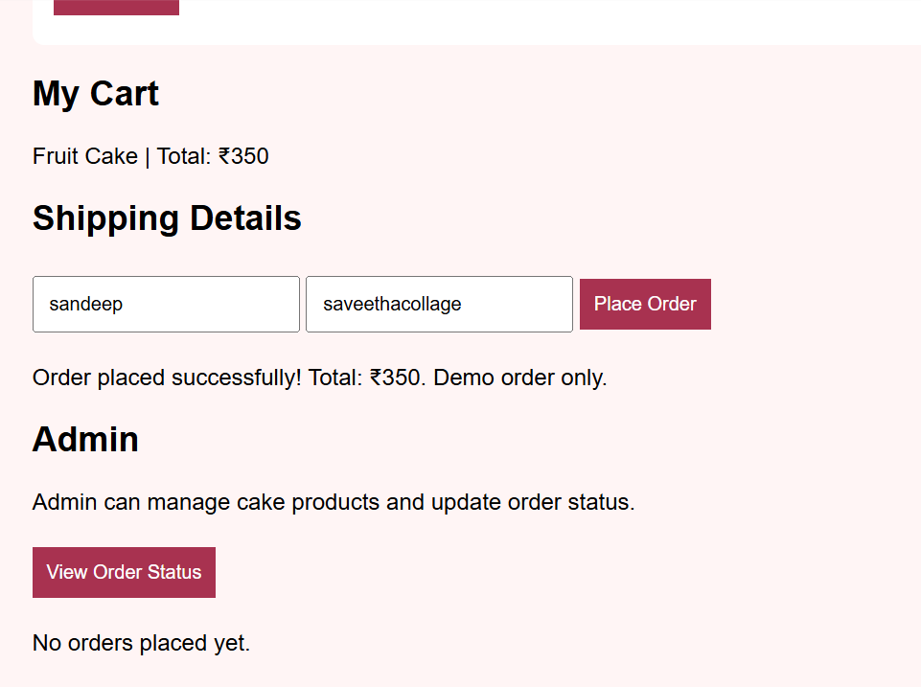
Result
The Online Cake Ordering webpage was created successfully. Users can search and filter cakes, add items to the cart, enter shipping details, place a demo order, and view its status.

