Aim
To develop a MedCare Hospital Appointment Booking System that enables patients to search hospitals and doctors, book appointments, manage appointment history, and provide feedback.
Algorithm
- Start the application.
- Register or log in as a patient.
- Search hospitals and doctors by location and specialty.
- Select a doctor and preferred appointment date and time.
- Book, cancel, or check appointment status.
- Submit check-in details and doctor feedback.
- Allow admins to manage doctors, appointments, and statistics.
- Allow hospitals to register and update their details and location.
- Stop the application.
Code

<!DOCTYPE html>
<html>
<head>
<title>MedCare Hospital</title>
<style>
body {
font-family: Arial, sans-serif;
background: #eef7ff;
margin: 0;
}
header {
background: #087f8c;
color: white;
text-align: center;
padding: 18px;
}
nav {
background: #05636d;
padding: 12px;
text-align: center;
}
nav a {
color: white;
margin: 10px;
text-decoration: none;
}
.container {
max-width: 650px;
margin: 20px auto;
padding: 20px;
background: white;
border-radius: 10px;
}
input, select, textarea, button {
width: 100%;
padding: 10px;
margin: 7px 0;
box-sizing: border-box;
}
button {
background: #087f8c;
color: white;
border: none;
cursor: pointer;
}
h2 { color: #087f8c; }
.item {
border: 1px solid #ddd;
padding: 12px;
margin: 10px 0;
border-radius: 6px;
}
</style>
</head>
<body>

<header>
<h1>MedCare Hospital</h1>
<p>Online Doctor Appointment System</p>
</header>

<nav>
<a href="#search">Search</a>
<a href="#booking">Book</a>
<a href="#history">Appointments</a>
<a href="#feedback">Feedback</a>
</nav>

<div class="container">
<h2>Patient Registration / Login</h2>
<input id="patient" placeholder="Patient Name">
<input id="email" type="email" placeholder="Email Address">
<button onclick="login()">Register / Login</button>
<p id="loginMsg"></p>

<hr>

<h2 id="search">Search Doctors</h2>
<input id="location" placeholder="Enter city, e.g. Chennai">

<select id="specialty">
<option value="">All Specialties</option>
<option>Cardiologist</option>
<option>Dermatologist</option>
<option>Dentist</option>
<option>General Physician</option>
<option>Pediatrician</option>
</select>
<button onclick="searchDoctors()">Search</button>
<div id="doctorList"></div>

<hr>

<h2 id="booking">Book Appointment</h2>
<form id="bookingForm">
<input id="doctor" placeholder="Doctor Name" required>
<input id="hospital" placeholder="Hospital Name" required>
<input id="date" type="date" required>
<select id="time" required>
<option value="">Select Time</option>
<option>09:00 AM</option>
<option>10:00 AM</option>
<option>11:00 AM</option>
<option>02:00 PM</option>
<option>03:00 PM</option>
</select>
<button type="submit">Book Appointment</button>
</form>
<p id="message"></p>

<hr>

<h2 id="history">Appointment History</h2>
<div id="appointments"></div>

<hr>

<h2>Check-in Form</h2>
<textarea id="symptoms" placeholder="Enter reason for visit or symptoms"></textarea>
<button onclick="checkIn()">Submit Check-in</button>
<p id="checkinMsg"></p>

<hr>

<h2 id="feedback">Doctor Feedback</h2>
<select id="rating">
<option value="5">5 - Excellent</option>
<option value="4">4 - Very Good</option>
<option value="3">3 - Good</option>
<option value="2">2 - Average</option>
<option value="1">1 - Poor</option>
</select>
<textarea id="review" placeholder="Write your review"></textarea>
<button onclick="submitReview()">Submit Feedback</button>
<p id="reviewMsg"></p>

<hr>

<h2>Hospital Location</h2>
<button onclick="openMap()">View Hospital on Google Maps</button>

<hr>

<h2>Admin Panel - Demo</h2>
<p id="stats">Total appointments: 0</p>
<button onclick="showStats()">View Appointment Statistics</button>
</div>

<script>
const doctors = [
{name:"Dr. Kumar", specialty:"Cardiologist",
hospital:"MedCare Hospital", location:"Chennai"},
{name:"Dr. Priya", specialty:"Dermatologist",
hospital:"City Hospital", location:"Chennai"},
{name:"Dr. Ravi", specialty:"Dentist",
hospital:"Health Care Centre", location:"Bengaluru"},
{name:"Dr. Anitha", specialty:"Pediatrician",
hospital:"MedCare Hospital", location:"Chennai"},
{name:"Dr. Arun", specialty:"General Physician",
hospital:"City Hospital", location:"Bengaluru"}
];

let appointments = [];

document.getElementById("date").min =
new Date().toISOString().split("T")[0];

function login() {
let name = document.getElementById("patient").value.trim();
if (!name) {
document.getElementById("loginMsg").textContent =
"Please enter your name.";
return;
}
document.getElementById("loginMsg").textContent =
"Welcome, " + name + "!";
}

function searchDoctors() {
let loc = document.getElementById("location").value.toLowerCase();
let spec = document.getElementById("specialty").value;

let found = doctors.filter(d =>
(!loc || d.location.toLowerCase().includes(loc)) &&
(!spec || d.specialty === spec)
);

let html = "";
found.forEach(d => {
html += `<div class="item">
<b>${d.name}</b><br>
Specialty: ${d.specialty}<br>
Hospital: ${d.hospital}<br>
Location: ${d.location}
<button onclick="selectDoctor('${d.name}','${d.hospital}')">
Book This Doctor
</button>
</div>`;
});

document.getElementById("doctorList").innerHTML =
html || "No doctors found.";
}

function selectDoctor(name, hospital) {
document.getElementById("doctor").value = name;
document.getElementById("hospital").value = hospital;
document.getElementById("booking").scrollIntoView();
}

document.getElementById("bookingForm")
.addEventListener("submit", function(e) {
e.preventDefault();

let patient = document.getElementById("patient").value.trim();
if (!patient) {
document.getElementById("message").textContent =
"Please enter your patient name first.";
return;
}

let booking = {
patient: patient,
doctor: document.getElementById("doctor").value,
hospital: document.getElementById("hospital").value,
date: document.getElementById("date").value,
time: document.getElementById("time").value,
status: "Booked"
};

let exists = appointments.some(a =>
a.doctor === booking.doctor &&
a.date === booking.date &&
a.time === booking.time &&
a.status === "Booked"
);

if (exists) {
document.getElementById("message").textContent =
"This doctor already has a booking at that time.";
return;
}

appointments.push(booking);
document.getElementById("message").textContent =
"Appointment booked successfully!";
this.reset();
showAppointments();
});

function showAppointments() {
let html = "";

appointments.forEach((a, i) => {
html += `<div class="item">
Patient: ${a.patient}<br>
Doctor: ${a.doctor}<br>
Hospital: ${a.hospital}<br>
Date: ${a.date}<br>
Time: ${a.time}<br>
Status: ${a.status}
<button onclick="cancelAppointment(${i})">
Cancel Appointment
</button>
</div>`;
});

document.getElementById("appointments").innerHTML =
html || "No appointments available.";
}

function cancelAppointment(i) {
appointments[i].status = "Cancelled";
showAppointments();
}

function checkIn() {
let symptoms = document.getElementById("symptoms").value.trim();
if (!symptoms) {
document.getElementById("checkinMsg").textContent =
"Please enter your reason for visit.";
return;
}
document.getElementById("checkinMsg").textContent =
"Check-in details submitted for this demo.";
}

function submitReview() {
let review = document.getElementById("review").value.trim();
if (!review) {
document.getElementById("reviewMsg").textContent =
"Please enter your feedback.";
return;
}
document.getElementById("reviewMsg").textContent =
"Thank you! Rating: " +
document.getElementById("rating").value + "/5";
document.getElementById("review").value = "";
}

function openMap() {
let hospital = document.getElementById("hospital").value.trim()
|| "MedCare Hospital";
window.open(
"https://www.google.com/maps/search/?api=1&query=" +
encodeURIComponent(hospital),
"_blank"
);
}

function showStats() {
document.getElementById("stats").textContent =
"Total appointments: " + appointments.length +
" | Active: " +
appointments.filter(a => a.status === "Booked").length +
" | Cancelled: " +
appointments.filter(a => a.status === "Cancelled").length;
}
</script>

</body>
</html>
Output:
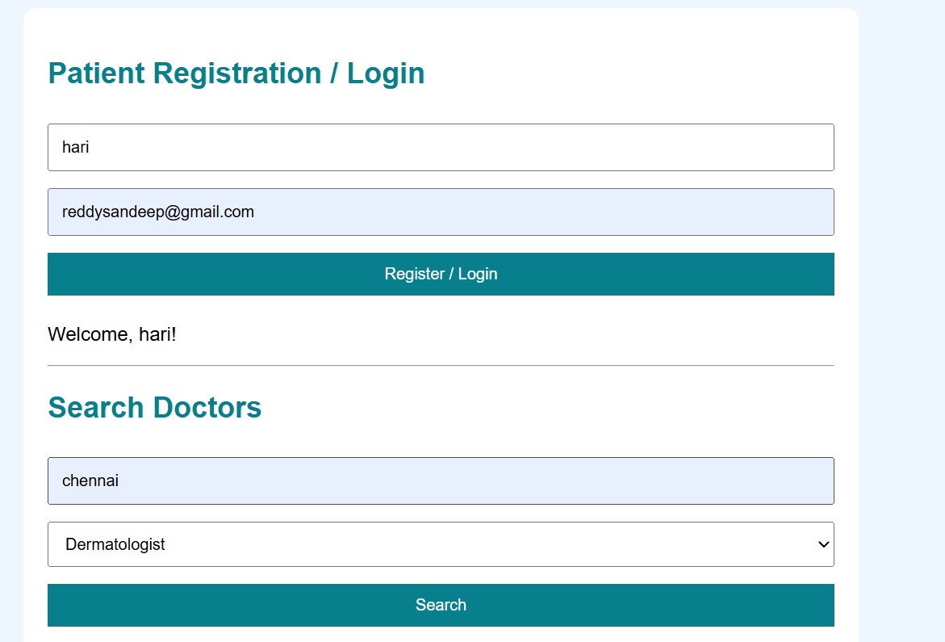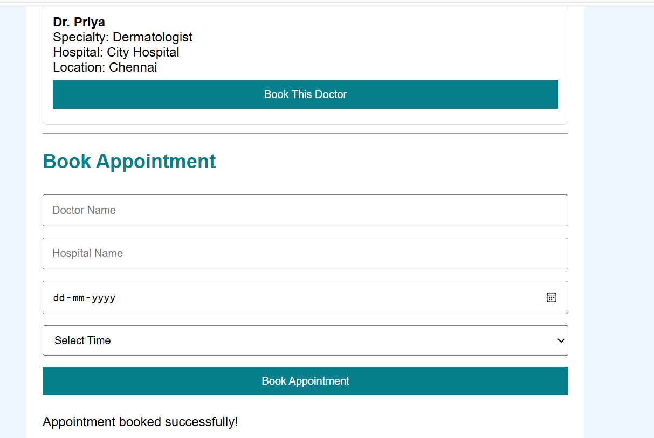
Result
The webpage demonstrates patient registration, doctor search by location and specialty, appointment booking and cancellation, check-in submission, feedback, hospital map search, and basic appointment statistics.

