Experiment 9: Online Shopping Website – TechSavvy
Aim
To design and develop an online shopping website using HTML, CSS, and JavaScript that allows users to browse electronic products, search items, add products to a shopping cart, and view the total price. It also provides basic product management features for the administrator.
Algorithm
- Start the program.
- Create a home page displaying electronic product categories.
- Display products with names, prices, descriptions, and availability.
- Provide a search option to find products.
- Allow users to add products to the shopping cart.
- Allow users to increase, decrease, or remove items from the cart.
- Calculate and display the total cart price.
- Provide a checkout option to display the order confirmation.
- Allow the administrator to add products and update or remove product details.
- Display the order status and stop the program.
HTML Code

<!DOCTYPE html>
<html>
<head>
<title>TechSavvy Online Shopping</title>
<style>
body {
font-family: Arial;
margin: 0;
background: #f2f5f9;
}
header {
background: #123456;
color: white;
padding: 20px;
text-align: center;
}
nav {
background: #222;
padding: 12px;
text-align: center;
}
nav a {
color: white;
margin: 15px;
text-decoration: none;
}
h2 { color: #123456; }
.container { padding: 20px; }
.products {
display: flex;
flex-wrap: wrap;
gap: 15px;
}
.card {
background: white;
padding: 15px;
width: 200px;
border-radius: 8px;
box-shadow: 0 2px 5px #bbb;
}
button {
background: #087f8c;
color: white;
border: none;
padding: 9px;
cursor: pointer;
margin: 4px;
}
input {
padding: 9px;
margin: 5px;
}
#cart {
background: white;
padding: 15px;
margin-top: 20px;
}
</style>
</head>
<body>

<header>
<h1>TechSavvy</h1>
<p>Your One-Stop Electronic Shopping Store</p>
</header>

<nav>
<a href="#home">Home</a>
<a href="#products">Products</a>
<a href="#cart">Shopping Cart</a>
<a href="#admin">Admin</a>
</nav>

<div class="container" id="home">
<h2>Product Categories</h2>
<p>Smartphones | Laptops | Tablets | Accessories</p>

<input type="text" id="search"
placeholder="Search products..."
oninput="displayProducts()">

<h2 id="products">Available Products</h2>
<div class="products" id="productList"></div>

<div id="cart">
<h2>Shopping Cart</h2>
<div id="cartItems">Your cart is empty.</div>
<h3 id="total">Total: ₹0</h3>
<button onclick="checkout()">Checkout</button>
</div>

<h2>Order Status</h2>
<p id="status">No orders placed.</p>

<h2 id="admin">Admin: Add Product</h2>
<input id="pname" placeholder="Product name">
<input id="price" type="number" placeholder="Price">
<input id="category" placeholder="Category">
<input id="description" placeholder="Description">
<button onclick="addProduct()">Add Product</button>
</div>

<script>
let products = [
{name:"Smartphone", price:15000,
category:"Smartphones",
description:"Latest Android smartphone"},
{name:"Laptop", price:45000,
category:"Laptops",
description:"High-performance laptop"},
{name:"Tablet", price:20000,
category:"Tablets",
description:"Portable touchscreen tablet"},
{name:"Headphones", price:1500,
category:"Accessories",
description:"Wireless headphones"}
];

let cart = [];

function displayProducts() {
let search = document.getElementById("search")
.value.toLowerCase();
let list = document.getElementById("productList");
list.innerHTML = "";

products.forEach((p, i) => {
if ((p.name + p.category + p.description)
.toLowerCase().includes(search)) {
list.innerHTML += `
<div class="card">
<h3>${p.name}</h3>
<p>Category: ${p.category}</p>
<p>${p.description}</p>
<h4>Price: ₹${p.price}</h4>
<p>Availability: In Stock</p>
<button onclick="addToCart(${i})">
Add to Cart
</button>
<button onclick="editProduct(${i})">
Edit
</button>
<button onclick="removeProduct(${i})">
Delete
</button>
</div>`;
}
});
}

function addToCart(i) {
let item = cart.find(x => x.name === products[i].name);
if (item) {
item.qty++;
} else {
cart.push({...products[i], qty:1});
}
displayCart();
}

function displayCart() {
let items = document.getElementById("cartItems");
let total = 0;

if (cart.length === 0) {
items.innerHTML = "Your cart is empty.";
} else {
items.innerHTML = cart.map((p, i) => {
total += p.price * p.qty;
return `${p.name} - ₹${p.price}
<button onclick="changeQty(${i},-1)">-</button>
${p.qty}
<button onclick="changeQty(${i},1)">+</button>
<button onclick="removeCartItem(${i})">Remove</button>`;
}).join("<hr>");
}

document.getElementById("total").innerText =
"Total: ₹" + total;
}

function changeQty(i, n) {
cart[i].qty += n;
if (cart[i].qty <= 0) cart.splice(i, 1);
displayCart();
}

function removeCartItem(i) {
cart.splice(i, 1);
displayCart();
}

function checkout() {
if (cart.length === 0) {
alert("Your cart is empty!");
return;
}
document.getElementById("status").innerText =
"Order placed successfully! Status: Confirmed.";
cart = [];
displayCart();
alert("Thank you for shopping at TechSavvy!");
}

function addProduct() {
let name = document.getElementById("pname").value.trim();
let price = Number(document.getElementById("price").value);
let category = document.getElementById("category").value.trim();
let description = document.getElementById("description").value.trim();

if (!name || price <= 0 || !category || !description) {
alert("Enter valid product details.");
return;
}

products.push({name, price, category, description});
displayProducts();
alert("Product added successfully!");
}

function editProduct(i) {
let price = prompt("Enter new price:", products[i].price);
if (price === null || price.trim() === "" ||
!Number.isFinite(Number(price)) || Number(price) <= 0) return;

let description = prompt("Enter new description:",
products[i].description);
if (description === null) return;

products[i].price = Number(price);
products[i].description = description;
displayProducts();
}

function removeProduct(i) {
if (confirm("Delete this product?")) {
let name = products[i].name;
products.splice(i, 1);
cart = cart.filter(p => p.name !== name);
displayProducts();
displayCart();
}
}

displayProducts();
displayCart();
</script>

</body>
</html>
Output:
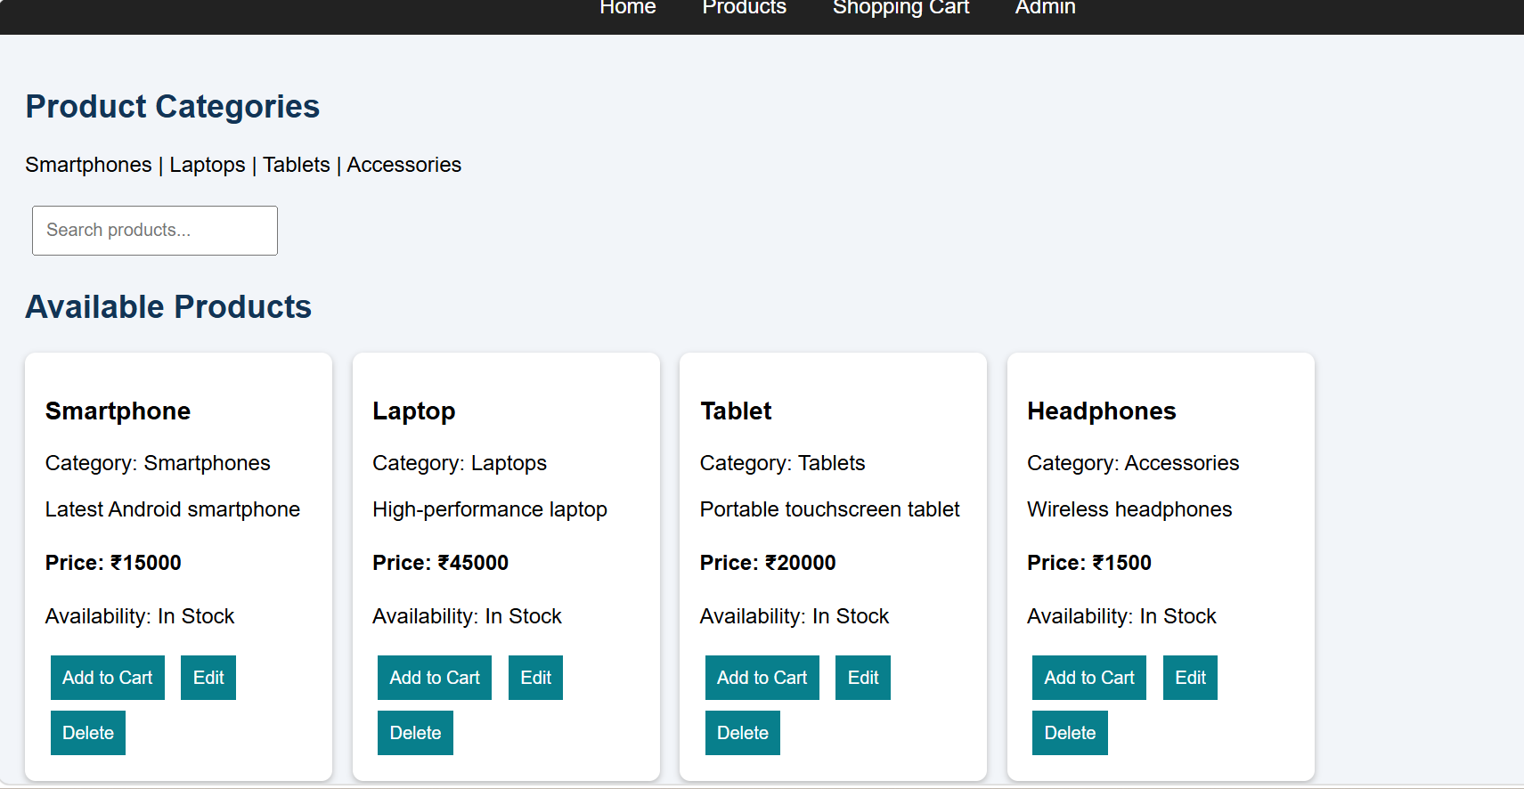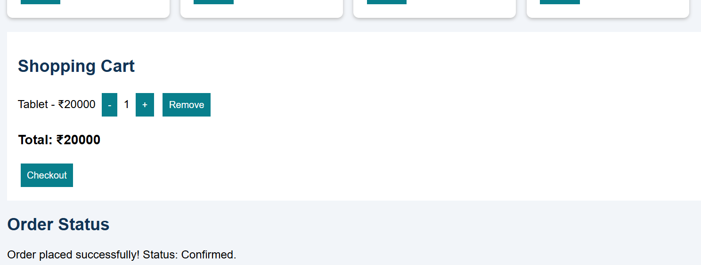
Result
Thus, the TechSavvy online shopping website was designed and implemented successfully using HTML, CSS, and JavaScript. It supports product display, search, shopping cart management, price calculation, checkout confirmation, and basic product administration.

