Chapter I- Introduction
- Background of the Project
The rapid growth of the internet and digital technologies has transformed the global retail industry. Clothing and apparel businesses, in particular, are increasingly shifting to online platforms to reach a wider audience, reduce operational limitations, and create a more personalized shopping experience. Traditional physical stores often face challenges such as limited customer reach, lack of real time product updates, and time-consuming order management.

To address these challenges, this project develops a B2C E-Commerce Platform for Clothing & Apparel, enabling customers to browse, order, and purchase clothing items online. For the vendor, the system provides tools to manage products, categories, suppliers, and sales insights efficiently. Additionally, the platform integrates a raw material supplier module and a sales prediction feature to support better business planning.

- Problem Statement
Traditional clothing stores often rely on manual record-keeping, face communication delays with suppliers, and lack systematic sales analysis. Customers experience inconvenience due to limited product visibility, physical distance, and the absence of 24/7 accessibility. Vendors struggle to manage products, track orders, and maintain supplier communication without a centralized system.

There is therefore a need for an online e-commerce platform that simplifies customer interactions, automates product and order management, and supports decision-making through analytics features.

- Objectives
- To develop a user-friendly B2C e-commerce platform that enables customers to browse clothing products, place orders, and track purchases online.
- To design an administrative system that allows efficient management of products, categories, suppliers, inventory, and sales records.
- To incorporate analytical and reporting features, including sales prediction, to support effective decision-making for the vendor.

- Review of Related Work and Literature
Direct B2C e-commerce systems are widely adopted by clothing and apparel brands that sell products directly to customers through their own websites. Unlike marketplace based platforms, these systems allow a single vendor to maintain full control over product listings, pricing, inventory, and customer interactions. Brand-owned online stores and single-vendor e-commerce websites demonstrate how direct selling improves brand identity, customer trust, and operational efficiency.

Existing studies on direct B2C e-commerce indicate that such systems reduce dependency on third-party platforms, lower commission costs, and enable businesses to maintain complete ownership of customer data. Research also highlights that web based B2C platforms improve order processing, inventory management, and customer satisfaction by providing real time product updates and continuous service availability.
Modern direct B2C e-commerce solutions commonly adopt modular system architectures, secure authentication mechanisms, and responsive user interfaces to enhance usability across devices. Literature further emphasizes the growing importance of analytical features, such as sales reports and demand forecasting, to support inventory planning and business decision making in retail environments.

Although many existing direct B2C platforms provide essential e-commerce functionalities, they often lack integrated raw material supplier management and advanced analytical features tailored for small scale clothing businesses. This project addresses these gaps by developing a direct B2C e-commerce platform specifically for the clothing and apparel sector, incorporating supplier management and a sales prediction feature to support efficient operations and informed decision-making.

- Development Methodology
The Agile methodology was used for developing this project. Agile focuses on iterative development, continuous feedback, and incremental improvement, allowing flexibility during development ideal for projects where requirements may evolve or expand.
- Requirements were refined over time as new features like the supplier module and sales prediction were added.
- Continuous testing and feedback improved project quality.
- Work was divided into manageable sprints, reducing complexity.

Testing / Quality Assurance

Construction / Iteration (Development in Sprints)

Deployment

Feedback (Customer Review & Changes)

Design the Requirements

Requirement Gathering

Figure 1.1: Agile Development Stages

Agile Implementation in This Project
- Sprint Planning: Requirements were analyzed and divided into tasks such as UI creation, backend development, authentication, product module, supplier module, and prediction module.
- Development Sprints: Each sprint focused on building and testing specific features.
- Daily Progress & Iteration: Tasks were regularly reviewed, and necessary changes were implemented immediately.
- Testing and Refinement: Modules were tested, debugged, and optimized after each sprint.
- Final Integration: All modules were combined for full system testing.
By following Agile, the project evolved smoothly, accommodating new ideas and improving the system iteratively.

- Data Collection
To ensure that the proposed system meets real-world requirements, both primary and secondary data collection methods were used during the development of this project.
Primary data was collected through informal interviews and discussions with potential customers and vendors involved in clothing and apparel businesses. These interactions helped identify customer expectations such as ease of product browsing, order tracking, and secure checkout, as well as vendor requirements including product management, inventory control, supplier coordination, and sales monitoring. Additionally, observations of existing direct B2C clothing websites were conducted to understand user interaction patterns and identify practical design and functionality requirements.
Secondary data was collected from academic journals, textbooks, research articles, and online resources related to B2C e-commerce systems and web-based retail platforms. Existing single-vendor e-commerce websites and documentation were reviewed to gain insights into system structure, features, and best practices. The combination of primary and secondary data provided a strong foundation for designing a user-friendly, efficient, and practical direct B2C e-commerce platform.

- Tools Used
- React.js - For developing a responsive and interactive frontend.
- PHP - For backend development and server-side operations.
- MySQL - For database management, storing product, customer, order, and supplier data.
- Bootstrap - For styling and creating a mobile-friendly user interface.
- Draw.io - For creating diagrams such as ERD, activity, and class diagrams.
- Power BI - Used for data visualization and generating reports, helping analyze sales and other project data effectively.
- WAMP - Local server environment for development and testing.
- Microsoft Word - For preparing the project report and documentation.

- Scope and Limitations
Scope
- Customer Features: Registration, login, product browsing, adding items to the cart, placing orders, and making secure payments using Khalti.
- Admin Features: A dashboard for managing products, categories, suppliers, inventory, and sales records efficiently.
- Supplier Module: Allows suppliers to submit quotations and handle raw material requests.
- Analytics & Reporting: Includes sales prediction and reporting tools to support informed decision-making for the vendor.
Limitations
- Supplier Module: Limited to quotation submission; advanced supplier management is not included.
- System Performance: Performance may vary depending on the hosting environment and hardware specifications.

- Report Organization
This report is organized into three main chapters:
- Chapter I- Introduction, background, problem statement, objectives, literature review, methodology, scope, and report structure.
- Chapter II- System development process including requirement analysis, design, implementation, and testing.
- Chapter III- Summary, conclusion, and recommendations for future improvements.

Chapter II- System Development Process

2.1 Analysis

2.1.1 Requirement Analysis
The system requirements for the B2C E-Commerce Platform for Clothing & Apparel were identified through observations, discussions with potential users, and studying standard e-commerce workflows. The requirements were categorized into functional and non-functional requirements.

Functional Requirements:
- Customer: Register, log in, browse products, view product details, add products to cart, place orders, and track order status.
- Admin: Secure login, manage products and categories, handle orders, manage suppliers, generate reports, and oversee raw material requests.
- Supplier: View material requests and submit quotations.
Non-Functional Requirements:
- Usability: The system should provide a simple, engaging, and user-friendly interface.
- Performance: Fast response time and optimized data handling.
- Security: Passwords must be hashed, inputs validated, and APIs secured to prevent unauthorized access.
- Scalability: The system should allow the addition of new modules and features in the future.
- Reliability: The system must operate smoothly without critical failures or interruptions.

2.1.2 Feasibility Study
- Technical Feasibility
The project uses technologies such as React.js for frontend development, PHP for backend operations, and MySQL for database management. These technologies are widely available, well-documented, and easy to implement, making the project technically feasible.
- Economic Feasibility
The overall cost of the project is minimal since all tools and technologies used are open-source and freely available, including development frameworks, server environments (WAMP), and design tools (Draw.io, Figma, Balsamiq).
- Operational Feasibility
The system is designed with a user-friendly interface, allowing both customers and administrators to interact with the platform efficiently. It’s simple navigation and clear workflows ensure smooth adoption and usability.

2.1.3 Object-Oriented Modelling
Object-Oriented modelling was used to understand the interactions and overall behavior of the system before moving into the design phase.

The Use Case Diagram captures the major actors of the system, Customer, Admin, and Supplier, and their interactions with key system functionalities such as registration, product browsing, order placement, payment, supplier quotation, and admin management operations. These models help ensure clarity in system requirements and guide the detailed design work that follows.
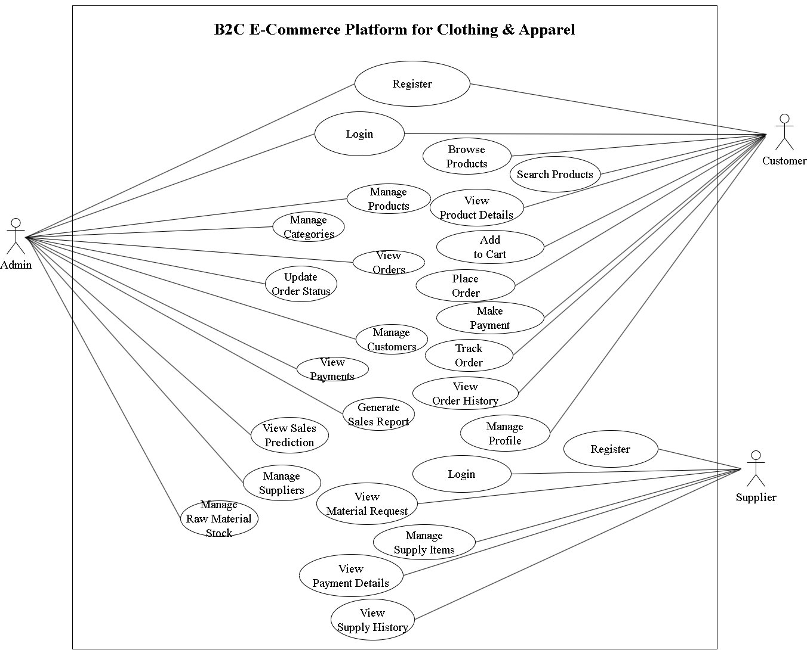
Figure 2.1: Use Case Diagram of B2C E-Commerce Platform for Clothing & Apparel

Table 2.1: Use Case Description (Place Order)

Use Case Identifier | UC-001
Primary Actor | Customer
Secondary Actor | System
Use Case Description | Customer confirms the selected products in the cart and places an order.
Pre-condition | Customer is logged in and has at least one product in the cart.
Post-condition | A new order is created and stored in the database; order status is 'Pending'.
Failure Scenario | Cart is empty, session expired, or database error occurs during order saving.

Table 2.2: Use Case Description (Manage Products)

Use Case Identifier | UC-002
Primary Actor | Admin
Secondary Actor | System
Use Case Description | Admin can add new products, update existing ones, or delete obsolete ones.
Pre-condition | Admin is authenticated and has access to the dashboard.
Post-condition | Product data is successfully updated in the product database.
Failure Scenario | Invalid form input, duplicate product name, or database connectivity issues.

Table 2.3: Use Case Description (View Material Request)

Use Case Identifier | UC-003
Primary Actor | Supplier
Secondary Actor | Admin (as requester)
Use Case Description | Supplier logs in to view raw material requests sent by admin.
Pre-condition | Supplier is authenticated and has pending or past requests.
Post-condition | Supplier sees a list of raw materials needed along with details.
Failure Scenario | No requests exist, session timeout, or system error fetching request data.

Table 2.4: Use Case Description (Make Payment)

Use Case Identifier | UC-004
Primary Actor | Customer
Secondary Actor | Payment Gateway
Use Case Description | Customer selects a payment method and completes the payment for an order.
Pre-condition | Customer has placed an order; order status is ‘Pending Payment’.
Post-condition | Payment is recorded, and the payment status is updated to ‘Paid’ or 'Confirmed'.
Failure Scenario | Payment fails due to insufficient funds, invalid card, or gateway timeout.

Table 2.5: Use Case Description (View Sales Prediction)
Use Case Identifier | UC-005
Primary Actor | Admin
Secondary Actor | Sales Prediction Module
Use Case Description | Admin accesses the dashboard to view future sales trends based on past data.
Pre-condition | Admin is logged in and sales history is available in the database.
Post-condition | System generates and displays a prediction graph or report.
Failure Scenario | No sales data available, prediction model fails, or data fetch error occurs.

2.2 Design

The design phase transforms the analyzed requirements into structured visual and technical representations of the system. This phase includes the development of user interface layouts, database architecture, and object-oriented models that represent the system’s internal structure and behavior.

2.2.1 User Interface Design
The user interface (UI) of the B2C E-Commerce Platform for Clothing & Apparel was designed to be intuitive, responsive, and visually appealing, providing a seamless experience for both customers and administrators. The design emphasizes ease of navigation, clarity of information, and consistency across different pages, ensuring that users can interact with the system efficiently without confusion.

The layout prioritizes critical information, such as product details, pricing, and order status, making it easily visible to users. Interactive elements like buttons, menus, and forms were designed with user-friendliness in mind. Additionally, the UI incorporates modern design principles, such as responsive grids, consistent color schemes, and readable typography, to enhance both usability and aesthetic appeal.

Key UI Screens Designed:

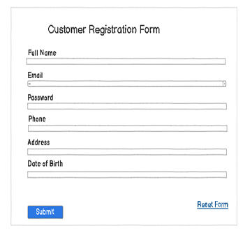
Figure 2.2: Low-Fidelity Wireframe of Customer Registration

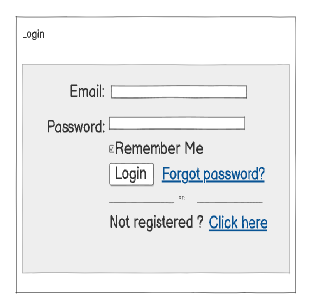

Figure 2.3: Low-Fidelity Wireframe of Customer Login
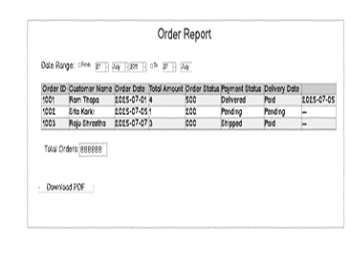
Figure 2.4: Low-Fidelity Wireframe of Order Report

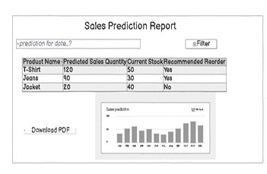
Figure 2.5: Low-Fidelity Wireframe of Sales Prediction Report

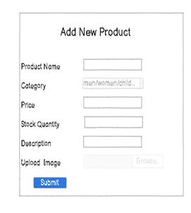
Figure 2.6: Low-Fidelity Wireframe of Admin Add Product

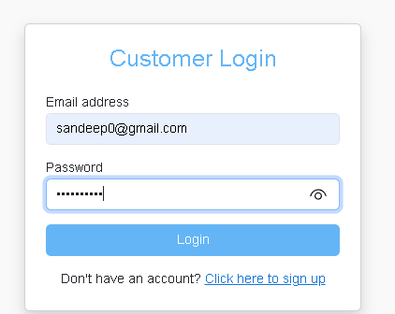

Figure 2.7: High-Fidelity Wireframe of Customer Login
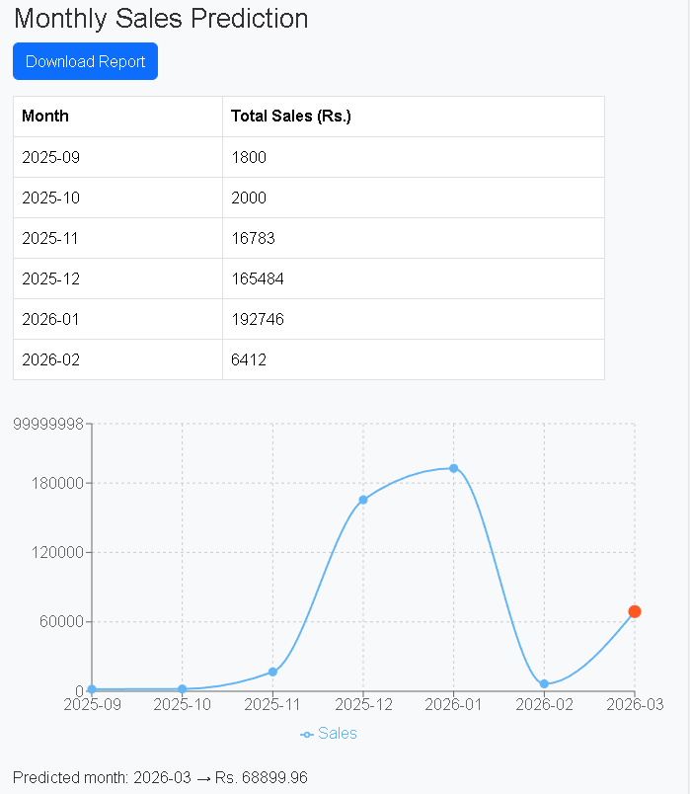
Figure 2.8: High-Fidelity Wireframe of Sales Prediction Report

Wireframes for these pages were prepared using Figma, ensuring a visually consistent and intuitive interface across all devices.

2.2.2 Database Design
Database design is the process of organizing data to ensure efficient storage, integrity, consistency, and easy retrieval. It involves identifying the key entities of the system, their attributes, and the relationships between them to create a logical and structured schema. This design ensures that all system modules—including customers, products, orders, suppliers, payments, and reports—can function smoothly. Properly defined relationships and keys also allow for secure data management, faster queries, and future scalability, making it easier to extend the system with new features such as advanced analytics or additional product modules. The design includes multiple tables representing the main entities of the system, with primary keys and foreign keys to establish relationships between them. This ensures referential integrity and supports smooth operation of all system modules.

Entity-Relationship (ER) Diagram
An ER diagram is a visual representation of entities, their attributes, and the relationships between them. It helps in understanding the structure of the database and how different tables are connected.

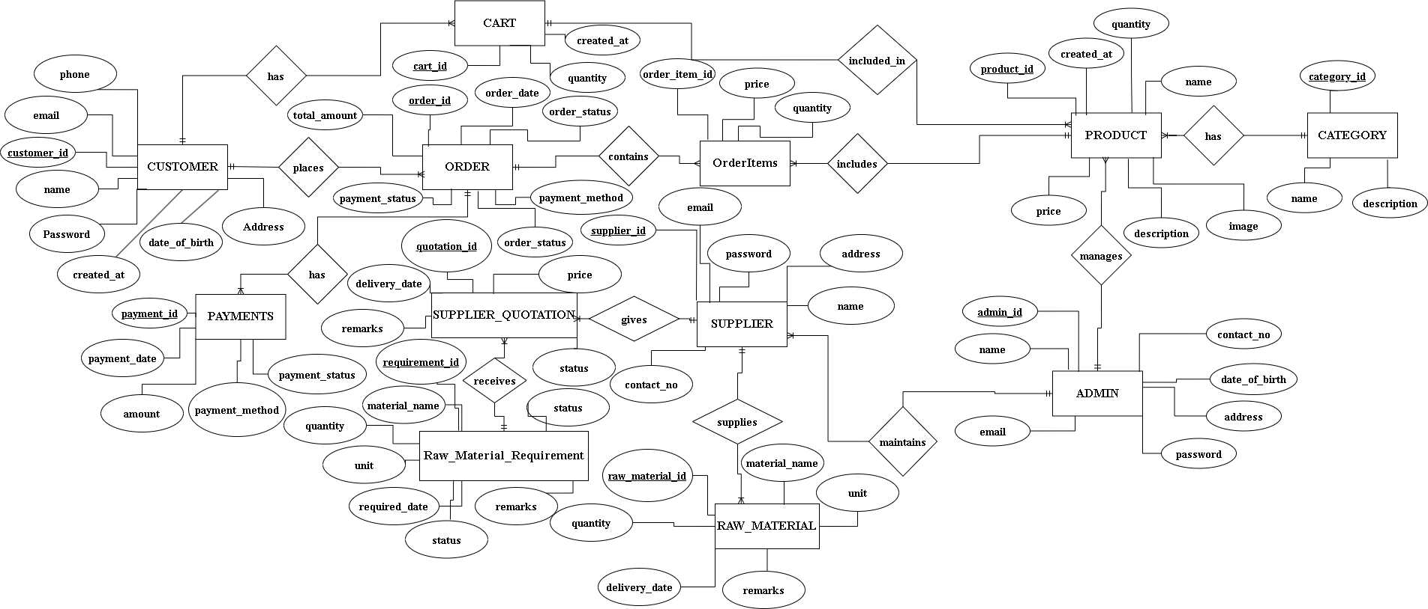
Figure 2.9: ER Diagram of B2C E-Commerce Platform for Clothing & Apparel
The Entity-Relationship (ER) diagram illustrates the core data structure and relationships within the B2C E-Commerce Platform. It highlights the main entities, including Customer, Product, Order, Payment, Admin, Supplier along with their key attributes. Customers can browse products, place orders, and make payments, while the admin manages products, categories, suppliers, and generates reports. Suppliers respond to material requests and submit quotations. Primary and foreign keys define relationships, ensuring data integrity and proper connections between tables. This diagram provides a clear overview of how data flows through the system and supports all operational modules efficiently.

Relational Model
A relational model represents the database in tabular form, showing tables, primary keys, foreign keys, and relationships. It is used to implement the database physically and ensures referential integrity between related tables.
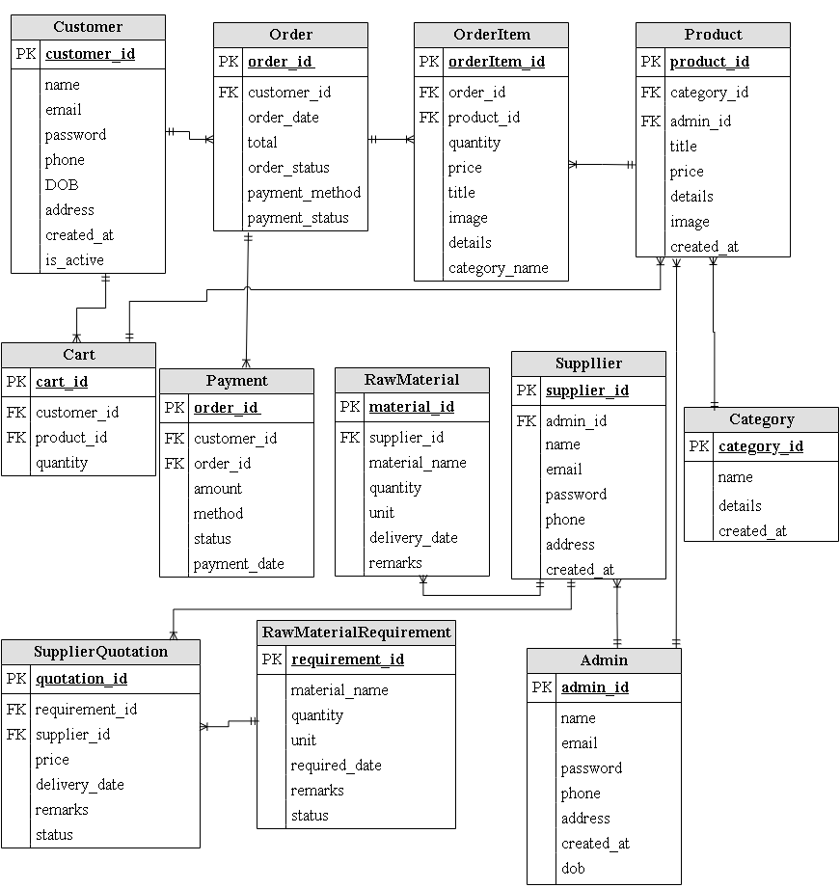
Figure 2.10: Relational Model of B2C E-Commerce Platform for Clothing & Apparel
The relational model provides a tabular representation of the system’s database, showing all tables, their primary keys, foreign keys, and the relationships between them. Key tables include Customer, Order, Order Item, Product, Category, Payment, Admin, Supplier, Raw Material, and Supplier Quotation. Customers place orders, which contain order items linked to products and categories. Payments are connected to orders, while admins manage products and suppliers. Suppliers respond to raw material requests and submit quotations. By organizing data in this structured format, the relational model ensures referential integrity, efficient data storage, and seamless interaction between all system modules, supporting smooth operations and future scalability.

2.2.3 Object-Oriented Design Models
Object-Oriented Design (OOD) models provide a structured representation of the system using objects, classes, and their interactions. They help translate requirements into a logical design that can be implemented efficiently and maintained easily.

Class Diagram
A class diagram represents the main entities of the system as classes, showing their attributes, methods, and relationships. It provides a static view of the system and helps in understanding how data and behavior are organized.
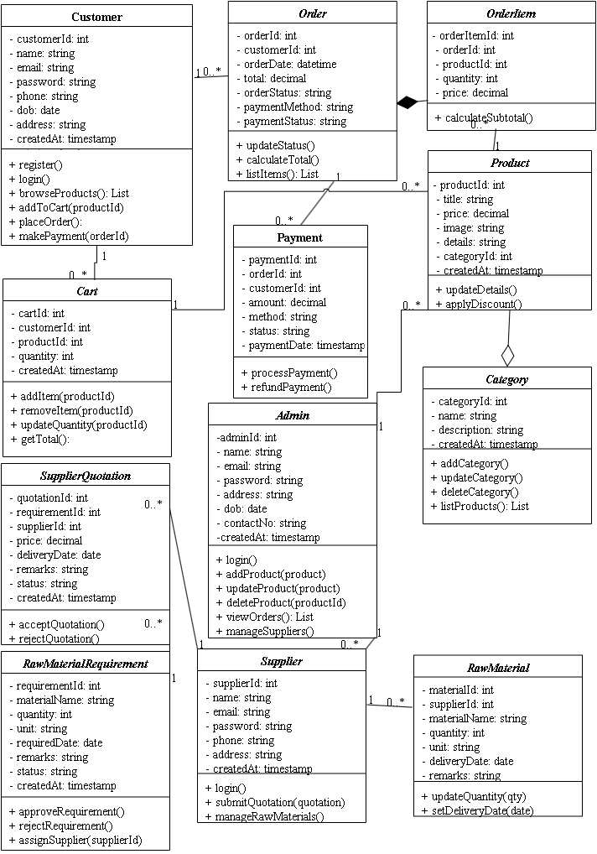Figure 2.11: Class Diagram of B2C E-Commerce Platform for Clothing & Apparel
The class diagram represents the core entities of the B2C E-Commerce Platform as classes, detailing their attributes, methods, and relationships. Key classes include Customer, Order, Order Item, Product, Category, Payment, Admin, and Supplier. Customers interact with orders and payments, while products are linked to categories and managed by the admin. Suppliers provide raw materials and respond to quotations. This diagram provides a static view of the system, illustrating how data is organized and how different classes interact. It helps developers understand system structure, define object behaviors, and plan the implementation of both frontend and backend modules, ensuring consistency and maintainability throughout the system.

Activity Diagram
An activity diagram represents the flow of activities or processes in the system. It helps visualize workflows such as order processing, product management, and report generation.
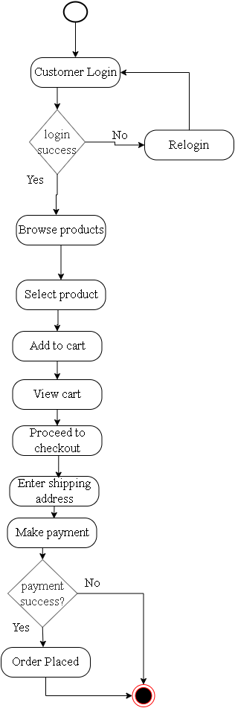
Figure 2.12: Activity Diagram of Customer Ordering Product

This diagram illustrates the workflow of a customer placing an order on the platform. The process begins with the customer browsing products and viewing details. They then add desired items to the cart and proceed to checkout, where payment is processed through the integrated system (e.g., Khalti). After payment, the order is confirmed and recorded in the system, allowing the customer to track its status. This activity diagram highlights the sequential flow of actions, decision points, and interactions with the system, ensuring that the order process is smooth, reliable, and user-friendly while providing a clear view of customer-system interaction.

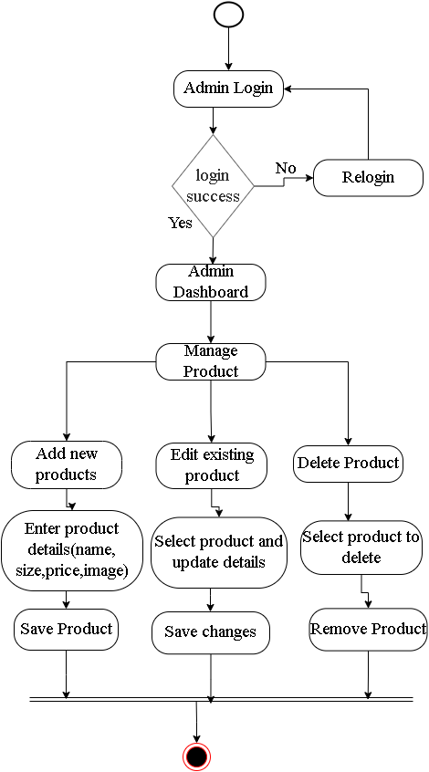

Figure 2.13: Activity Diagram of Admin Managing Products
This diagram represents the workflow of the admin managing products in the platform. The admin can add new products, update details like price or description, or remove products no longer available. Each action interacts with the database to ensure changes are accurately reflected on the platform. The diagram also shows validation and confirmation steps, ensuring only authorized updates are applied. This activity flow demonstrates how the admin maintains an organized and up-to-date product catalog, supporting smooth operations and helping customers access accurate product information. It emphasizes efficiency, consistency, and control over product management processes.

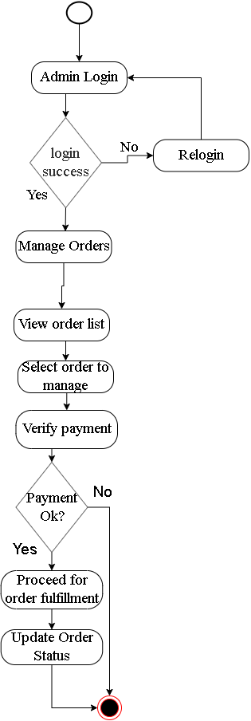

Figure 2.14: Activity Diagram of Admin Managing Order
This diagram depicts the admin’s workflow for handling customer orders. It starts with the admin viewing incoming orders, verifying payment and product availability, and updating the order status (e.g., pending, processed, shipped). The admin can also handle cancellations or modifications if necessary. This activity ensures that orders are processed accurately and on time, providing customers with reliable updates and delivery information. The diagram visualizes the step-by-step process of order management, highlighting the admin’s role in maintaining operational efficiency, improving customer satisfaction, and supporting seamless communication between the system and stakeholders.

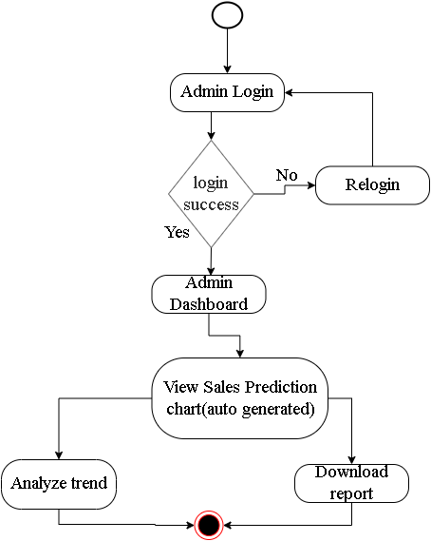

Figure 2.15: Activity Diagram of Admin Using Sales Prediction System
This diagram shows how the admin uses the sales prediction feature to make informed business decisions. The admin accesses historical sales data and generates predictive reports using analytics tools. The system processes the data to identify trends, forecast demand, and provide insights for inventory planning and marketing strategies. The admin can then plan stock levels, manage suppliers, and optimize product availability based on these predictions. This activity diagram illustrates the analytical workflow, showing how data-driven decision-making supports operational efficiency and helps the business anticipate customer needs while minimizing overstock or shortages.

Component Diagram
A component diagram represents the high-level modular structure of the system, showing the main components, their interfaces, and dependencies.
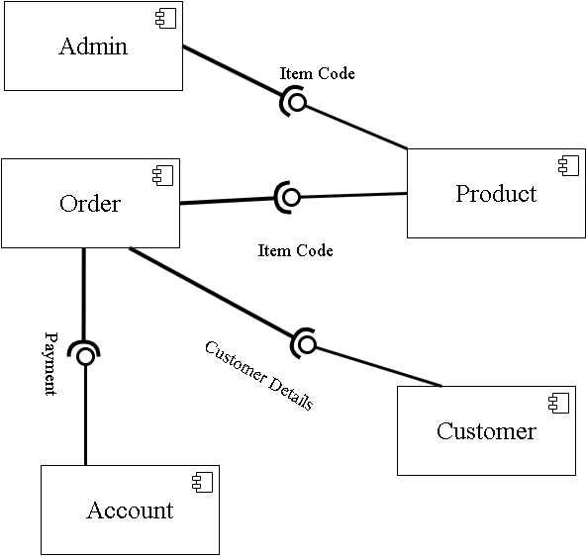
Figure 2.16: Component Diagram of B2C E-Commerce Platform for Clothing & Apparel
The component diagram illustrates the modular structure of the B2C E-Commerce Platform, highlighting the main system components and their interactions. Key components include Admin, Customer, Product, Order, Payment, Account, and Order Management. The Customer interacts with the system to browse products, view details, place orders, and make payments through the Order Payment Account module. The Admin manages products, items, and orders, ensuring data integrity and smooth operations. Components are connected through defined interfaces, allowing seamless communication and coordination between modules. This diagram provides a clear overview of system organization, showing dependencies, interactions, and how the platform maintains modularity, efficiency, and scalability.

Deployment Diagram
A deployment diagram shows the physical architecture of the system, including nodes (hardware or servers), software artifacts, and their deployment relationships. It helps visualize how the system will run in a real environment.
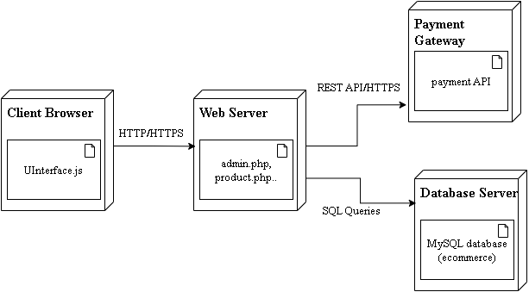
Figure 2.17: Deployment Diagram of B2C E-Commerce Platform for Clothing & Apparel

The deployment diagram represents the physical architecture of the B2C E-Commerce Platform, showing how components are deployed and interact in a real environment. The client browser communicates with the web server through HTTP/HTTPS, allowing customers to browse products, place orders, and access reports. The web server interacts with the database server using SQL queries to retrieve or update data related to customers, products, orders, and payments. It also connects with the payment gateway via REST APIs over HTTPS to process transactions securely. This diagram clearly demonstrates the flow of data, communication paths, and the physical setup required to ensure a secure, responsive, and scalable system.

Sequence Diagram
A sequence diagram illustrates the interaction between objects over time for specific scenarios. It shows how messages are exchanged during processes like login, order placement, and supplier quotation submission.

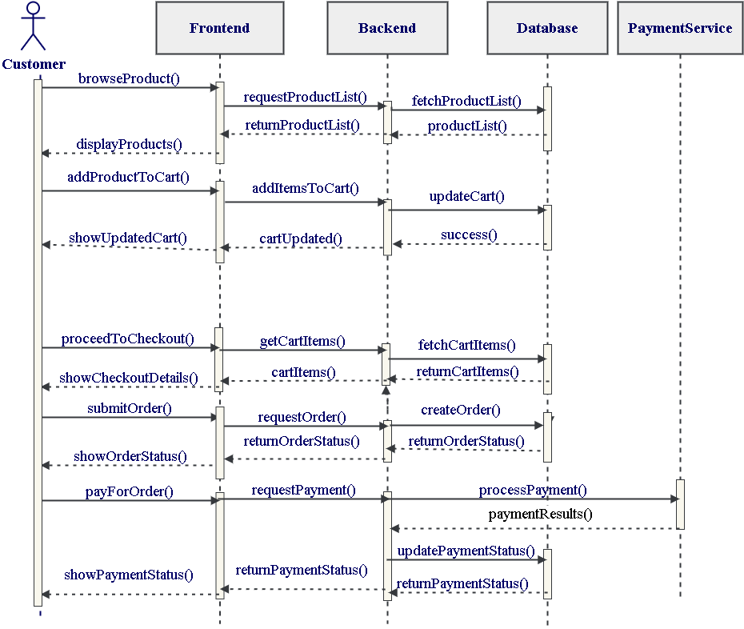
Figure 2.18: Sequence Diagram of B2C E-Commerce Platform for Clothing & Apparel
The sequence diagram shows how different system components interact with each other over time to complete specific tasks. It illustrates the flow of messages between the Customer, Web Interface, Backend Server, Database, Payment Gateway. In the order placement process, product details are fetched, an order is created, and payment is processed through the payment gateway. This diagram helps clearly explain the step-by-step interaction, timing, and responsibility of each component within the system.

2.3 Implementation
The implementation phase involves the actual development of the system based on the analysis and design models. This includes setting up the environment, developing frontend and backend modules, integrating the database, and performing testing to ensure the system works as intended.

2.3.1 Tools and Technologies Used
The development of the B2C E-Commerce Platform for Clothing & Apparel utilized the following tools and technologies:
- Frontend: React.js was chosen for building the user interface because of its component-based architecture, efficient rendering, and reusability of components.
- Backend: PHP was used for server-side scripting to handle business logic, database interactions, and API endpoints.
- Database: MySQL was selected as the relational database management system to store structured data for customers, products, orders, suppliers, and payments.
- Development Environment: WAMP Server provided a local server environment for running PHP and MySQL.
- Design Tools: Low-fidelity wireframes and diagrams were created using Draw.io, while Figma and Balsamiq were optionally used for prototyping.
- Data Visualization Tool: Power BI was used to analyze sales data and generate visual reports, supporting better business insights and decision-making.
- Code Editor: Visual Studio Code was used for developing and managing both frontend and backend code.

These tools were chosen for their compatibility, ease of use, and suitability for developing a complete e-commerce system with an efficient workflow and proper documentation.

2.3.2 Module Description
The system is divided into several functional modules to ensure modularity, ease of maintenance, and clear separation of responsibilities. Each module is designed to handle specific operations of the B2C E-Commerce Platform effectively.

Customer Module
The Customer Module allows users to register and log in securely to the platform. Customers can browse clothing products by category, view detailed product information, add items to the cart, place orders, and complete payments. The module also enables customers to track their order status, ensuring a smooth and convenient shopping experience.

Product & Admin Module
This module provides administrative control over the system. Admin users can securely access the dashboard to add, update, or remove products and categories. It also allows admins to manage customer orders, handle supplier coordination, process raw material requests, and generate reports, including sales prediction reports, ensuring efficient system operation.

Order Module
The Order Module manages all order-related activities. It handles order creation, order status updates, and payment processing. Multiple products within a single order are managed using the OrderItem structure, ensuring accurate tracking of purchases and transaction records.

Supplier Module
The Supplier Module enables suppliers to view raw material requests submitted by the admin and respond by providing quotations. This module supports smooth communication between the admin and suppliers, helping ensure timely availability of required materials.

Sales Prediction Module
The Sales Prediction Module is designed to forecast future product demand using historical sales data. In this project, exponential smoothing is used as the prediction technique, as it gives more importance to recent sales data while still considering past trends. This approach helps produce more realistic and timely predictions for a clothing and apparel business.
Implementation Details:
- Historical monthly sales were aggregated from product-level data.
- Exponential smoothing was applied with a smoothing factor (α) of 0.3.
- The model was tested and validated in Python (Jupyter Notebook) before implementation in PHP and React for the live system.
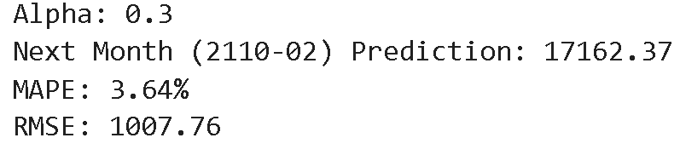
Figure 2.19: Accuracy Test of Exponential Smoothing
These results indicate that the module provides reliable short-term sales forecasts, supporting inventory planning, procurement decisions, and promotional strategies.

2.3.3 Business Intelligence (Reports and Visualization)
Business Intelligence (BI) features were implemented in the system to support data analysis, reporting, and informed decision-making. The platform uses a combination of React-based visualizations and Power BI reports to present sales and performance data in a clear and meaningful way.

Basic and real-time visualizations such as sales prediction, sales summaries, order counts, and product-wise performance charts were implemented directly in the admin dashboard using Recharts, a charting library for React. These visualizations allow the admin to quickly monitor daily activities within the system.

For advanced analysis, Power BI was used to generate detailed reports such as sales trends, category-wise analysis, revenue distribution. Data extracted from the MySQL database was used to create interactive dashboards.
React-based Recharts snapshots (Admin Dashboard):

Figure 2.20: Monthly Sales Prediction

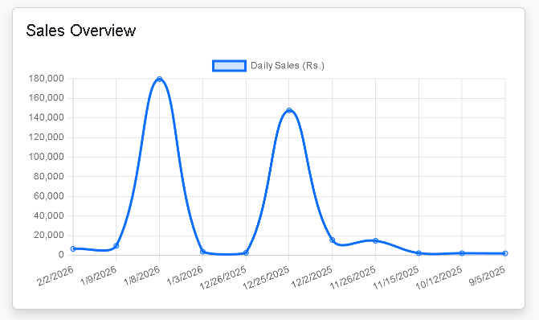
Figure 2.21: Sales Overview Line graph

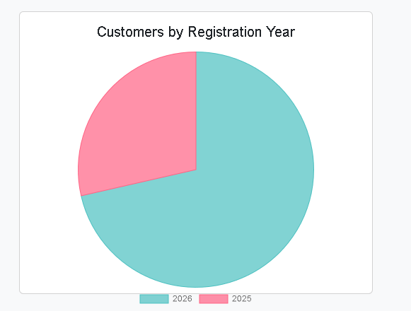
Figure 2.22: Pie Chart of Customer Registration

Power BI snapshots

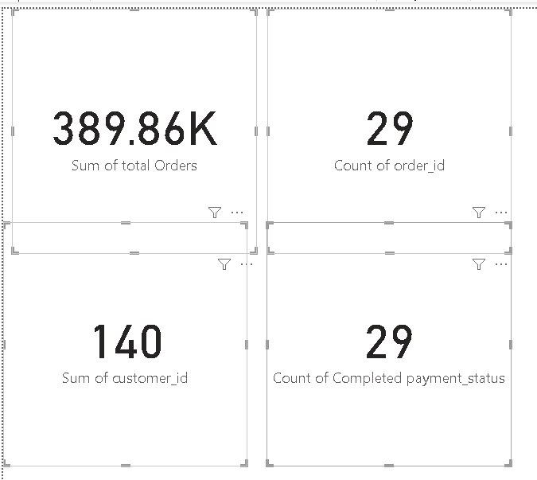
Figure 2.23: Summary Cards

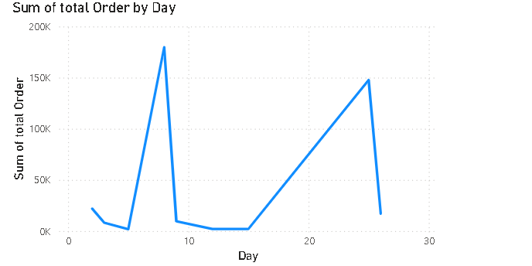
Figure 2.24: Total Order Line Graph

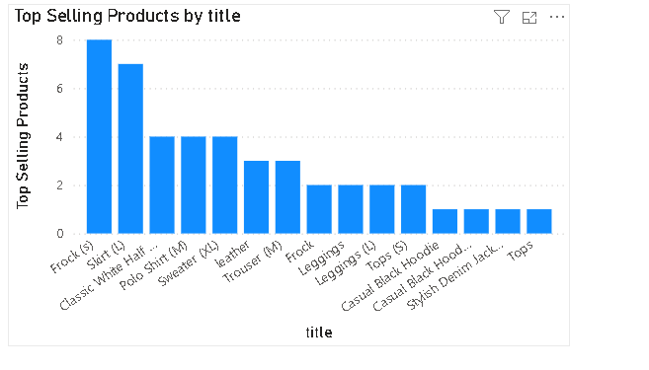
Figure 2.25: Bar Graph of Top Selling Products

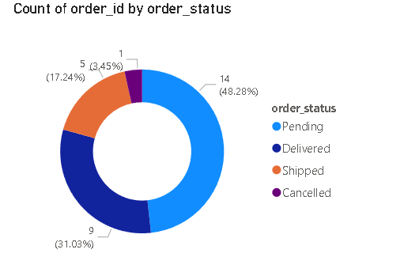
Figure 2.26: Donut Chart

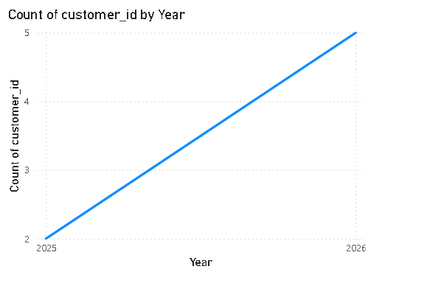
Figure 2.27: Line Graph of Customer Registration

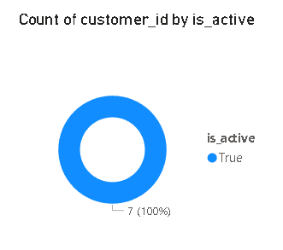
Figure 2.28: Donut Chart of Active Customer

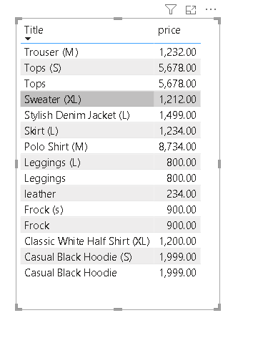
Figure 2.29: Matrix of Products and Price

These demonstrate advanced reporting and decision-making support, showing that the system can handle both operational and strategic insights.

2.3.4 Testing
Testing is a critical phase of the system development process, conducted to ensure the correctness, reliability, and functionality of the B2C E-Commerce Platform for Clothing & Apparel. The system was tested using multiple approaches, primarily focusing on functional testing to validate both individual modules and overall system performance.
Functional testing was performed to verify that all features operated according to the specified requirements. This included testing customer authentication, product browsing, cart operations, order placement, payment processing, and administrative functions. Each module was tested independently to ensure accurate data processing and expected outputs.
The following test cases were implemented and documented:
- Customer Login: Positive and negative scenarios were executed to validate correct login behavior and proper error handling.
- Customer Order Placement: Positive and negative test cases verified that orders could be placed successfully under valid conditions, and errors were correctly handled for invalid or incomplete inputs.
- Admin Product Management: Positive test cases confirmed that administrators could successfully add new products, ensuring that product information is properly stored and displayed.
These tests were performed on the local development environment using Chrome browser, and all functional requirements passed successfully, demonstrating that the system is stable, reliable, and ready for deployment.

Table 2.6- Positive Test Case for Customer Login

Test Scenario ID |  | AUTH-CUS-LOGIN |  |  | Test Case ID |  |  | AUTH-CUS-LOGIN-POS-001
Test Case Description |  | Customer Login – Positive test case |  |  | Test Priority |  |  | High
Pre-Requisite |  | A registered customer account must exist in the system. |  |  | Post-Requisite |  |  | Customer is logged into the system dashboard.
Test Execution Steps:
S.N | Action |  | Inputs | Expected Output |  | Actual Output | Test Browser |  | Test Result | Test Comments
1 | Launch application |  | http://localhost:3000 | Home page displayed |  | Home page displayed | Chrome |  | Pass | Application launched successfully
2 | Navigate to Login page |  | Click on Login | Login page displayed |  | Login page displayed | Chrome |  | Pass | Login page loaded
3 | Enter valid email and password |  | Email: sandeep@gmail.com  Password: ****** | User logged in successfully |  | User logged in successfully | Chrome |  | Pass | Login successful, dashboard displayed

Table 2.7- Negative Test Case for Customer Login

Test Scenario ID |  | AUTH-CUS-LOGIN |  |  | Test Case ID |  |  | AUTH-CUS-LOGIN-NEG-002
Test Case Description |  | Customer Login – Negative test case |  |  | Test Priority |  |  | High
Pre-Requisite |  | User is not logged in |  |  | Post-Requisite |  |  | User remains on login page with error message
Test Execution Steps:
S.N | Action |  | Inputs | Expected Output |  | Actual Output | Test Browser |  | Test Result | Test Comments
1 | Launch application |  | http://localhost:3000 | Home page displayed |  | Home page displayed | Chrome |  | Pass | Application launched successfully
2 | Navigate to Login page |  | Click on Login | Login page displayed |  | Login page displayed | Chrome |  | Pass | Login page loaded
3 | Enter invalid email and password |  | Email: invalid@gmail.com  Password: ****** | Error message displayed |  | Error message displayed | Chrome |  | Pass | Invalid email detected
4 | Enter valid email and invalid password |  | Email: sandeep@gmail.com  Password: ****** | Error message displayed |  | Error message displayed | Chrome |  | Pass | Incorrect password prevented login

Table 2.8- Positive Test Case for Customer Order Placement

Test Scenario ID |  | ORD-CUS-PLACEMENT |  |  | Test Case ID |  |  | ORD-CUS-PLACEMENT-POS-003
Test Case Description |  | Customer places an order successfully |  |  | Test Priority |  |  | High
Pre-Requisite |  | Customer must be logged in and have at least one product in the cart |  |  | Post-Requisite |  |  | Order is created successfully and status is set to “Pending”
Test Execution Steps:
S.N | Action |  | Inputs | Expected Output |  | Actual Output | Test Browser |  | Test Result | Test Comments
1 | Launch application |  | http://localhost:3000 | Home page displayed |  | Home page displayed | Chrome |  | Pass | Application launched successfully
2 | Browse  products  and add  to cart |  | Product: Leggings, Quantity: 1 | Product added to cart |  | Product added to cart | Chrome |  | Pass | Product successfully added
3 | Navigate to Cart page |  | Click on Cart icon | Cart page displayed with selected items |  | Cart page displayed. | Chrome |  | Pass | Cart Page loaded
4 | Proceed to Checkout” |  | Click “Proceed to Checkout” | Checkout page displayed |  | Checkout page displayed | Chrome |  | Pass | Checkout page loaded
5 | Enter Shipping Address and Contact |  | Address: Kathmandu, Nepal  Phone: 9841234567 | Shipping and contact information accepted |  | Shipping and contact information accepted | Chrome |  | Pass | Details accepted
6 | Place Order |  | Click “Place Order” | Order created successfully, status “Pending” |  | Order created successfully, status “Pending” | Chrome |  | Pass | Order processed successfully

Table 2.9- Negative Test Case for Customer Order Placement

Test Scenario ID |  | ORD-CUS-PLACEMENT |  |  | Test Case ID |  |  | ORD-CUS-PLACEMENT-NEG-004
Test Case Description |  | Customer attempts to place an order with invalid inputs, empty cart, or incorrect checkout details |  |  | Test Priority |  |  | High
Pre-Requisite |  | Customer must be logged in |  |  | Post-Requisite |  |  | Order is not created, and proper error messages are displayed
Test Execution Steps:
S.N | Action |  | Inputs | Expected Output |  | Actual Output | Test Browser |  | Test Result | Test Comments
1 | Launch application |  | http://localhost:3000 | Home page displayed |  | Home page displayed | Chrome |  | Pass | Application launched successfully
2 | Navigate  to Cart  page |  | Click on Cart icon | Cart page displayed |  | Cart page displayed | Chrome |  | Pass | Cart page loaded
3 | Attempt to proceed to checkout with empty cart |  | Cart has no items | Error message: “Cart is empty. Please add products before checkout.” |  | Error message displayed | Chrome |  | Pass | Empty cart prevented checkout
4 | Proceed to checkout with products but leave shipping address blank |  | Address: [blank], Contact: 9841234567 | Error message: “Shipping address is required.” |  | Error message displayed | Chrome |  | Pass | Empty address prevented order placement

Table 2.10- Positive Test Case for Admin Adding Product

Test Scenario ID |  | ADM-PROD-MGMT |  |  | Test Case ID |  |  | ADM-PROD-ADD-POS-005
Test Case Description |  | Admin adds a new product to the system successfully |  |  | Test Priority |  |  | High
Pre-Requisite |  | Admin must be logged in and have access to the dashboard |  |  | Post-Requisite |  |  | New product is added to the system and visible in the product listing
Test Execution Steps:
S.N. | Action |  | Inputs | Expected Output |  | Actual Output | Test Browser |  | Test Result | Test Comments
1 | Launch admin dashboard |  | http://localhost:3000/admin | Admin dashboard displayed |  | Admin dashboard displayed | Chrome |  | Pass | Dashboard loaded successfully
2 | Navigate to “Manage Product” page |  | Click on “Add Product” menu | Add Product page displayed |  | Add Product page displayed | Chrome |  | Pass | Add Product page loaded
3 | Enter product details |  | Name: Leggings  Category: Women  Price: Rs. 800  Description: Comfortable leggings  Image: leggings.jpg | Product details accepted |  | Product details accepted | Chrome |  | Pass | All inputs valid and accepted
4 | Submit product form |  | Click “Add Product” button | Product added successfully message displayed; product appears in product list |  | Product added successfully; product listed | Chrome |  | Pass | Product added and visible in listing

Chapter III- Conclusion and Recommendation
3.1 Summary
The B2C E-Commerce Platform for Clothing & Apparel was developed to provide a modern, efficient, and user friendly online shopping system. The platform addresses limitations of traditional retail by enabling customers to browse products, place orders, and track their purchases from any location at any time. It also equips the adminr with tools to manage products, categories, inventory, orders, suppliers, and generate reports.
The system is divided into distinct modules for customers, admin, suppliers, and includes a sales prediction feature to support business planning. Developed using React for the frontend, PHP for the backend, and MySQL as the database, the system follows Agile methodology, enabling iterative improvements and integration of new features.
The platform provides a reliable, scalable solution for online clothing retail, enhancing customer experience while streamlining operational management for the vendor.
3.2. Conclusion
The B2C E-Commerce Platform for Clothing & Apparel successfully demonstrates the development of a complete online retail system tailored for the clothing and apparel sector. Customers can seamlessly browse products, manage carts, place orders, and track their purchases, while vendors can efficiently manage products, categories, orders, suppliers, and reports.
The integration of the Supplier Module and Sales Prediction feature improves operational efficiency and supports data-driven decision-making. The system’s modular design, responsive interface, and secure data management ensure reliability, usability, and scalability. In conclusion, the platform meets its objectives by delivering a functional, modern, and maintainable e-commerce system, providing a foundation for future enhancements.
3.3 Recommendation
Although the system is functional, it can be further improved in the future through:
- Mobile Application Development: Creating Android and iOS apps to increase accessibility.
- Full Supplier Workflow: Extending the supplier module to include invoice management, delivery tracking, and supplier rating.
- Product Recommendation System: Using AI-based algorithms to provide personalized product suggestions to customers.
- Enhanced Security: Strengthen authentication, role-based access control, and encrypted communication to ensure secure operations across the platform.
Implementing these recommendations can evolve the platform into a fully commercial-ready e-commerce solution with advanced features and improved usability.

References
Chen, J., Guo, Z. C., & Tang, Y. (2019). Research on B2C e-commerce business model based on system dynamics. American Journal of Industrial and Business Management, 9, 854–874. doi:https://doi.org/10.4236/ajibm.2019.94058
GeeksforGeeks. (2023). E commerce architecture | System design for e commerce website. GeeksforGeeks. Retrieved from https://www.geeksforgeeks.org/system-design/e-commerce-architecture-system-design-for-e-commerce-website/
Gokulpriya, R. (2024). E-commerce sales analysis dashboard using business intelligence tool – Microsoft Power BI. IJIRMPS, 12(4). Retrieved from https://www.ijirmps.org/papers/2024/4/230837.pdf
Meena, A., Singh, A. P., Mittal, K., Tiwari, S., & Malviya, J. (2023). Design and implementation of an e-commerce platform for online grocery shopping with multi-payment integration. International Journal of Research – Granthaalayah, 11(11), 202-212.
Pandey, H., & Gupta, R. (2023). Study and development of e-commerce website. International Journal for Research in Applied Science & Engineering Technology. doi:10.22214/ijraset.2023.53065

Appendices

Product Page
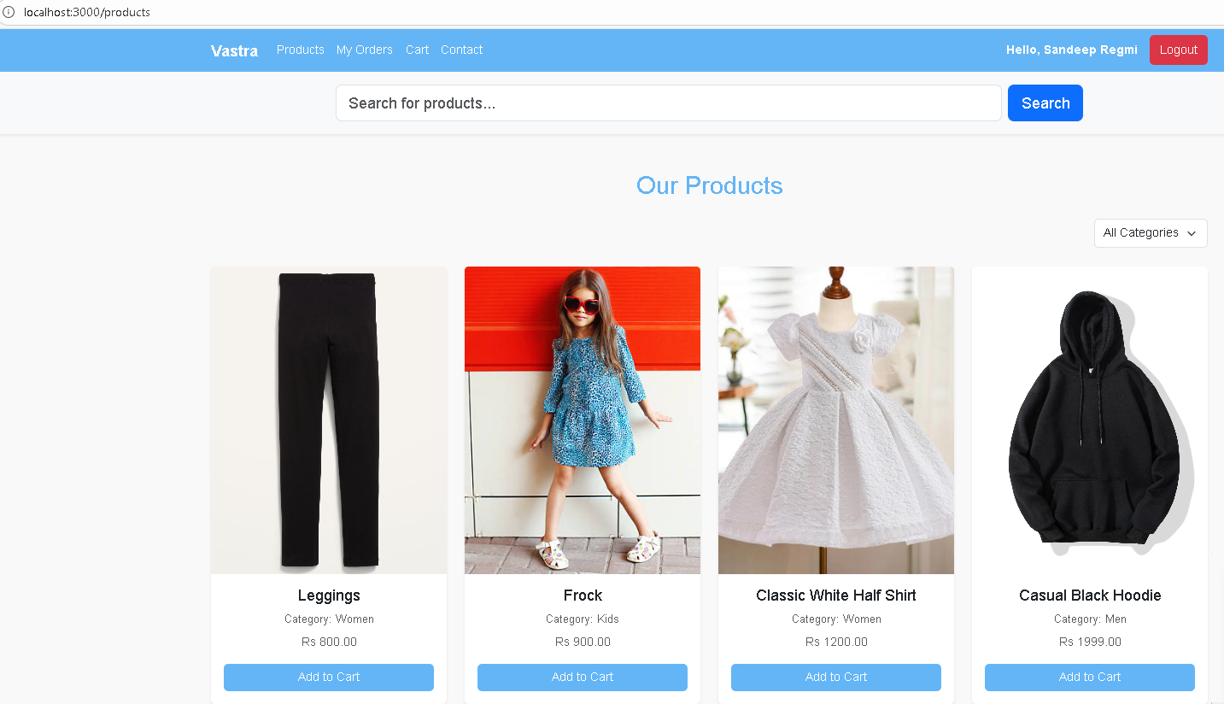
Customer Login Page


Search Product
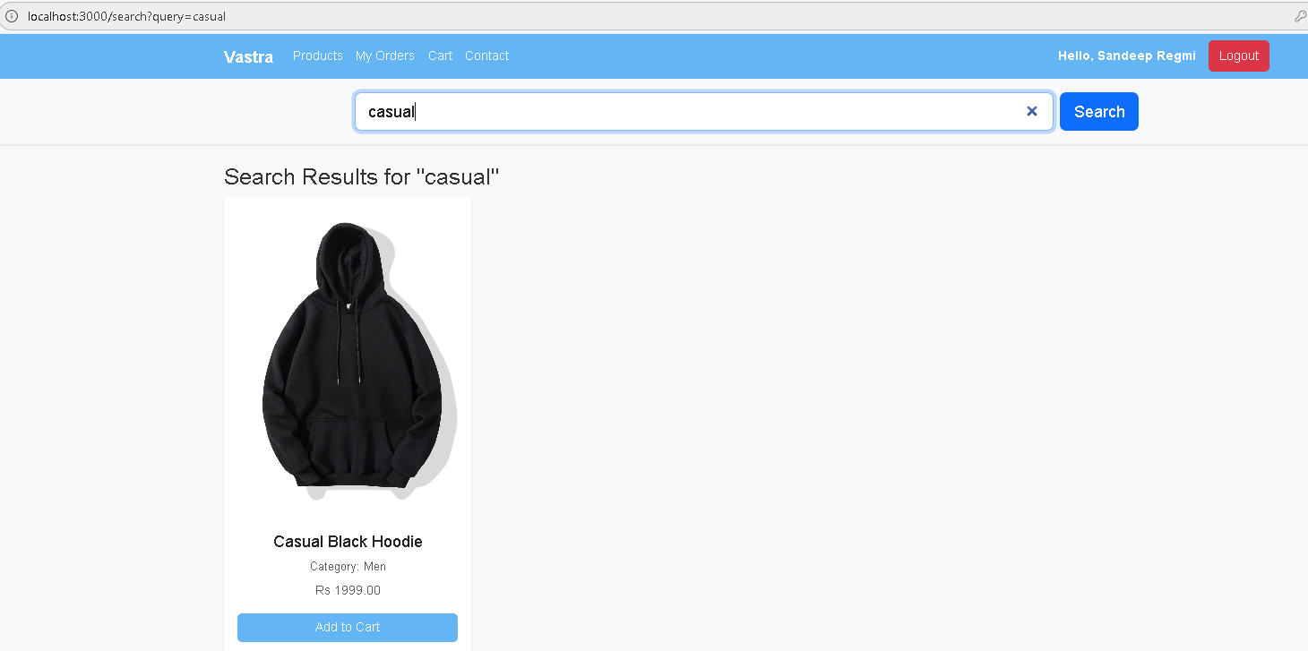

Cart Page
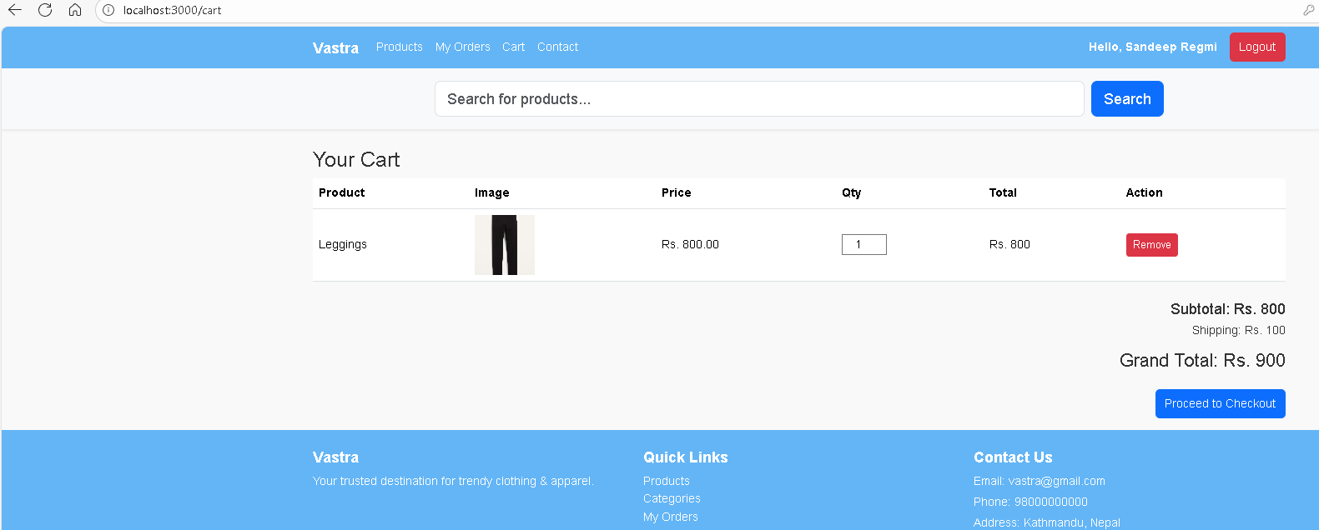

Admin Login Page
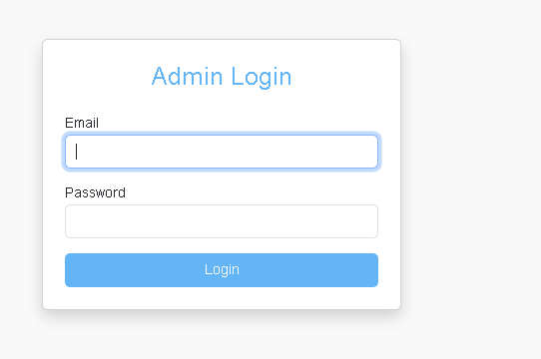

Admin Dashboard
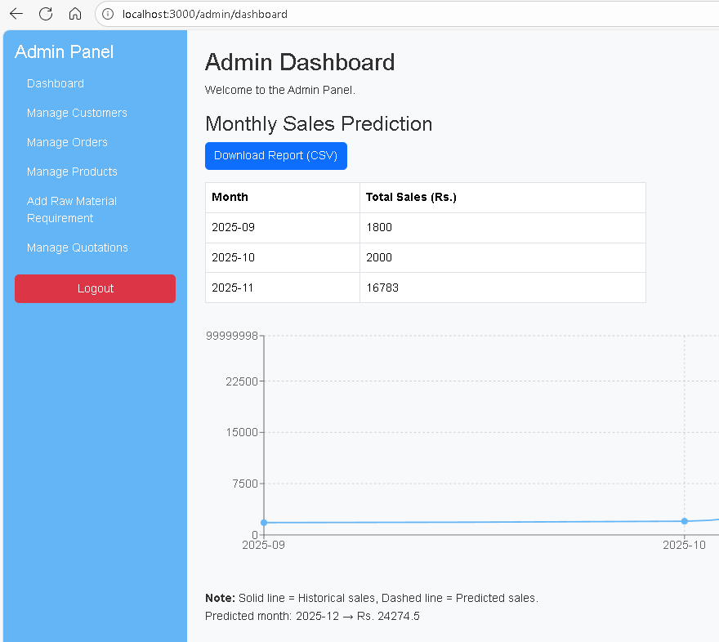
Manage Product
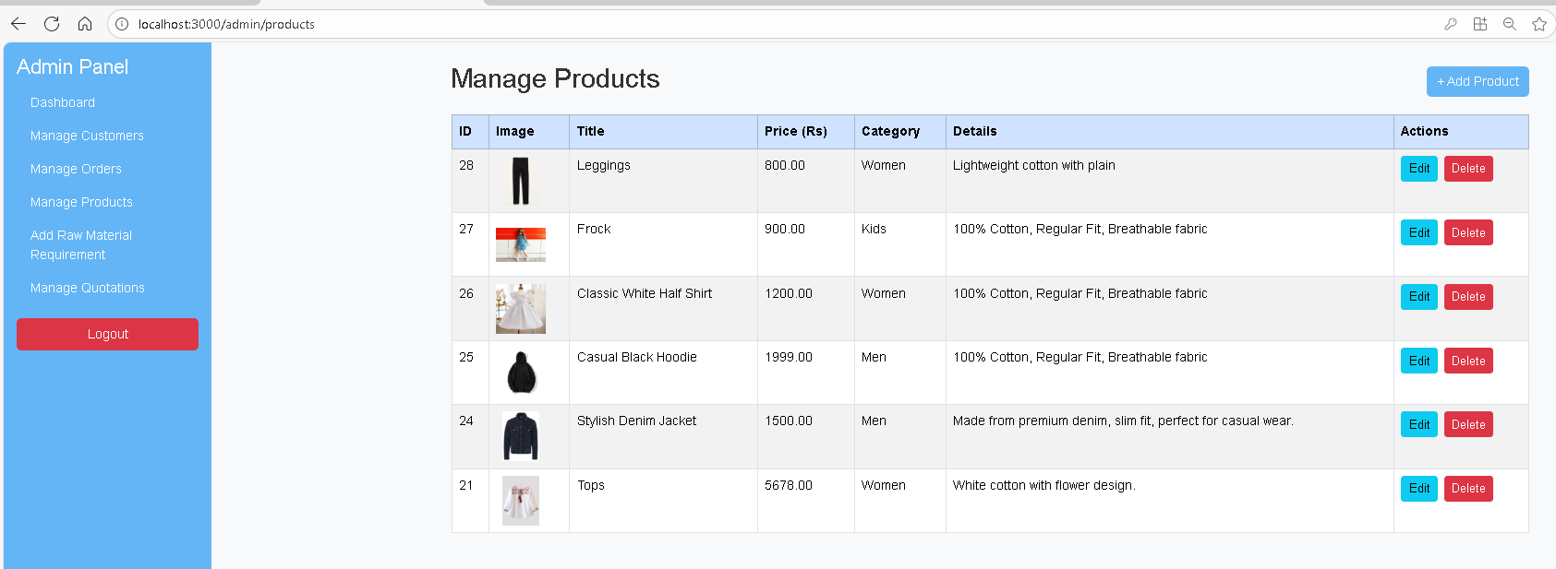

Manage Order
