## **Objectives**

* Explain various ways of conditional rendering
* Explain how to render multiple components
* Define list component
* Explain about keys in React applications
* Explain how to extract components with keys
* Explain React Map, map() function

In this hands-on lab, you will learn how to:

* Implement conditional rendering in React applications

## **Prerequisites**

The following is required to complete this hands-on lab:

* Node.js
* NPM
* Visual Studio Code

## **Notes**

Estimated time to complete this lab: **60 minutes.**

Create a React App named “bloggerapp” in with 3 components.

1. Book Details
2. Blog Details
3. Course Details

Implement this with as many ways possible of Conditional Rendering.

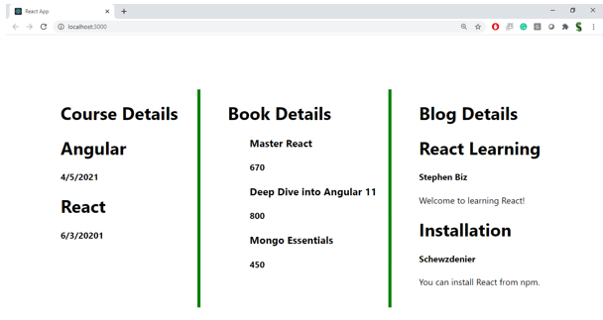

**Hint:**

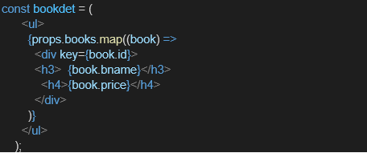

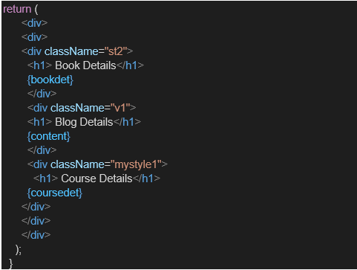

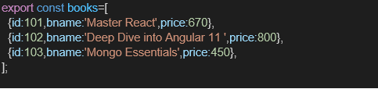

**CODES + OUTPUT :**

### App.js

import React, { useState } from 'react';import BookDetails from './BookDetails';import BlogDetails from './BlogDetails';import CourseDetails from './CourseDetails';

function App() {

const [activeComponent, setActiveComponent] = useState('book');

const renderComponent = () => {

switch (activeComponent) {

case 'book':

return <BookDetails />;

case 'blog':

return <BlogDetails />;

case 'course':

return <CourseDetails />;

default:

return <h3>Select a valid component</h3>;

}

};

return (

<div style={{ padding: '20px' }}>

<h1>Blogger App</h1>

<div style={{ marginBottom: '20px' }}>

<button onClick={() => setActiveComponent('book')}>Book Details</button>

<button onClick={() => setActiveComponent('blog')}>Blog Details</button>

<button onClick={() => setActiveComponent('course')}>Course Details</button>

</div>

{/* Conditional Rendering via function */}

{renderComponent()}

</div>

);

}

export default App;

### *BookDetails.js*

import React from 'react';

function BookDetails() {

const books = [

{ id: 1, title: 'Atomic Habits', author: 'James Clear' },

{ id: 2, title: 'Deep Work', author: 'Cal Newport' },

{ id: 3, title: 'Ikigai', author: 'Héctor García' }

];

return (

<div>

<h2>Book List</h2>

<ul>

{books.map((book) => (

<li key={book.id}>

<strong>{book.title}</strong> by {book.author}

</li>

))}

</ul>

</div>

);

}

export default BookDetails;

### *BlogDetails.js*

import React from 'react';

function BlogDetails() {

const blogs = [

{ id: 101, title: 'React Basics', content: 'Learn about components, props, and state.' },

{ id: 102, title: 'Using Hooks', content: 'A look into useState and useEffect.' },

{ id: 103, title: 'React Router', content: 'How to do routing in React.' }

];

return (

<div>

<h2>Blog Posts</h2>

{blogs.length === 0 ? (

<p>No blogs to show.</p>

) : (

blogs.map((blog) => (

<div key={blog.id}>

<h3>{blog.title}</h3>

<p>{blog.content}</p>

<hr />

</div>

))

)}

</div>

);

}

export default BlogDetails;

### CourseDetails.js

import React from 'react';

function CourseDetails() {

const courses = [

{ id: 'c1', name: 'React for Beginners', level: 'Beginner' },

{ id: 'c2', name: 'Advanced React', level: 'Advanced' },

{ id: 'c3', name: 'React with TypeScript', level: 'Intermediate' }

];

const isCourseAvailable = courses.length > 0;

return (

<div>

<h2>Available Courses</h2>

{/* Conditional Rendering with && operator */}

{isCourseAvailable && (

<ul>

{courses.map((course) => (

<li key={course.id}>

{course.name} ({course.level})

</li>

))}

</ul>

)}

{/* Conditional Rendering with ternary */}

{!isCourseAvailable ? <p>No courses available.</p> : null}

</div>

);

}

export default CourseDetails;

