**Linked Lists**

**What is a Linked List?**

A linked list is a sequence of elements where each element points to the next one, like a chain. Each element is called a node.

**Example:**

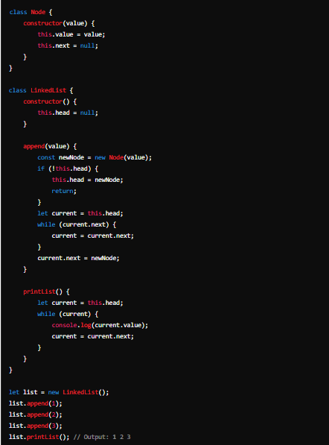

**Stacks:**

**What is a Stack?**

A stack is like a stack of plates. You can only take the top plate off the stack, and you can only add a new plate on top. This is called LIFO (Last In, First Out).

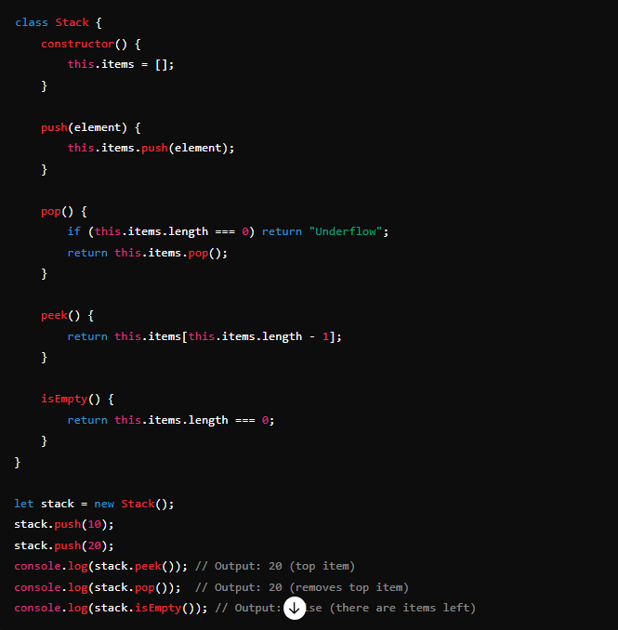

**Queues**

**What is a Queue?**

A queue is like a line of people waiting. The first person in line is the first to be served. This is called FIFO (First In, First Out).

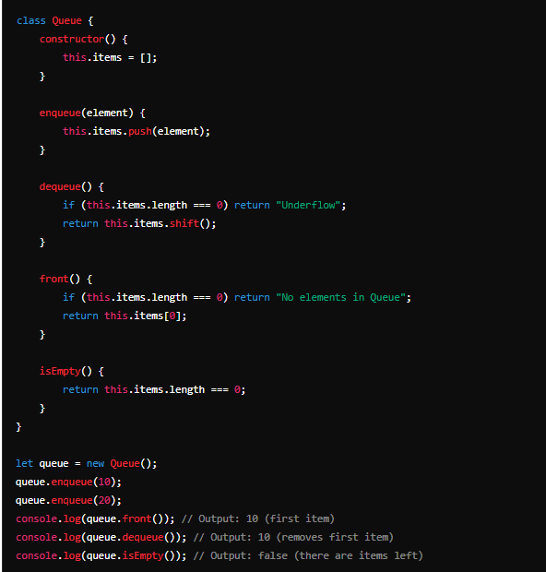

**Binary Search**

**What is Binary Search?**

Binary search is a method to find an item in a sorted array by repeatedly dividing the search interval in half. It's much faster than searching each item one by one.

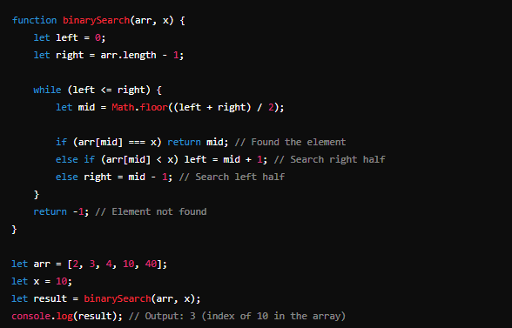

**Heaps**

**What is a Heap?**

A heap is a special tree-based data structure that satisfies the heap property. In a max heap, for any given node C, if P is a parent node of C, then the value of P is greater than or equal to the value of C. In a min heap, the value of P is less than or equal to the value of C.