Poverty, Race, Jobs, and Transportation in Kansas City

Point of Contact: Ye Wang, wanye@umkc.edu

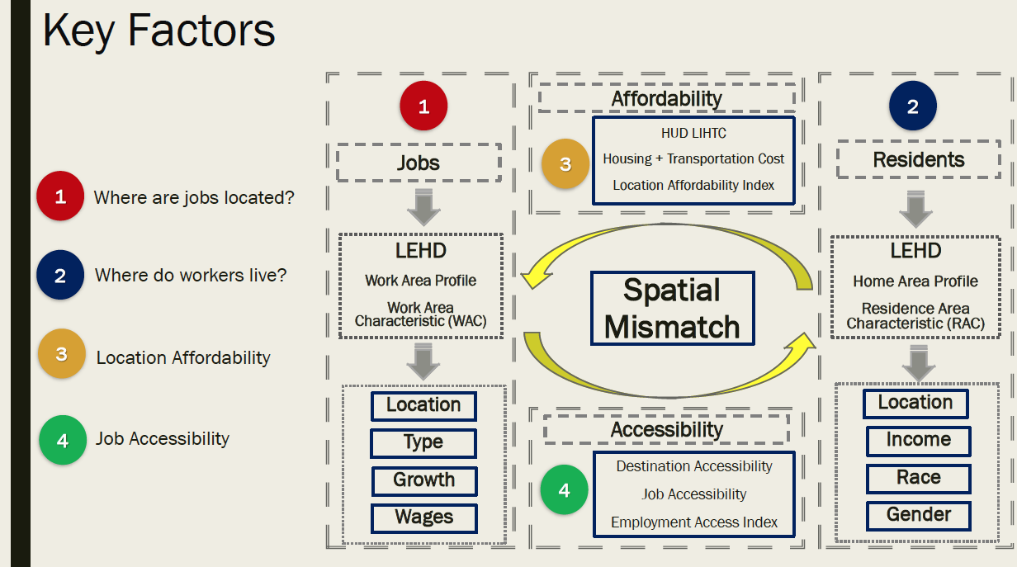According to reports, minorities, particularly African Americans, have limited accessibility to jobs due to high poverty and social isolation. There is a serious spatial mismatch in Kansas City between jobs and people who need jobs to get out of poverty. This project has two goals, and you can focus on either one or both:

1. 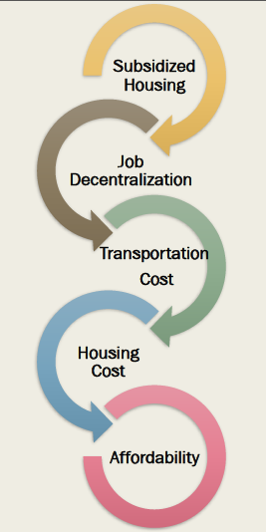Identifying and visualizing spatial mismatch between jobs and low-income residents in Kansas City, with demographic profiles (race, ethnicity, gender, and age). To accomplish this goal, you need to integrate data on unemployment, household, income, census data, property value, major employers, pay rates, etc. Here is a useful source of local data sets: <https://data.kcmo.org/>.

This chart from US Census’s “Job Growth and The Spatial Mismatch between Jobs and Low-Income Residences,” by Dr. Sardari, Reza describes four steps and multiple data sources to identify the spatial mismatch.

1. Creating a predictive model that can predict and visualize mobility issues in Kansas City metro. The following are the five solutions that Dr. Sardari recommended to reduce the mismatch. Can you create a model that is able to predict the effects of a potential solution (for example, adding a new bus line, building a new factory, adding a new highway) on improving mobility and job accessibility for low-income residents in KC?