**ASE LAB-10 REPORT**

**Lab id: 5_2**

**Sandeep Reddy Salkuti (24)**

**Pranathi Nalluri (22)**

1. **Creating IAM user in AWS account:**

IAM user can be created when we create application and need to make api calls to aws or when someone joins to our team then we create user to them. we can perform user creation using console or CLI.

Steps followed for creating user are:

1. Login to AWS management console and go to IAM user page.
2. Click on users tab and add user button.
3. Give any username to user and set password for the user account so next time we can login to user with username and password.
4. Set permissions and policies if needed and save the user.

I have created user1 as user and screenshot is attached below.

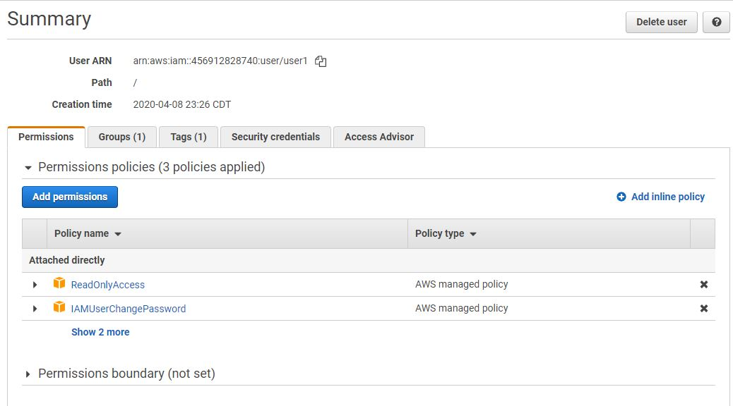

**Group:**

Group is created to add team members in a project like as users to work on them and give them specific permissions to perform operations like read, write etc.

Steps followed in creating group are:

1. Login to console in click on groups tab and click add group
2. Give group name and set permissions to group for access.
3. Click create group and now users can be added under group.

Group is created as group1 and I have added user to group and screenshot is attached below.

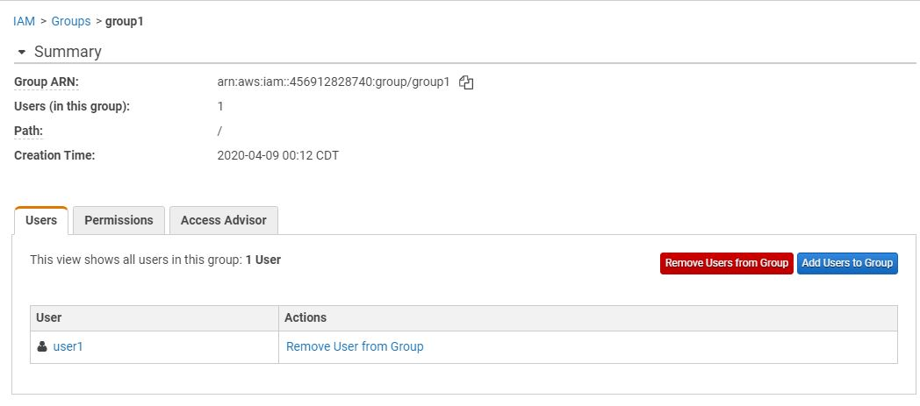

**Role:**

IAM roles is an entity with set of permissions for making service requests to AWS. They are not associated with specific group they are managed with applications or aws services.

Below is the screenshot of role created with specific permission policies.

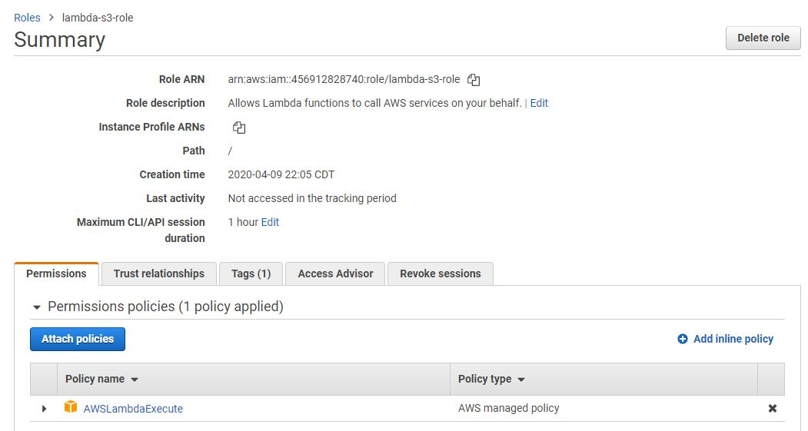

**Bucket:**

Bucket is storage unit which allows to store and retrieve data from any part of the world and below is the bucket created like mysourcebucke as the source bucket and mysourcebucke--resized as destination buckets these are used in lambda operations.

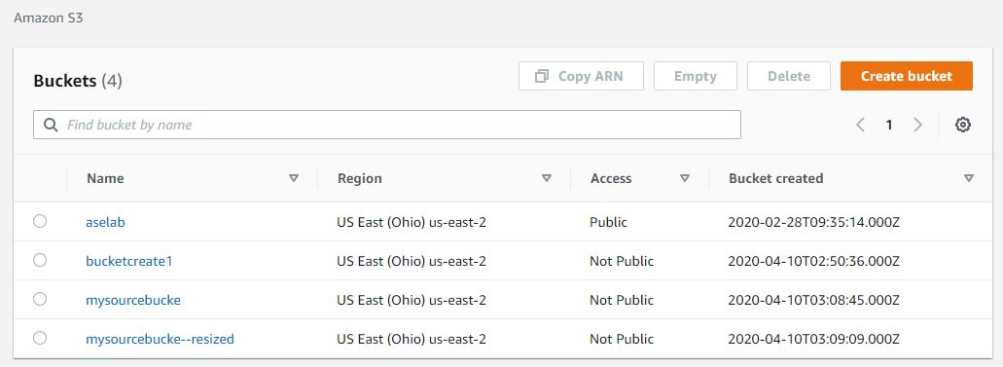

**2.Installation of AWS CLI:**

AWS CLI is command line interface used to interact with AWS account and perform same operations as we do in console and after installation you can check in command prompt with “aws – version” as command to verify for successfully installed or not and below is the screenshot attached.

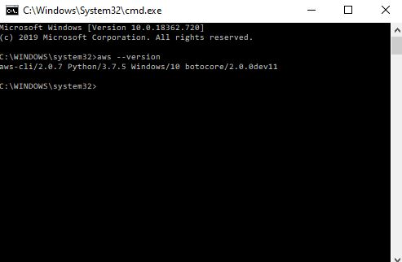

**3.Configure AWS CLI:**

We can configure AWS CLI from our command prompt using command “aws configure” which asks for access key id, secret key, region name and output format of data. If we need to configure for other user created the we can use command as “aws configure –profile user1” and screenshot is attached below.

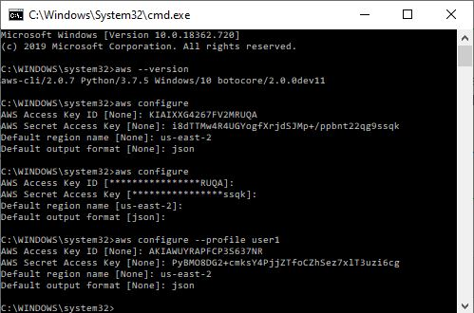

1. **Using AWS Lambda with Amazon S3:**

Here we create a source bucket and when we upload image or file to the bucket it call lambda function which reads the image object created from source bucket and creates thumbnail object in the destination bucket with size of the file reduced or resized.

For creating lambda function we can create on console and in CLI so below is screenshot captured in CLI.

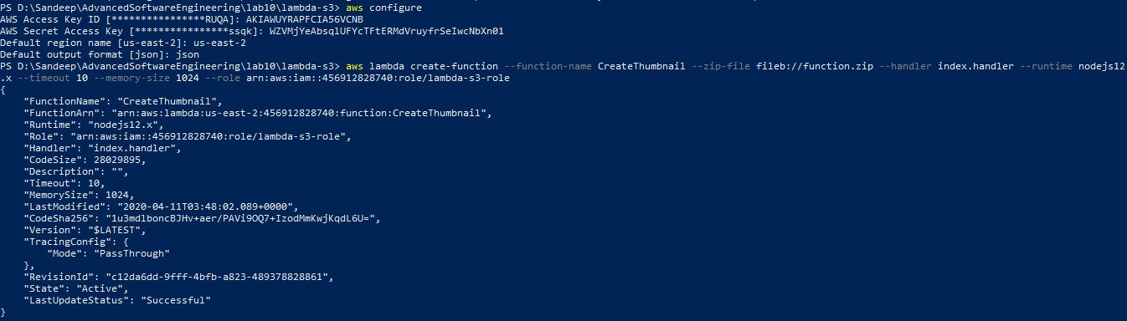

Below is the screenshot for lambda function created.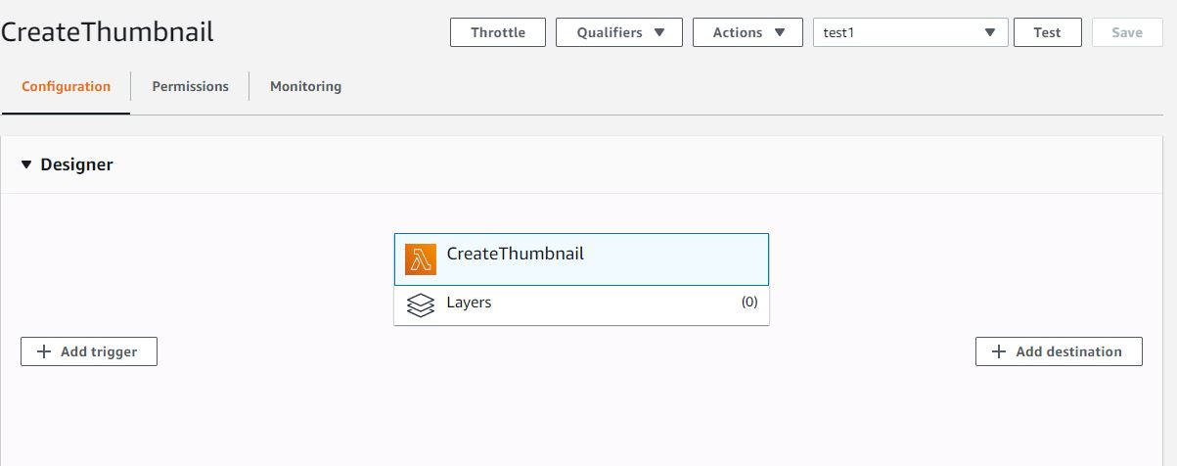

Now we invoke event with giving source bucket name and key which is the image name uploaded in source bucket and for reference screenshot is attached below

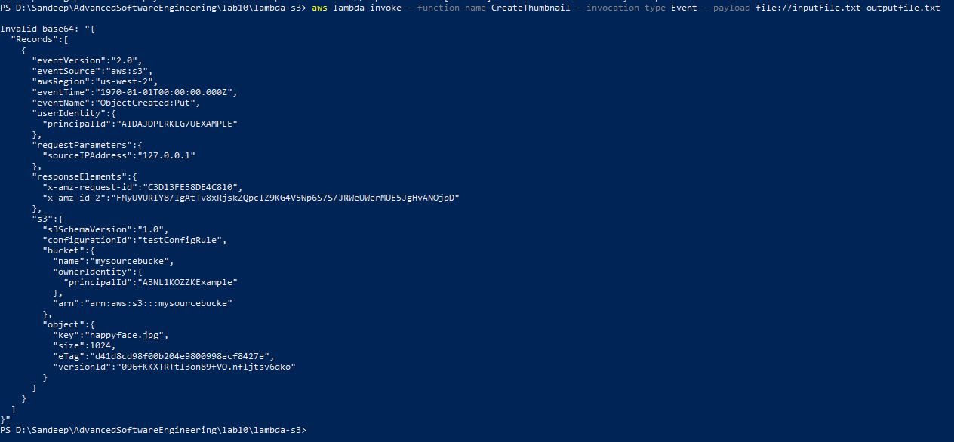

At the end test lambda function before that edit JSON file with name of source bucket and key . Then when we upload file in source bucket file is shown as below with size of 3.3kb.

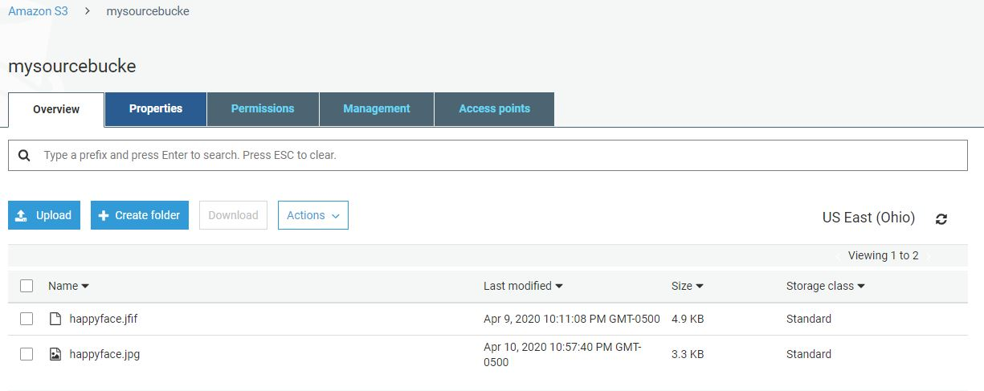

After uploading when we run the test event then resized file is shown in destination bucket with prefix of file as resized and it is 1.3kb and screenshot is attached below.

