**ASE LAB-8 REPORT**

**Lab id: 5_2**

**Sandeep Reddy Salkuti (24)**

**Pranathi Nalluri (22)**

Library management system helps a user to create a book record with some book basic details and if necessary make changes to them and update back to list or delete them from records. All saved data is stored in the mongodb where database is created as test and with collection name as user-data. Below are screenshots attached with descriptions.

1. On launching the application in v s code editor with running commands as node app.js applications runs on specified port 3000 and below page is displayed. Here it shows data of created records earlier and with add button above.

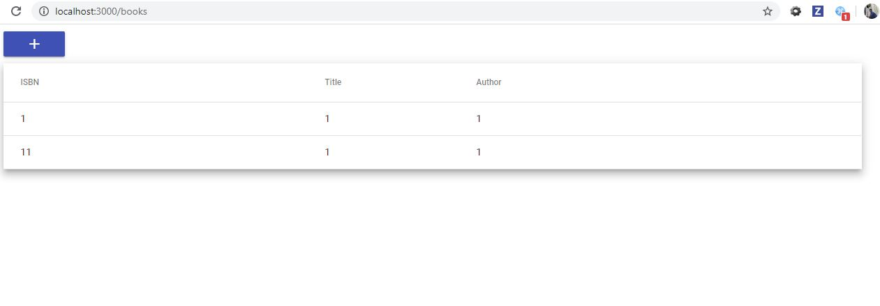

1. On clicking the create button create book page opens and with some fields are displayed and screenshot is attached below.

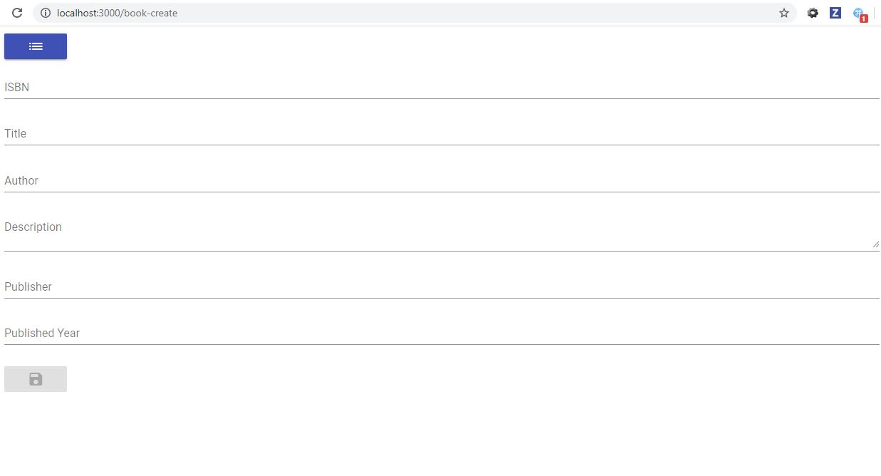

1. If user does not enter all fields validation error message is displayed and save data button is disabled until all conditions are satisfied and screenshot is attached below.

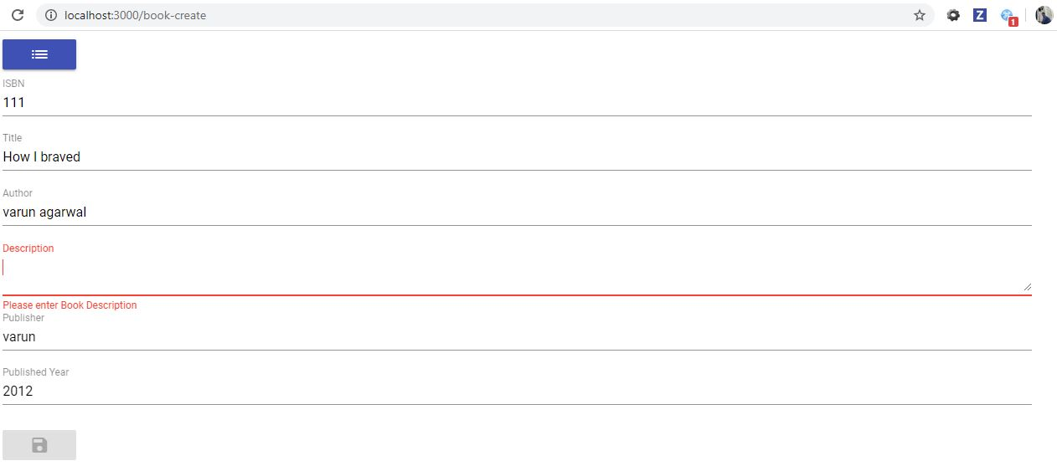

1. Upon clicking save button data is saved as below with title and description values are added as header and some fields are displayed under below. Edit and delete buttons are given below the data, if user needs to edit it takes back to create page with data filled earlier and if data is deleted it shows as deleted on main page and screenshot is attached below.

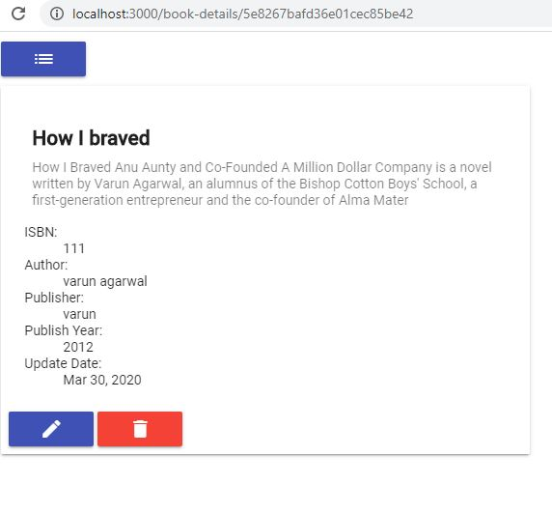

1. The created data is shown in main page as below with additional row added to previous data and three main fields are displayed and screenshot is attached below.

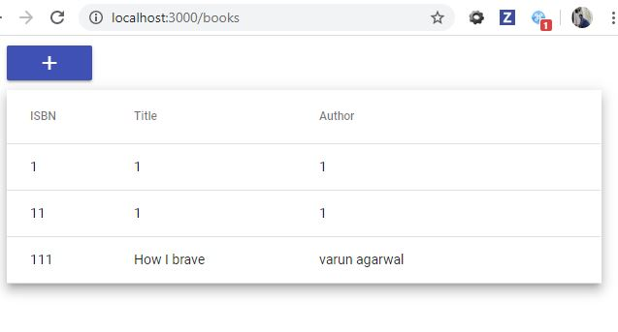

1. If user needs data to get deleted user clicks on the record and edit or delete option is shown to perform operation and screenshot is attached below.

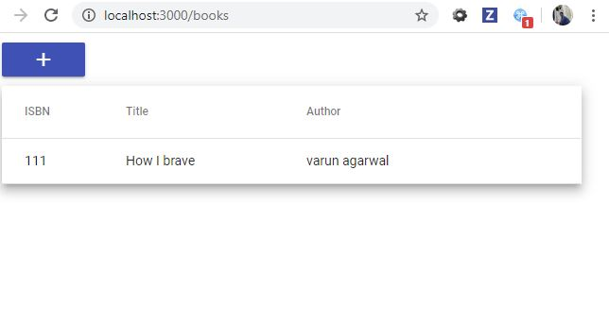

1. Data created is stored in mongodb database where I have created user and used connect string to connect to my application. Then created a database named test with collect named user-data. So whatever data created is stored in database as document collection with key-value pair database is updated instantly upon actions and screenshot is attached below.

