**ASE LAB-7**

**labid: 5_2 SandeepReddySalkuti(24)**

**Pranathi Nalluri (22)**

**HOW TO DEPLOY NODE.JS APP ON AWS EC2 SERVER**

NodeJs is javascript runtime environment which is used to build scalable network applications where it is perfectly used for applications which run on multiple devices.AWS EC2 provides user to access virtual machine to deploy their application on server by calling instance. Through this instance they can launch or create or terminate server instances whenever needed .

We basically follow seven steps to complete this process.

1. Create an account on Amazon Web services
2. Launch an EC2 instance
3. Allow SSH into our instance
4. Installing Nodejs on vm
5. Install Git and Clone any github repository
6. Start the nodejs application
7. Make app running using pm2
8. **Create an account on Amazon Web services:**

Register account on AWS and login into AWS console below is the screenshot shown.

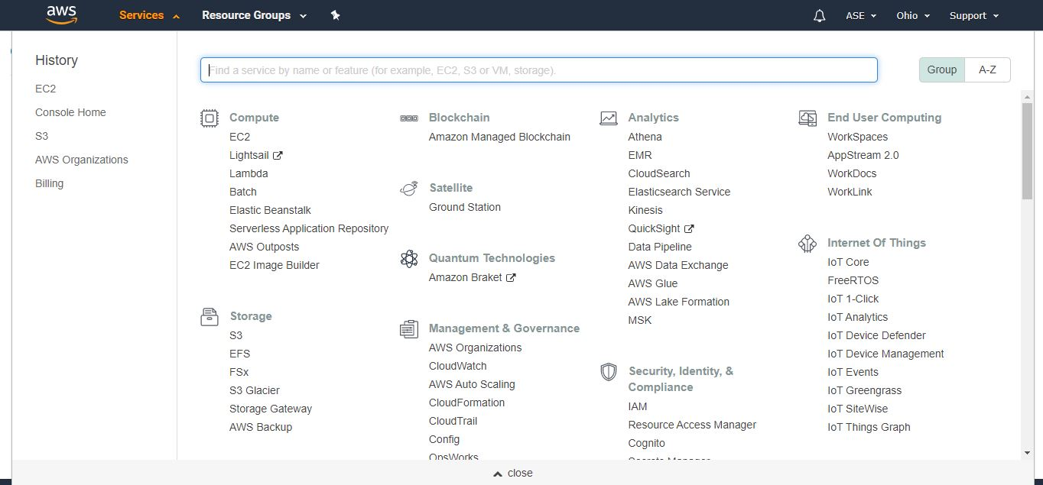

1. **Launch an EC2 instance:**

Once you login to application under services click EC2 which takes to EC2 dashboard and launch instance there.

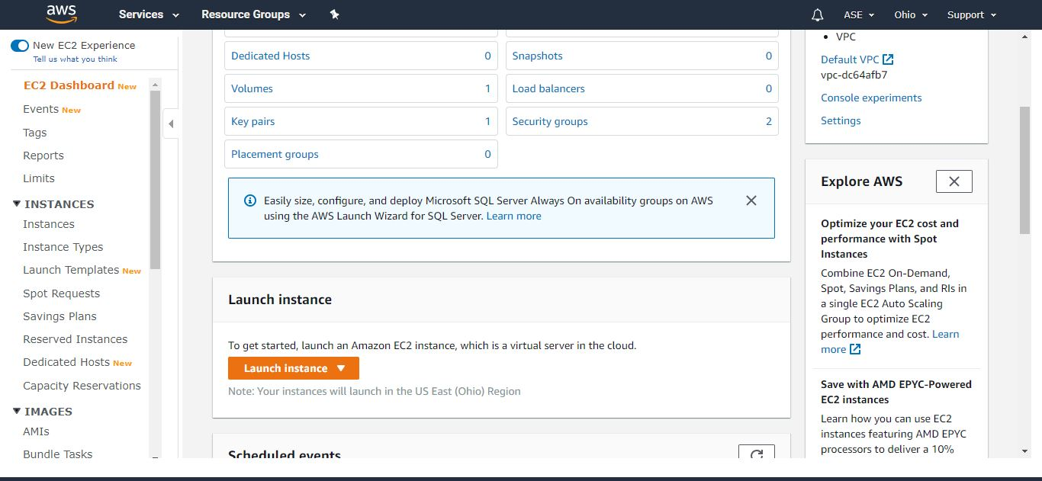

After launching instance select ubuntu server which prompts to choose instance further where select general purpose and free tier eligible type and configure instance details.

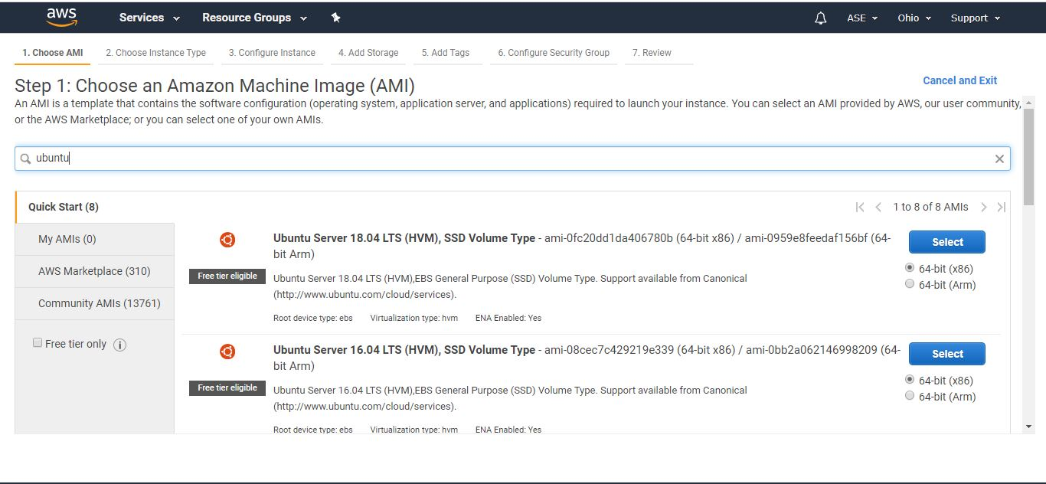

Process those seven steps like go next next click add tags and give key as server name and value as some value to it and click configure security group.

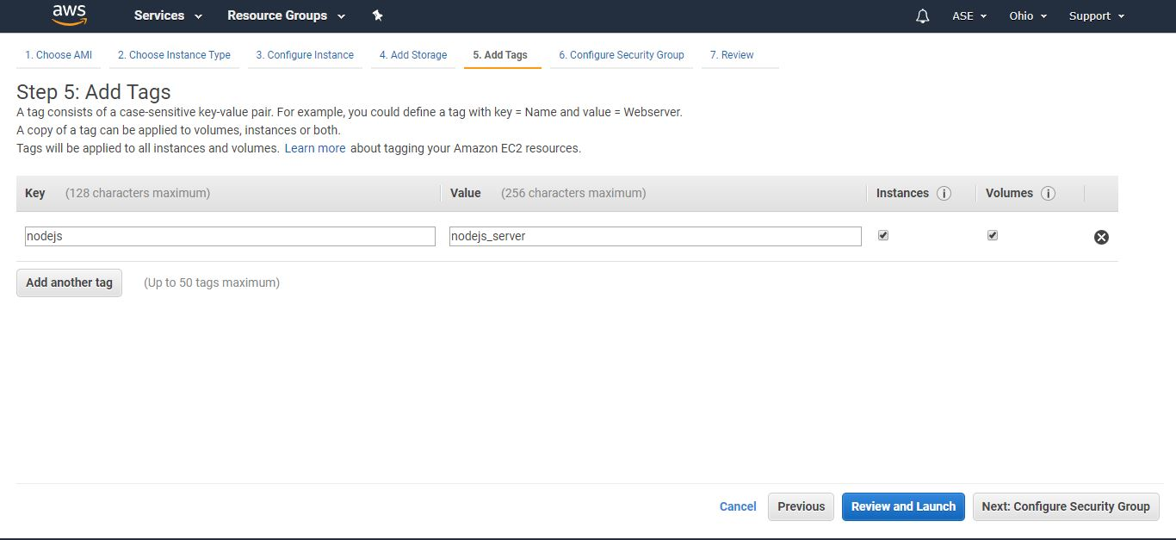

Configure some security groups like add some port numbers 80, 443 etc. and save them.

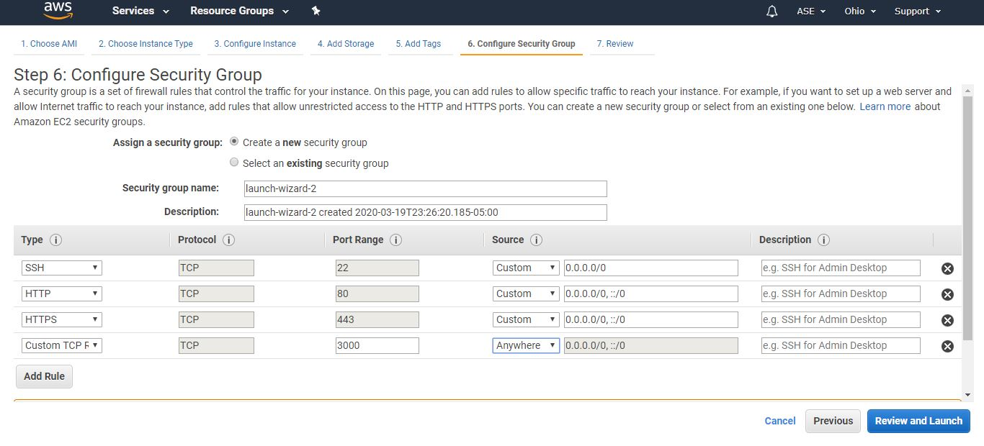

Then click launch where it asks for choosing existing key pair or create new one. Create new pair and download that key pair it will be downloaded as .pem file where we need to change .pem to .ppk file as I am windows user.

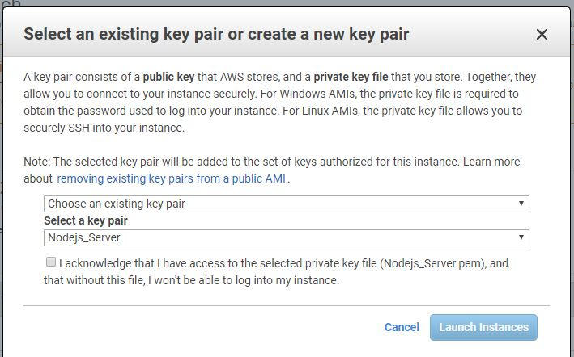

1. **Allow SSH into our instance:**

For format change we need to install putty and start puttygen where we load our .pem file where it asks to save privatekey and save the options the file generated is .ppk key file.

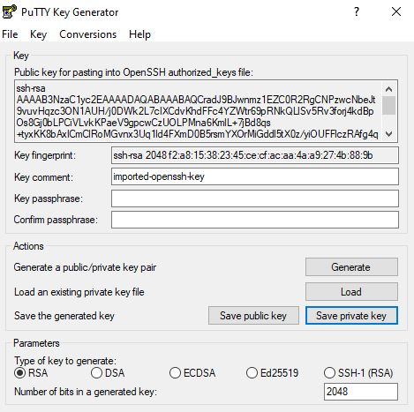

Now go to our instance created and click connect button it opens popup this shows that we are connected with EC2 remote server.

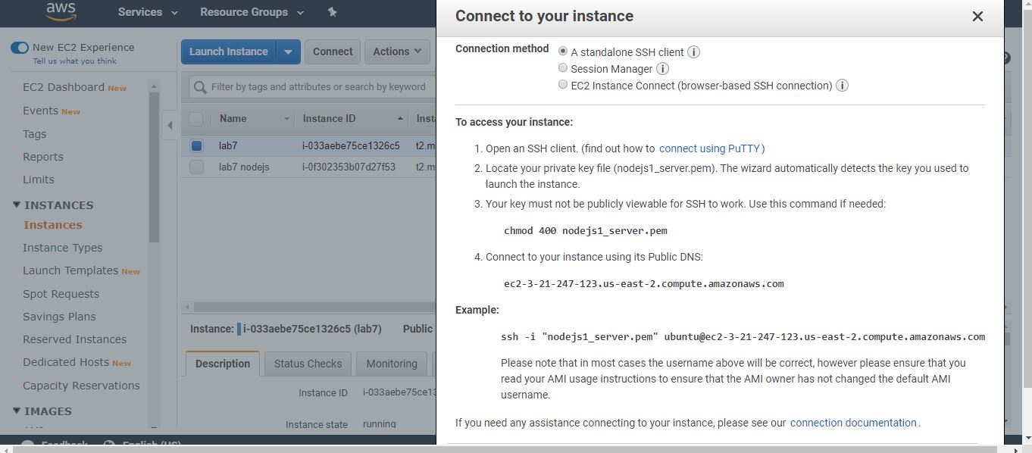

Next we open putty and connect to hostname we received from instances and in auth tab browse key we saved earlier and open it where it launches ubuntu vm.

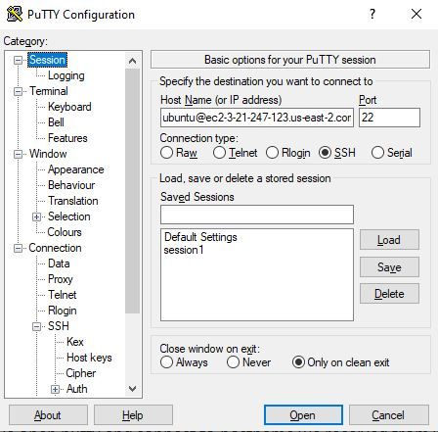

1. **Installing Nodejs on vm:**

Now as we are connected we are installing required packages in environment to make our nodejs app work. For installing we use following command for ubuntu.

# Using Ubuntu

curl -sL https://deb.nodesource.com/setup_12.x | sudo -E bash -

sudo apt-get install -y nodejs

After installing check node version as node –v screenshot is attached below

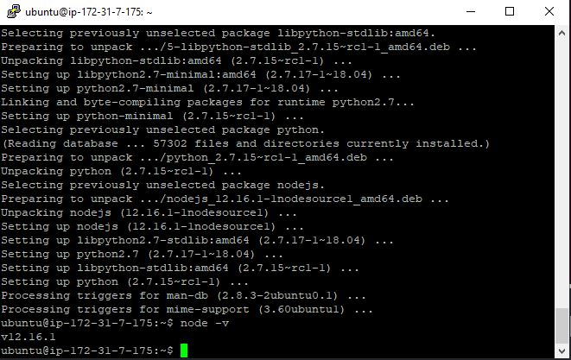

1. **Install Git and Clone any github repository :**

Now after installation install git using command **sudo apt-get install git** and clone repository from github git clone <https://github.com/johnpapa/node-hello.git> 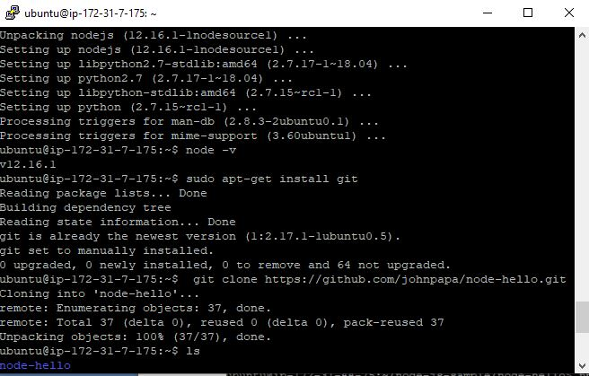

1. **Start the nodejs application:**

Now install npm and run nodejs application go to the file using ls and find out root file to run application and run as node index.js it shows that application is running on some server.

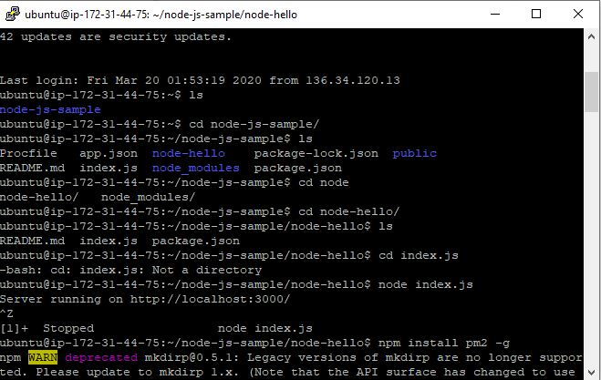

Now go to the instances page and copy the ipv4 public key under our instance created and paste in google url space and append server localhost port received from above and run it says page cannot be loaded. So edit inbound rules by going to security group and add the port number.

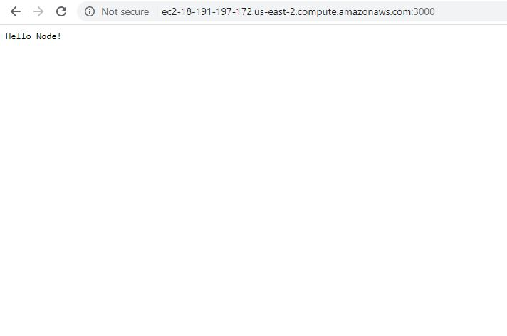

**7)Make app running using pm2:**

Keep app running using pm2. Run below commands

Npm install pm2 –g

Sudo pm2 start index.js

Even after closing of terminal it runs without loading all commands just load session in putty

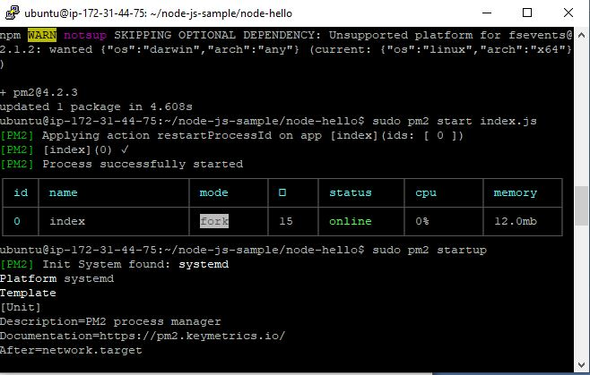

GITHUB LINK: <https://github.com/sandeepsalkuti/lab7>