1. This is the front page of the static web page I have created with HTML, CSS, BOOTSTRAP with no functionalities added. This page is my personal blog which includes posts posted by me related to computer information mostly.

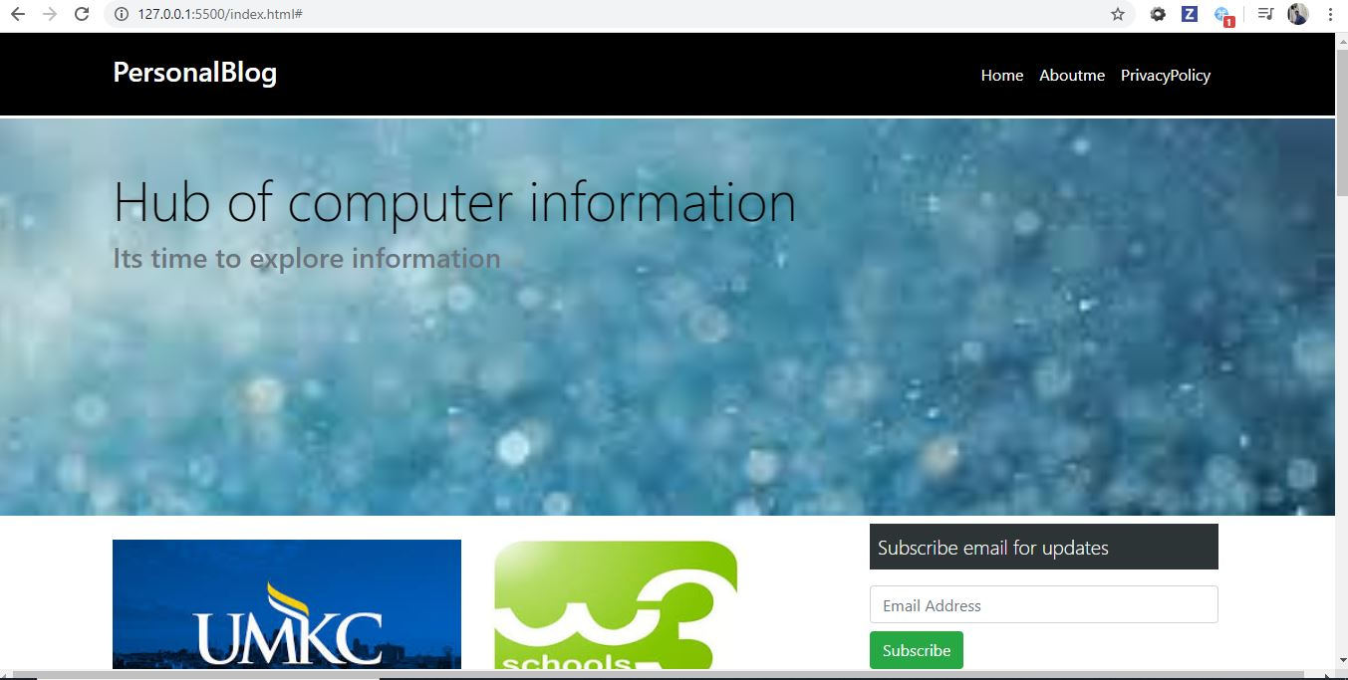

2) In this part of page I added subscribe email part at side bar along with some social where we can connect and my personal twitter given to connect and some posts related to online tutorials and universities information are given in container at left side.

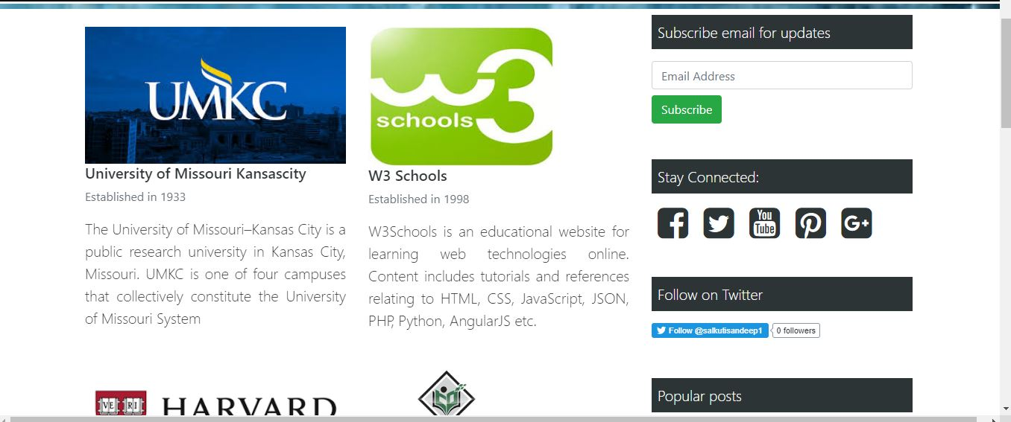

1. This part is added at bottom of some posts posted which includes you tube video this plays within page and below that added pagination concept where current page is shown and active and other pages can be navigated from here.

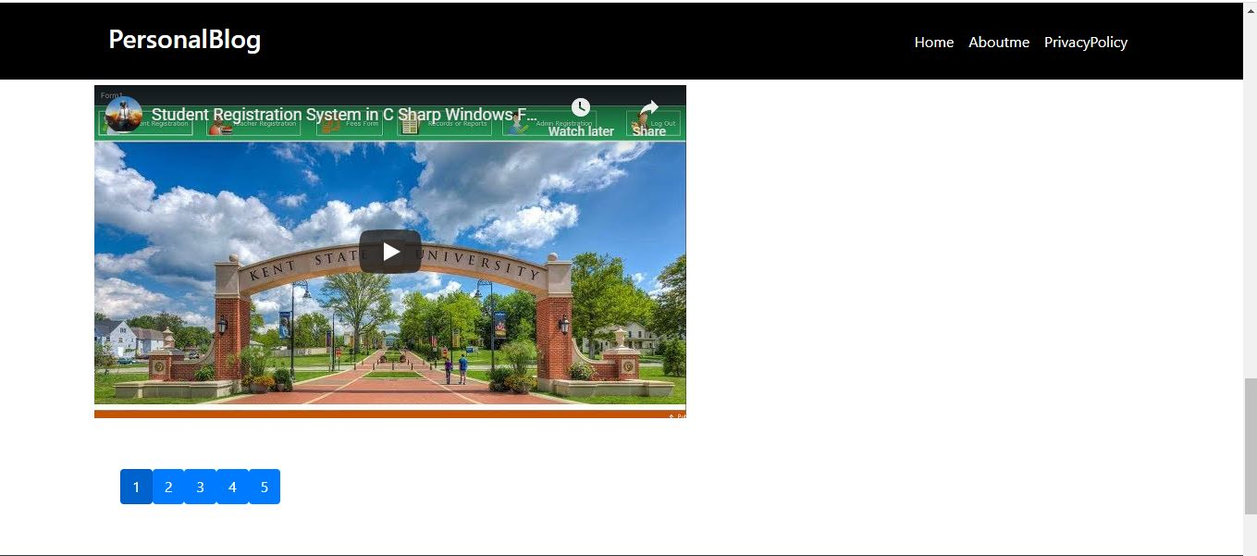

1. This is the footer page with including details like About me and some recent posts along with request of following us on different social media.

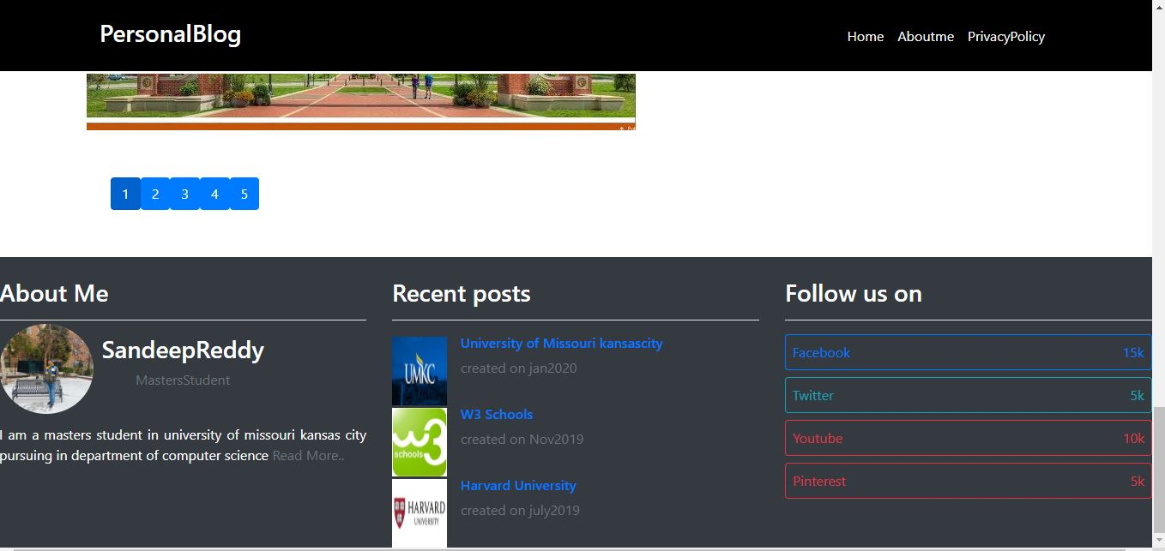

Hosting Static app on AWS S3 bucket:

1) Created account on AWS and used S3 storage to host my application public.

2) Created bucket and uploaded my files there.

3) Edited policy editor to make public and after that hosted to static website hosting and saved it.

4) After successful adding copied below endpoint.

  http://aselab.s3-website.us-east-2.amazonaws.com