First four lectures

Date: 24-04-2025 Lecture 1
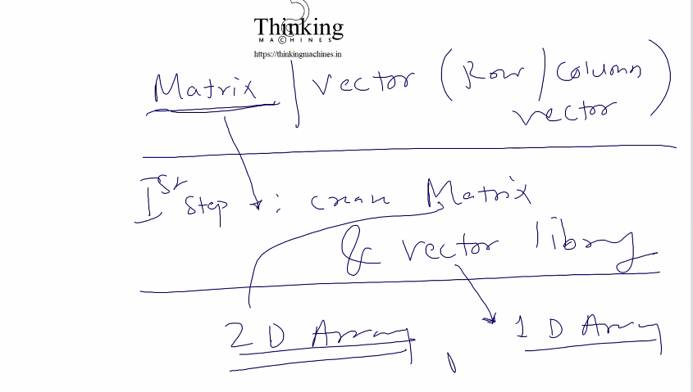
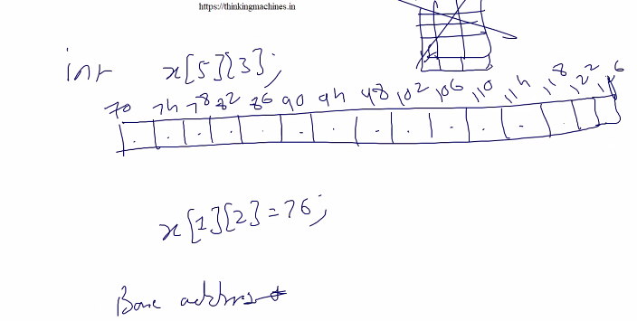
Data k liye matrix and vector library banana and we go for dynamic array

Read theory of address calculation and read row major and column major
no. of column is very imp to reach to a row , har row kitne column he ye imp he janna., to take jumps.
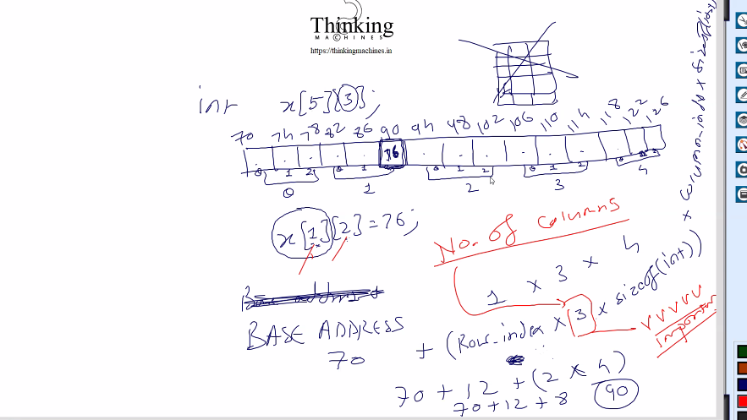

Next ek function bnayege jiske parameter base add & no. of columns
Problem 1: C me Esa function likhna possible nahi he jo kisi bhi size k array ka base address accept kr ske.
e.g. :- void func(int arr[][]); // it will give compile time error
void func(int arr[3][5]); & void func(int arr[][5], int rows); this both will compile.
Because C needs the number of columns at compile time to compute memory offsets.
It stores arrays in row-major order, and does pointer arithmetic like:
*(arr + i * columns + j)
See details execution of above: say arr[1][2]
For i = 1, j = 2, columns = 3:

Step 1: Calculate offset
i * columns + j = 1 * 3 + 2 = 5

Step 2: Pointer arithmetic
arr + 5 // Move 5 integers ahead from base address

Step 3: Dereference
*(arr + 5) // Fetch value at that memory location

Ye arithmetic humko likhna pdega function bnane wale ko coz he can’t use syntax
K[r]c] .

Answer to Problem 1:
- Write function like this : void print(int *arr, int rows, int cols)
Take base address and do calculation
for (int i = 0; i < rows; i++) {
for (int j = 0; j < cols; j++) {
printf("%d ", *(arr + i * cols + j)); // manual 2D access
}
printf("\n");
}
Note: You cannot do base[r][c] because base is a pointer to int, not a 2D array.
C interprets base[r][c] as:
*(*(base + r) + c)
But base is just an int *, not a pointer to pointer (int **), and not a 2D array. So:
*(base + r) gives you an int, not an array, That causes undefined behavior or compiler error

- Write function like this : this is for any type
void print2D(void *base, int rows, int cols, int size)
char *ptr = (char *)base; // cast to char* for byte-wise pointer arithmetic
for (int i = 0; i < rows; i++) {
for (int j = 0; j < cols; j++) {
int *elem = (int *)(ptr + (i * cols + j) * size); this is actual calculation for generic
printf("%d ", *elem); // change cast depending on data type
}

See if user pass double type then how it will works
(char *)base will replace as (char *)dptr | Treat memory of double * as raw bytes

cptr[i] | Access individual byte i of the double

sizeof(double) | Usually 8 bytes (i.e., 8 elements in total)
Expression | Meaning |  | Works if...
base[r][c] |  | *(*(base + r) + c) |  | base is 2D array or int**

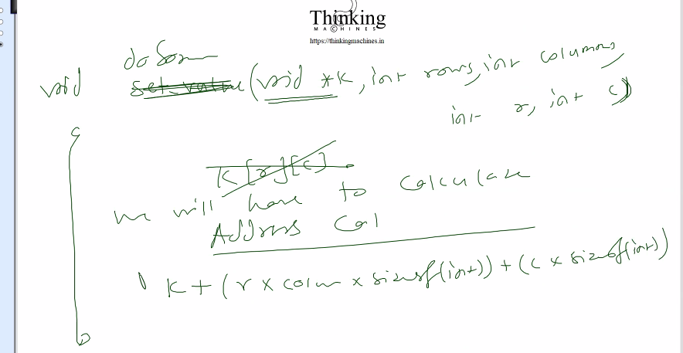

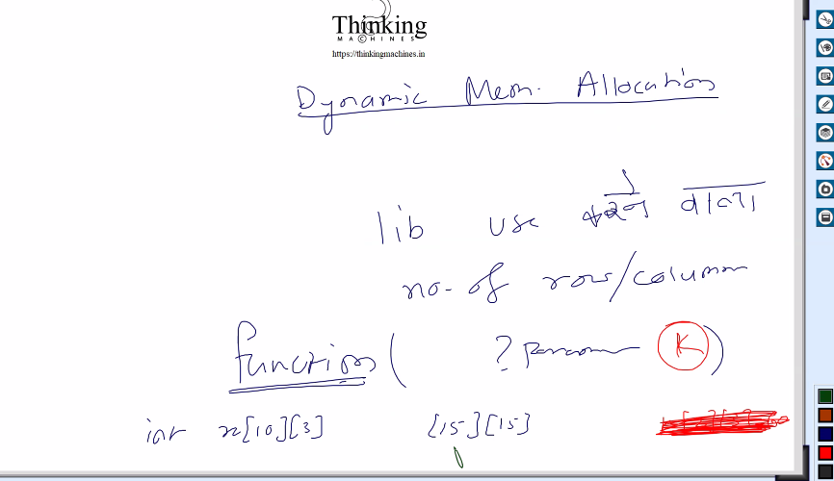

Problem 2: Array k case me segmentation fault 999.9% out of bound k case me aata he kyuki c me bound checking nahi hoti he. Other lang me exception bna diya.
e.g. user k[][] me kuch bhi pass kr skta he , kuch bhi index like k[09099][989]
Answer 2: segmentation fault na aaye uske liye kya kre: Array wale ds ko encapsulate kr dege and ek structure me. Ab user ko array access krne k liye humare function k through jana hoga
But ab is case me user k[][] is syntax ka use nahi kr payega to manipulate the array.
C me encapsulate krna means : library ka user structure k member ko access na kr paye.
Agar ye syntax k[][] use krwana he to phir CPP me operator overloading kr k krwa do.
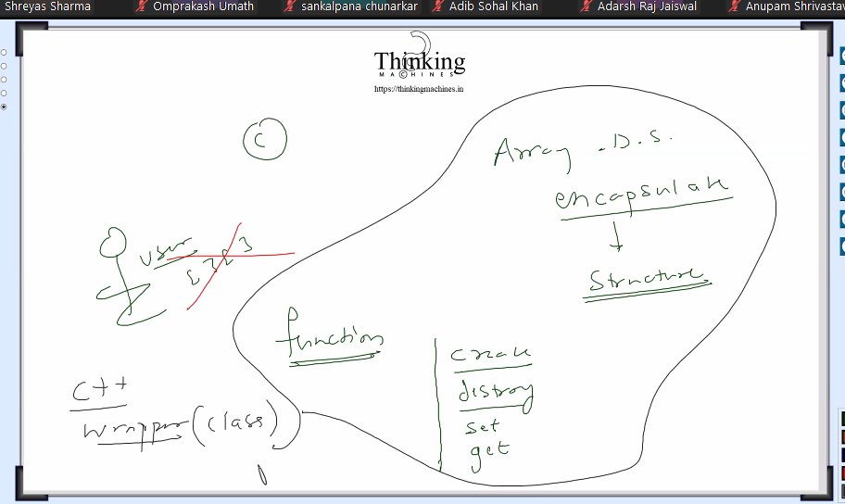 Java me to object rhta he to length nikali jaa skti he.

Dynamic memory allocation: memory leak issue will not occur if we free the memory dhyan se.
Chalo encapsulation wala code: structure me row and column rkhe taki bound check kr ske.

Pointer can be used as an array to access the elements ,coz vo address calculation ki theory see the below example
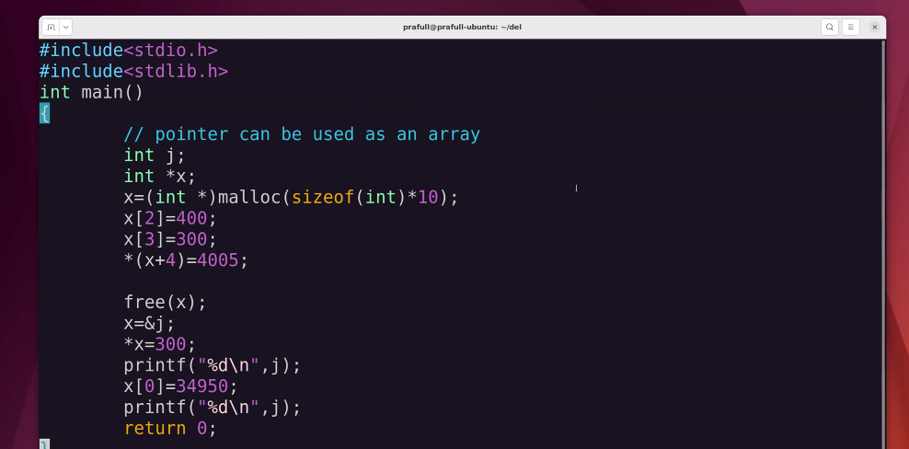
Above example me segmatation fault aa skta he x[1] likhege to .
Segmetation fault is undefined behavior we can see with nelow example:

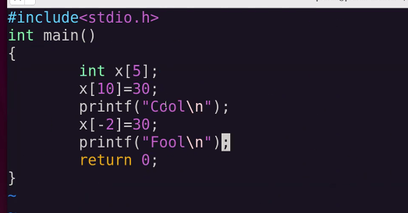
Cool bhi print hua fool bhi print hua means application crash nahi hui .
X[10] and x[-2] are out of bound pr phir bhi app crash nahi hui , jbki honi thi, to this is called undefined behavior.
***************************

5* 6
5 block k ek array jisme har element int * type k block ka address.
Har k against ek 6 ka array
X Is pointer to array of pointers of type int of length 5
And each element of that array of length 5 will point to block of and array of int. of length 6 each
Means each element hold base address of that actual array that represent row.

Let see code: ye code sb kachre ke dibbe me jayega , it is just to develop the bas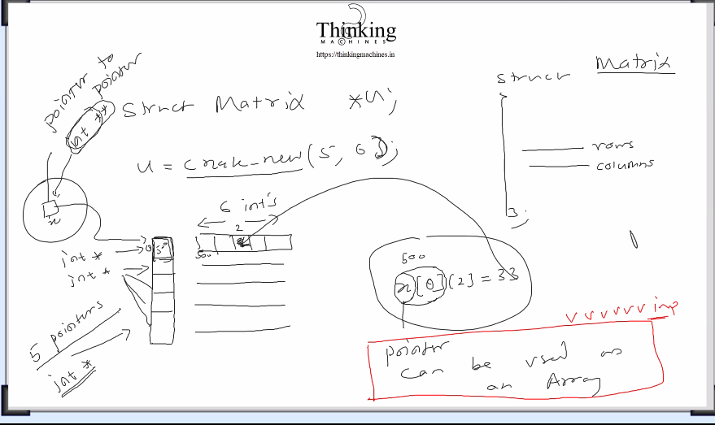ics

Struct matrix se ek structure bnaya and uska address m ko assign kiya.

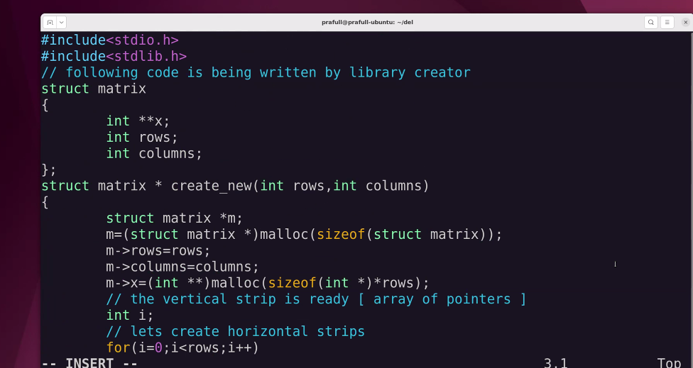
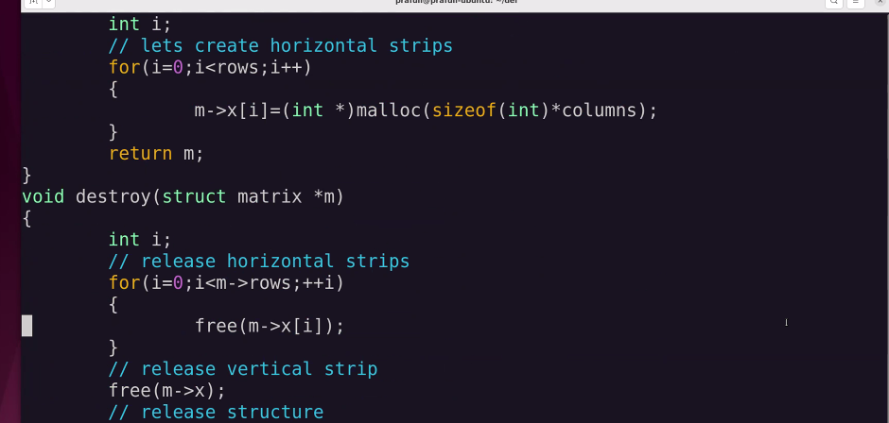
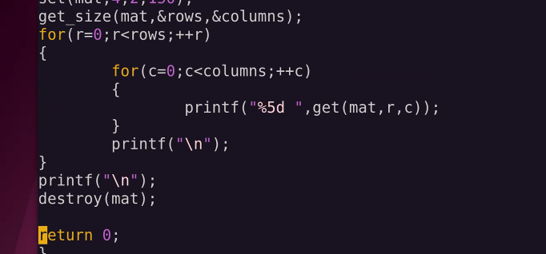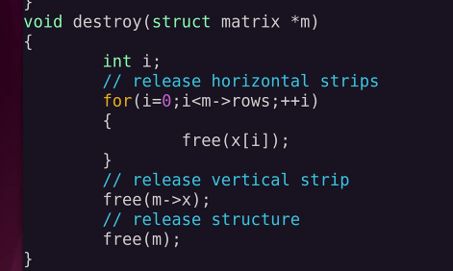

Struct matrix k; esa likhege to local structure create hoga and function khtam hote hi iski death ho jayegi.
Struct matrix *k= malloc()//something; esa likhege to dynamic structure create hoga and function khtam hote hi k ki death ho jayegi but k jisko point kr raha he uski nahi. Usko free(k) krna pdega

Issue: we did for int similarly we have to write for double , char and each type .
Cpp me template use kr skte the. But c me kya kre.

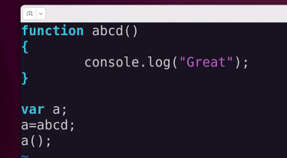
Internally abcd ek pointer he not a function name.
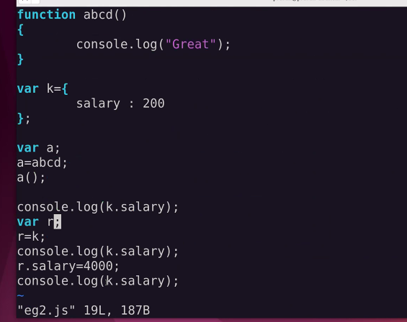
Here k and r are pointers to object or function.
Named structure and named object ka tarika bnd , sara khel pointers ka he. Nameless objects.

Date: 4/24 2026 lecture 2
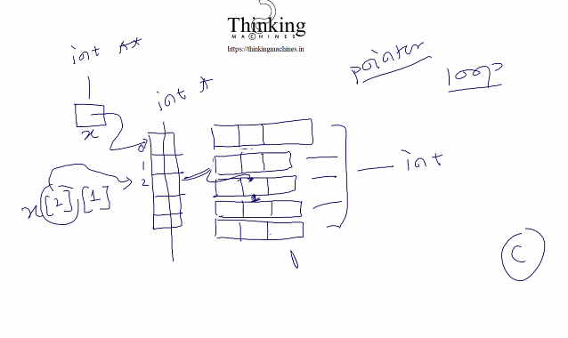
Abhi tk. Ye design dekha ab dusra design dekhte he. Jisme double [][] use nahi krega library likhne wala.
Ab ye library bnana 1 month lgega
C and python speed difference 4 guna .
Copilot plugin hata do to watt lg jayegi.
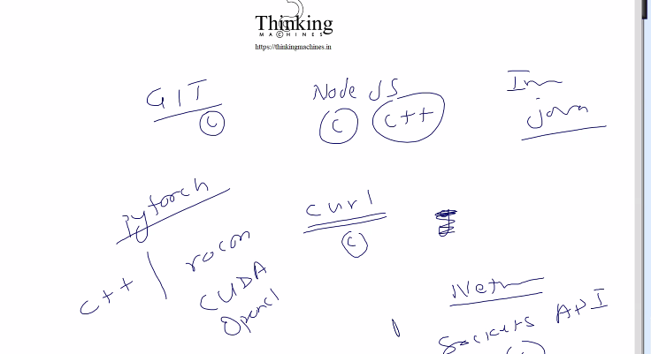

Socket api json me bnna chalu ho gaya coz c k developer nahi mil paa rahe he.nahi to socket api pura c me hi chala aa raha he kisi ki himmat nahi hui bdlne ki.
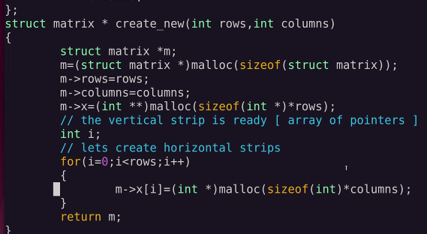
Ye cpp me likhege to logic kuch nahi bdlega. Wording change ho jayega like malloc ki new.

Ye c me difficult he[c me 8 line me krna pdega] , cpp me easy ho jayega[class user ek line me likh skta he]
Architects bchege , achhe design and prompts, baki sara workforce khtm. : architect mtlb design bnane wala , jese humne 2d array representation k 2 design dekhe , ek to k[][] wala, and ek k[]
Means puri 2d ko single patti me ye niche wala idea.
Means ye designs architect ne hi bnayi he, and har ek ka ek alag fayda he.

Next idea: 5*4 ka matix chahiye to continuity me 0-19 ki jagah allocate kr li jaye.
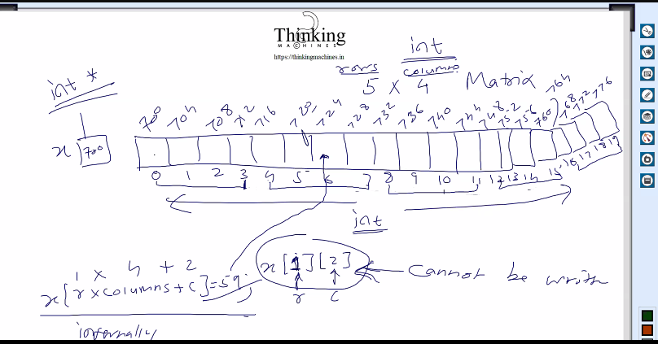
Ye naya formula. arr[i*columns +c] and it is similar to *(arr + i*columms +j)
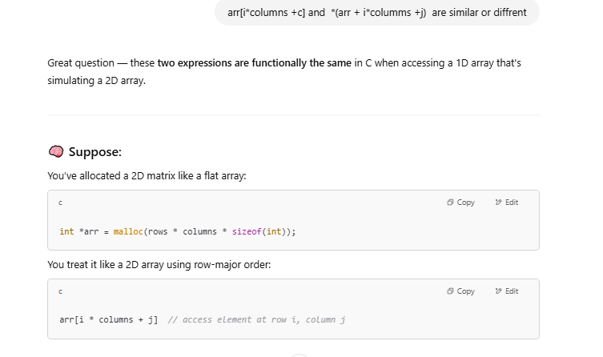
Array of pointers ka kaam khtam. Vo nahi lena pdega.
Is formula se r and c ko single index me map kr diya. Means 2d ka koi kaam nahi
Abhi bhi user and developer x[1][2] nahi likh payega.
Ssh ka pura kaam c ka he vo virtual machines ka.
Ab jo krne wale he usme main() change nahi hoga.
free(m) : Achha free ko to bs base address dete he and length to dete nahi phir vo kese saare element delete krta he?
Ans:while allocating , malloc() kuch to store krta he uske bharose freee vo puri memory release krta he.
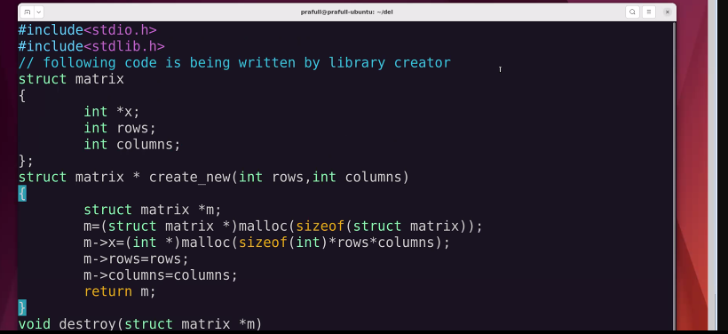
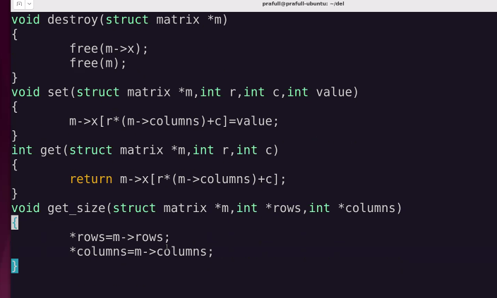
C me koi function ek se jyada value return nahi krta and humko multiple value return krwana to uske liye jisme value chahiye unke addresses pahuchao function us address wali memory me result update kr dega.
Main vahi purana wala.

Ab segmentation fault:
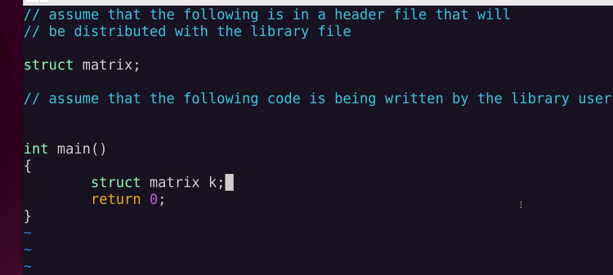
Above Code compile nahi hoga, but k k liye kese memory allocate ki jaye , kyunki structure ka definition hi nahi he.
e.g. int x likha to x ko 4 byte allocate kr dege kyuki int ki definition k according int 4 byte ka hota he.
But matrix k to isme k ko kitni memory assign ki jaye kyuki ki data type matrix ki definition to kahi he nahi. Bs declaration he.
See below error : vo bol raha he size of k in unknown
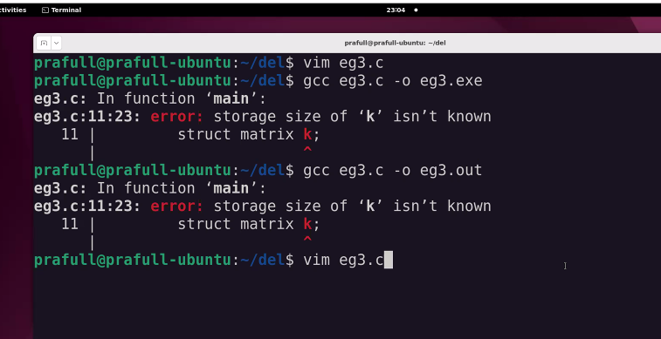
Saamne wala esa likh k structure create kr hi nahi payega. Compile error aayega.
Esa likh skta he : esa is liye likh skta he coz pointer ka size fix hota he 4 byte vo kisi bhi type ka ho to ko is pointer to isko 4 byte allocate ho jayega.
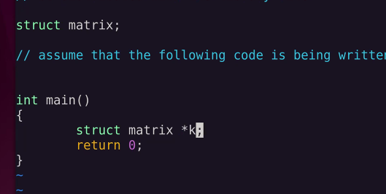
Header file me data type likh diya(declare kr diya) and definition kahi or , to us header file ka use krne wala pointer bna skta he but structure nahi bna payega;
And developer vo definition compile time pr available krwa dega.
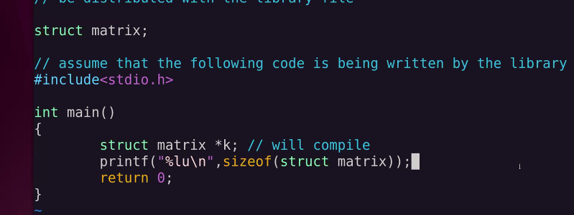
Structure nahi bn skta pr pointer bna skta he. Yadi structure ko define kr k chhod diya jaye.
So this way we can encapsulate the members of structure.: means user will not decide how much memory to be allocated to structure , only developer has right to allocate the memory in case via a function like create _structure() it will return the address of created structure and the user can hold the address in pointer defined by him.
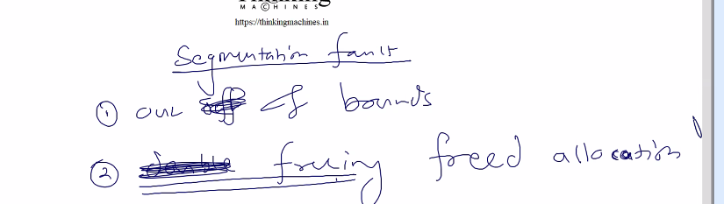
Memory leak se crash nahi hogi but freeing the freed allocation is very riskiy ye galti lib user krega.
Seee: let see mat ki value 700 jo ki kisi memory ka address he to us address pr jaa k memory free ho jayegi ab again destroy(mat) , stil mat ki value 700 means kisi memory location ka address , but is baar vo location to he hi nahi to kya destroy krega.
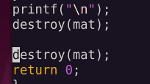
how to fix this: memory free krne k baad mat ki value bhi null kr do inside destroy function but
Mat nahi jaa raha he , mat ki value jaa rahi he , but humko ko mat ka bhi address chahiye
Means mat ka address + mat jisko point kr raha he uska address means mat ki value.
Means mat ki value and uska address dono chahiye.
Mat = 700;
700 pr jo pada usko maar diya, but mat me to abhi bhi 700 pda he.
Mat= null to nahi ho skta;
To mat ko khali kese kre , mat ka address paas kro destroy ko.
Let see the logic: library creater macro define krega , macro means internal definition change.
Means user likhe sam(x) and internally vo kuch esa ho jaye sam(&x) to humara kaam ho jayega.
See ki macro are compile time or run time.
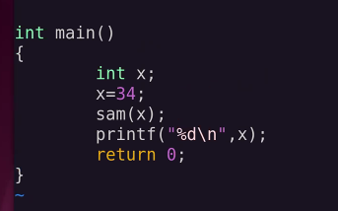
Isme guarantee k sath x ki value 34 rahegi.

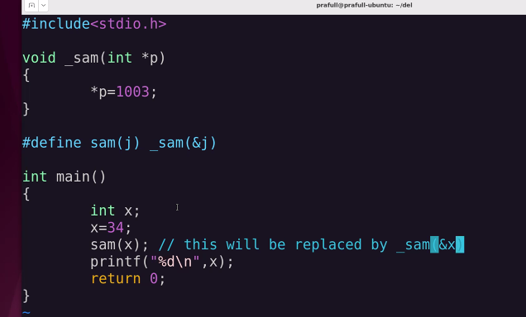
Ye macro define kiya function ka.
Cpp me param k sath & lga de to alias bn jayega but vo hi c me krne k liye macro ka use kr skte he
Ye bahut deep he iska use hr kahi nahi krna nahi to logo k dimag khrab ho jayege.
Read the topic macro in c and their uses;
m me mat name k variable ka add aayega;
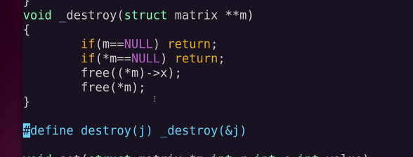
Macro kahi pr bhi define kr skte he
Abhi bhi compile nahi hoga.
Galti *m= null nahi likha
Final code:
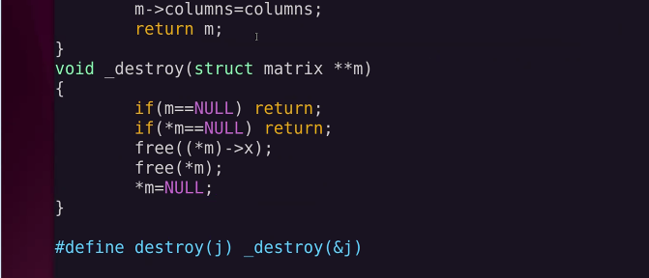
destroy ka macro bna diya.

Ab konsa trick use kre, [][] wala ya [] wala: ye do design architect ne diye he.
But symatry wale case me ye kaam aayega, asymmetric me nahi.
Template compile nahi hota, source code dena pdega. Kyuki type known nahi he.
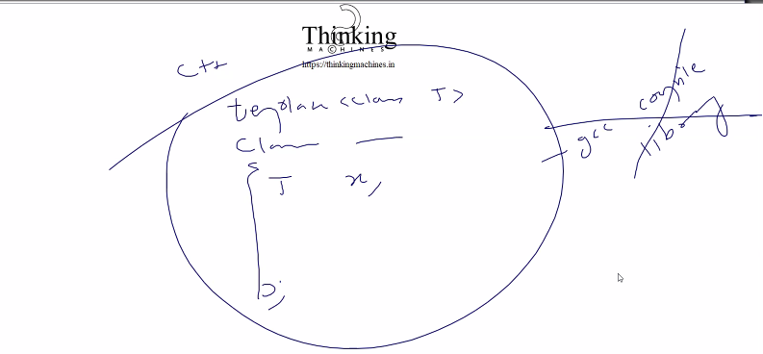
Run time pr vo khud class create kr k usko compile kr k use krega.

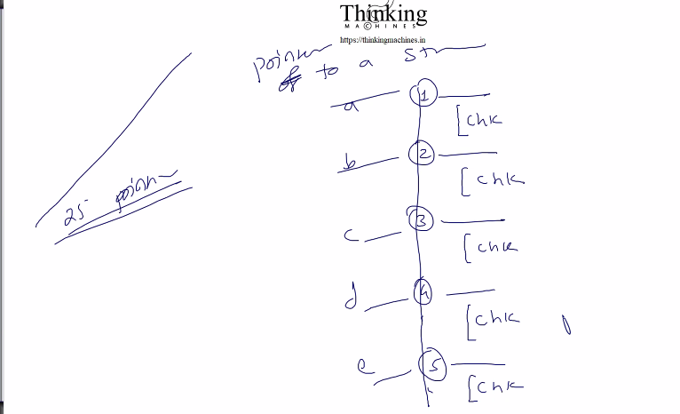
How to free before wale , iske liye goto ka use kr ke end me saari mem
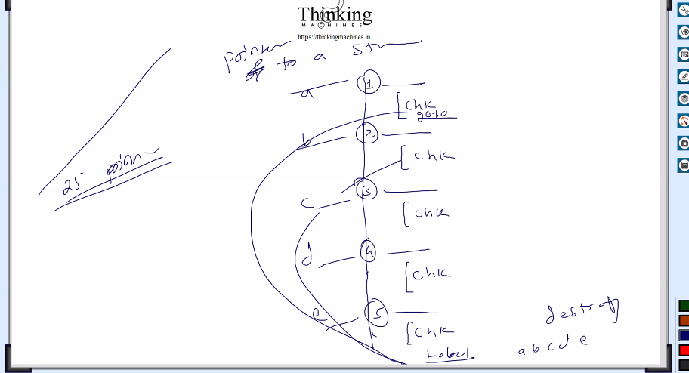
Date: 26-04-2025
2nd way
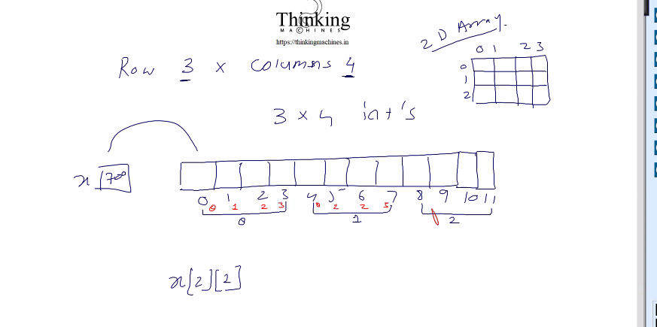

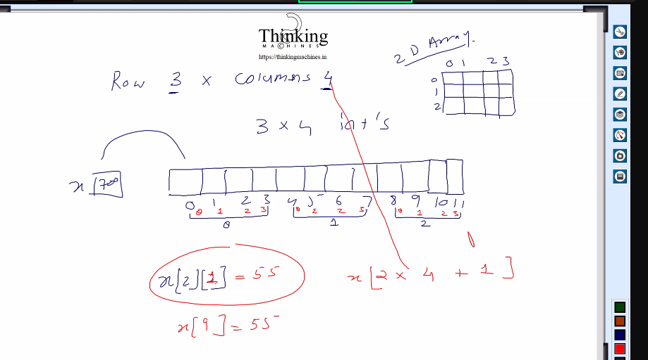

ML ki Team me ghusne dege ki nahi: if nahi why
Who decide to get into that team : resource manager,
New comp me sidhe ml ki team me ghus skte he but withing company not possible

Bahut
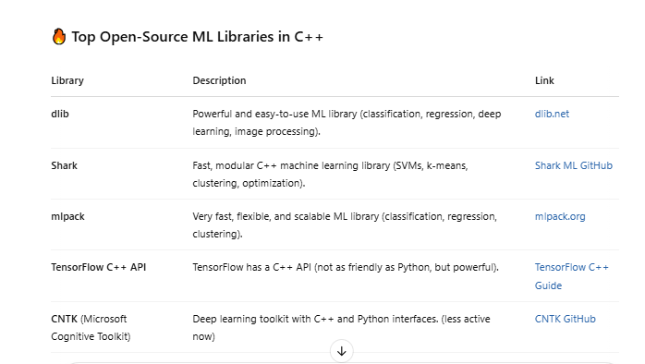
Inme contribution kr skte he: in projects me contribute kr skte he
Khud ka server and khud site to us pr khud ki site host kr skte he.
Is pr presentation dege
Git pr kr skte he: but limited
Khud k server pr kuch bhi kr skte he.
3-4 saal lgege

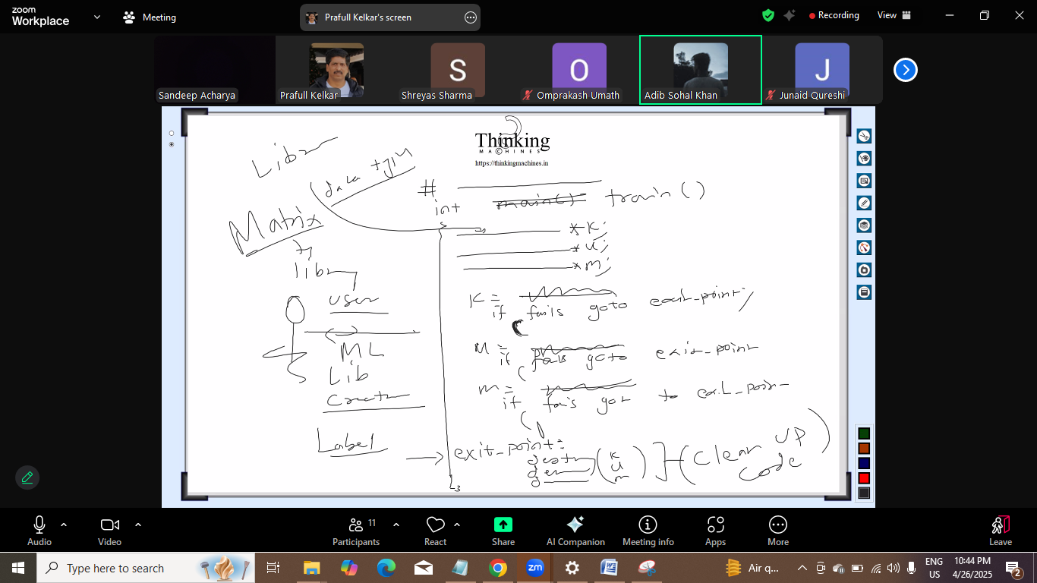
Isme kya problem aa skti he: segmentation fault aayega
Kese:
K ko m ko u ko function jo lotayega vo assign hoga
If k pr fail hua and and u and k ko destroy ki koshish kri at end by skipping m and u
U ki value garbage rahegi , to kya kre
Ans: null assign krna pdega ,
Read garbage collection
2 tarike:
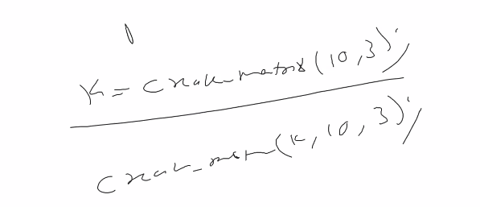


Ya to esa likh de declare(k) and uski vajah se pointer declare kr k usko null assign ho jaye to usme null daal do. Pr ye accha nahi lgega.
Jb bhi pointer declare krege usi time pr usko assign krna he esa rule likhega
By default pointer ki value garbage he and garbage ko destroy krne ki try krege to seg fault aayega
Pichli baar double destroy wali baat this usko macro se solve kiya tha.
User ko inform kr dege ki pointer declare k time pr kuch assign krna he ya to function call ya null.
Function fail hoga to vo null return krega
Java me garbage me garbage ka koi rule nahi vaha code compile nahi hoga agr kisi bhi path pr value assign nahi kri to

Errror hadling k liye kya kre kyuki exception handling is not available in c.
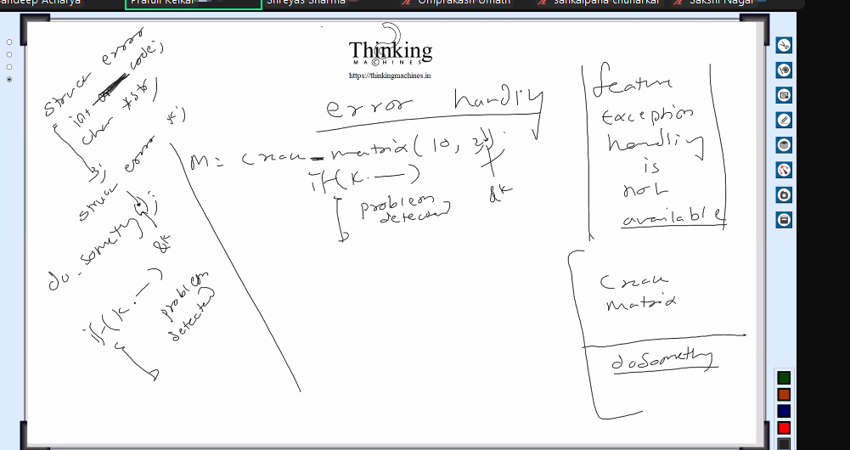
Approach creatematrix ko struct ka ref pass krege.
Har function me last argument error struct ka address pass krege.
Har function me paas kr rahe to consistency , but 6 me paas 8 me nahi to dikkhar ya 6 me koi or sequence and 8 me koi or
Or solution: library create krne wala global struct ka point le le , is case me ye extra argument pass nahi krna pdega.
Kuch macros he jisse function ka name and konse line pr error aayi ye pta chl jayega, logging to krega.
Vo error wale structure me function bnayege to end user , like hasError() ye library creater krega.
Agar multhreading aa jayegi to watt lg jayegi global wale idea ki.
Multithreading: hr thread pr unction load kr dege and vo function usi thread pr chlega
Sol: har thread k liye allow kr do

Paallel programming: ek hi function ka code alag alag processor pr chla raha he.
e.g. ek program har row ka sum compute krna he and ese 5 rows he to 5 processor lgaya
vo thread spericfic wala parallel programming me fail ho jayega
kyuki ml me parallel programming ka hi use he. Like gpu use kna
to finally har function call me structure ka address paas krna pdega.
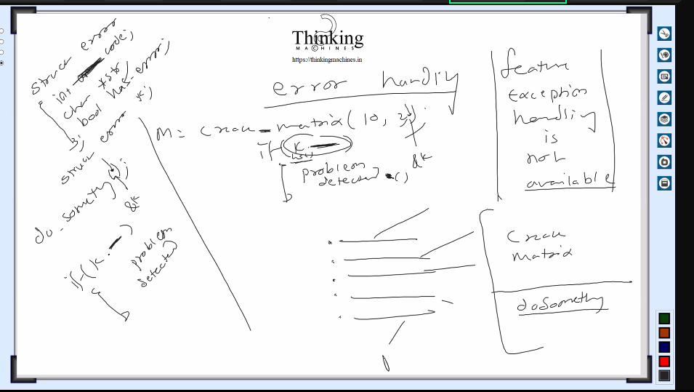
Opencl kuda sb l ibraries parallel programming k liye hi he: gpu utilization for number crunching
Gpu ka full utilization.
Ab user ko us structure k bare me p
Khtre se bchne k liye forword declaration: user struct k structure nahi bna payega vo bs pointer hi bna payega.
Library is tarike se bnana he ki baad me parallel programming ka use kiya jaye to lib user pr uska koi fark na pade.

Way1: complete structure bnao
Way 2: incomplete structre
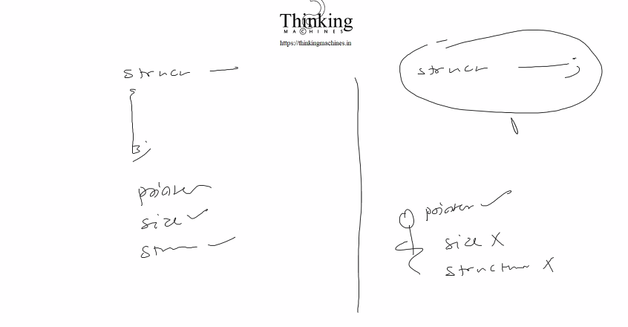
Way 2 ka benefit: in future struct me kuch modification krna pda like int liya in future long int me change krne ki baat aayi to user k code ki waat lg jayegi.
Us naye change k liye naya functionality introduce krege, purani functionality to vahi rahegi , purane ka signature nahi change krege.
Hum naya bnayege and usko document krege.existing ka signature and return type change nahi krege.
Kyuki end user ne to purane function k bharose bahut sari coding kr li hogi.
Like user react a version ka code b version pr nahi chlegi
Incomplete k case me user structure nahi bna payega , bnane ki kkoshish krega to code compile nahi hoga.
Documentation k liye bhi tooll he
Java linux ka documentation upto date and well documented.
So this second is called forward declaration.

Ab vo error wala kaam:
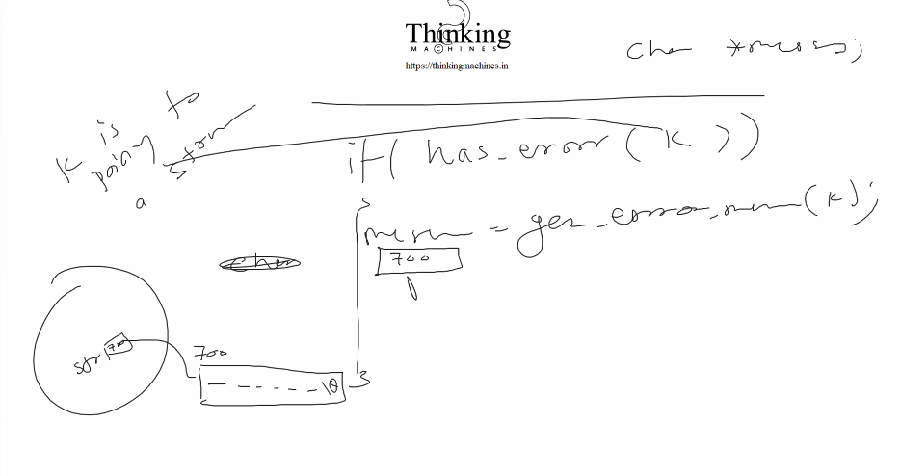
Above code me seg fault ka issue.
Uska solution geterror ka tarika cannge:

Samne wale storage ka address dega and uska size bhi btayega and like usne 10 diya to 9 pr copy kr k 10th pr \0 dal dege.

Mrix creation , error handlning, accessing and setting data.
Error se related,
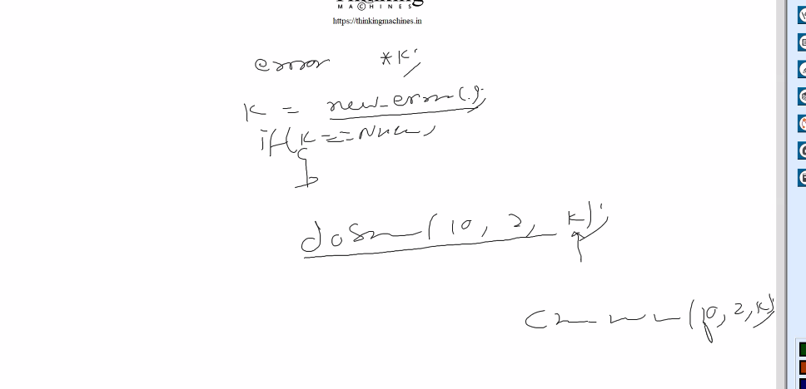
Errror wale function fail ho gaye kya ye determine krne ki jarurat nahi hogi.
To ye last argument vo error wali lib k function k l iye applicable nahi hoga ,
New_error() is also part of our lib.
To user ko btana he document me ki new_error me vo k wala argument pass nahi kre.

But java wala aaj bhi deprication ka message de deta he but purana code bhi naye version pr chlata he.

Date: 4/29
Alag alag data type k liye alag alag struct : is there any common way to do it?
Answer this in next session
Abhi vo error wale ka code implementation : abhi single lib bnayege, bad me mat ki alag and ml ki alag
See folder structure:
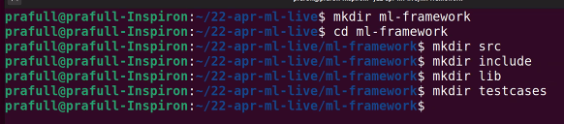

C k liye bhi build system available he, kuch tools he search on web like java k case me gradle and maven.
Include folder me ek folder error
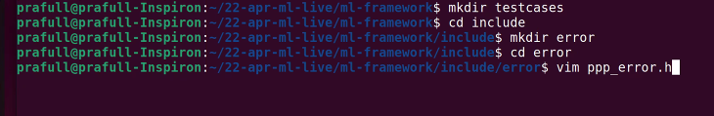
ppp is a prefix , it can be changed. Humko ppp use nahi krna he humara khud ka kuch.
Ye vo header files he jo public k liye available rahegi.

Typesdeg ki vajah se struct ppp_err ki jagah only ppp_errr se kam ho jayega
Struct _ppp_err = ppp_err by using typedef we given another name to struct ppp_err
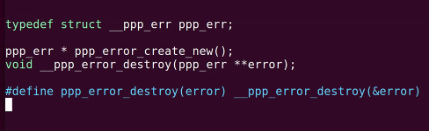
Ye hum structure and unke function declare kr rahe he is header file me
Char 8 bit ka but humko phli bit signed bit na mana jaye to unsigned likh dege uske aage.
Ye esa ye maan k kr rahe he ki humari value negative nahi ho skti
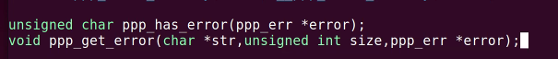
One more to reuse error structure, reset nahi jamega to usko clear_error krege
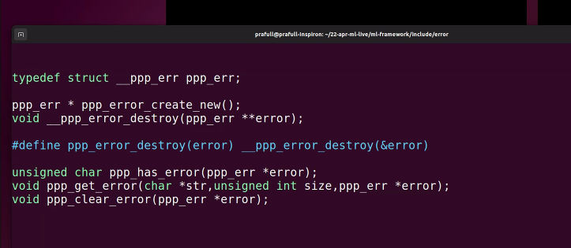

Esa ho skta he:
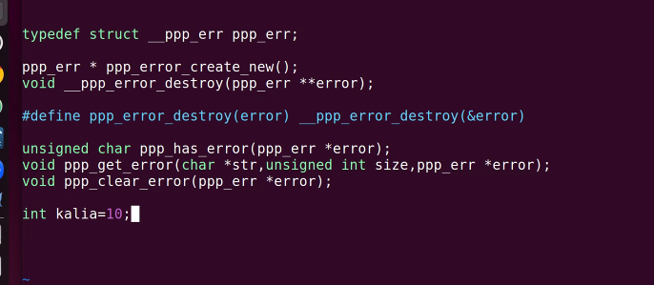
Agar ye header file multiple time include ho gayi to kalia ka redeclaration ho jayega
To is se bchne k liye kya : include guard to avoid double inclusion of header files.
__PPP is pre
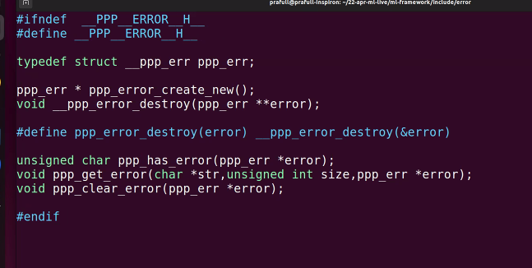

Final code
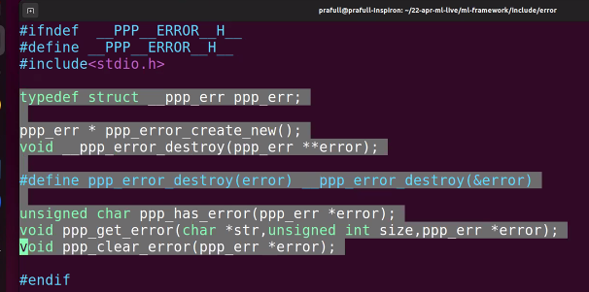

Ab mann lo user multiple header file include na kre alag se and only single file include kre
To uske liye hum ek single header file bnayege and usme saari header file include kr dege
Like this
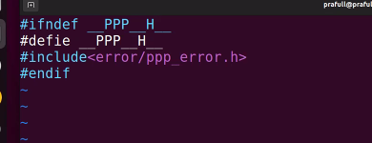

Folder structure:
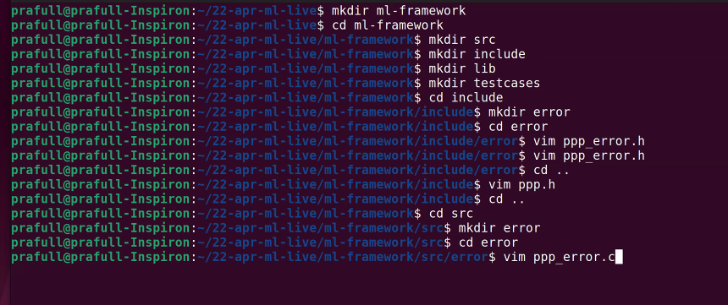

Now one by one define krte he:
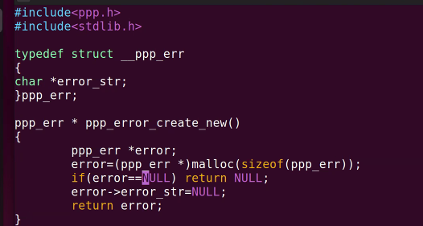
We are not exposing name error_str to user it is only for library creater.

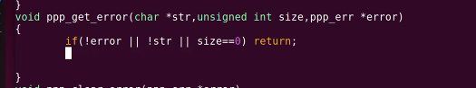
Isme kya error: empty string k liye kya ?
Note: jaha >=0 wala code likhna he waha ye unsigned wala issue kr skta he
++i prefix is faster than i++ postfix.

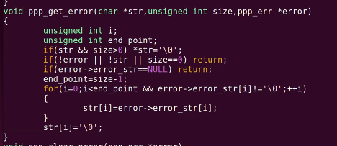
Error message ko user k buffer me copy krne ka kaam.
Ek seterror bhi bnega but usko header file me nahi likhege vo humara private function he.
Framework bnane wala use kreg. Use krne wala nahi.

Read: difference between a constant pointer and a pointer to a constance. Also what is readonly parameter.
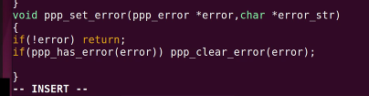
But dusra tarika jisse function wali call bch jayegi.
Function wale call jyada better he for purpose of modify in future.
Lambdas: lambdas k chkkar me bahut ssare types create ho rahe he.
Ek async await wali duniya and ek vo jisme async await nahi tha to usme dependency chain fit krni pdti.
Har callback me request but isse code ganda ho jayega. To uske liye async await.
But log iska galat use krne lge.
Lambda me internally anonymous classes bnti he.
Problem: structure k daache me malloc fail ho gaya like below to kya kre.
Fas gaye ki error set krte waqt allocation nahi hua to kya.
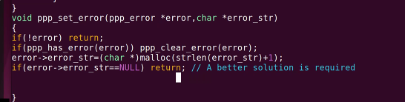

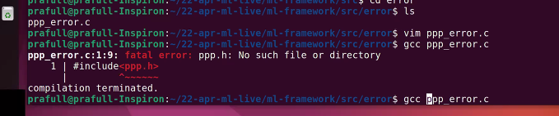
Compiler ko path btana pdega

Final code:
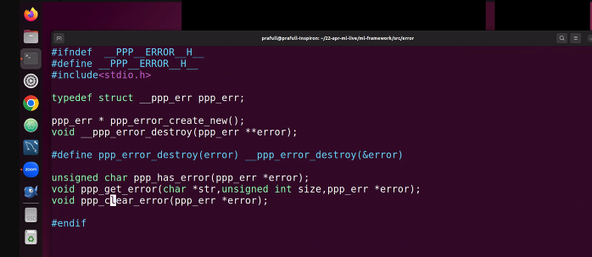
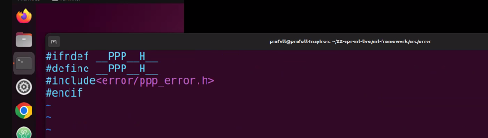

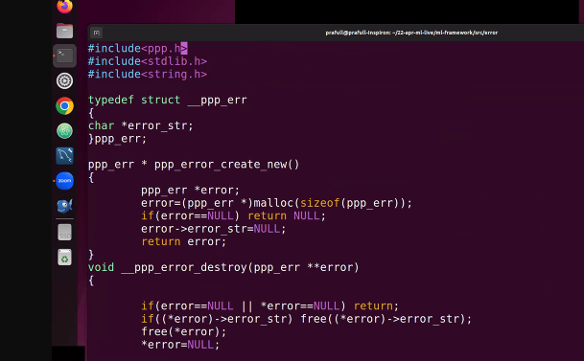
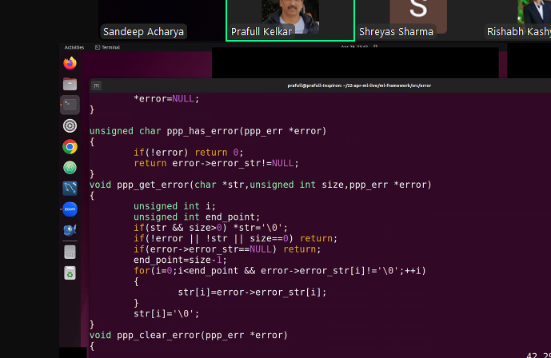

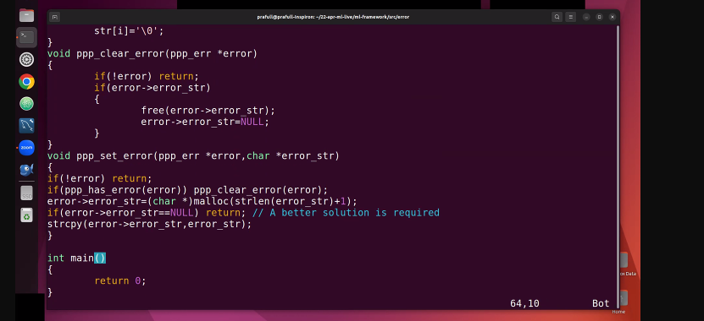
Ye jo 2 issue he :

