Date: 20-january-2026
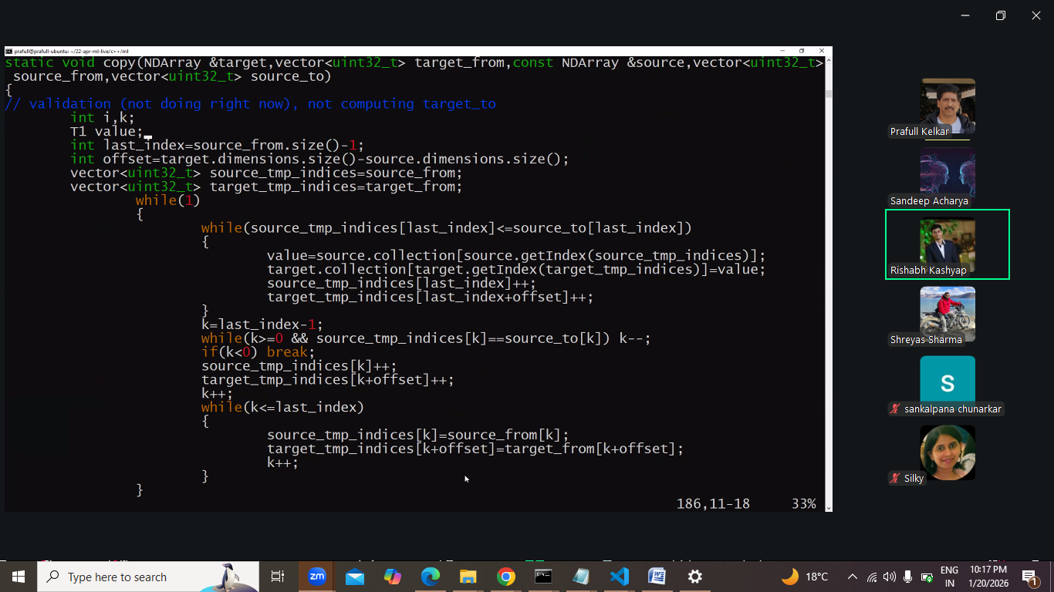
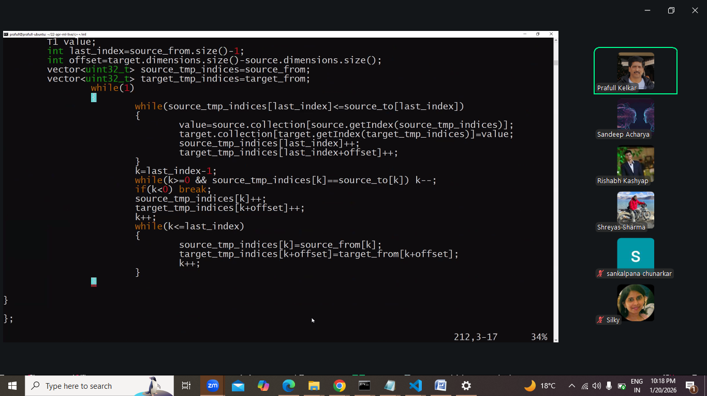
Ye workout kiya tha
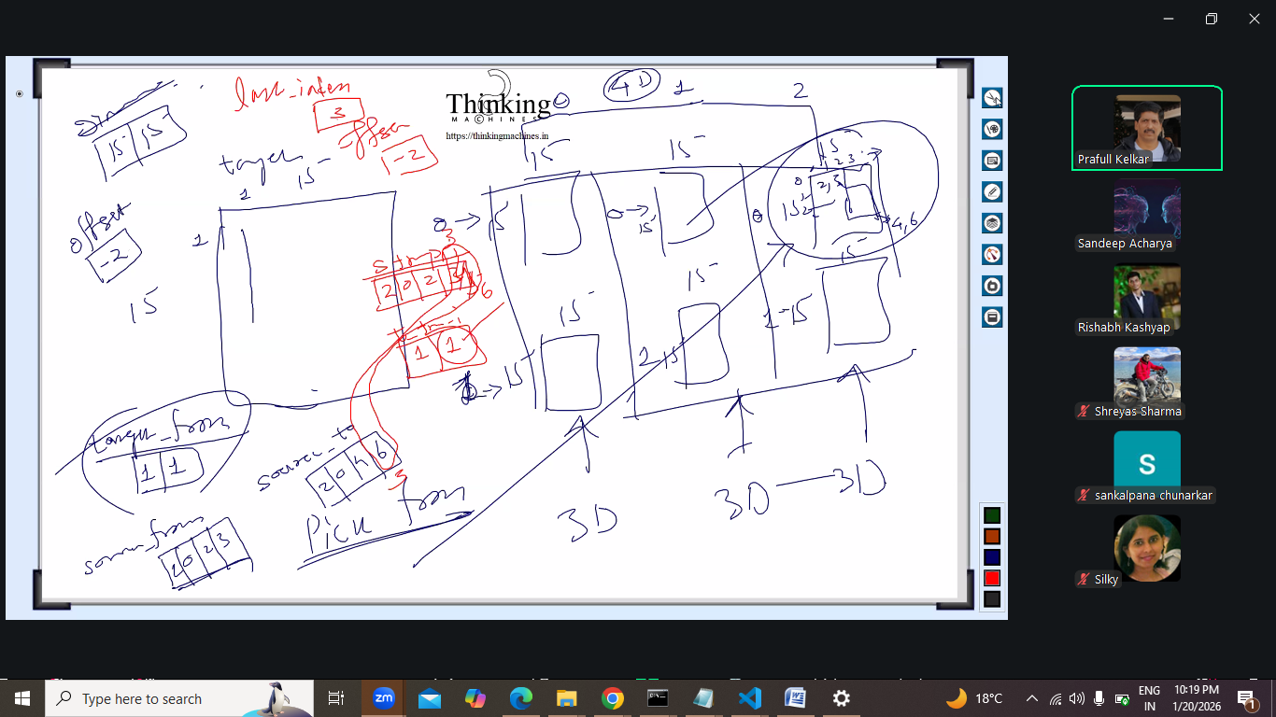

Next multiplication ka khel he:
Abhi nd ki nahi 2d ki baat krte he
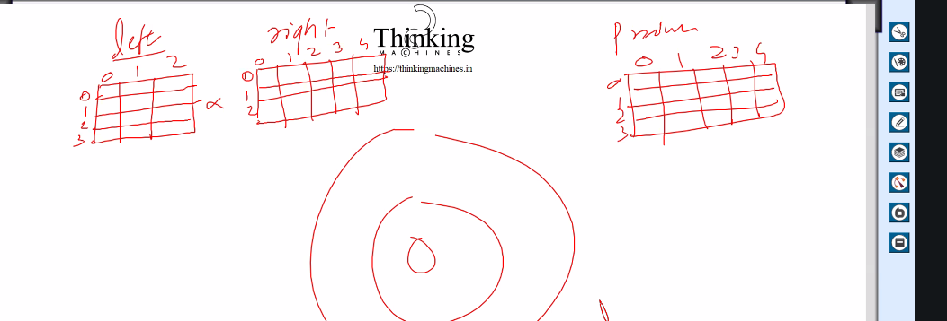

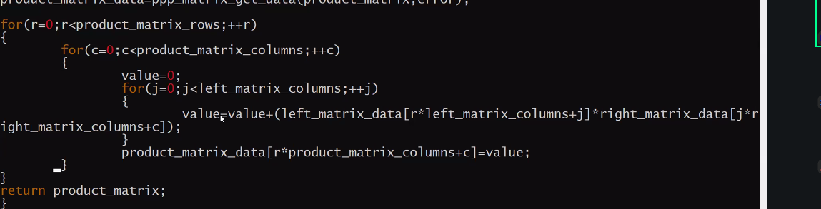
Ye logic likha tha iska diagram dekhte he
R*j +j*C ye rhta he and finally r*c
Rc=rjjc // for reminding
Ourter loop s r and c tk and inner j se vo common wale tk
e.g. 4*3 3*6 , r 0se 2, c 0 se 5, j 0 se 2;
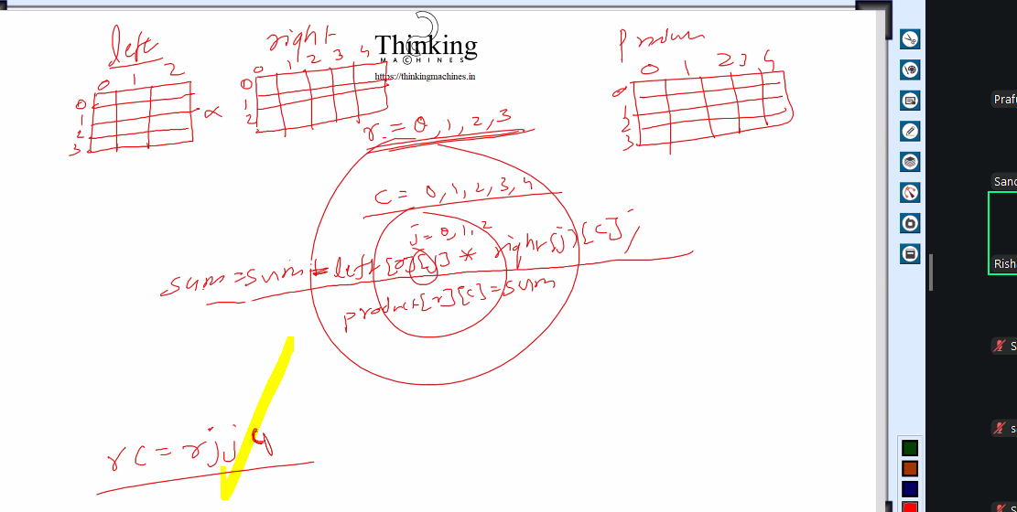

Next: kuch code dekhte he
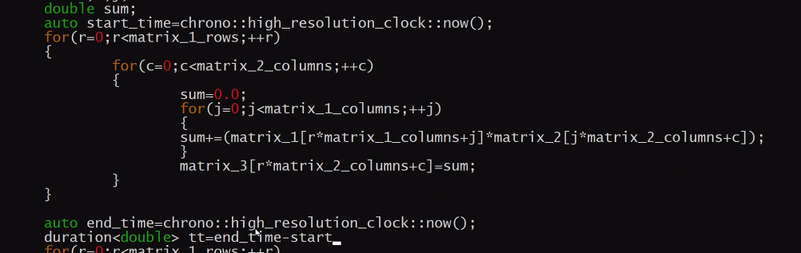
Chrono timing k lie.
Ye vo 3 loop rtna he isko
Note: g++ k 3 optimization flag he unme se ek he o2
Inko study krna he.
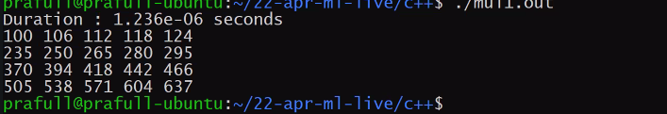
Isko online matrix calculator se verify kr skte he.
Abhi time bahut km he
Abhi size 512*512 and 512*600 kiya
Iska time aaya ye upar
Ab or bdate he
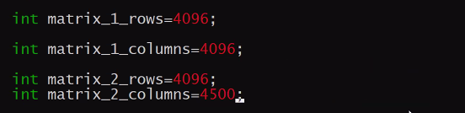
Iska time 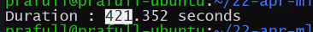 ye aaya

Cache miss ka case: abhi jo algo likha he usme cache miss ho raha he
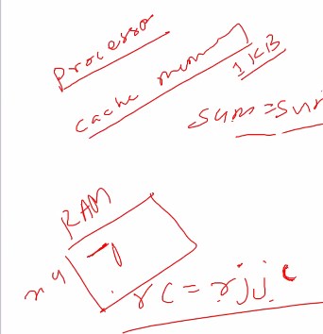
Processor , cache 1kb, ram to cache
Ram me x,y
Cache me ram se chunk leta he,
Hum x ki uthane gaye the to y ki bhi utha leta he
Ab y cache me he.
Ab j ki baat kre jo x and y se bahut dur he
To jb vo j uthane jayega to ram se layega.

Ram to cache me hum hmara algo change kr le ki bhai jo cache me he uski ko use kr lo.
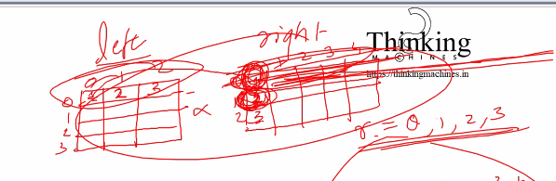
Left me phla uthane gaya to chunk cache me le kr aa gaya.
Udr right me bhi chunks uthaya pr usme se phla hi processs kiya and next row pr jump kiya
Pichili row k useless column hata he next row k chunk me job bhi aayega vo cache me.

Ab algo change:
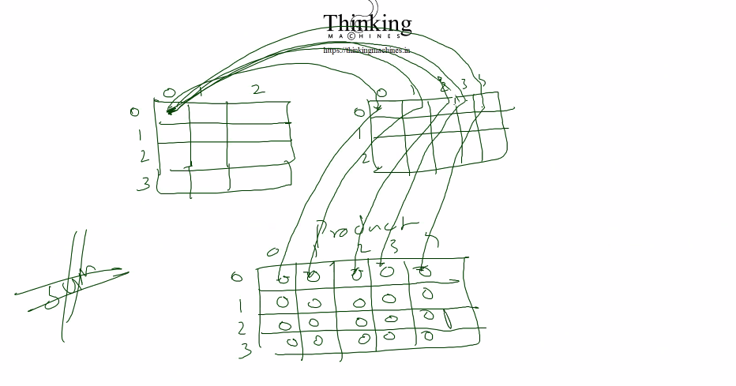
Ese krt he
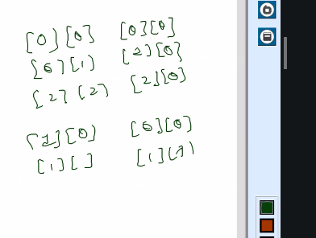
Next:
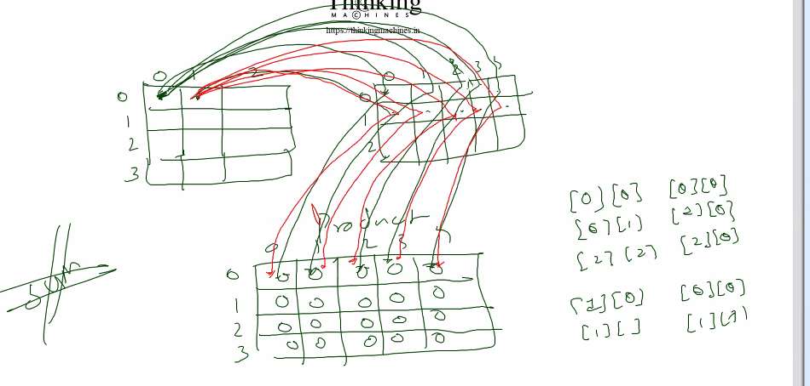
Next:
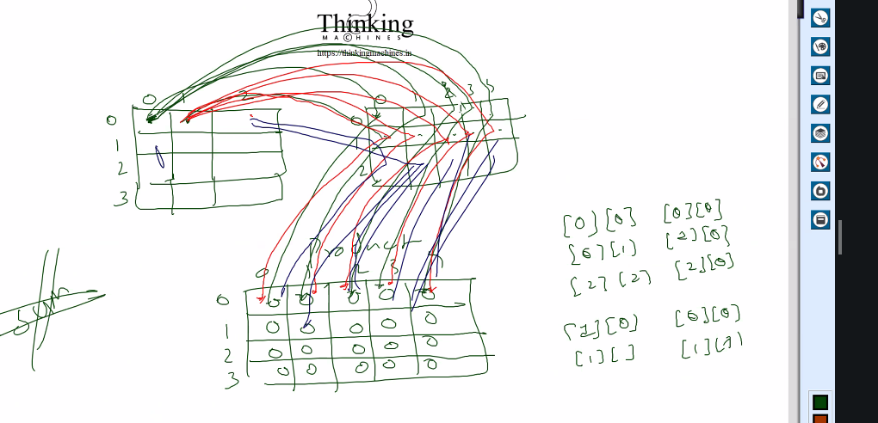
Esa kr k final accumulation ho gaya
Esa krne se cache miss km ho jayega.
Ab iske bad left wale ki next row utaho .
And so on.
Ab iska implementation :
Sir ne 2 din tk practice kri tb ja k vo ye shortcut bna paaye
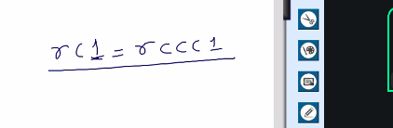
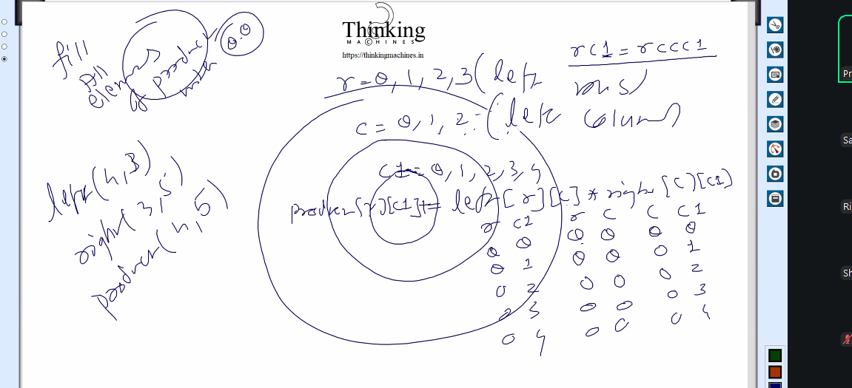
Isme bhi or optimize kr skte he r c constant he to usko ek variable me sotre kr k multiply se bcho
But is se jyada fark nahi pda.kyuki multiplication jyada time nhi leta.
Ab iske hisab se vo mul1 wala legacy program ko change kiya,
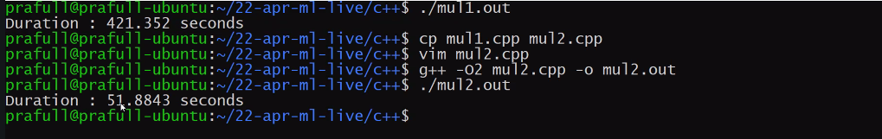
Ye time aaya is se
Isko multithreading pr le ja skte he.
Vector ki ek data naaam ki method he vo
Legacy me kya krte he:
Left ki first row ka right k first column se and result , result mat k firstrow first col me
Left ki first row ka right k second column se and result , result mat k firstrow secondcol me
Left ki first row ka right k third column se and result , result mat k firstrow thirdcol me
Isiliye outer me left ki row tk and inner me right k colt k kyuki final product R*C bnta he
Ab left ki row index k liye R and column index k liye J use krege
right ki row index k liye J and column index k liye C use krege
resultt ki row index k liye R and column index k liye C use krege
ab address calculation ka simple funda:
row major: humare pass r*c hota he row k case me r* number of columns in that matrix +c
column major: r*c hota he, colum major k case me c*number of rows + r

hum row major use krte he.

To left k liye r*c = r*j
To formala bnega : r*numberofcolumnInLeftMatrix + j
Right k liye: r*c = j*c
To formula bnega: j*numberofcoluminRightmatrix + c;
Result k lie: r*c=r*c
r*numberofcolmnsinREsult mat + c

Abhi legacy me accumulation ka kaam nahi tha sidha ek baar me hi result store.
Optimized wale me hum accumulation ka kaam krege, to result wale matrix ko phle 0 se populate.

Ab legacy me left ki row k saare index for (i=0;i<rows;i++) ka combo right k column k sare index for(j=0;j<cols:j++) sath tha and sum kr j result[i][j] pr put.
Abhi optimize wale me
Left ki row and right ki bhi row hi rhegi and inko us third loop me accumulate krte jayega.
Legacy : r*j j* c
Outer loop r pr , inner loop c pr and
sum wala loop j pr
Optimize: r*j j*c
Outer loop r pr and inner loop j pr jo ki right wale ka r he isliye.
And is baar Accumulation wala loop c pr .
Address k formule to vahi rahege.
Result rc
Left rj
Right jc
Bs loop kis pr chlana he ye baat chage hui and sum ki jagah accumulation wala kaam

To hum result k cell tak pahuchne k liye r,c wale 2 loop lagate he
And j k use hum left and right k liye krte he
Left k first row k first cell ka multiplication right ki first row k har element k sath and respective result , result matrix ki first row me
Left k

Aj ka ss
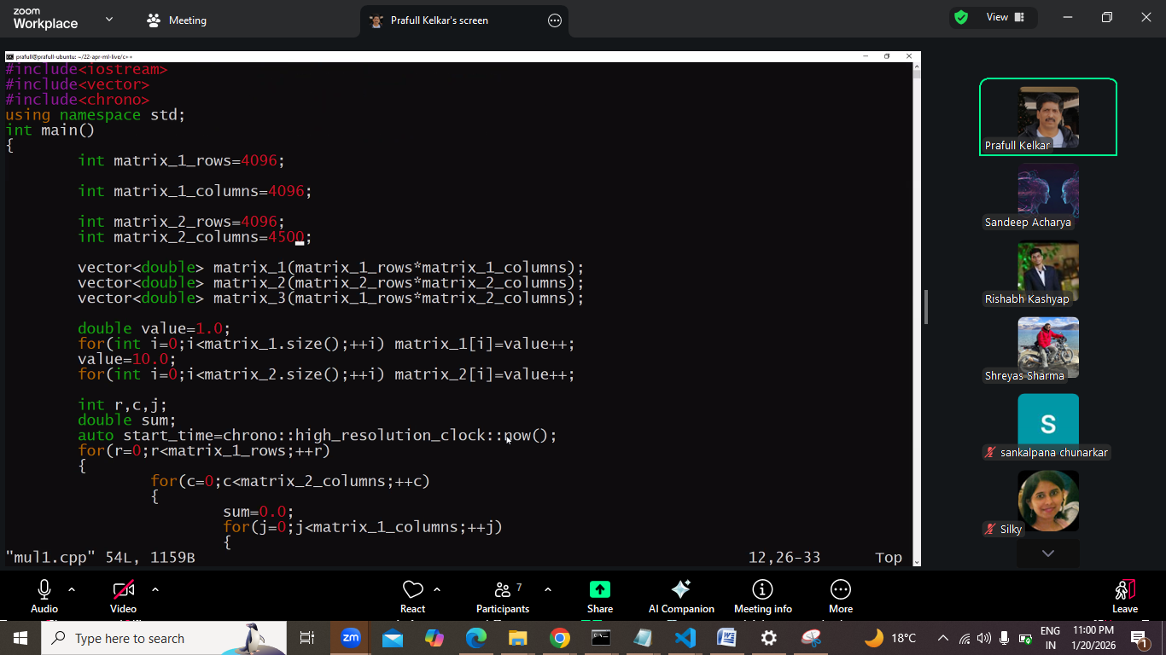
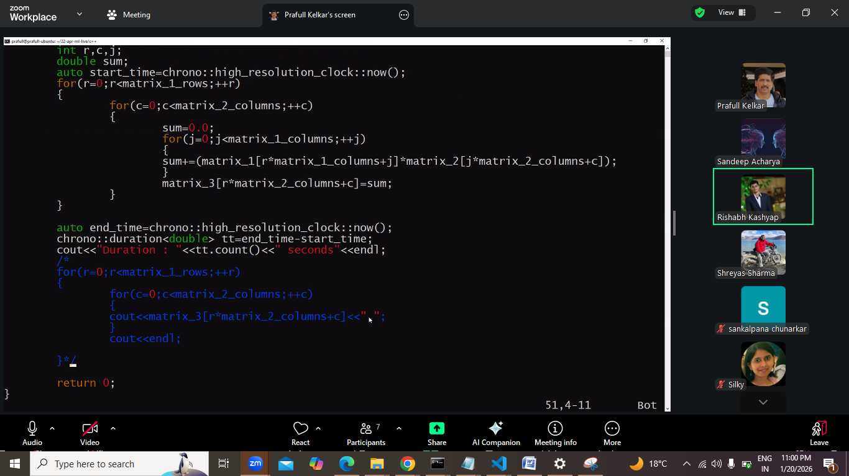
Mul2:
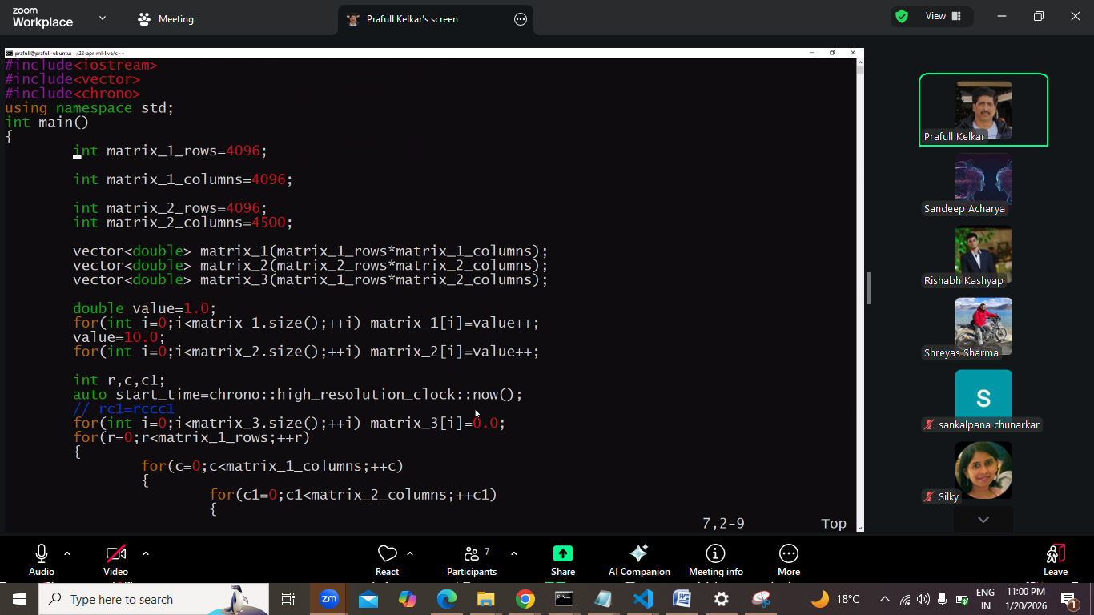
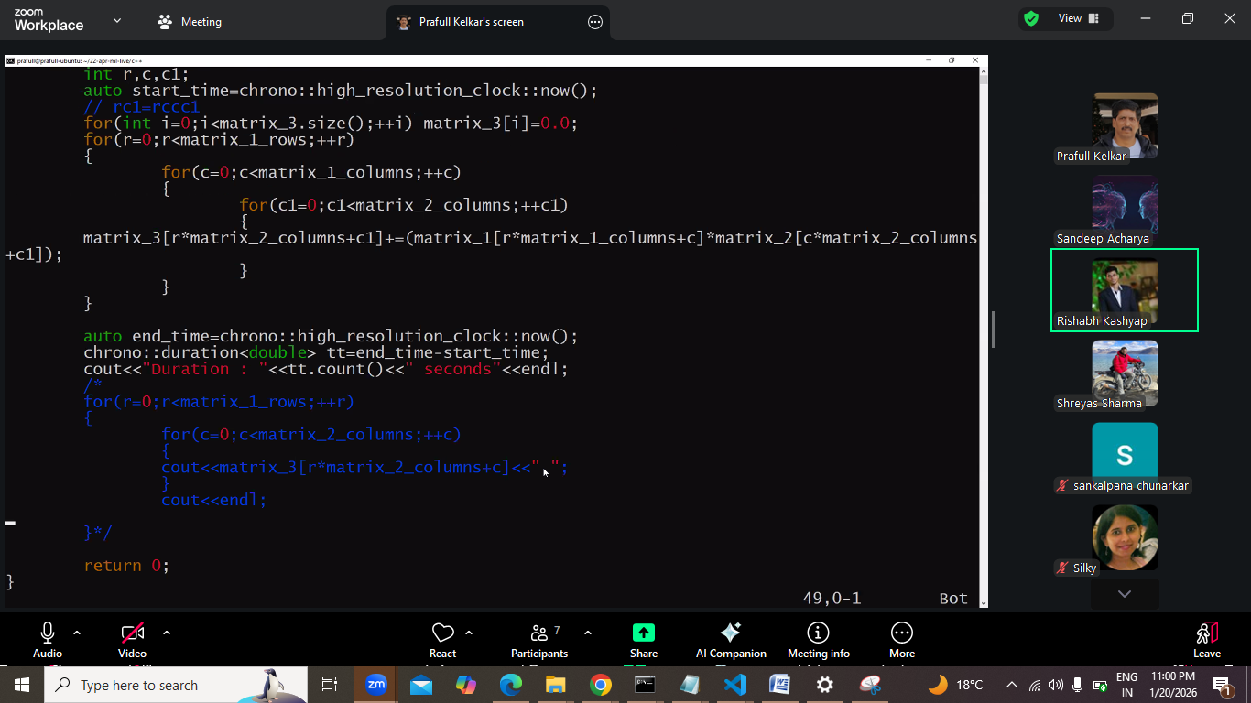

Task: 3d multiplication dekhna he
Next is example ki threading krege.

Next:
Multiplication ka jo function bnayege usme matrix k addresses paas krege.
Copy nahi bnyaege
Udr pointer me pkdede, and dereferecneing krege. To *P lgega
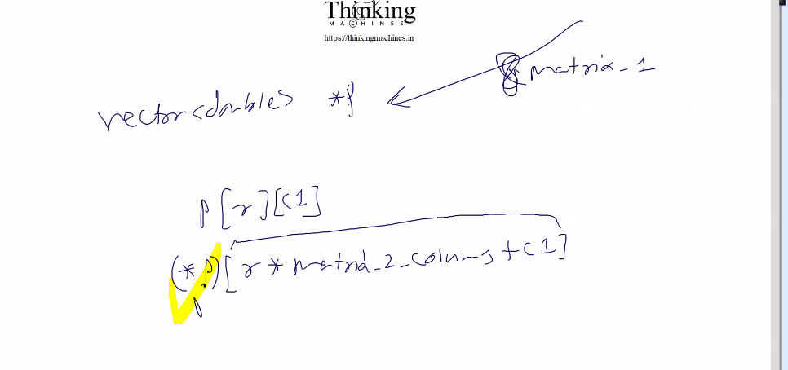
P pr [] nahi chl skta p jisko point kr raha he us pr chlega isliye *p
Pr is se bchne k liye global variable lege
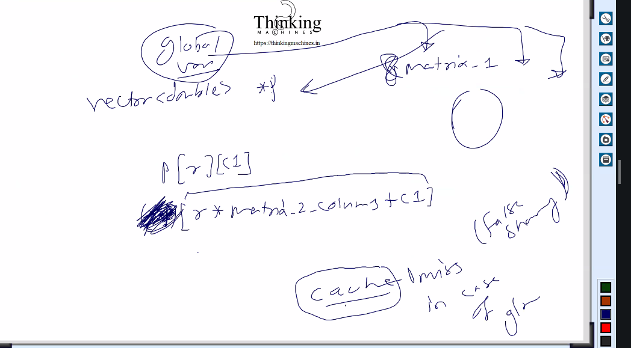
Cache miss in global sharing.
Pr usme itna time lga isliye phir ye idea drop kiya
Ab array se access krna he to linear fashion me kre, to cache miss se bchege.
Study: cache miss in global sharing and cache miss in

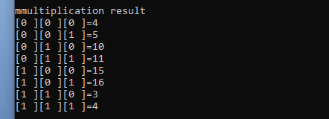
3D multiplication ka ss.

Date : 24-january-2026
Recording pdi he local me day 81 k naam se. and ss to he hi aaj ke
Aaj ka discussion tha ki vo jo optimize wala d multiplication kiya tha , usi ka use kr k multiplication ko threads k bich me distribute krna
Uska ss:
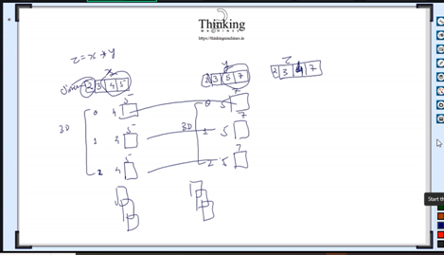
Neural network and logistic read krna he.
Neural network ka derivative nikalna he: sir btayege
This Lecture is about to distribute multiplication work among threads
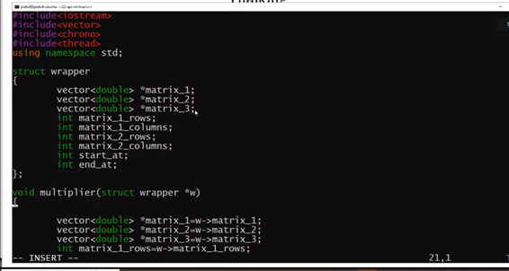
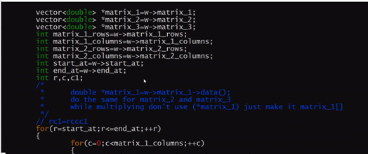
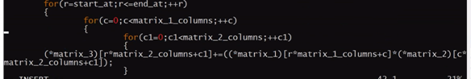
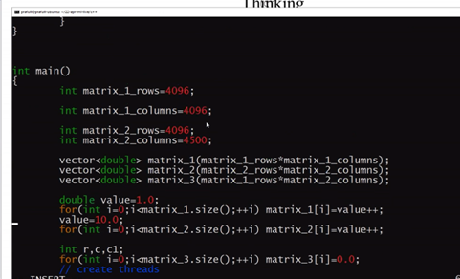
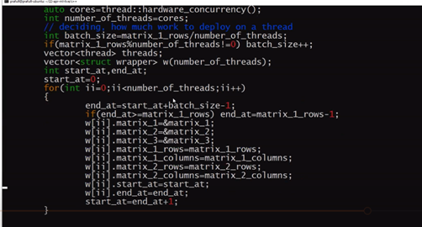
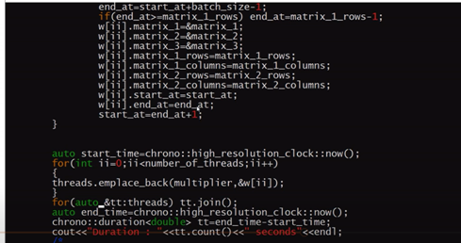
Op:
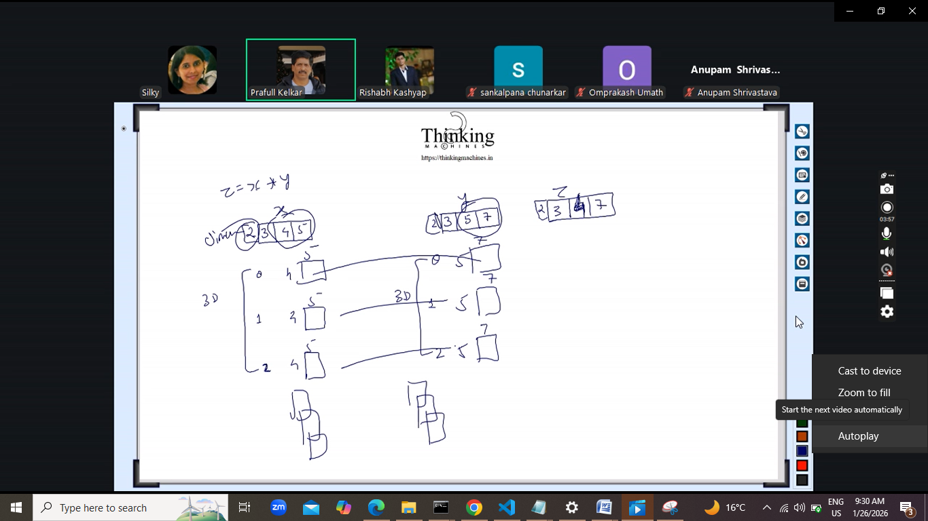
Neural network and logistic read krna he.
Neural network ka derivative nikalna he.
Lecture is about to distribute multiplication work among threads
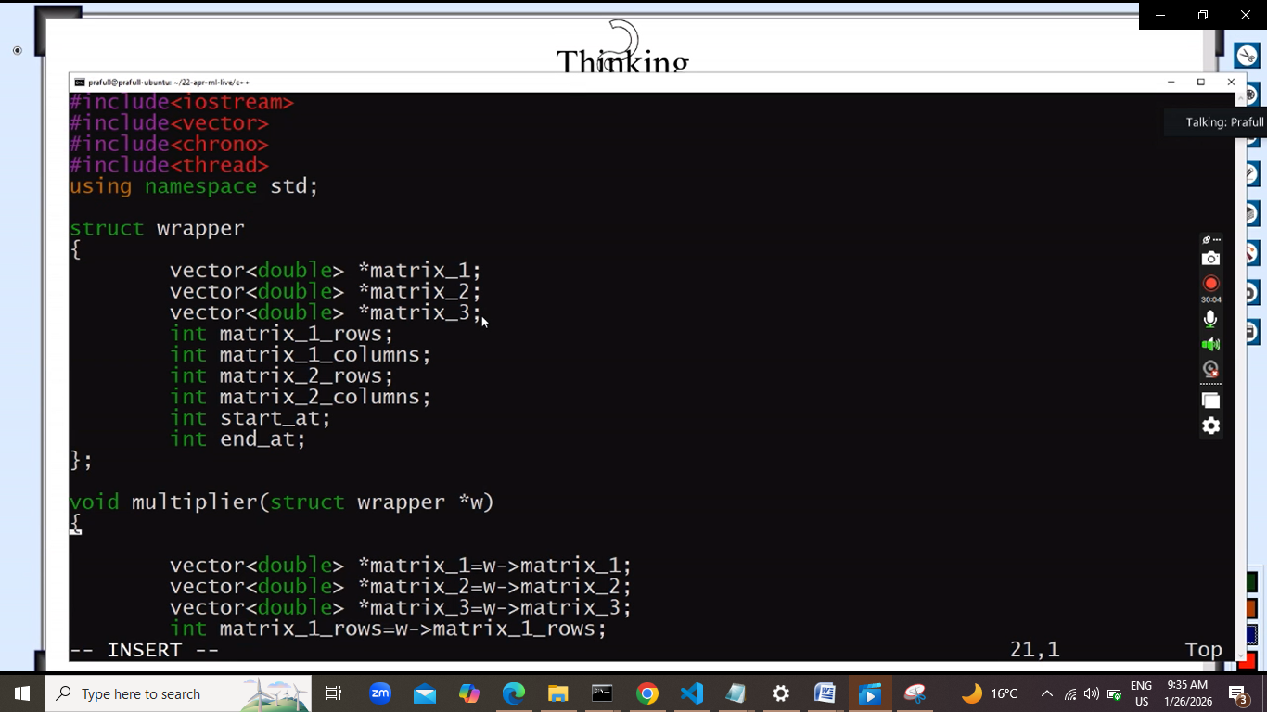
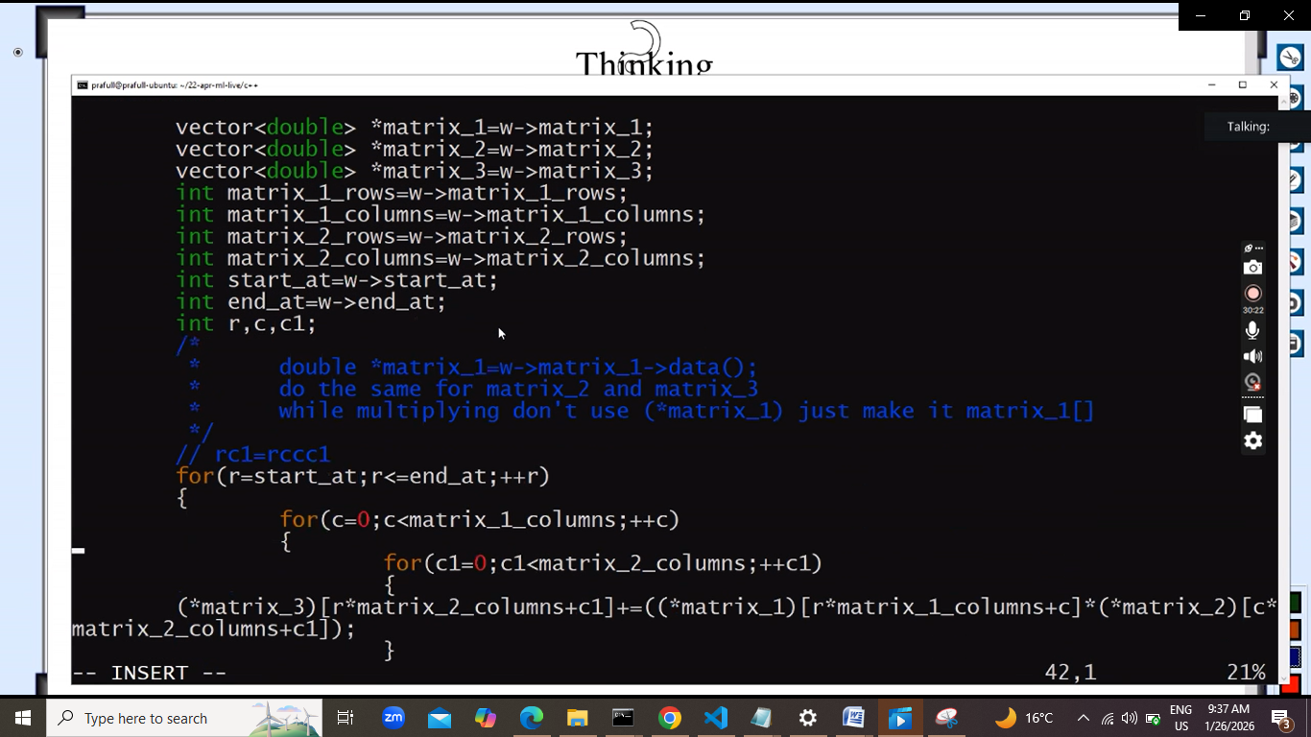
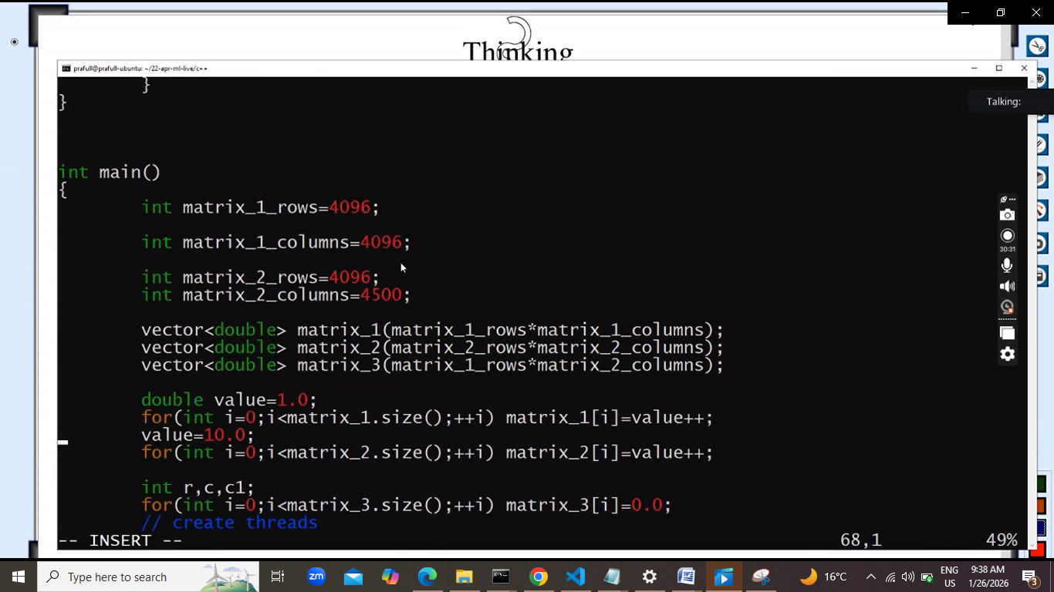

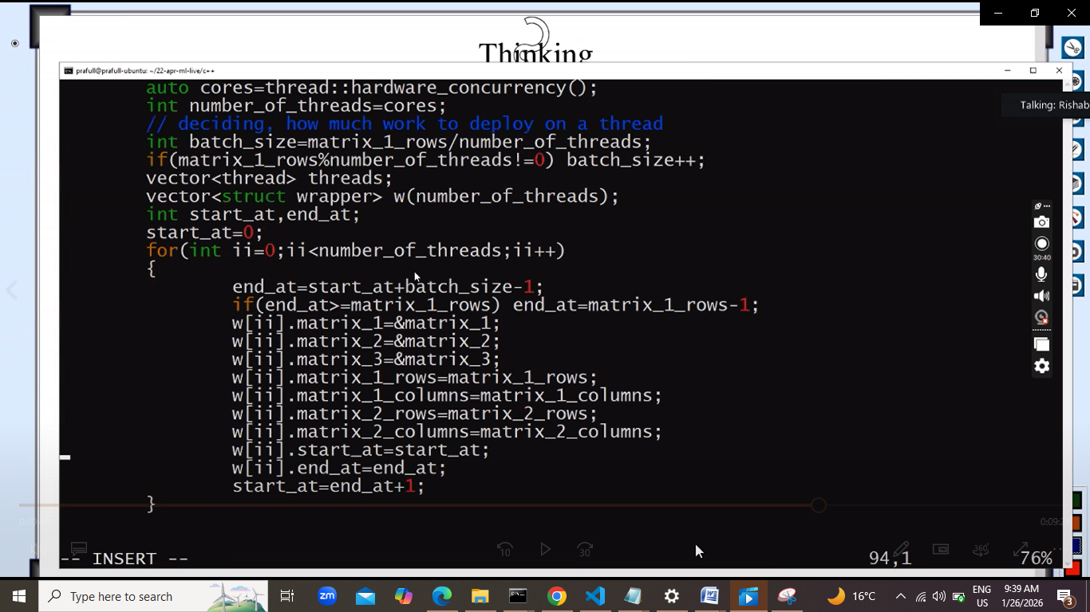
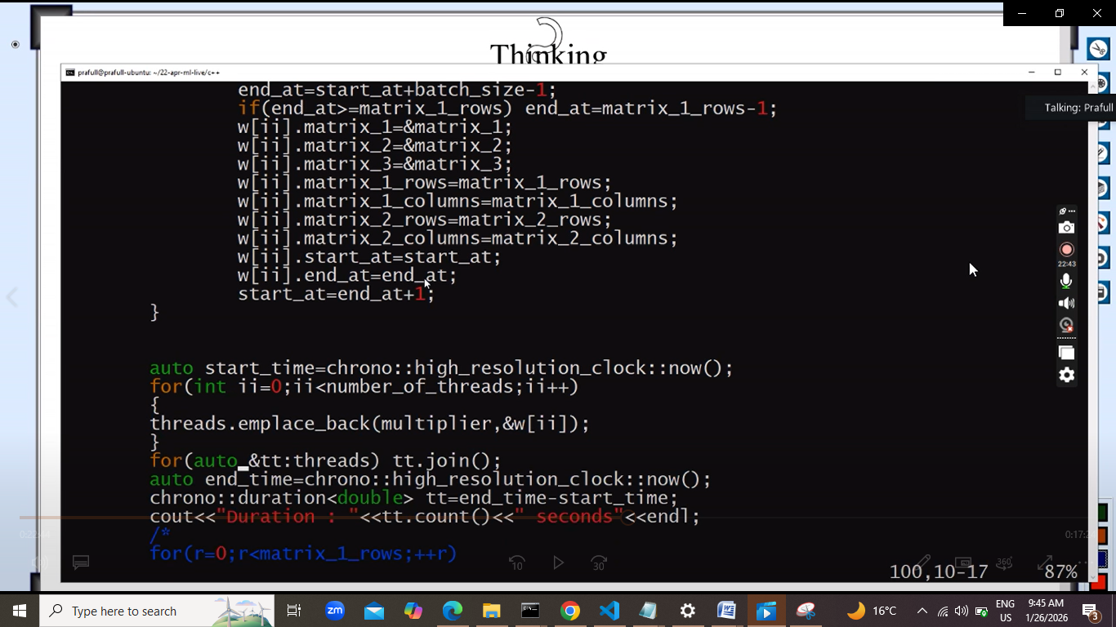

Next: ek array k sum ko 4 threads me divide kiya
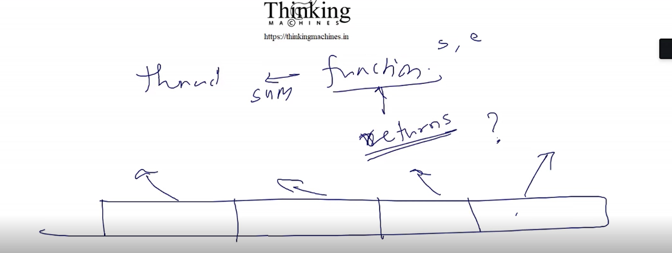
Har thread start lega end lega and kuch return krega ,
To vo jo return krega usko kese le?
Means aggreagate kese kre.

Uska approach:
Since 4 part me divide kr rahe he , to 4 ka verctor ya 4 ka array
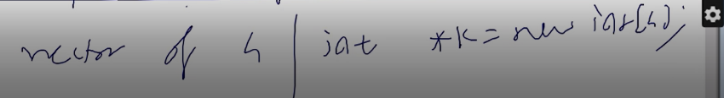
And jb thread ka object bnayege.to
Thred(adder ka address, start at, end at) pass krege
To iske sath vo vector ka index bhi paas krege.
To naya signature bnega
Thred(adder ka address, start at, end at, &k[ii])
Ii kaha se aayega vo for loop se aayega , for loop on ii.
Ese me return wali khtm vo function ka return type void ,
And vo calculation humare dwara pass kiye gaye address pr rkh dega.
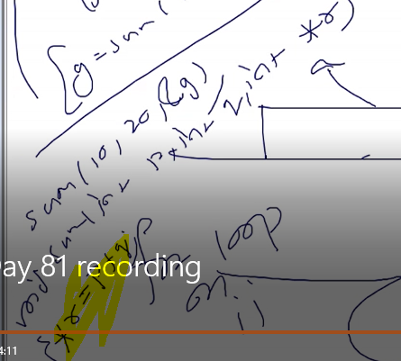
Like this. Mtlb function ka return type void and address dege to vo us pr result likh dega.
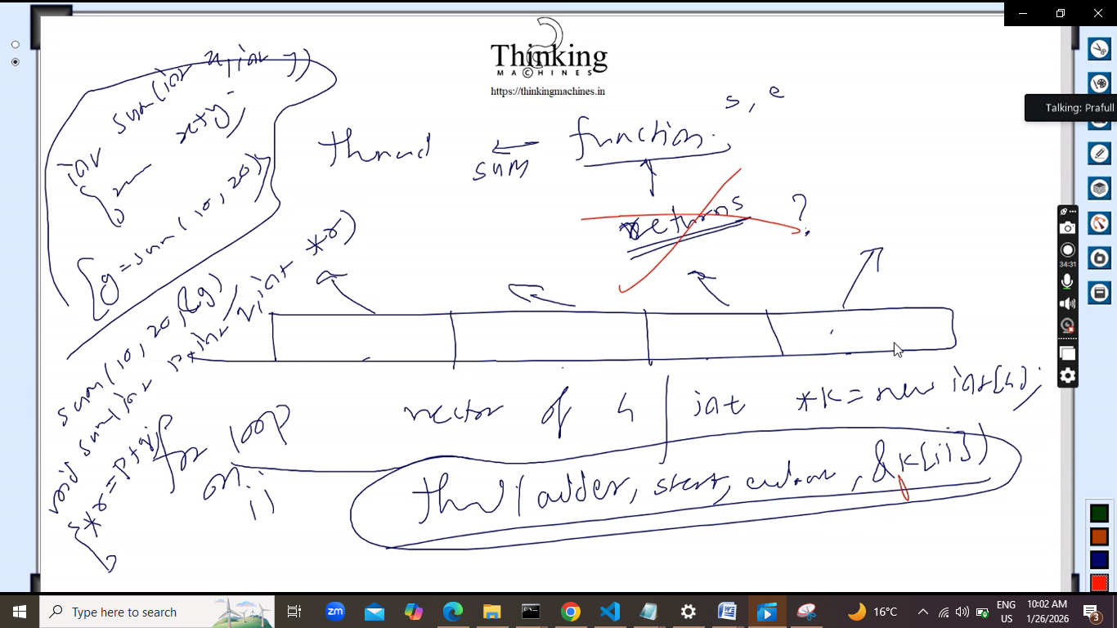
Phir jb humare paas k pura populate ho jayega. To phir ek or thread ko kaam pr laga dege jo uska sum kr de.
Halanki vo main thread pr bhi kr skte he.
Means collect distribute , collect distribute and finally humare hath me single value hogi.
Ek or approach:
Global array le lo. Threads us global aray ko update kre.
Thread receive start,end, golabal array ka index jis pr us part ka sum rkhna he.

Next:
Itna hone k baad we can go for reading about.
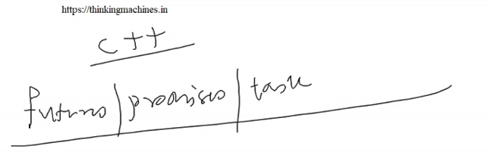
Ye in context to c++ he , not in js.
Abhi log puchte he ki Rust and Golang sikh le kya?
But jisko c/c++/java me 8 saaal ka experience he , and
Thorough c cpp and [ java for
Virtual machine wala context and safe programming lang].
Itna aa gaya to phir vo Rust and goland sikhne ka koi sense nahi he.
Haa agar koi project milta he to haste khlte jarurat k hisab se kaam ho jayega.
Nahi to jitna java sikha utna rust sikhne bethe to vo senseless he.
To humko only c++ strong krna he.
C++ ne networking kr lo.
C++ me kuch he hi nahi to phir sidhi c ki networking kaam aayegi.
Jese c me multithreading k lie kuch functionality he to unhone c++ me wrap kr diya and clases bna di like future promises task
But c++ me koi class nahi he socket se related ,
Kyuki vo bna bhi le to koi sense nahi he , andr sidhe unko c ka hi code likhna pdega.
Thread k case me to phir bhi event loop wala concept / mechanism he
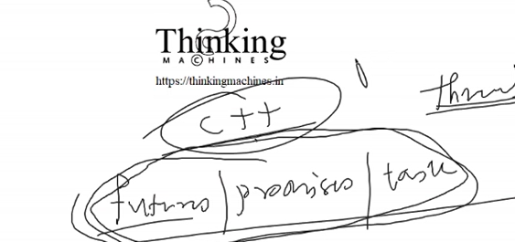
Ki thread ka jo function chlega vo future me ek return value generate krega
And hum future ki get() method call krege and vo get internally join() k through atka degi.
Or aage tbhi bdegi jb join khtm hoga and tb tk vo result jo he vo ready ho chukka hoga.
Inka ek ek example dkhna he. Ye aa jyega
So:
Network programming c ki karo.
C++ ki threading krao
To finally hum multithreaded server likh skte he.
And job hi backend ki programming he vo multithreaded server pr kese chlega ye sochnaa he.
To ye chize worth it he.

Date: 27-january-2026
Ab humare isme multithreading me
Synchronization and communication between thread aana chahiye kya?
Ans: nahi.
Parallel programming ka ek or tarika dekhte he.
Uske phle humko practical kr k feedback dena he.
Sir lower end ki machine pr kr rahe he practical.
Bina thread k bhi parallel programming kr skte he
# k sath jb bhi kuch likhte he usko preprocessing directive to the compiler.
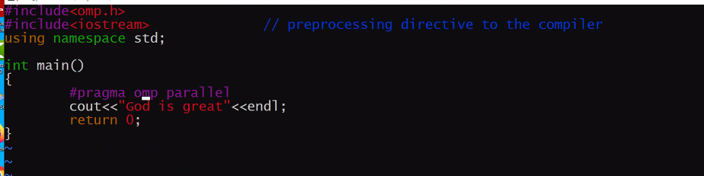
Jinte core utne threads bnege.
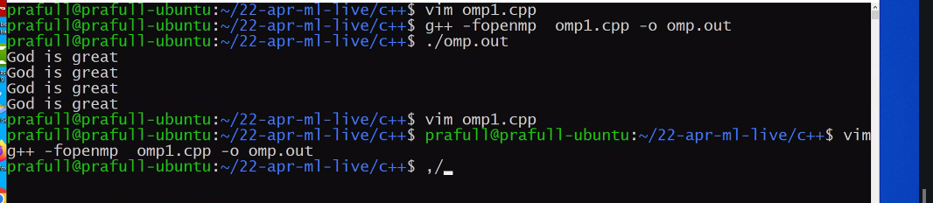

Next:
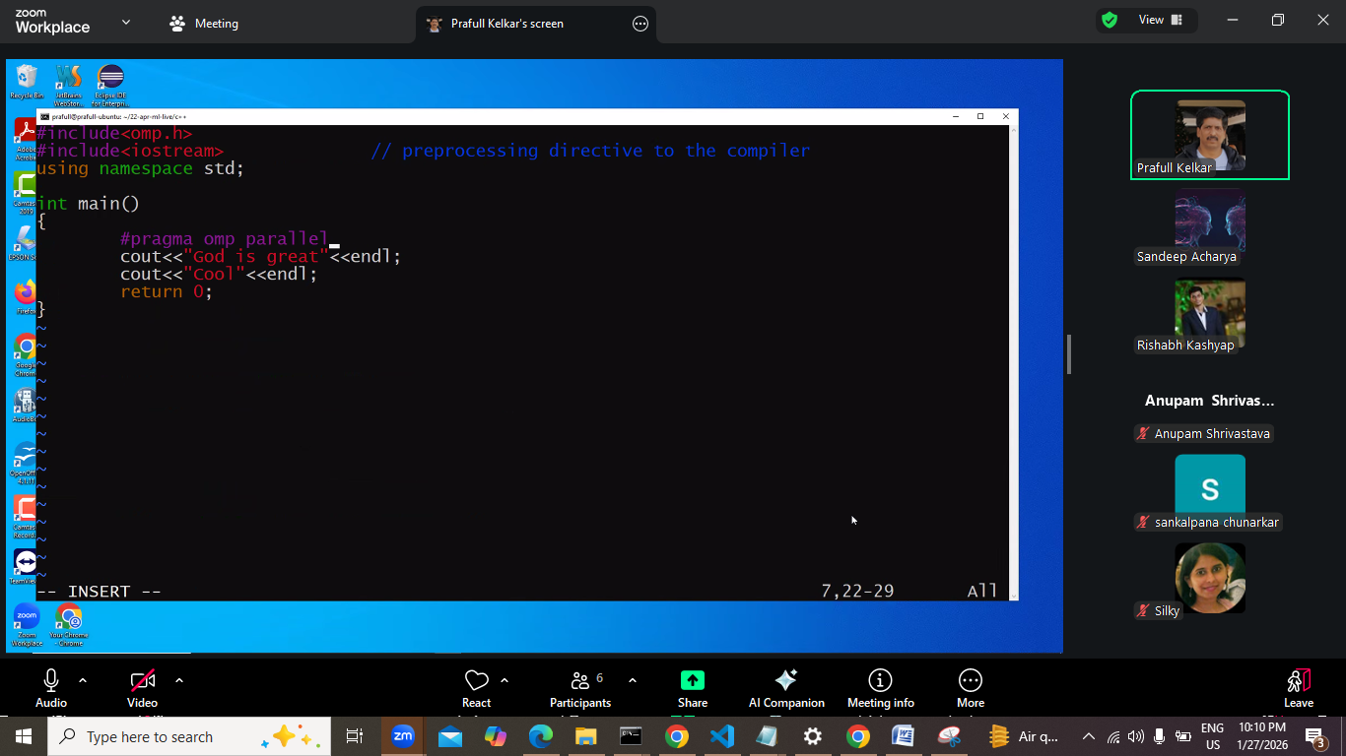
Cooll parallelize nahi hua
Next:
Agar block bna de
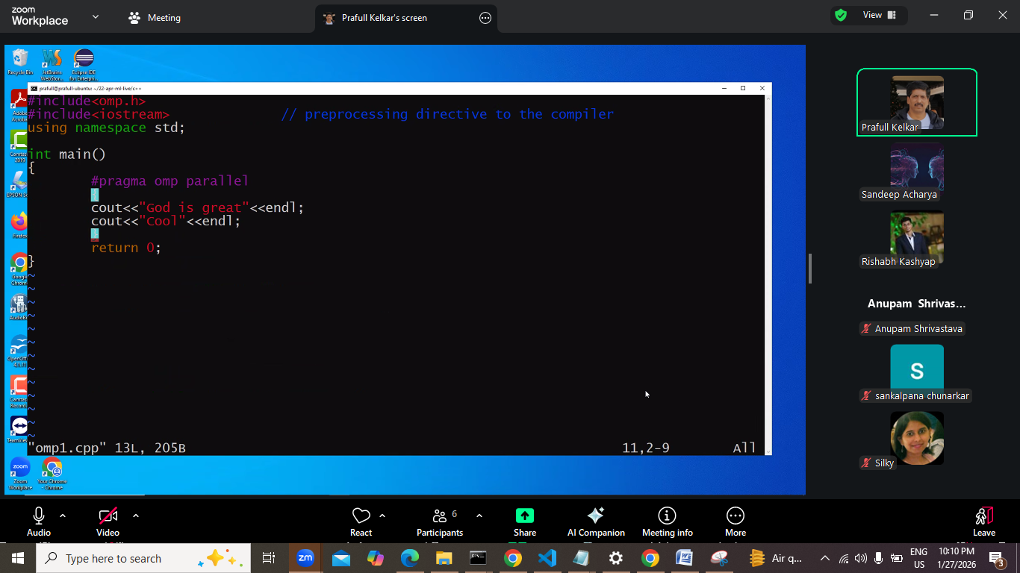
To pura block parallelize ho jayega
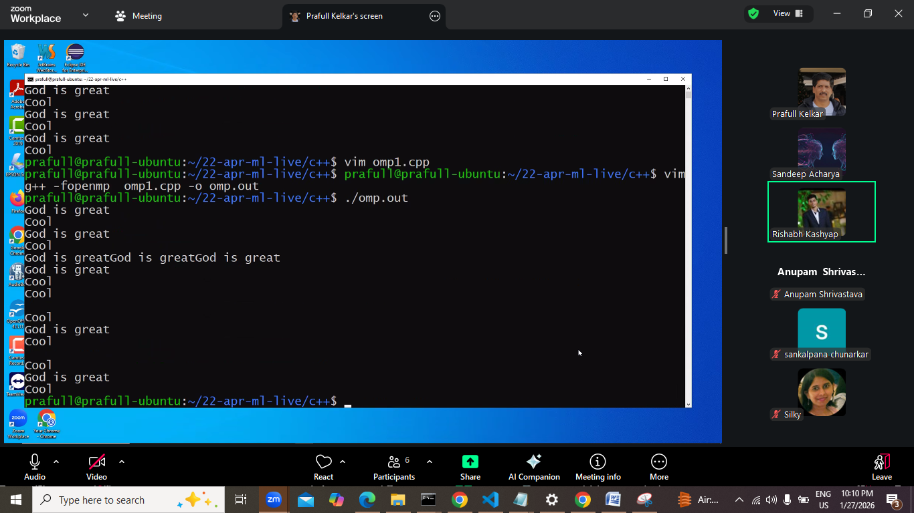
Mix output aayega context swithing ki bajah se aayega.
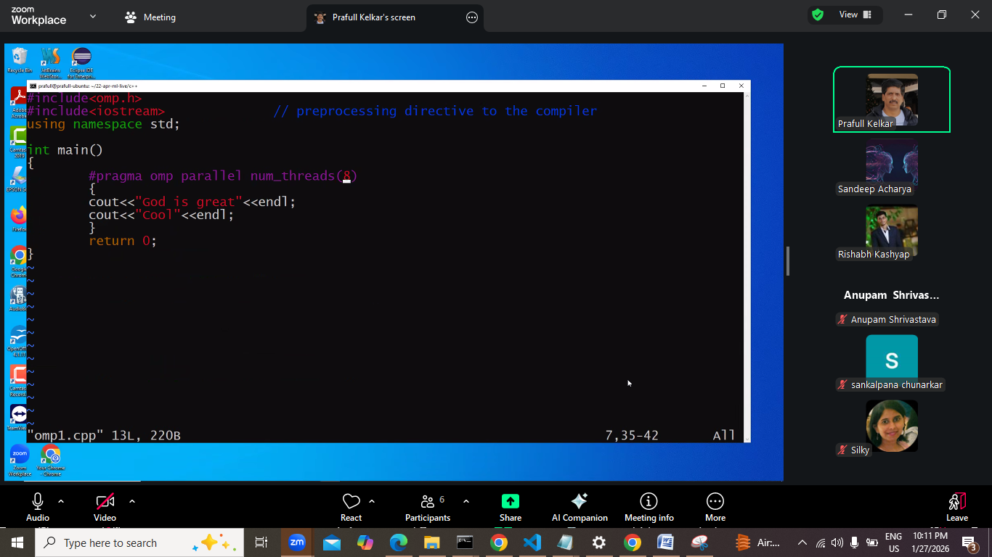
Ye 8 jo likha ye hint he jaruri nahi ki 8 hi thread bne.

Ab parallel k sath for: esa kr k bol rahe ki for ko parallelize kr do
Work distribution ka load humara nhil
Break , exit nahi krana he loop ko loop complete hone ki guarantee dena he
For ko parallelize krna ka rule: there should no code to breakout the loop.

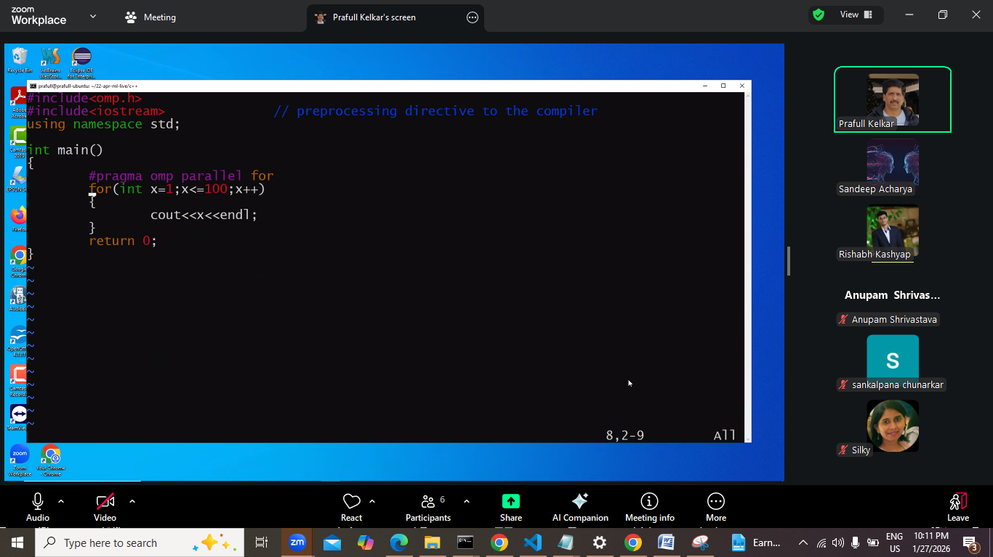

First code me 1 line thi to us ek line k baad implicit barrier add hoga join() wala
Kahi na kahi code to thread wala hi chlega. Hum nahi likh rahe to compiler likhga.

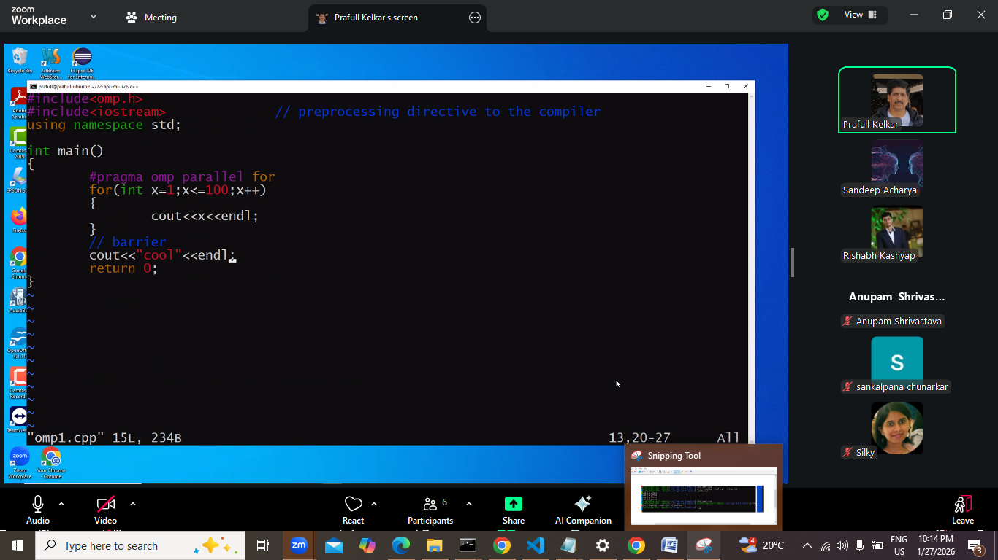
Jese cool he to cool k phle barrier laga hua he internally , join wala
Issiliye cool saaare threads ka kaam khtm hone k baad hi print hoga.

Next:
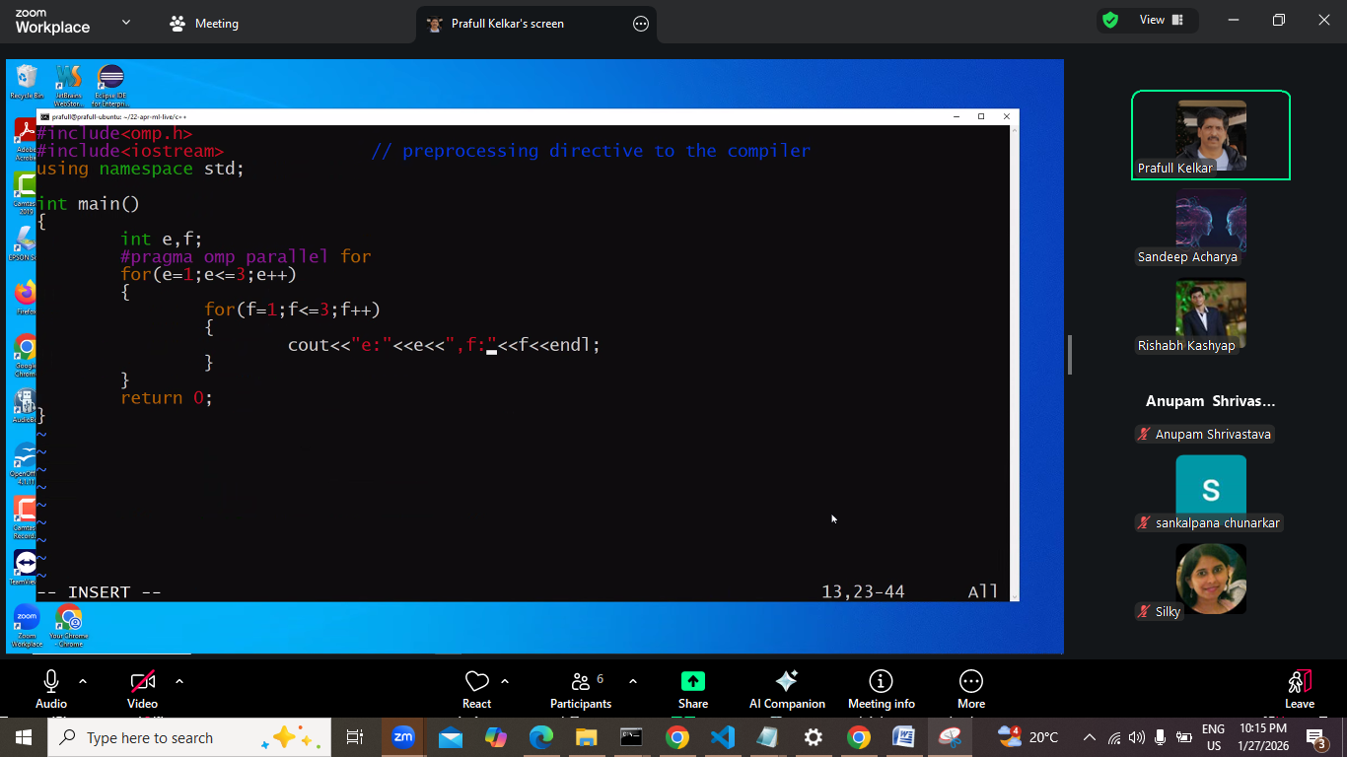
Iska kya output aana chahiye:

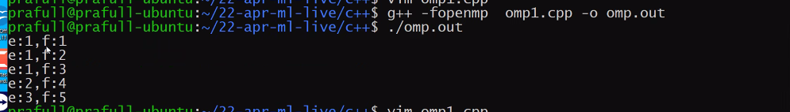
Ye aaya , jo ki expected nahi tha.
Work distribute kese hua.
e ki value teeno k liye alag alg he and f teeno k liye common he.
To humko smjhana he ki f teeno k liye common he.
Say work distrubutaion ho chuka e ka bharose
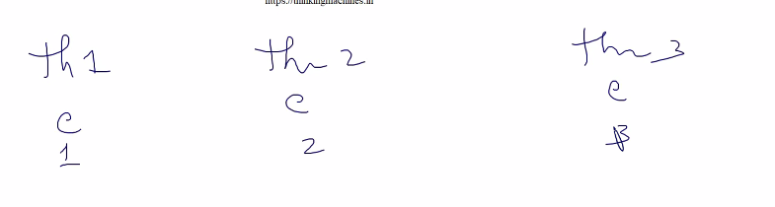
Context swithing me kisi bhi thread ka number phle aa gaya.
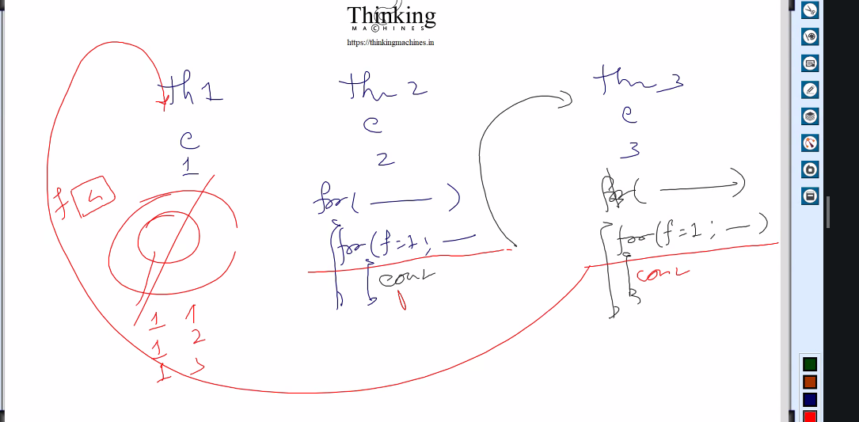

Outer loop k andr k jo bhi variable he vo shared rhege
Humko btana pdega ki teeno ka f alag alga lo iske liye

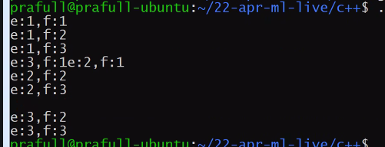
Final output
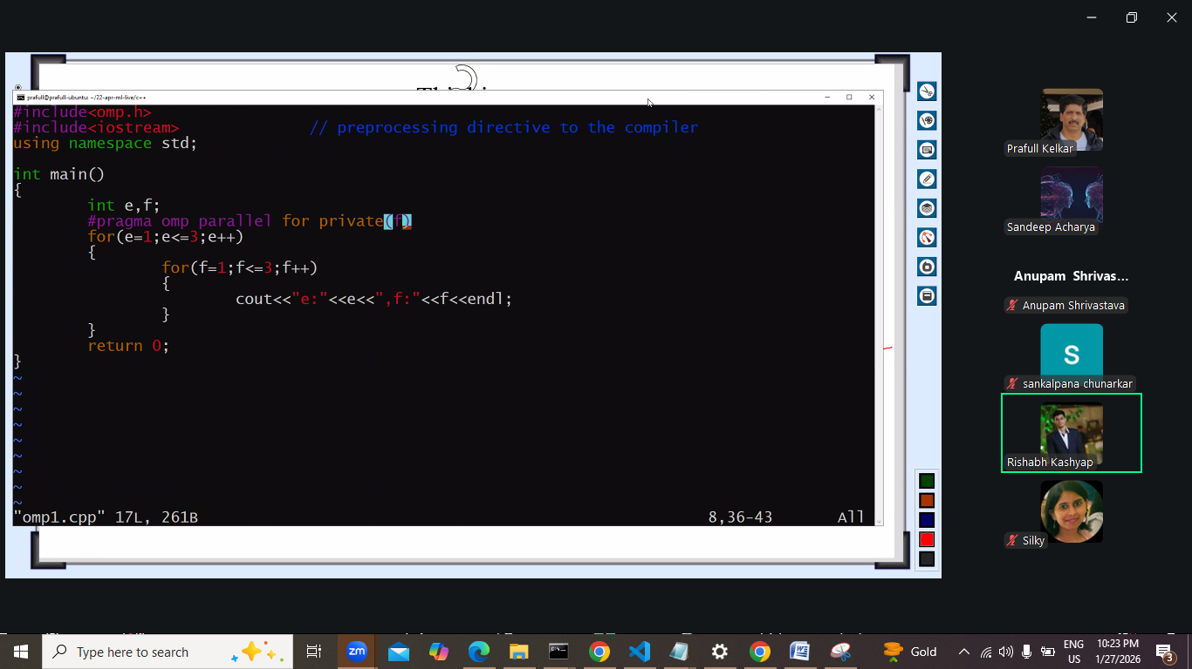
Usko private k sath declare kiya for private se.
Humare program me ek or loop he
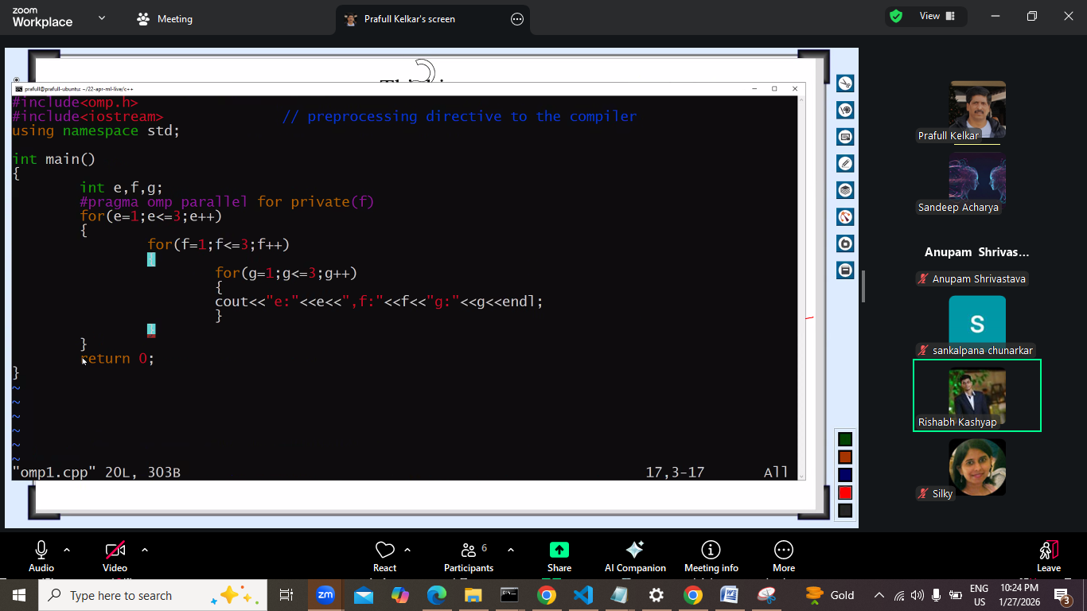
Phir gdbd , to g ko bhi private bnate he, ki bhai ye har thread k liye alag he.
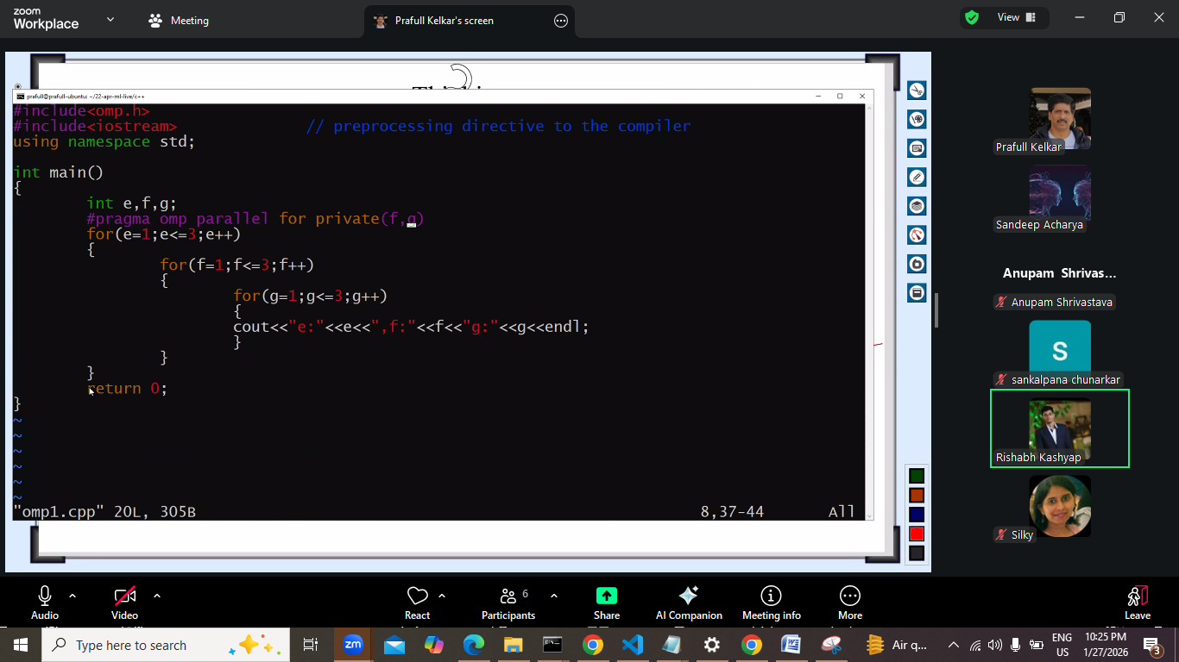

Note: agar private wali baat hata de and variable declaration loop k andr kre to problem nahi aani chaiye, kyuki phir har thread k liye naya declaration hoga.

Next isko matrix multiplication k liye le jaatehe.
Usme isliye le jaa skte he coz , har cell readable he write kuch nahi kr rhe he.
Work distribution ki chinta nahi , number of threads dene ki chinta nahi.
-openmo nahi krege to sequential hi chalega , isliye compile ese hi krna he.
Vvvvvimpppppppppppppppppp.

SS:
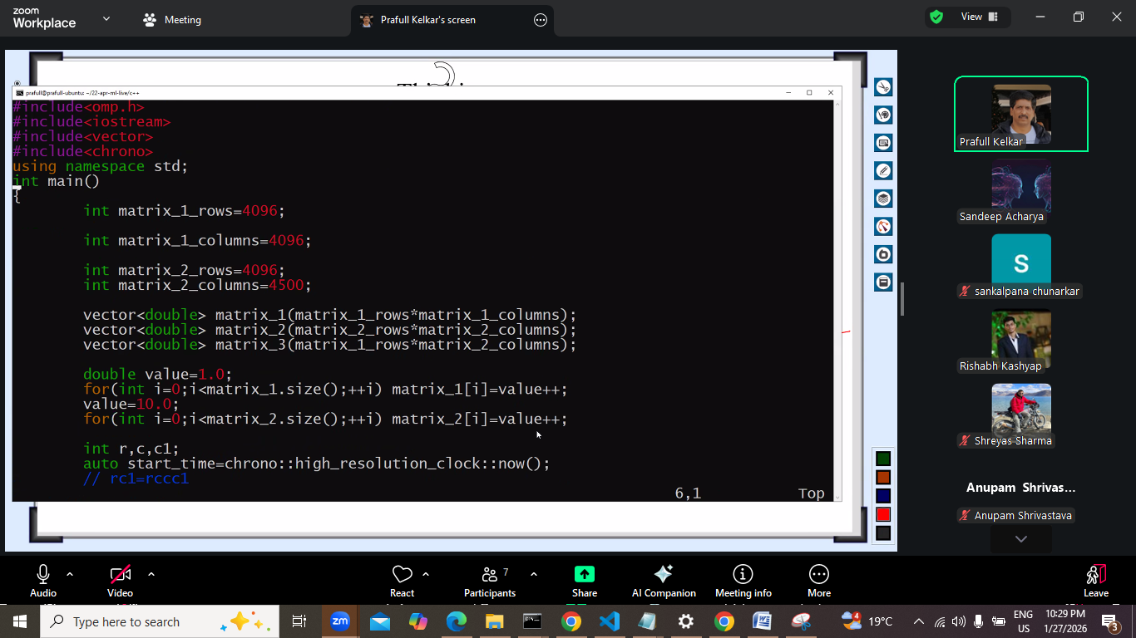
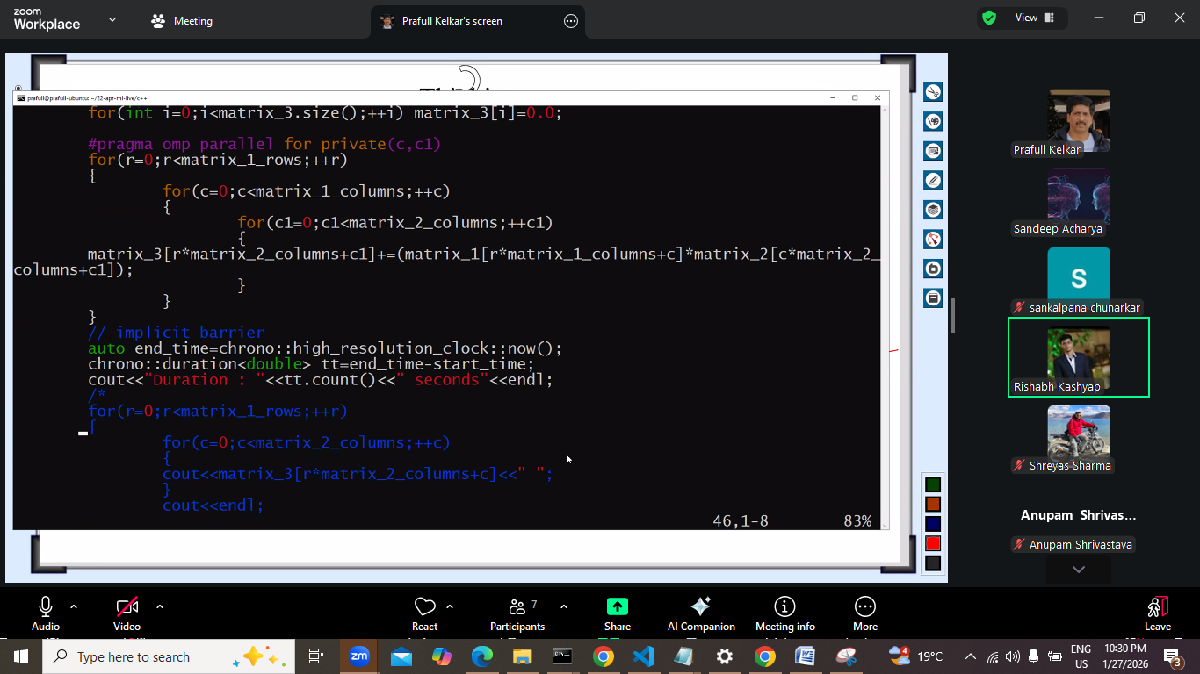
Ye pragma wali line bdayi bs.
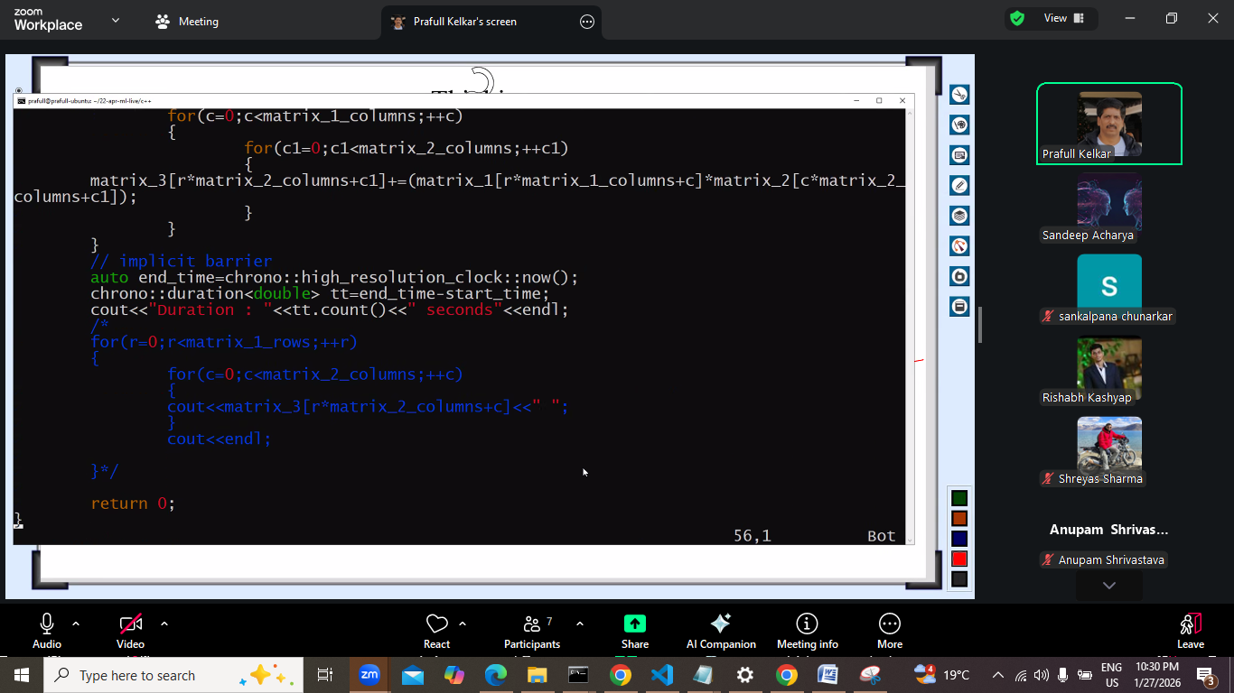

Next::
Maan lo multiply krna he
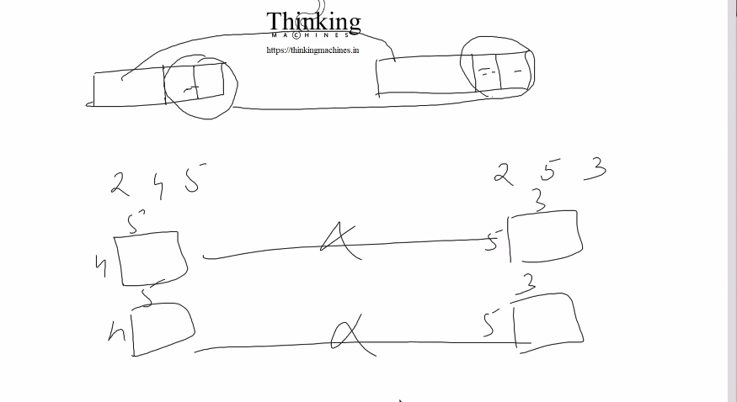
Multiplication me yahi rule rhaega.
First 2 2d k hisab se rhege baaki saare same.
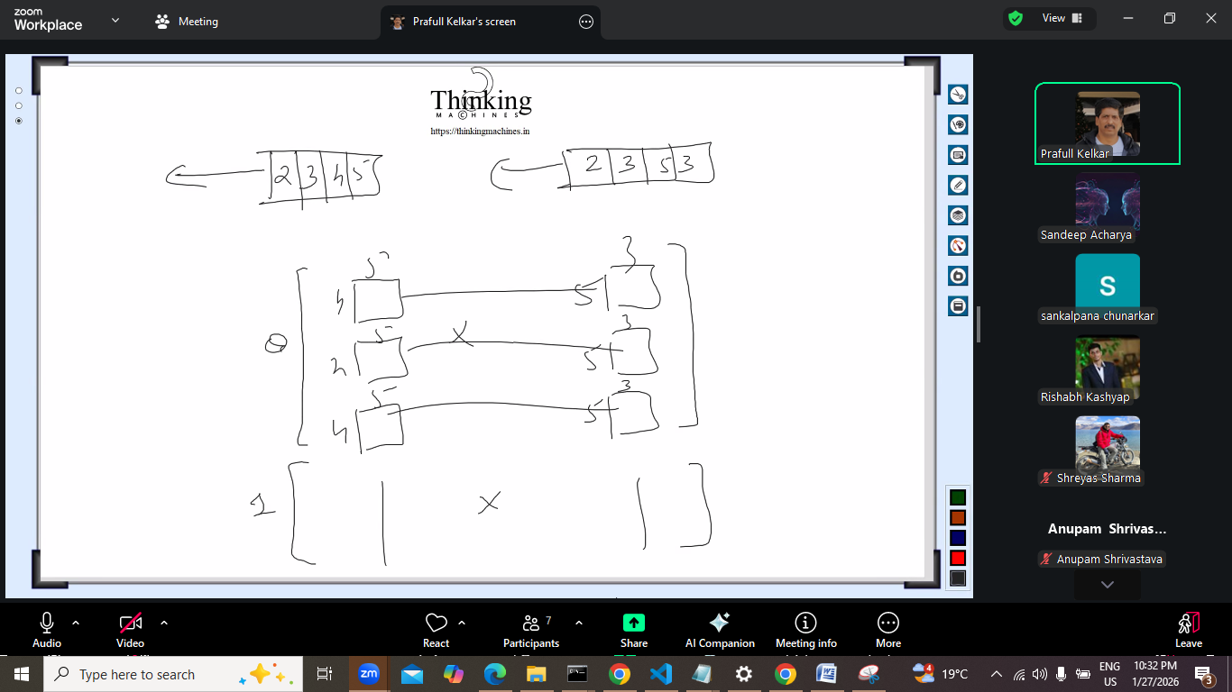

Ab problem kuch or he:
Loop aayega and loop me
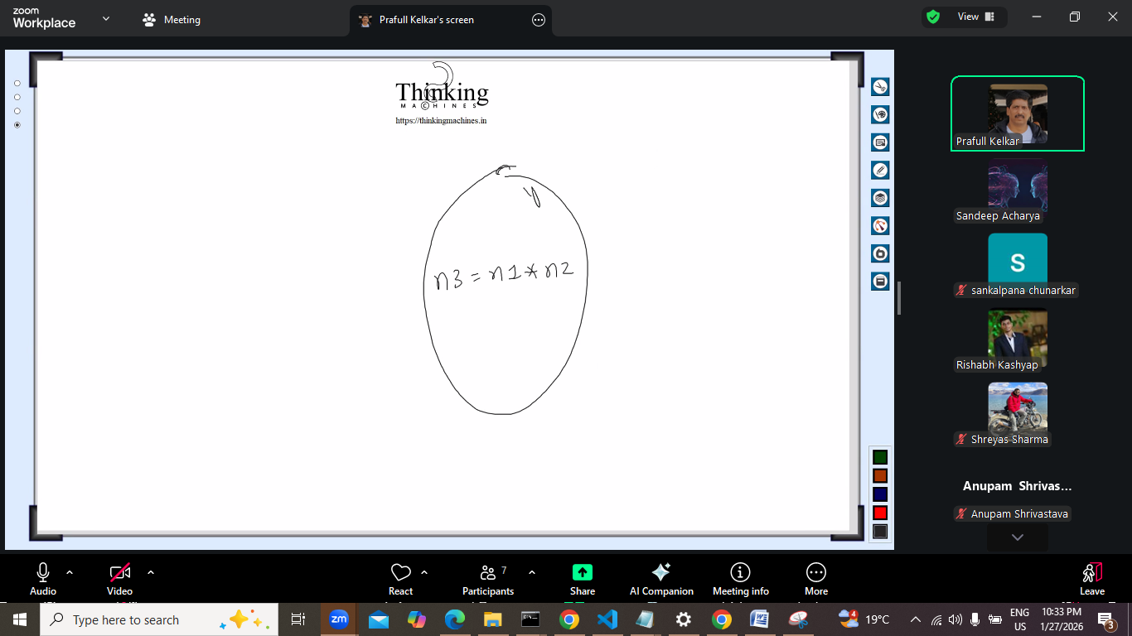
Ye krne ki baat krege to kya problem aayegi.
N3 update hoga update rule k hisab se , to isme kya issue he?
- Har baar n1 jis class se bna usme * naam ka function bnega. Rto ki vajah se vo n3 me move ho jayega.
- But n1 har baar bnega. Ye bahut bda issue he.
- NDArray me * naam ka function jo n2
- Har cycle pr naye naye matricss bnte jayege.

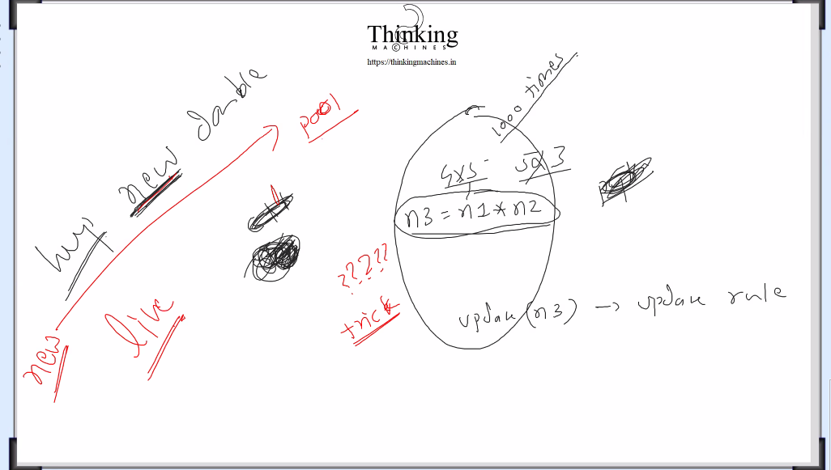
Pool sequential jesa
Memory ki jarurat pdegi to isi pool ka use krna
Usi se kaatna he and live k phle jo memory bn gayi vo final usi ko manage krna he.
Offset ka use kr k.
First cycle pr pool bn jaye
C hota to container bnate



C me hum bol rahe the ki cc me rkhna result.
Cpp me vo pool kese bnaye.
Container free kb krna he.

