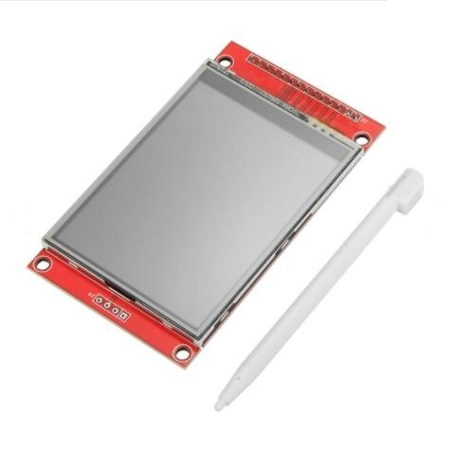
Touch: Resistive
Display Size: 2.8″
Size: 8.5 x 4.8cm
Input Voltage (V): 3.3 to 5
Driver IC: ILI9341
Color Depth: 262K/65K
Resolution (dots): 240 x 320
This TFT display is big (2.8″ diagonal) bright and colorful! 240×320 pixels with individual RGB pixel control, this has way more resolution than a black and white 128×64 display.
- As a bonus, this display has a resistive touchscreen attached to it already, so you can detect finger presses anywhere on the screen. This display has a controller built into it with RAM buffering so that almost no work is done by the microcontroller.
- The display can be used in two modes: 8-bit and SPI. For 8-bit mode, you’ll need 8 digital data lines and 4 or 5 digital control lines to read and write to the display (12 lines total). SPI mode requires only 5 pins total (SPI data in, data out, clock, select, and d/c) but is slower than the 8-bit mode. In addition, 4 pins are required for the touchscreen (2 digital, 2 analogs).
- This 2.8 inch SPI Touch Screen Module is wrapped up into an easy-to-use breakout board, with SPI connections on one end and 8-bit on the other. Both are 3-5V compliant with high-speed level shifters so you can use with any microcontroller. If you’re going with SPI mode, you can also take advantage of the onboard MicroSD card socket to display images.

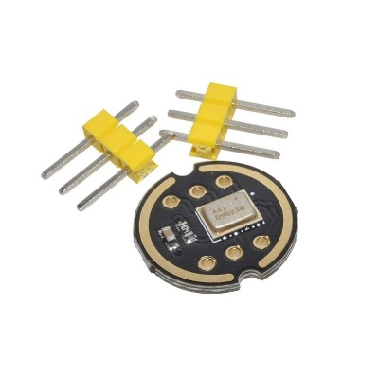
INMP441 MEMS High Precision Omnidirectional Microphone Module I2S
The INMP441 is a high-performance, low-power, digital output, omnidirectional MEMS microphone with a bottom port. The complete INMP441 solution consists of a MEMS sensor, signal conditioning, analog to digital converter, anti-aliasing filter, power management, and industry-standard 24-bit I2S interface.
The I2S interface allows the INMP441 to be directly connected to digital processors such as DSPs and microcontrollers without the need for an audio codec for use in the system. The INMP441 has a high signal-to-noise ratio and is an excellent choice for near-field applications. The INMP441 has a flat wideband frequency response that results in a high definition of natural sound.
Interface definition
- SCK: Serial data clock for I2S interface
- WS: Serial data word selection for I2S interface
- L/R: Left/Right channel selection.
- When set to low, the microphone outputs a signal on the left channel of the I2S frame.
- When set to high level, the microphone outputs signals on the right channel
- SD: Serial data output of the I2S interface.
- VCC: Input power, 1.8V to 3.3V.
- GND: power ground
NMP441 connection with ESP32
- SCK -GPIO14
- SD – GPIO32
- WS – GPIO15
- L/R – GND
- GND – GND
- VDD – VDD3.3

Features and Specifications:
- Digital I2S interface with high precision 24-bit data
- High signal to noise ratio is 61 dBA
- High sensitivity – 26 dBFS
- Stable frequency response from 60 Hz to 15 kHz
- Low power consumption: low current consumption 1.4 mA
- High PSR: -75 dBFS
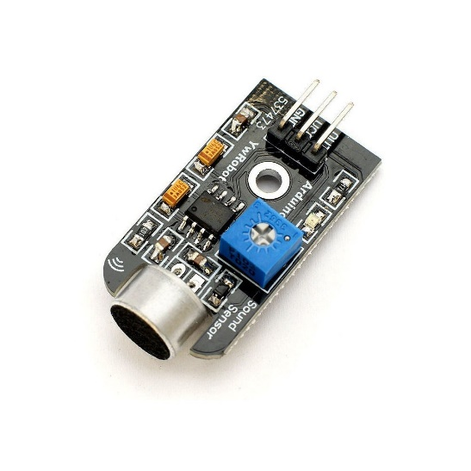This is an Analog Sound Sensor Microphone Module for Arduino. Some Applications like interactive voice switch and loudness level indicator is very suited for this module.

Features :
- Detectable sound signal size
- Built-in filter-rectifier circuit, DC signal output
- Good sensitivity, built-in amplifier circuit, adjustable gain
- Voltage signal for sound intensity can be obtained by AD conversion
- Analog voltage signal output, signal amplitude VCC/2
- Compatible for Arduino sensor interface.
IC Chip | LM386
Operating Voltage (VDC) | 5
Signal Amplitude | Vcc/2
PCB Size ( L x W ) mm | 35 x 18
Mounting Hole(mm) | 3
Shipment Weight | 0.006 kg
Shipment Dimensions | 5 × 3 × 2 cm

