All the Pages will have Header , Footer and Menu

Header



Menu

Color and background



Actual Menu   
welcome page and login page



Menu for rest all pages   


Home Page Body

Login Page 

Login Page Body

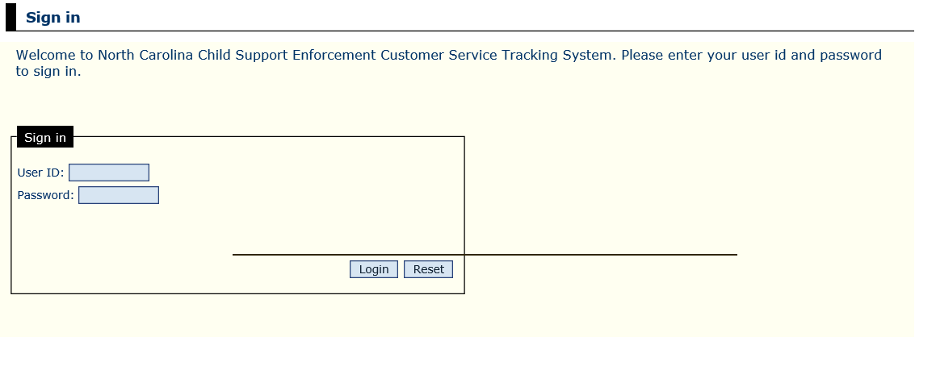

Welcome page body

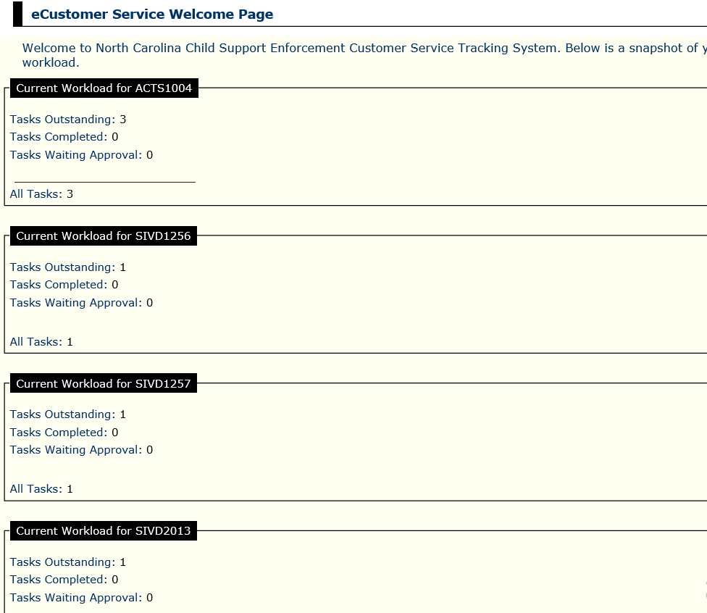

All the values in Task outstanding Task Complete and Tasks Awaiting Approval are coming from Database

Administration Menu Click

Body of the page

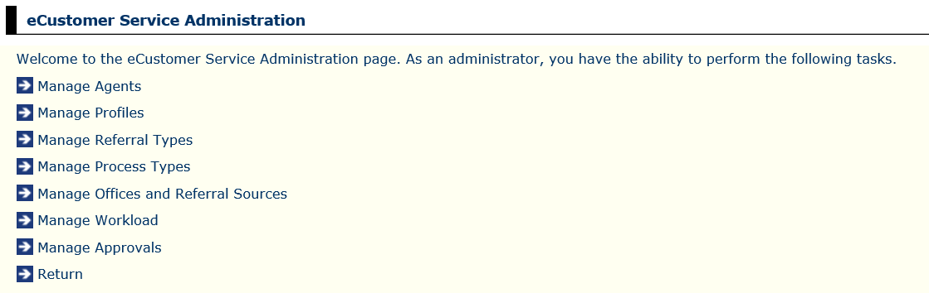

Manage Agents selection 🡪

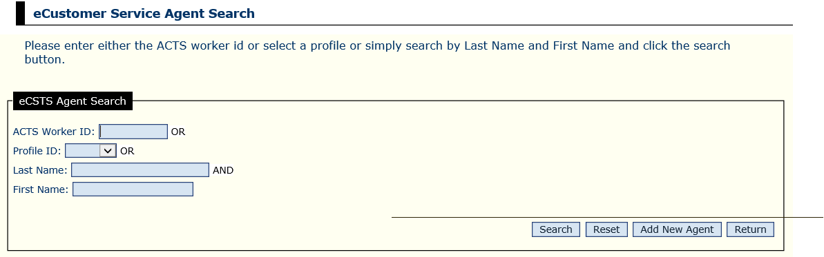

Reports Menu Click

Body of the page



Tasks Menu Click

