git –version



Configuring   




List of all config

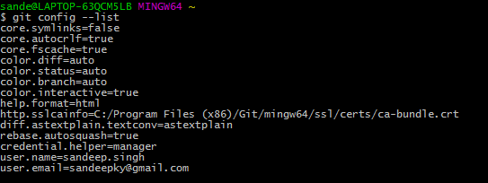

Looking at just one config  


Start a git project (Repository) at location C:\Users\sande\newbeginig\GIT\GITTutorialProject



Hidden files at this location (do not edit or touch these files)

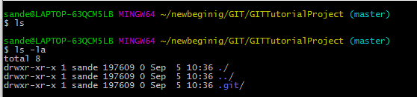

Added a text file FirstFile at C:\Users\sande\newbeginig\GIT\GITTutorialProject

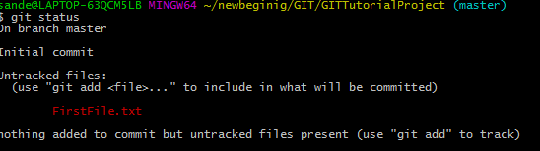

git add .

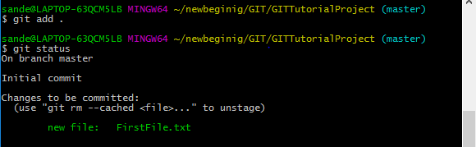

git commit taking a snap shot at that point of time  
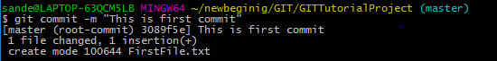



Looking at history of commit   
git log

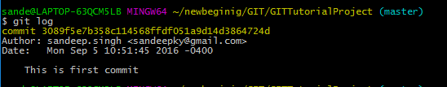

git log –author “sandeep” Looking for log of specific user (Partial user name will give results too)

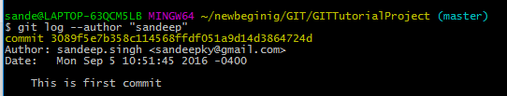

Add a new SecondFile in project

Adding jut this file   
  


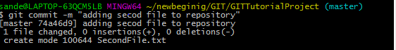

Work flow

Working directory ---🡪 Staging Area---🡪 Repository

Changes made to First File  
This is First file  
to   
This is First file here  
Adding NEW Line

git diff shows difference between working directory and Repository

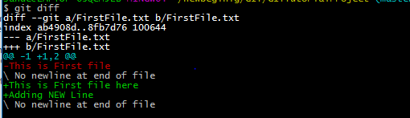

File ThirdFile   
Edit content and look at git diff (working Directory vrs Repository)  
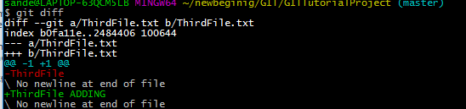

Now add this (Move to Staging)  
git add .a  
Now git diff don’t show any difference  


git diff –staged will show difference between staged and Repository  
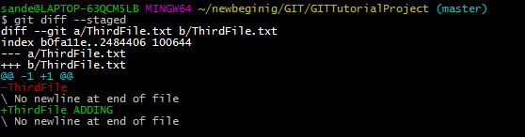

Renaming a file   
ThirdFile.txt to ThirdFileNew.txt

git mv ThirdFile.txt ThirdFileNew.txt

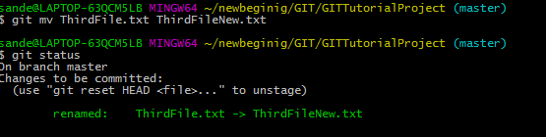

git checkout from Repository  
File in repository SecondFile.txt  
Adding some line  
File in working Directory   
Adding some line HERE



git checkout --- SecondFile.txt



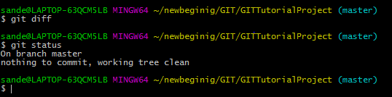

Content of SecondFile.txt

Adding some line

Reverting back to older version   
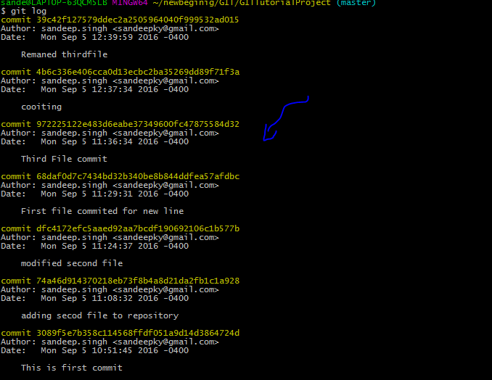

Git checkout – 972225122e48 ThirdFile.txt



