**18CS2205R – DATABASE MANAGEMENT SYSTEMS**

**PROJECT BASED REPORT**

**ON**

**SPOT EXAMINATION**

**submitted in partial fulfillment of the requirement for the award of the degree of**

**BACHELOR OF TECHNOLOGY**

**In**

**COMPUTER SCIENCE AND ENGINEERING**

**By**

CH. Pavankumar (180030689)



**DEPARTMENT OF COMPUTER SCIENCE AND ENGINEERING**

**K L (Deemed to be) University**

Green Fields, Vaddeswaram, Guntur District – 522 502

**(2019-2020)**

**ABOUT THE PROJECT:**

Our project is Spot Examination. We need to design a project in which the students can register and through the provided username and password they can login and the students can write the online exam. There will be a admin to monitor our website.

**AIM OF THE PROJECT:**

The aim of the project is to design a database using SQL commands. The tables have to created as per the topic of the project, insert five values in each of them and perform various SQL operations.

**SOFTWARE REQUIRED:**

1. Run SQL Command Line

**IMPLEMENTATION:**

The implementation has 3 parts in it.,

1. Table creation
2. Values insertion
3. Queries

According to the project, we have 3 tables created. They are.,

1. Signup.
2. Helprequest.
3. Users.

**ER DIAGRAM**

**ADMIN:**



**USER:**



**CREATING TABLES:**

1. CREATE TABLE REGISTRATION(

NAME VARCHAR(50) NOT NULL,

DOB VARCHAR(50) NOT NULL,

EMAIL VARCHAR(50) NOT NULL,

UNIVERSITY VARCHAR(50) NOT NULL,

USERID VARCHAR(50) NOT NULL,

PASSWORD VARCHAR(50) NOT NULL,4

AGE NUMBER(10);

);

1. CREATE TABLE HELPREQUEST(

USERNAME VARCHAR(50) NOT NULL,

COMMENTS VARCHAR(50) NOT NULL

);

1. CREATE TABLE USERS(

USERNAME VARCHAR(50) NOT NULL,

PASSWORD VARCHAR(50) NOT NULL

);

1. CREATE TABLE ADDQUESTIONS(

QUESTION VARCHAR2(50),

OPTION1 VARCHAR2(50);

OPTION2 VARCHAR2(50);

OPTION3 VARCHAR2(50);

OPTION4 VARCHAR2(50);

CORRECTOPTION VARCHAR2(50);

);

**INSERTING VALUES:**

**Inserting values into signup table:**

INSERT INTO REGISTRATION VALUES(‘VENKATA’,’GOWTHAM’,’CONVEY2GOWTHAM12@GMAIL.COM’,’KLU’,’GOWTHAM’,’GOWTHYAM’,’19’);

INSERT INTO REGISTRATION VALUES(‘VENKATA’,’AVINASH’,’CONVEY2AVINASH12@GMAIL.COM’,’KLU’,’AVINASH’,’AVINASH’ ,’19’);

INSERT INTO REGISTRATION VALUES(‘VENKATA’,’SAI’,’SAIKALYAN@GMAIL.COM’,’KLU’,’SAI123’,’SAI123’ ,’19’);

INSERT INTO REGISTRATION VALUES(‘PAVAN’,’KALYAN’,’PAVANKALYAN@GMAIL.COM’,’KLU’,’PAVAN’,’PAVAN123’ ,’19’);

INSERT INTO REGISTRATION

VALUES(‘VENKATA’,’GIRIDHAR’,’GIRIDHARVENKAT@GMAIL.COM’,’KLU’,’GIRI’,’GIRI123’ ,’19’);

**INSERTING VALUES INTO HELPREQUEST:**

INSERT INTO HELPREQUEST VALUES(‘PAVAN’,’I FORGET MY PASSWORD’);

INSERT INTO HELPREQUEST VALUES(‘SIRI’,’I CANT GET MY MARKS’);

INSERT INTO HELPREQUEST VALUES(‘NISHITHA’,’ I FORGET MY PASSWORD’);

INSERT INTO HELPREQUEST VALUES(‘SAI’, I HAVE TROUBLE WITH MARKS’);

INSERT INTO HELPREQUEST VALUES(‘KUMAR’,’ I CANT GET MY MARKS’);

**INSERTING INTO USER:**

INSERT INTO USER VALUES(‘PAVAN’,’PAONE’);

INSERT INTO USER VALUES(‘SIRI’,’SIRI123’);

INSERT INTO USER VALUES(‘SAI’,’SAI’);

INSERT INTO USER VALUES(‘NISHITHA’,’NISHITA123’);

INSERT INTO USER VALUES(‘KUMAR’,’KUMAR45’);

**INSERTION INTO ADDQUESTIONS:**

INSERT INTO ADDQUESTIONS VALUES(‘JAVA COMPILER NAME IS:’,’JAVAC’,JAVAH’,’JAVAP’,’JAVA’);

INSERT INTO ADDQUESTION VALUES(‘JAVA DEVELOPED IN YEAR:’,’1991’,’1992’,’1993’,’1995’);

INSERT INTO ADDQUESTION VALUES(‘EXTENSION OF BYTECODE:’,’.CLASS’,’.BYTE’,’.JAVA’,’.JAVAC’);

INSERT INTO ADDQUESTION VALUES(‘DIFFERENT TYPE OF JAVA’,’J2ME’,’J2SE’,’J2DE’,’J2EE’);

INSERT INTO ADDQUESTION VALUES(‘JAVA INTEREUPT NAME IS:’,’JAVAC’,’JAVAP’,’JAVA’,’JAVADOC’);

**SCREENSHOTS:**

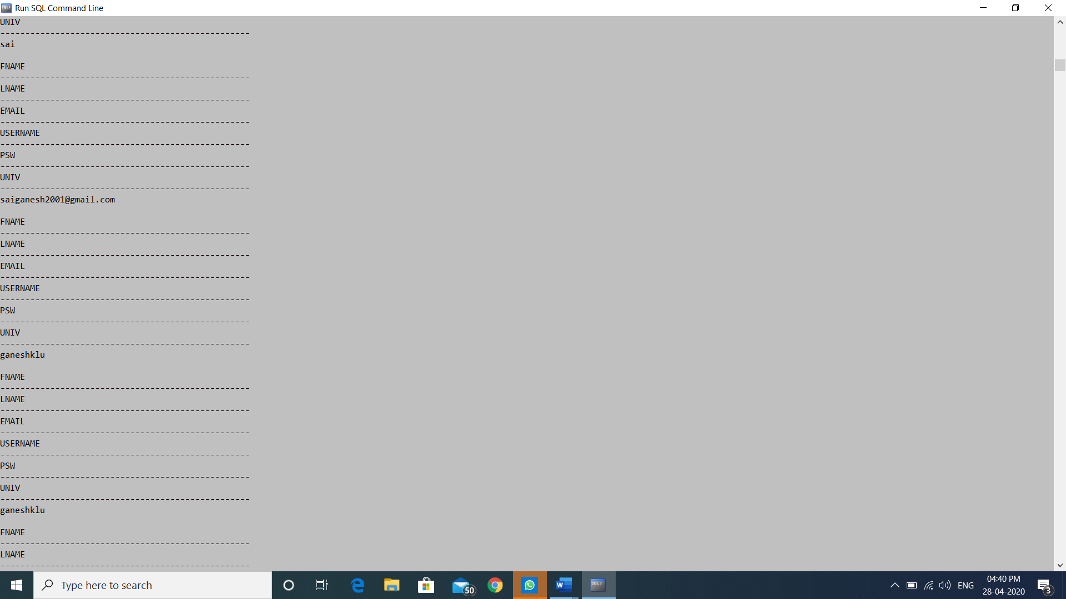

**SCREENSHOT 2:**

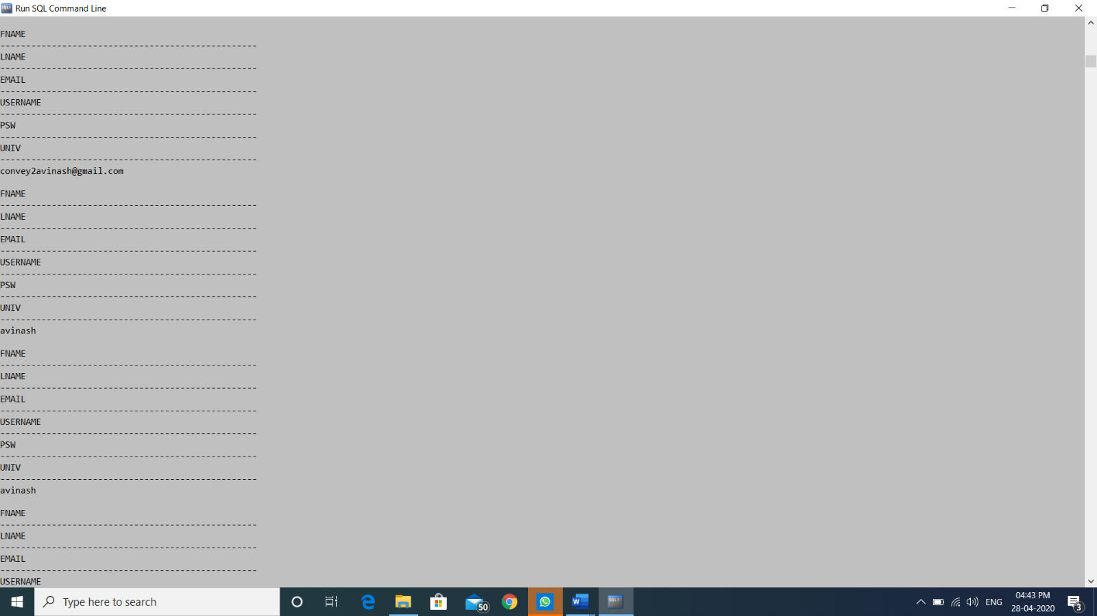

**COMMANDS USING AGGREGATE FUNCTIONS:**

* **MAX:**

SELECT MAX(AGE) FROM SIGNUP GROUP BY AGE;

* **COUNT:**

SELECT COUNT(USERNAME) AS TOTLAUSERS FROM SIGNUP;

* **JOIN FUNCTION:**

SELECT SIGNUP.USERNAME,SIGNUP.PASSWORD FROM SIGNUP INNER JOIN USERS ON SIGNUP.USERNAME=USERS.USERNAME;

**SCREENSHOT:**

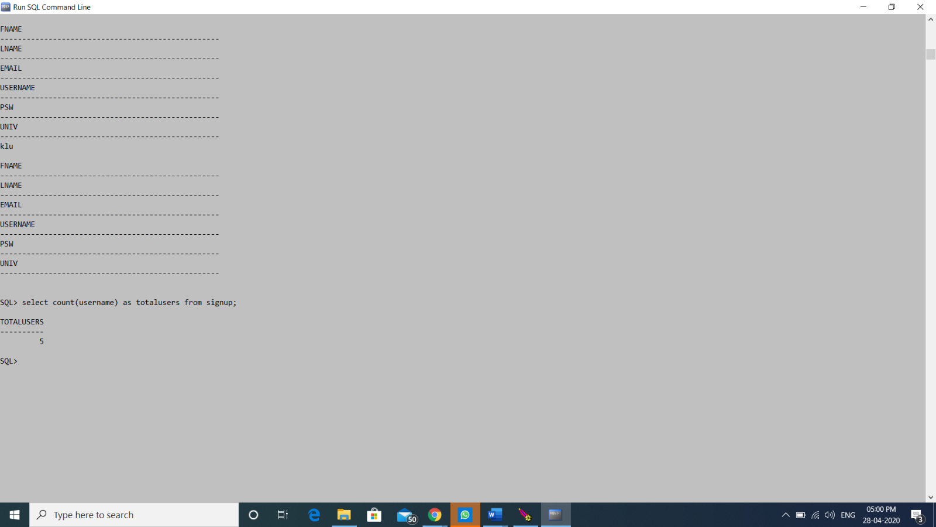

**CONCLUSION:**

From this project, we have learnt how to design a database based on the given conditions and execute the same successfully on Run SQL Command line.