## 2.1. Creating a webpage to work with angular

## Create a web page in Angular & display the results shown below.

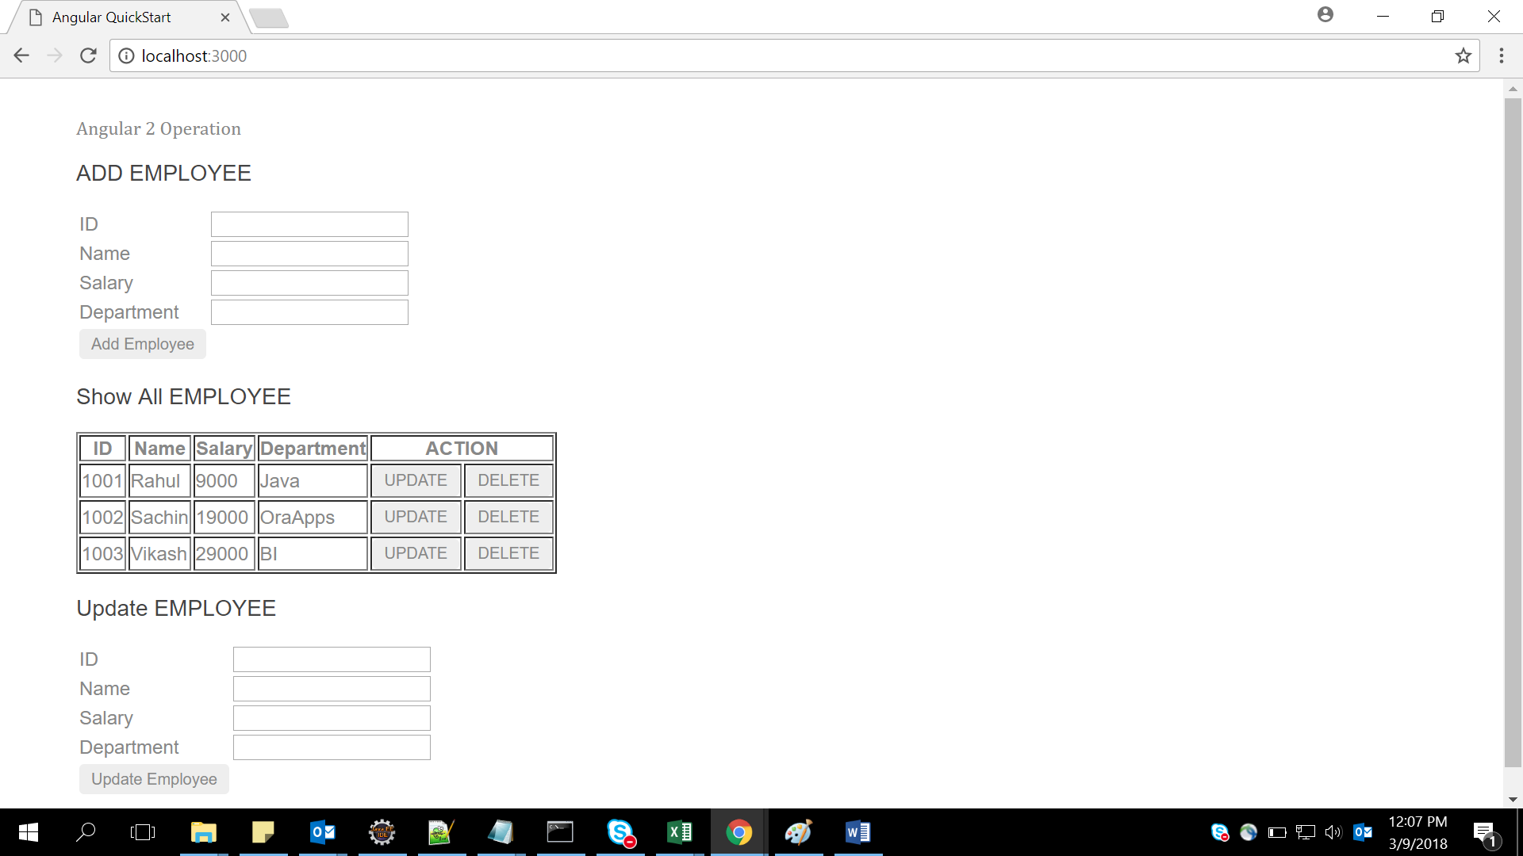

Show all data comes from array as below :

[

{empId:1001,empName:"Rahul",empSal:9000,empDep:"Java"},

{empId:1002,empName:"Sachin",empSal:19000,empDep:"OraApps"},

{empId:1003,empName:"Vikash",empSal:29000,empDep:"BI"},

];

When the user enter Id, name, salary & department in Add Employee & click button Add Employee data will come in Show All Employee & message will display as shown in figure below –example inserted id 1004,name rashi,salary 87000,department BI

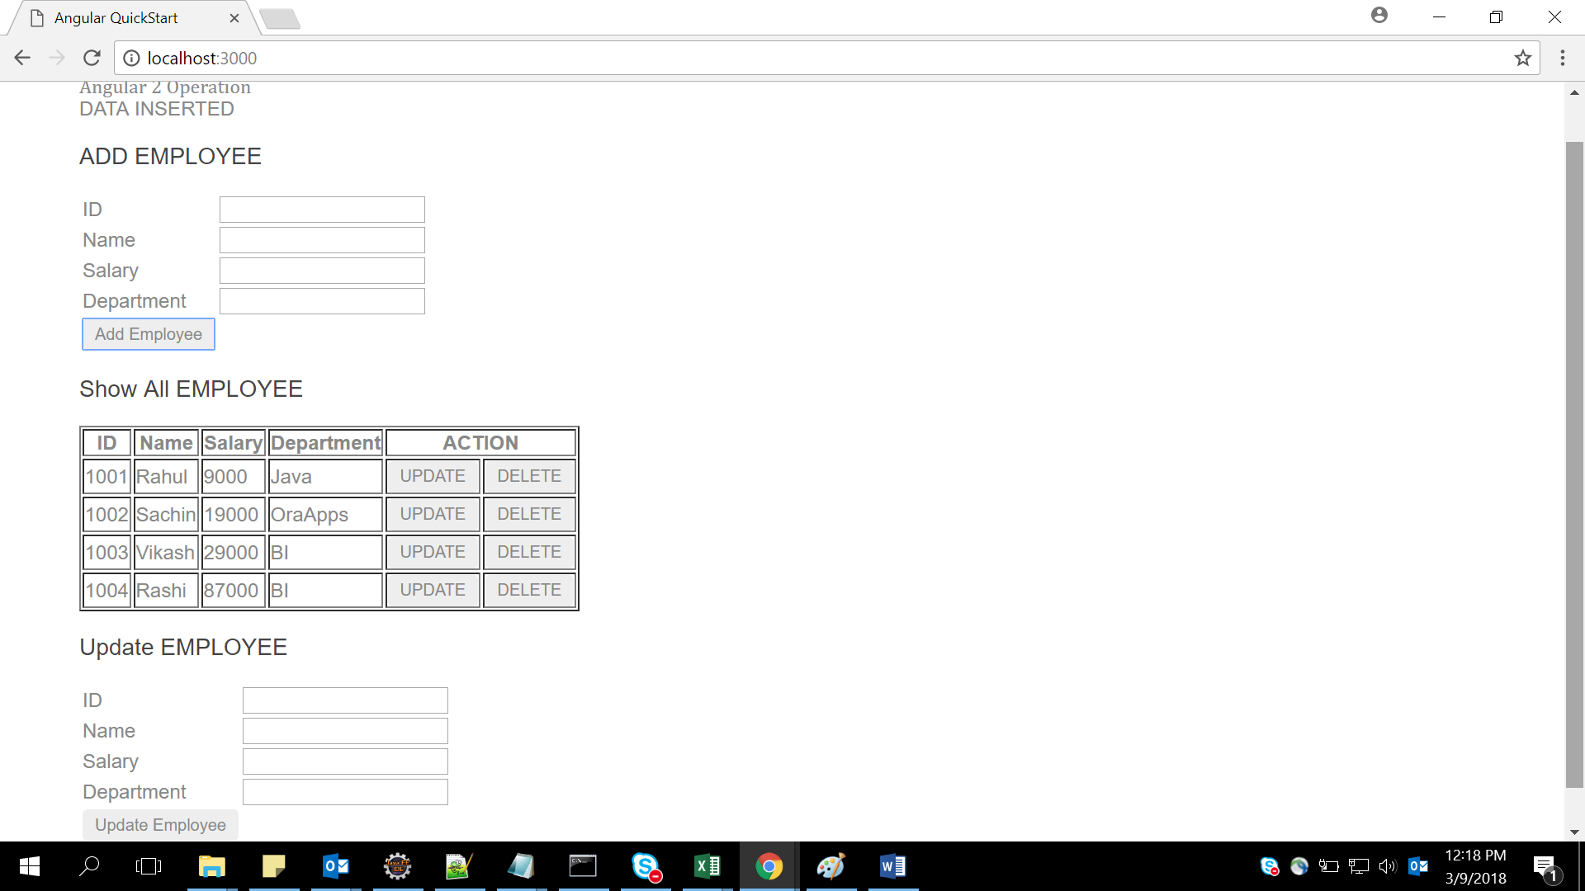

When we click button “Delete” that particular row will be deleted from Show All Employee & message will come ”DATA Deleted” as shown in below figure –Example delete rows 1003 by pressing delete button

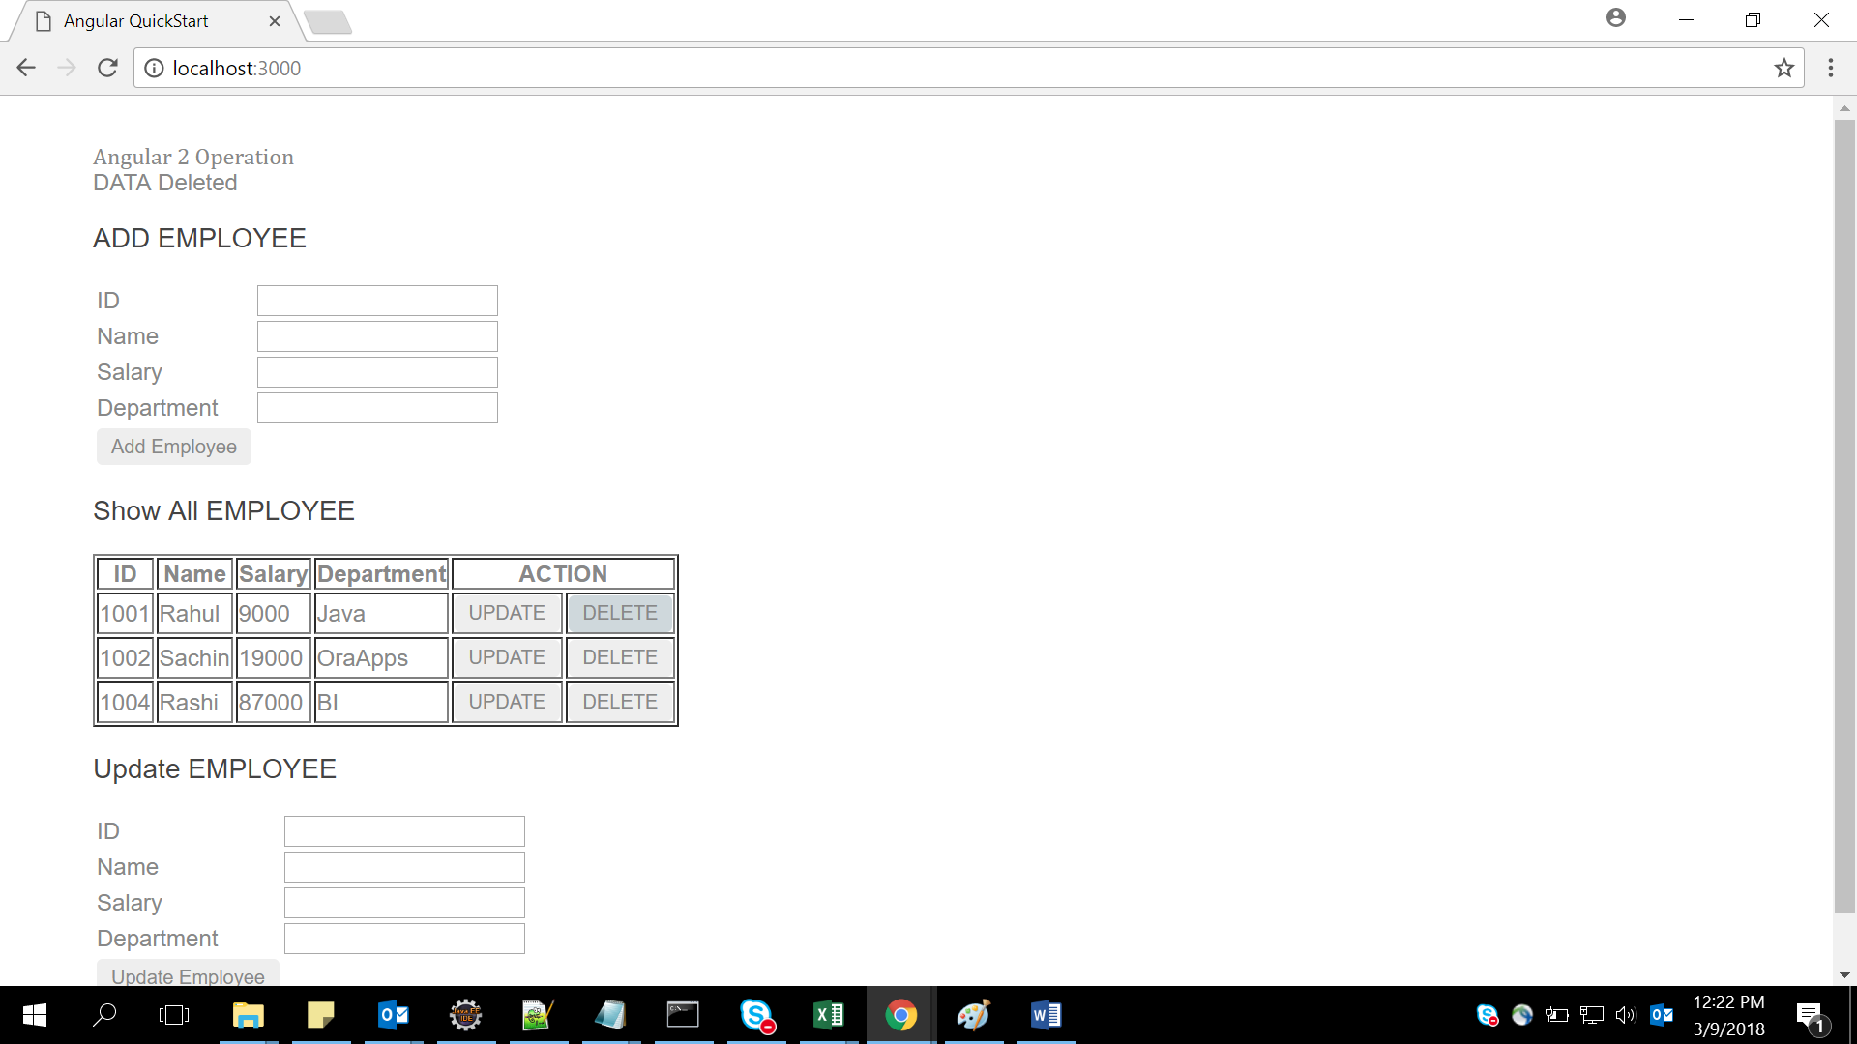

When we click button “Update” that particular row will be come in Update employee from Show All Employee & as shown in figure & when updated employee button click the data will update in show All employee & message will display

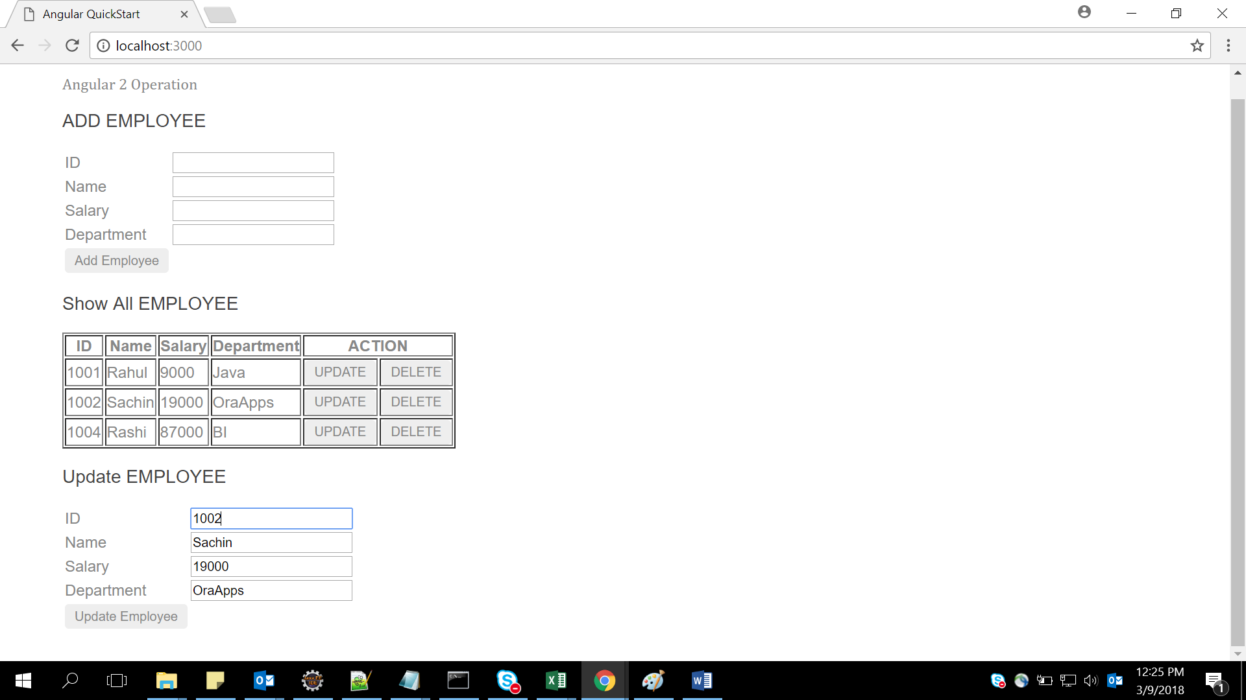

After Update employee button clicked data updated in show all employee & message came

