## Read the booklist.json file with the help of Angular service & display the images shown below;

Use <booklist.json>

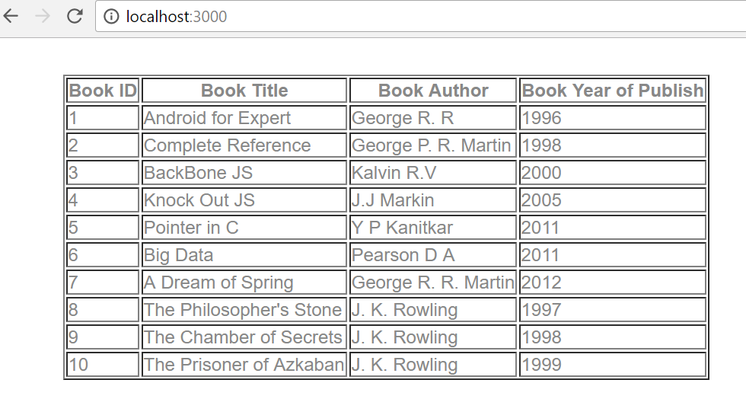

4.2: **Extended assignment 4.1 read booklist.json & apply search filter on id, title, year & author ,as shown in diagram**

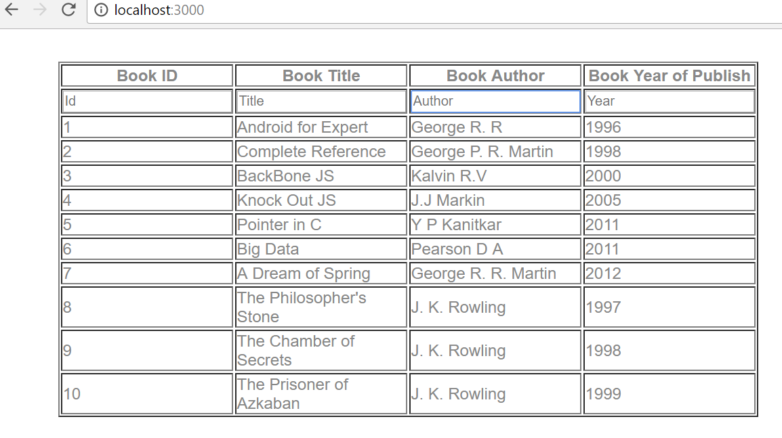

If we Search author, id, title, year only searched value will display in output …..searching K in author

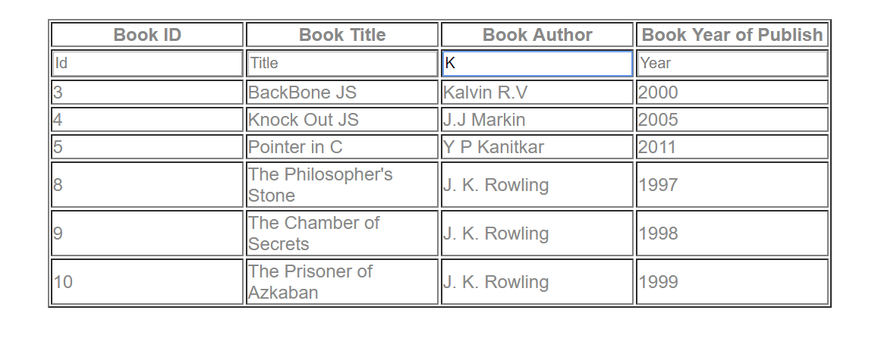

Searching Book Title …..A

