Assessment Parameters
- Solution Completeness (all requirements addressed) – 70 %
- Working solution for each requirement – 20 %
- Comments and Coding standards – 20%
- Bootstrap style and database design– 10 %
- ScreenShot should be submitted along with the solution
- The solution(Project) created by the trainee should have the name like AppName_Empid Ex:ABCCorp_675467
- Code with compilation errors will not be considered for evaluation
_______________________________________________________________________
Angular 5 [Marks 70]

Problem Statement: XYZ Company requires an Ecommerce Single Page application ,The Initial requirement for the company is first page is the SearchForm this page the person can search the product, another page should show all the available products.

- Use the following json file to store the data filename should be db.json(use the same data):
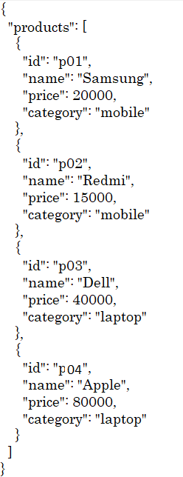
- Design the following using Angular 5 using router concept such that when the first page is loaded, it will redirect to Searchform the page should be like this.

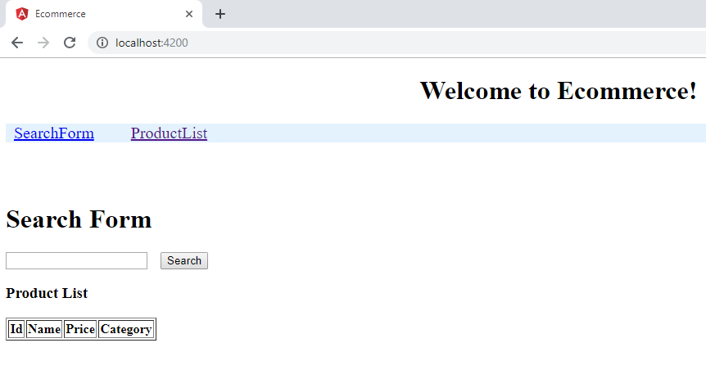

- When person click on Search Form page should be visible ,person can search the product by name or by category. The screen shot should be like this.

ByName of the product (user can enter any case product name but it shoule be visible)

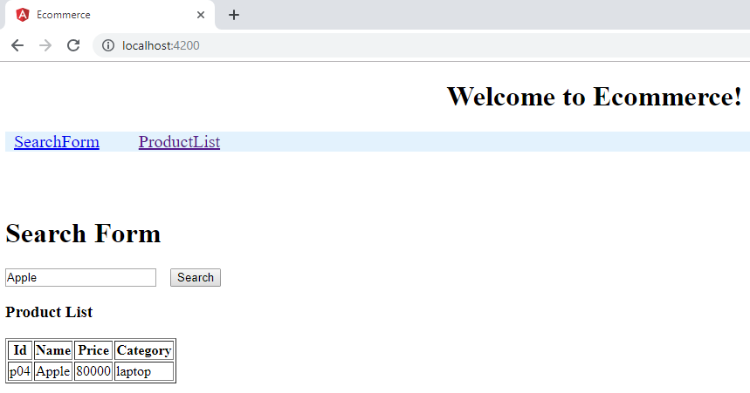

ByCategory of the product (user can enter any case category name but it shoule be visible)

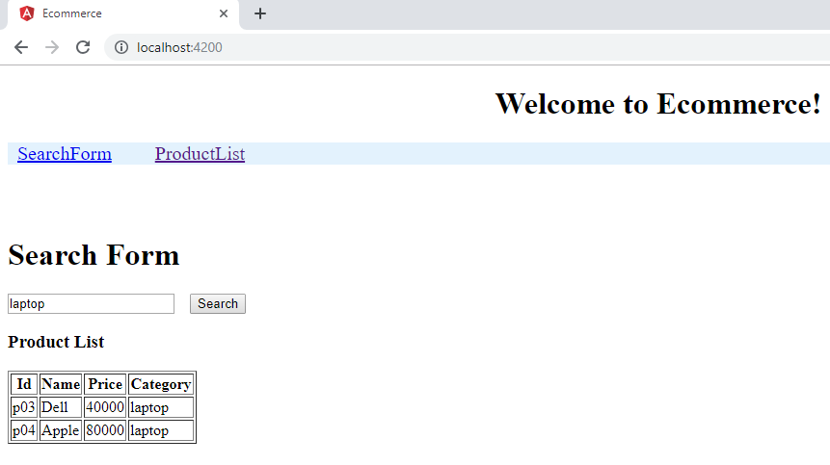

- When person click product List it should display all the available products details as follows.

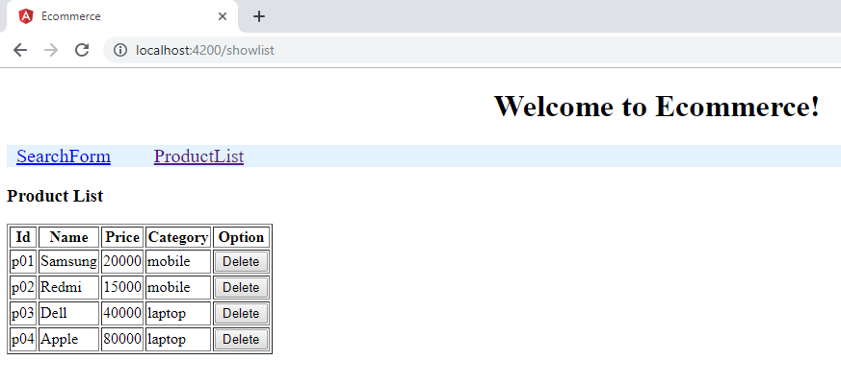

- When person click on the Delete button, that row will be deleted, example when click on the Apple delete button entire row get deleted, then page should show as follows.

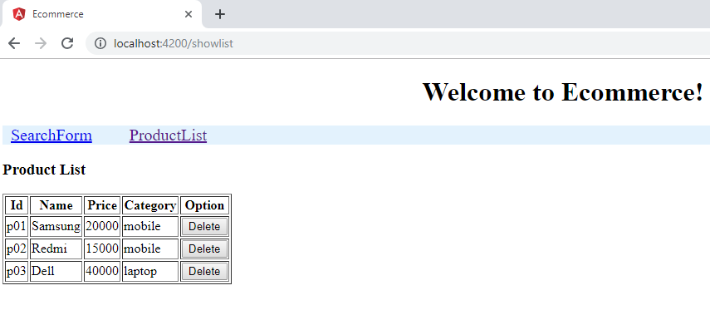

Marks Distribution
Parameters | Marks
Display home page(SearchForm) as per requirement using router concept | 10
Displaying the list of all products with details in the ProductList page | 15
Search Form should take the data as product name or category name and display the data according to the requirement | 15
Delete the row when clicking the delete button , update the page with remaining data. | 15
Coding convention ,packing as layered architecture, Proper naming convention of file | 5
Createing json file for storage | 5
Using bootstrap properly style the page | 5

