Table of Contents

Abstract 2

Dedication 2

Acknowledgements 2

List of Tables 2

List of Figures 2

Introduction 2

Software Architecture in Autonomous Vehicles 3

AutoDrive Challenge II 4

Thesis Overview 4

Background and Literature Review 4

Planning and control in Autonomous Vehicles 4

Global Path Planning 4

Decision making in AV 4

Control and vehicle maneuvering 4

Planning and control approaches 5

Classical Rule Based approaches 5

Optimization Based approaches 5

Learning Based approaches 5

Software Development 5

V-systems Engineering Process 5

Highway Lane Changing for Autonomous vehicles 5

Lane change decision making 7

Lane change problem formulation 7

Static Obstacle Lane Change 7

Dynamic Obstacle Lane Change 7

Lane Change Trajectory Generation 7

Sensitivity Analysis of Environment uncertainties for Lane Change Scenario 7

Lane Changing in challenging weather conditions. 7

Vehicle Mass Uncertainty 8

Lane Changing Path Profiles 8

Artificial Potential Field based Lane Change in the presence of uncertainties. 8

Verification and Validation 9

Overview 9

Model in loop V&V 9

Overview and setup 10

Hardware in loop V&V 10

Overview and setup 10

# Abstract

# Dedication

# Acknowledgements

# List of Tables

# List of Figures

# Introduction

Autonomous vehicles, also known as self-driving cars, have been in development for many years. The first autonomous vehicles were developed in the 1980s and 1990s, but they were very basic and not capable of driving on public roads. In the early 2000s, more advanced autonomous vehicles began to be developed, and they were able to navigate simple roads and highways under certain conditions.

Autonomous vehicles are being developed and tested for a variety of applications, including personal transportation, public transportation, and logistics. There is significant interest in using autonomous vehicles in these areas because they have the potential to improve safety, reduce costs, and increase efficiency. In the transportation industry, autonomous vehicles are used to operate taxi or ride-hailing services, providing a convenient and affordable transportation option for passengers. They could also be used to operate public transportation systems, such as buses or shuttles, allowing for more reliable and efficient service. In the logistics industry, autonomous vehicles could be used to transport goods between warehouses, distribution centers, and other locations, potentially reducing the need for human drivers and improving delivery times.

Over the past decade, there has been significant progress in the development of autonomous vehicles. Many car manufacturers, tech companies, and startups are working on developing autonomous vehicles that can drive in a wide range of conditions and environments. These vehicles use a variety of sensors, such as lidar, radar, and cameras, to gather data about their surroundings and make decisions about how to navigate the road. They also use complex algorithms and machine learning techniques to analyze the data and make decisions about how to safely operate the vehicle.

There are currently several autonomous vehicles on the road that are being tested by companies and organizations around the world. Some of these vehicles are fully autonomous, meaning they do not require a human driver at all, while others are semi-autonomous, meaning they still require a human driver to take control under certain circumstances. While autonomous vehicles are not yet widely available to the general public, it is expected that they will become more common in the coming years as the technology continues to advance.

## Software Architecture in Autonomous Vehicles

The software architecture of an autonomous vehicle is the overall design and structure of the software systems that enable the vehicle to sense its environment, make decisions, and control its movements. The software architecture of an autonomous vehicle typically consists of multiple layers or modules, each of which is responsible for a specific aspect of the vehicle's operation. Mainly, the modules include Perception, Localization, Decision Making and Control.

At the highest level, Perception and localization are two important capabilities for autonomous vehicles, as they allow the vehicle to sense its environment and determine its position and orientation. A perception system is responsible for interpreting the data gathered by the vehicle's sensors and creating a model of the vehicle's surroundings. The perception system uses techniques such as computer vision and machine learning to analyze the sensor data and identify objects and features in the environment, such as other vehicles, pedestrians, and road signs. Localization refers to the process of determining the position and orientation of the vehicle in its environment. This is typically done using a combination of techniques, such as GPS, LiDAR, visual localization, and inertial measurement unit (IMU) localization.

Perception and localization are closely related, as the vehicle's perception of its surroundings is used to inform its localization. For example, if an autonomous vehicle uses visual localization to determine its position, it will need to be able to identify features in its environment, such as landmarks or road signs, to match them to a pre-built map of the area. Similarly, if the vehicle uses LiDAR localization, it will need to be able to detect and measure the distance to objects in its environment in order to create a map of the surroundings.

Next is the decision-making system that is responsible for determining the appropriate actions for the vehicle to take based on its current state and its goals. The decision-making system uses various algorithms to analyze the data from the perception system and make decisions about how to operate the vehicle safely and effectively.

At the lowest level, the software architecture of an autonomous vehicle typically includes a control system that is responsible for managing the vehicle's physical systems, such as the steering, braking, and acceleration. The control system receives input from the higher-level planning modules, and it sends commands to the vehicle's actuators to control the vehicle's movements.

Finally, the software architecture of an autonomous vehicle typically includes a communication system that is responsible for transmitting and receiving data to and from other systems, such as the vehicle's sensors, actuators, and external systems, such as traffic lights and other vehicles. The communication system helps to coordinate the operation of the different components of the vehicle and ensure that the vehicle is able to interact with its environment in a safe and efficient manner.

Overall, the software architecture of an autonomous vehicle is a complex and sophisticated system that enables the vehicle to sense its environment, make decisions, and control its movements in a dynamic and unpredictable environment. As the technology continues to advance, it is expected that the software architectures of autonomous vehicles will become increasingly sophisticated and capable of handling a wide range of driving scenarios.

## AutoDrive Challenge II

The challenge aims to have 10 university teams develop and demonstrate an autonomous vehicle (AV) that can navigate urban driving courses as described by SAE Standard (J3016™) Level 4 automation.

More about the challenge and the targets.

## Thesis Overview

Brief description of all the thesis contents.

# Background and Literature Review

## Planning and control in Autonomous Vehicles

### Global Path Planning

### Decision making in AV

### Control and vehicle maneuvering

## Planning and control approaches

### Classical Rule Based approaches

Describe classical approaches

### Optimization Based approaches

### Learning Based approaches

Describe learning based approaches

#### Imitation Learning

#### Reinforcement Learning

## Software Development

### V-systems Engineering Process

#### Model in Loop development

#### Software in Loop development

#### Processor in Loop development

#### Hardware in Loop development

# Highway Lane Changing for Autonomous vehicles

There are several key challenges that autonomous vehicles (AVs) must overcome to navigate on highways safely and effectively. Some of these include:

1. Lane keeping and lane changing: AVs must be able to accurately detect and stay within the lanes on the highway, as well as safely and smoothly change lanes when necessary. This requires robust perception and localization capabilities, as well as sophisticated control algorithms.

Lane keeping and lane changing are important capabilities for autonomous vehicles (AVs) to have when driving on highways. These tasks can be challenging for AVs because they require the vehicle to accurately perceive and understand its environment, as well as make safe and smooth driving decisions. One of the key challenges in lane keeping is accurately detecting and tracking the lanes on the road. This is typically done using a combination of cameras, lidar, radar, and other sensors, which can detect the edges of the lanes and other road markings. The sensor data is then processed using computer vision algorithms that can identify the lanes and track their position over time.

Once the lanes have been detected and tracked, the AV can use control algorithms to keep the vehicle within the lanes. This typically involves using a combination of steering, braking, and acceleration commands to control the position and speed of the vehicle. The control algorithms should be robust enough to handle different road conditions and lane geometry, such as curved roads and merging lanes.

Lane changing is similarly challenging and requires the AV to have a precise understanding of its environment and the intentions of other vehicles on the road. The AV must detect and track the other vehicles and use this information to plan and execute safe lane changes. This typically involves assessing the speed, position, and trajectory of the other vehicles, and using this information to calculate safe gaps for lane changes. The AV must also take into account the surrounding traffic and any potential hazards, such as construction or emergency vehicles.

To ensure safety, the decision-making and control algorithms for lane keeping and lane changing are typically tested extensively in simulation and on test tracks before being deployed on real roads.

In general, Lane keeping and lane changing are complex task for autonomous vehicles, it is important to note that many companies are testing their AVs on different geographical locations to adapt and enhance their systems to work optimally based on different weather conditions, and traffic flow.

1. Handling high-speed driving: AVs must be able to safely and comfortably drive at high speeds, which can be challenging due to the large forces involved. This requires the vehicle to have precise and responsive steering, braking, and acceleration capabilities.
2. Handling merging and merging traffic: AVs must be able to safely enter and exit highway on-ramps and off-ramps, as well as navigate through merging traffic. This requires the vehicle to have an accurate understanding of its environment and the intentions of other vehicles on the road.
3. Handling different weather and lighting conditions: AVs must be able to operate in a wide range of weather and lighting conditions, including rain, fog, snow, and darkness. This requires the vehicle to have robust perception capabilities that can handle occlusions and reflections caused by different weather and lighting conditions.
4. Handling emergency and unexpected events: AVs must be able to safely and smoothly handle emergency and unexpected events, such as sudden braking by other vehicles, lane closures, and construction zones. This requires the vehicle to have an accurate understanding of its environment and the ability to make rapid and safe decisions.
5. Handling traffic laws and regulations: AVs must be aware and follow all traffic laws and regulations. which can vary from state to state, country to country and region to region. They should also be designed to handle specific situations such as emergency vehicles, school buses and many more.

Overall, developing AVs that can safely and effectively navigate on highways requires a combination of advanced sensor technologies, sophisticated perception and decision-making algorithms, and rigorous testing and validation.

## Lane change decision making

### Lane change problem formulation

### Static Obstacle Lane Change

### Dynamic Obstacle Lane Change

## Lane Change Trajectory Generation

# Sensitivity Analysis of Environment uncertainties for Lane Change Scenario

## Lane Changing in challenging weather conditions.

Lane changes for autonomous vehicles in challenging weather conditions, such as heavy rain, snow, or fog, can be a complex task. Autonomous vehicles rely on a variety of sensors, such as cameras and LIDAR, to detect and interpret the road and other vehicles. In challenging weather conditions, these sensors can be affected by reduced visibility, glare, and reflections.

To safely perform lane changes in challenging weather conditions, autonomous vehicles must have the following capabilities:

1. Weather-adaptive sensors: The vehicle's sensors must be able to detect and track objects in challenging weather conditions and be able to adjust their performance accordingly.
2. Weather-adaptive control systems: The vehicle's control systems, such as the steering and braking systems, must be able to respond quickly and accurately to the road conditions, adjusting the vehicle's trajectory and speed as necessary to maintain stability and avoid skidding.
3. Weather-adaptive software algorithms: The vehicle's software must be able to process sensor data and adjust the vehicle's behavior in real-time to ensure a safe journey. This includes adjusting the vehicle's speed, trajectory, and following distance based on the road conditions.

It's worth mentioning that the implementation of these capabilities is a challenging task, and some companies are still working to improve the system to work under all weather conditions.

Top of Form

Some of the critical parameters to analyze the lane change behavior in challenging weather conditions can be:

1. Traction control: Autonomous vehicles must have a reliable traction control system to maintain a stable and safe trajectory on slippery roads. This includes monitoring wheel slip and adjusting the engine's power output to prevent skidding.
2. Speed: The vehicle's speed must be adjusted based on the road conditions to ensure safe lane changing. On slippery roads, the vehicle should be driven at a lower speed to increase stability and reduce the risk of skidding.
3. Steering and braking: The vehicle's steering and braking systems must be able to respond quickly and accurately to the road conditions. This includes adjusting the steering angle and brake pressure to maintain control of the vehicle and avoid skidding.
4. Sensor performance: The vehicle's sensors, such as cameras and LIDAR, must be able to accurately detect and interpret the road and other vehicles in the presence of adverse weather conditions, such as heavy rain and fog.
5. Road information: The vehicle's software must have access to accurate and up-to-date information on the road conditions, such as the location of standing water or ice, to adjust its behavior and ensure a safe journey.
6. Vehicle dynamics: the vehicle's dynamics, such as the vehicle mass, center of gravity, and tire-road friction, must be taken into account when making lane changes on slippery roads.
7. Emergency braking: the vehicle must be able to apply emergency braking when it detects a potential collision or hazardous situation.

Overall, lane changing for autonomous vehicles in slippery road conditions requires a combination of advanced sensors, control systems, and software algorithms to safely navigate the vehicle in these challenging conditions.

## Vehicle Mass Uncertainty

## Lane Changing Path Profiles

# Artificial Potential Field based Lane Change in the presence of uncertainties.

# 

# Verification and Validation

## Overview

## Model in loop V&V

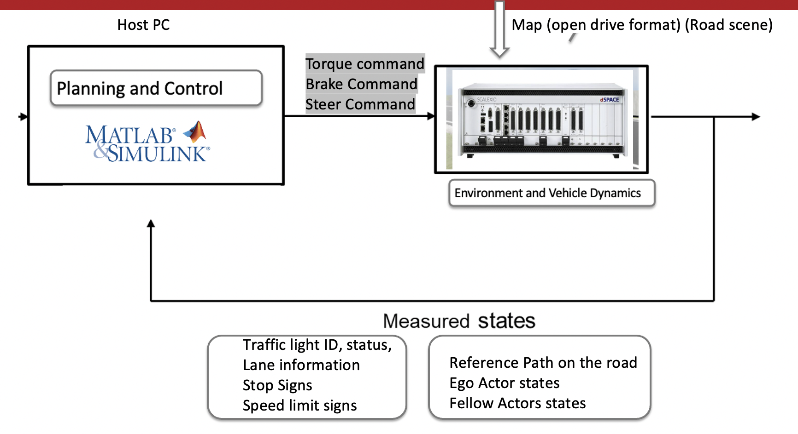

### Overview and setup

## Hardware in loop V&V

### Overview and setup