Home Page – Please fix if search, go to sign in page (https://dev.rimark.us/login/)



Newsfeed – Mobile

Please fix padding too thick, fix search, remove Google API drop down

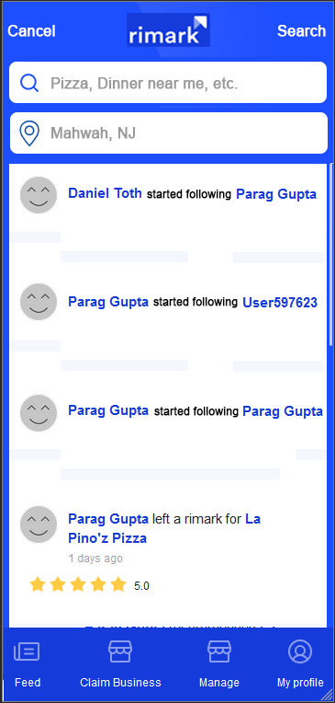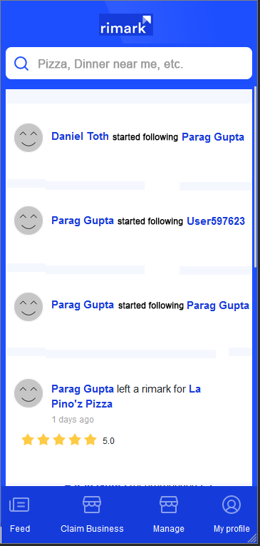This is how newsfeed should look If you click in search a drop down appears as below

After you search, it should look like below, and if you were to search again, the drop down would then show with search / cancel on the top corners

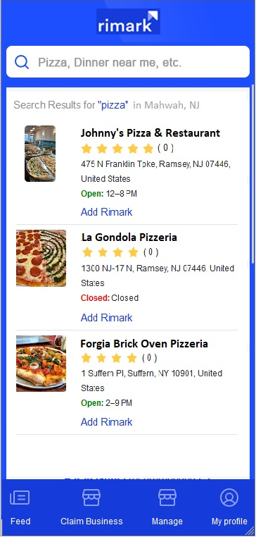

Please fix search results UI/UX as above and make picture also hyperlink to business page on both desktop and mobile

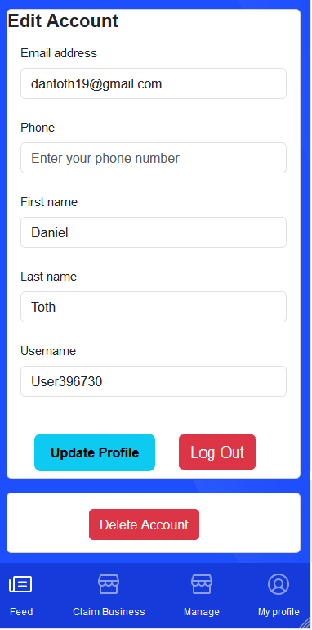Mobile Edit profile please fix delete account button and put it like it is in picture

Still need to review prior document 3 with fixes like profile page etc. Please go over old doc and make sure all fixes are completed.

Also make it where only the business can reply to Rimarks if they’re logged into their page

Reference Google Maps – Example

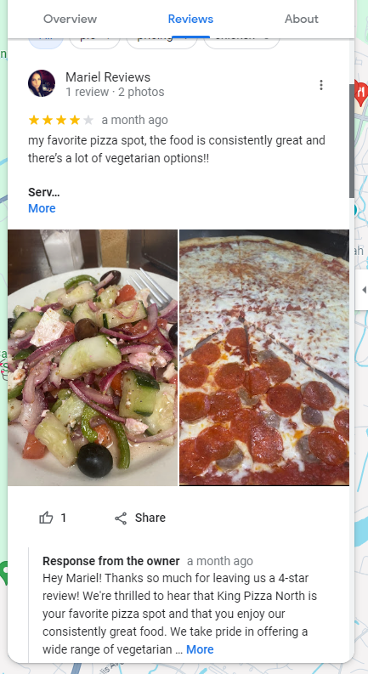

For CRM

**Business**

Under Businesses have the sub menu

* Registered Business (currently showing 2384 businesses – incorrect, only show businesses that have been registered.

Please provide the following Columns

Business Name | Business Email | Date Registered | Premium | Premium Date | Last Login

We will provide a Yes/No under premium if they pay with the date they paid on

Need to be able to sort each column up/down

Reviews

* Please provide following Columns
* Full Name | Username | Business Name | Review | Rating | Date
* Need to be able to sort each column up/down

Users

* Please provide following Columns
* Full Name | Username | Email | Phone | City | State | Zip Code | Last Login

This should be good to start and we can meet once updates are made, thank you!