GMM Product Recommendation System
Complete Deployment Guide — AWS SageMaker
B2B Construction Supply | 5,000 Customers | 5,463 Products | 50,000 Transactions

GitHub: https://github.com/sandeeptiwari0206/gmm-newdata

Who is this guide for? Anyone with an AWS account can follow these steps from scratch — clone the repo, configure credentials, upload data, and run the full pipeline to generate product recommendations.

What you will have at the end:
- A fully trained GMM clustering model (7 clusters) on AWS SageMaker
- A complete 5-step automated SageMaker Pipeline
- A CSV file with top product recommendations for every customer
- A registered model in SageMaker Model Registry for version control

Table of Contents
1 Project Overview & Architecture ........ 3
2 Prerequisites & Requirements ........ 4
3 Project File Structure ........ 5
4 Step-by-Step Setup ........ 6
4.1 Clone the Repository ........ 6
4.2 Install Python Dependencies ........ 6
4.3 Configure AWS Credentials ........ 6
4.4 Create S3 Bucket ........ 7
4.5 Create IAM Role ........ 7
4.6 Update config.yaml ........ 8
4.7 Upload Data to S3 ........ 9
5 Pipeline — Detailed Explanation ........ 10
5.1 Pipeline Overview ........ 10
5.2 Step 1 — Preprocessing ........ 10
5.3 Step 2 — Training (GMM Algorithm) ........ 11
5.4 Step 3 — Evaluation (BIC Check) ........ 11
5.5 Step 4 — BIC Condition Gate ........ 12
5.6 Step 5 — Generate Recommendations ........ 12
6 Running the Pipeline ........ 13
7 Viewing Results & Output Files ........ 14
8 Understanding the Output CSV ........ 15
9 GMM Algorithm Deep Dive ........ 16
10 Scoring Formula & Strategies ........ 17
11 Cost Estimate ........ 18
12 Troubleshooting ........ 18
13 All Commands Quick Reference ........ 19

1 — Project Overview & Architecture
This project builds a machine learning-powered product recommendation system for a B2B construction supply business. GMM (Gaussian Mixture Model) clustering groups the 5,463 products into behavioural segments based on price, popularity, and revenue patterns. Each customer is then matched to the cluster that best represents their purchase history, and unseen products from that cluster are ranked and recommended.

Architecture
Your Machine ──clone──► GitHub Repo
│
│ aws s3 cp (data upload)
▼
AWS S3 Bucket ◄────────────────────────────────────────────┐
(input data) │
│ │ outputs
▼ │
SageMaker Pipeline ─────────────────────────────────────────┘
┌──────────────────────────────────────────────────────────┐
│ Step 1: GMMPreprocessing (sm_preprocessing.py) │
│ ↓ │
│ Step 2: GMMTraining (sm_training.py) ← GMM HERE │
│ ↓ │
│ Step 3: GMMEvaluation (sm_evaluation.py) │
│ ↙ ↘ │
│ Step 4: GMMBICCondition Step 5: GMMGenerateReco │
│ (register model) (sm_generate_recommendations.py)│
└──────────────────────────────────────────────────────────┘
↓
S3: all_customer_recommendations.csv (FINAL OUTPUT)

Dataset
products_raw.csv 5,463 products — category, brand, price, L1/L2 classification
users.csv 5,000 customers — customer ID and segment
invoices.csv 50,000 transactions — links customers to purchased products

Appendix — Block Diagrams
The following diagrams provide three views of the GMM Recommendation System architecture — from a simple overview to a fully detailed DevOps block diagram. All diagrams are available in draw.io XML format (gmm_drawio.xml) for editing.

Edit these diagrams: open app.diagrams.net → File → Import From → Device → select gmm_drawio.xml

Diagram 1 — Basic Block Diagram
High-level overview showing the four main components: GitHub Repository, Local Machine, AWS S3 Bucket, SageMaker Pipeline (5 steps), and Model Registry. Best for presentations and executive summaries.

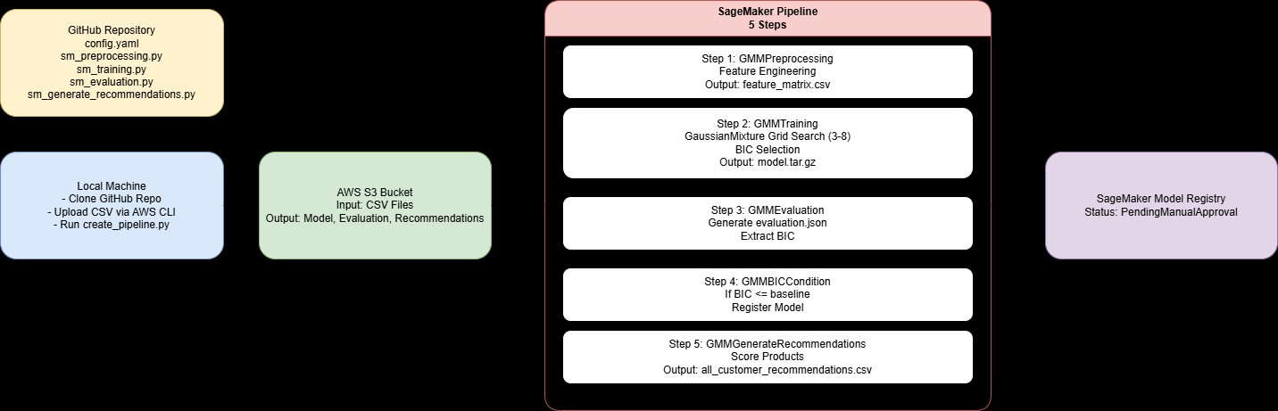
Figure 1 — Basic Block Diagram: High-level GMM Pipeline Overview

Diagram 2 — Standard Block Diagram
Intermediate-level diagram showing Developer End, AWS End with IAM, S3, SageMaker Pipeline Orchestration, CloudWatch, the 5 pipeline steps with condition branching, Model Registry with versions and approval flow, and S3 output files.

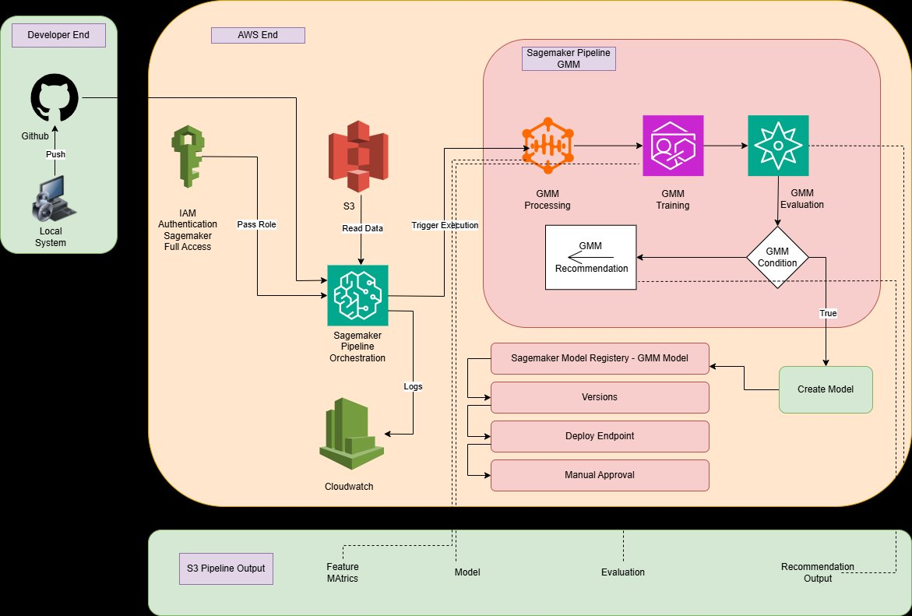
Figure 2 — Standard Block Diagram: Developer to AWS Flow with Pipeline Steps

Diagram 3 — Detailed DevOps Block Diagram
Full DevOps architecture diagram showing all layers: Developer Machine with local files and commands, AWS Cloud zone with IAM Role, S3 input bucket, SageMaker Pipeline Orchestrator and CloudWatch, the complete 5-step SageMaker Pipeline with instance types, inputs/outputs, algorithm details, BIC condition gate and branch, S3 output files, and the Model Registry with version management and deployment endpoint.

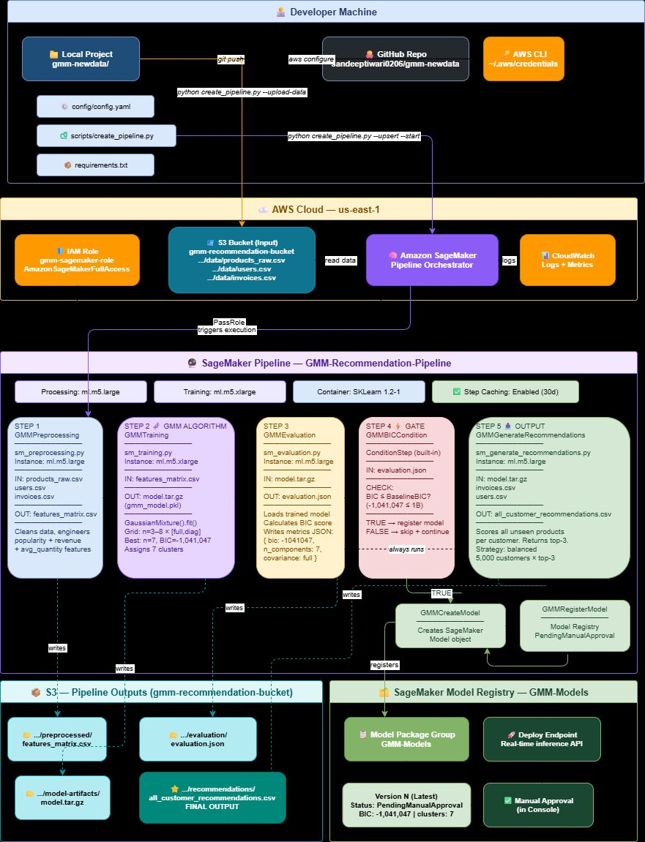
Figure 3 — Detailed DevOps Block Diagram: Complete Architecture with All Layers

2 — Prerequisites & Requirements
Requirement | Minimum Version / Value | Purpose
AWS Account | Active account | SageMaker, S3, IAM access
Python | 3.8+ | Run local scripts
AWS CLI | 2.x | Upload data, configure credentials
sagemaker SDK | >=2.100.0 | step_args API required
boto3 | >=1.26 | AWS SDK for Python
scikit-learn | >=1.0 | GaussianMixture, preprocessing
pandas / numpy | Latest | Data manipulation
RAM | 8 GB+ | Local preprocessing
products_raw.csv | 5,463 rows | Product catalog
users.csv | 5,000 rows | Customer master data
invoices.csv | 50,000 rows | Purchase transaction history

Critical — sagemaker SDK version: This pipeline uses step_args=processor.run() API which requires sagemaker >=2.100.0. Run: pip install --upgrade sagemaker before starting.

3 — Project File Structure
gmm-newdata/
├── config/
│ └── config.yaml ← All settings (YOU EDIT THIS)
├── data/
│ └── raw/
│ ├── products_raw.csv ← Put your data here
│ ├── users.csv
│ └── invoices.csv
├── scripts/
│ ├── create_pipeline.py ← Main pipeline definition
│ ├── sm_preprocessing.py ← Step 1
│ ├── sm_training.py ← Step 2 — GMM algorithm
│ ├── sm_evaluation.py ← Step 3
│ └── sm_generate_recommendations.py ← Step 5
├── src/
│ ├── inference.py ← Endpoint handler
│ └── utils.py ← Config loader
├── requirements.txt
└── README.md

File / Folder | Purpose
config/config.yaml | All project settings — bucket, region, instance types, hyperparameters
scripts/create_pipeline.py | Defines and registers the SageMaker Pipeline (5 steps)
scripts/sm_preprocessing.py | Data cleaning, feature engineering, outputs preprocessed CSV
scripts/sm_training.py | GMM grid search — trains best model, saves model.tar.gz
scripts/sm_evaluation.py | Loads trained model, calculates BIC, writes evaluation.json
scripts/sm_generate_recommendations.py | Generates top-N recommendations CSV for all customers
src/inference.py | SageMaker endpoint inference handler
src/utils.py | load_config, get_sagemaker_config helpers
data/raw/ | Local CSVs before S3 upload
requirements.txt | Python dependencies

4 — Step-by-Step Setup

4.1 Clone the Repository
git clone https://github.com/sandeeptiwari0206/gmm-newdata.git
cd gmm-newdata

4.2 Install Python Dependencies
# Create virtual environment (recommended)
python -m venv venv
source venv/bin/activate # Mac / Linux
venv\Scripts\activate # Windows

# Install all packages
pip install -r requirements.txt

# Verify sagemaker version (MUST be >= 2.100.0)
python -c "import sagemaker; print(sagemaker.__version__)"

# If version is too old:
pip install --upgrade sagemaker boto3

4.3 Configure AWS Credentials
aws configure

# Enter when prompted:
AWS Access Key ID: YOUR_ACCESS_KEY_ID
AWS Secret Access Key: YOUR_SECRET_ACCESS_KEY
Default region name: us-east-1
Default output format: json

# Verify credentials work:
aws sts get-caller-identity
# Expected: returns your Account ID and ARN

Where to get credentials: AWS Console → Top-right your name → Security Credentials → Access Keys → Create Access Key

4.4 Create S3 Bucket
# Replace with your preferred unique bucket name
aws s3 mb s3://gmm-recommendation-bucket --region us-east-1

# Verify:
aws s3 ls | grep gmm

Note: S3 bucket names are globally unique. If the name is taken, use: gmm-reco-yourname-2025

4.5 Create IAM Role for SageMaker
SageMaker needs an IAM role to access S3, CloudWatch and ECR:

AWS Service | Required Permission / Policy
SageMaker | AmazonSageMakerFullAccess (managed policy)
S3 | s3:GetObject, s3:PutObject, s3:ListBucket on your bucket
ECR | ecr:GetAuthorizationToken, ecr:BatchGetImage
CloudWatch | logs:CreateLogGroup, logs:PutLogEvents (auto via SageMaker policy)
IAM PassRole | iam:PassRole on the SageMaker execution role itself

Option A — AWS Console (easiest):
- AWS Console → IAM → Roles → Create Role
- Select: AWS Service → SageMaker → Next
- Attach policy: AmazonSageMakerFullAccess → Next
- Name: gmm-sagemaker-role → Create Role
- Open the role → copy the ARN (arn:aws:iam::123456789:role/gmm-sagemaker-role)

Option B — AWS CLI:
# Create trust policy
cat > trust-policy.json << 'EOF'
{
"Version": "2012-10-17",
"Statement": [{
"Effect": "Allow",
"Principal": {"Service": "sagemaker.amazonaws.com"},
"Action": "sts:AssumeRole"
}]
}
EOF

# Create role
aws iam create-role \
--role-name gmm-sagemaker-role \
--assume-role-policy-document file://trust-policy.json

# Attach policy
aws iam attach-role-policy \
--role-name gmm-sagemaker-role \
--policy-arn arn:aws:iam::aws:policy/AmazonSageMakerFullAccess

# Get ARN
aws iam get-role --role-name gmm-sagemaker-role --query 'Role.Arn' --output text

4.6 Update config.yaml
Open config/config.yaml — update the 2 required fields:
sagemaker:
role_arn: "arn:aws:iam::YOUR_ACCOUNT_ID:role/gmm-sagemaker-role" # ← CHANGE THIS
bucket: "gmm-recommendation-bucket" # ← CHANGE THIS
region: "us-east-1"
pipeline_name: "GMM-Recommendation-Pipeline"
model_package_group: "GMM-Models"
sklearn_version: "1.2-1"
instance_type_training: "ml.m5.xlarge"
instance_type_processing: "ml.m5.large"
baseline_bic: 1000000000
enable_cache: true

data:
sagemaker:
prefix: "gmm-recommendation"

training:
n_components_min: 3
n_components_max: 8
covariance_types: ["full", "diag"]
random_state: 42

Config Key | Default | Description
sagemaker.role_arn | arn:aws:iam::... | SageMaker execution role ARN — update this
sagemaker.bucket | gmm-recommendation-bucket | S3 bucket for all artifacts — must exist
sagemaker.region | us-east-1 | AWS region
sagemaker.pipeline_name | GMM-Recommendation-Pipeline | Pipeline display name in console
sagemaker.sklearn_version | 1.2-1 | SKLearn container version
sagemaker.instance_type_training | ml.m5.xlarge | Training job instance
sagemaker.instance_type_processing | ml.m5.large | Processing job instance
sagemaker.baseline_bic | 1000000000 | BIC threshold for model registration gate
training.n_components_min | 3 | Minimum GMM clusters to try
training.n_components_max | 8 | Maximum GMM clusters to try
training.covariance_types | ["full","diag"] | GMM covariance types for grid search
training.random_state | 42 | Reproducibility seed

4.7 Upload Data to S3
Put your 3 CSVs in data/raw/ then run:
# Verify files are present
ls data/raw/
# Expected: invoices.csv products_raw.csv users.csv

# Upload using pipeline script
python scripts/create_pipeline.py --upload-data

# Verify upload succeeded
aws s3 ls s3://gmm-recommendation-bucket/gmm-recommendation/data/

5 — Pipeline — Detailed Explanation

5.1 Pipeline Overview
# | Step Name | Script | What It Does
1 | GMMPreprocessing | sm_preprocessing.py | Loads 3 CSVs, engineers features (popularity, revenue, avg_qty), outputs clean CSV
2 | GMMTraining | sm_training.py | Grid searches GMM, selects best BIC model, saves model.tar.gz — ALGORITHM IS HERE
3 | GMMEvaluation | sm_evaluation.py | Calculates BIC score, writes evaluation.json for the condition gate
4 | GMMBICCondition | (built-in) | If BIC <= threshold: create SageMaker Model + register in Model Registry
5 | GMMGenerateRecommendations | sm_generate_recommendations.py | Always runs — generates top-N recommendations CSV for all 5,000 customers

5.2 Step 1 — GMMPreprocessing (sm_preprocessing.py)
Input: 3 raw CSVs from S3 | Output: preprocessed feature CSV

- Loads products_raw.csv, users.csv, invoices.csv
- Calculates per-product stats from invoices: popularity (unique buyers), total_revenue, avg_quantity
- Merges product catalog with transaction statistics
- Handles missing values and type conversions
- Writes clean feature matrix CSV to S3 preprocessed/ folder

5.3 Step 2 — GMMTraining (sm_training.py) ← ALGORITHM IS HERE
Input: preprocessed CSV | Output: model.tar.gz (gmm_model.pkl + cluster assignments)

# This is the core of sm_training.py:

from sklearn.mixture import GaussianMixture
import numpy as np, joblib

best_bic, best_model = np.inf, None

for n_comp in range(n_min, n_max + 1): # tries 3,4,5,6,7,8
for cov_type in ['full', 'diag']:
gmm = GaussianMixture(
n_components = n_comp,
covariance_type= cov_type,
random_state = 42,
max_iter = 300,
n_init = 3,
)
gmm.fit(feature_matrix) # ← CLUSTERS FORM HERE
bic = gmm.bic(feature_matrix) # evaluate quality

if bic < best_bic: # lower BIC = better
best_bic = bic
best_model = gmm # keep best model

# Assign every product to its cluster
labels = best_model.predict(feature_matrix)
probs = best_model.predict_proba(feature_matrix)

# Save model
joblib.dump(best_model, 'gmm_model.pkl')

# Result for this dataset:
# n_components=7, covariance_type=full, BIC=-1,041,047

5.4 Step 3 — GMMEvaluation (sm_evaluation.py)
Input: model.tar.gz | Output: evaluation.json

Loads the trained model and records its quality metrics:
# evaluation.json written by sm_evaluation.py:
{
"metrics": {
"bic": -1041047.69,
"n_components": 7,
"covariance_type": "full",
"converged": true
}
}

5.5 Step 4 — GMMBICCondition (Condition Gate)
Built-in SageMaker conditional step — reads BIC from evaluation.json and decides whether to register the model:
# Logic in create_pipeline.py:
ConditionLessThanOrEqualTo(
left = new_bic, # -1,041,047 (from evaluation.json)
right = p_bic # 1,000,000,000 (baseline threshold)
)
# -1,041,047 <= 1,000,000,000 → TRUE
# if_steps run: GMMCreateModel + GMMRegisterModel
# Model registered with status: PendingManualApproval

5.6 Step 5 — GMMGenerateRecommendations (sm_generate_recommendations.py)
Input: model + invoices.csv + users.csv | Output: all_customer_recommendations.csv

- Runs in parallel with Step 4 — always executes regardless of BIC condition
- Loads trained GMM model, loads all customer purchase history
- For each customer: determines preferred cluster from past purchases
- Scores all products NOT yet bought by that customer
- Returns top-N products ranked by final_score
# Arguments:
--top-n 3 # top 3 per customer
--min-n 3 # skip customer if fewer than 3 options available
--strategy balanced # scoring weight scheme

6 — Running the Pipeline

6.1 First-Time Full Deploy (Recommended)
Uploads data + registers pipeline + starts execution — all in one command:
python scripts/create_pipeline.py --upload-data --upsert --start

6.2 Individual Commands
# Upload data only
python scripts/create_pipeline.py --upload-data

# Register/update pipeline definition only (no execution)
python scripts/create_pipeline.py --upsert

# Register + start execution
python scripts/create_pipeline.py --upsert --start

# Force re-run all steps (ignore cache)
python scripts/create_pipeline.py --upsert --start --no-cache

# Custom BIC threshold
python scripts/create_pipeline.py --upsert --start --baseline-bic 500000

6.3 Monitor in AWS Console
- AWS Console → SageMaker → Pipelines
- Click: GMM-Recommendation-Pipeline
- Click the latest execution
- Each step shows status: Executing / Succeeded / Failed
- Click any step → View Logs → opens CloudWatch for that step's output

6.4 Monitor via Python
import boto3
sm = boto3.client('sagemaker', region_name='us-east-1')

# List executions
execs = sm.list_pipeline_executions(
PipelineName='GMM-Recommendation-Pipeline'
)['PipelineExecutionSummaries']
print('Latest status:', execs[0]['PipelineExecutionStatus'])

# List step statuses
steps = sm.list_pipeline_execution_steps(
PipelineExecutionArn=execs[0]['PipelineExecutionArn']
)['PipelineExecutionSteps']
for s in steps:
print(f"{s['StepName']:45} {s['StepStatus']}")

6.5 Expected Run Time
- Step 1 GMMPreprocessing — 3–5 min
- Step 2 GMMTraining — 8–15 min (12 GMM combinations)
- Step 3 GMMEvaluation — 3–5 min
- Step 4 GMMBICCondition — ~1 min
- Step 5 GMMGenerateRecommendations — 5–10 min
Total: approximately 20–40 minutes end-to-end

7 — Viewing Results & Output Files

7.1 S3 Output Locations
S3 Path | Contents
gmm-recommendation/preprocessed/ | Cleaned feature matrix CSV
gmm-recommendation/model-artifacts/.../model.tar.gz | Trained GMM model + preprocessor + cluster assignments
gmm-recommendation/evaluation/evaluation.json | BIC score, n_components, covariance_type
gmm-recommendation/recommendations/all_customer_recommendations.csv | FINAL OUTPUT: top-N product recommendations for every customer

7.2 Download Recommendations CSV
aws s3 cp \
s3://gmm-recommendation-bucket/gmm-recommendation/recommendations/all_customer_recommendations.csv \
./results/recommendations.csv

# Preview in Python:
import pandas as pd
df = pd.read_csv('results/recommendations.csv')
print(df.shape) # (rows, columns)
print(df[['customer_id','rank','product_name','final_score']].head(15))

7.3 View Training Logs (CloudWatch)
# List all SageMaker log groups
aws logs describe-log-groups \
--log-group-name-prefix /aws/sagemaker --query 'logGroups[].logGroupName'

# View Training job logs
aws logs get-log-events \
--log-group-name /aws/sagemaker/TrainingJobs \
--log-stream-name [YOUR-TRAINING-JOB-NAME]/algo-1-[TIMESTAMP]

# You will see lines like:
# [1/12] n_comp=3 cov=full BIC=-798404.24 converged=True
# [7/12] n_comp=7 cov=full BIC=-1041047.69 converged=True ← BEST
# Best: n_components=7 covariance_type=full BIC=-1041047.69

7.4 Inspect the Trained Model
import boto3, tarfile, io, joblib, pandas as pd

s3 = boto3.client('s3', region_name='us-east-1')

# Find model artifact path
res = s3.list_objects_v2(
Bucket='gmm-recommendation-bucket',
Prefix='gmm-recommendation/model-artifacts/'
)
model_key = [o['Key'] for o in res['Contents'] if o['Key'].endswith('model.tar.gz')][0]
print('Model path:', model_key)

# Download and extract
obj = s3.get_object(Bucket='gmm-recommendation-bucket', Key=model_key)
with tarfile.open(fileobj=io.BytesIO(obj['Body'].read())) as tar:
tar.extractall('/tmp/gmm_model/')

# Load and inspect
gmm = joblib.load('/tmp/gmm_model/gmm_model.pkl')
print('Number of clusters:', gmm.n_components) # 7
print('Covariance type: ', gmm.covariance_type) # full
print('Cluster weights: ', gmm.weights_.round(3))

8 — Understanding the Output CSV
The final file all_customer_recommendations.csv has one row per (customer, recommended product) pair.

Column | Type | Meaning
customer_id | ID | Unique customer identifier
rank | Number | Product rank for this customer — 1 is best
product_id | ID | Unique product identifier
product_name | Text | Full product name
category | Text | Product category
brand | Text | Brand name
price | ₹ | Product unit price
popularity | Number | Total orders across all customers
total_revenue | ₹ | Cumulative revenue from this product
final_score | 0–1 | Weighted recommendation score — higher is better
cluster_id | 0–6 | GMM cluster the product belongs to
cluster_prob | 0–1 | Probability of cluster membership (1.0 = definitive)
preferred_cluster | 0–6 | Cluster representing this customer's purchase history
strategy | Text | Scoring strategy: balanced / popular / value / diverse
reasons | Text | Human-readable explanation for this recommendation

Sample Row Explained
customer_id = C00001
rank = 1 ← Best recommendation for this customer
product_id = P02654
product_name = Valspar 1 Quart Specialty Paints
category = Paints & Coatings
price = 91.70
final_score = 0.580 ← Overall match score
cluster_id = 1 ← Product is in Cluster 1 (Paints)
preferred_cluster= 1 ← Customer historically buys Cluster 1
cluster_score = 1.0 ← Perfect cluster match!
strategy = balanced
reasons = Matches your purchase pattern | Good price match

9 — GMM Algorithm Deep Dive
The Gaussian Mixture Model is a probabilistic clustering algorithm. Unlike K-Means (which assigns each point to exactly one cluster), GMM assigns each product a probability of belonging to each cluster — providing soft, overlapping assignments.

Why GMM for Product Clustering?
- Products can share characteristics across multiple categories — GMM handles this naturally
- Probability scores let us build confidence-weighted recommendations
- BIC score makes model selection (choosing number of clusters) automatic and principled
- Works well when cluster shapes are non-spherical (e.g. price distributions are skewed)

How the EM Algorithm Works (Inside GMM)
Iteration 0: Randomly initialize cluster centers and covariances

E-Step (Expectation):
For each product, calculate: P(cluster k | product features)
→ 'What is the probability this product belongs to cluster k?'

M-Step (Maximization):
Update cluster parameters (mean, covariance, weight)
using the probabilities from E-Step

Repeat until BIC stops improving (converged = True)

Features Used for Clustering
The GMM uses 4 numerical features extracted from the dataset:
Feature 1: price — Product unit price (₹)
Feature 2: popularity — Number of unique customers who ordered this product
Feature 3: total_revenue — Total revenue generated by this product
Feature 4: avg_quantity — Average quantity per order

All features are normalized with StandardScaler before fitting.

Final Cluster Results (This Dataset)
Cluster 0: Safety Equipment — avg price ₹78.87 — 18 products
Cluster 1: Paints & Coatings — avg price ₹65.11 — 33 products
Cluster 2: Adhesives & Sealants — avg price ₹26.92 — 11 products
Cluster 3: Fasteners — avg price ₹87.99 — 34 products
Cluster 4: Plumbing — avg price ₹1,083 — 8 products ⚠ expensive
Cluster 5: Power Tools — avg price ₹295.93 — 42 products
Cluster 6: Safety Equipment — avg price ₹34.97 — 25 products (budget tier)

10 — Scoring Formula & Strategies
After clustering, each product is scored for each customer using a weighted formula:

final_score = (cluster_score × weight_cluster)
+ (popularity_score × weight_popularity)
+ (revenue_score × weight_revenue)
+ (price_score × weight_price)

Score Component | Balanced | Popular | What It Measures
cluster_score | 0.30 | 0.20 | How well product cluster matches customer's preferred cluster
popularity_score | 0.20 | 0.35 | Normalized purchase frequency across all customers
revenue_score | 0.20 | 0.20 | Normalized total revenue contribution
price_score | 0.15 | 0.10 | How close price is to customer's historical spending range

Example — C00001 → Valspar Paints (Rank 1): cluster_score=1.0 (×0.30=0.300) + popularity_score=0.5455 (×0.20=0.109) + revenue_score=0.1674 (×0.20=0.033) + price_score=0.919 (×0.15=0.138) = final_score 0.580

Changing Strategy
The strategy is set in create_pipeline.py Step 5 arguments:
arguments=[
'--strategy', 'balanced', # ← change to: popular / value / diverse
'--top-n', '3',
]

11 — Cost Estimate
Resource | Approx Cost | Notes
ml.m5.large Processing ×3 | ~$0.15/run | Preprocessing + Evaluation + Recommendations steps
ml.m5.xlarge Training ×1 | ~$0.23/run | GMM grid search job
S3 Storage | ~$0.02/GB/mo | Model artifacts + CSVs — typically under 500 MB
Total per pipeline run | ~$0.50–1.00 | For this dataset size; varies by region

Cost Tip: Enable caching (enable_cache: true in config) so unchanged steps are not re-billed on subsequent runs. With caching, a re-run after only data changes typically costs under $0.25.

12 — Troubleshooting
Error / Symptom | Fix
step_args TypeError | Upgrade SDK: pip install --upgrade sagemaker (need >=2.100.0)
AccessDenied on S3 | Add s3:PutObject to IAM role for your bucket ARN
ResourceNotFound: model package group | Create Model Package Group first in SageMaker console, or change approval_status
GMM did not converge | Increase max_iter (300→500) in sm_training.py or reduce n_components_max
Recommendations CSV empty | Check invoices.csv has data; lower --min-n flag value
Pipeline stuck in Executing | Check CloudWatch logs under /aws/sagemaker/ProcessingJobs for error details
BIC condition always fails | Increase --baseline-bic or verify evaluation.json was written correctly
ImportError in container | All required libs (sklearn, pandas, numpy, joblib) are pre-installed in SKLearn container

Checking Logs for Any Failing Step
# In AWS Console:
SageMaker → Pipelines → [your pipeline] → [execution] → [failed step] → View Logs

# Or via CLI — find your job name first:
aws sagemaker list-processing-jobs --query 'ProcessingJobSummaries[0].ProcessingJobName'

# Then get the log stream:
aws logs describe-log-streams \
--log-group-name /aws/sagemaker/ProcessingJobs \
--log-stream-name-prefix [JOB-NAME]

13 — All Commands Quick Reference
Command | Purpose
python scripts/create_pipeline.py --upload-data | Upload CSVs from data/raw/ to S3
python scripts/create_pipeline.py --upsert | Register / update pipeline definition in SageMaker
python scripts/create_pipeline.py --upsert --start | Register pipeline and start execution immediately
python scripts/create_pipeline.py --upload-data --upsert --start | Full fresh deploy: upload + register + run
python scripts/create_pipeline.py --no-cache | Disable step caching — force all steps to re-run
python scripts/create_pipeline.py --baseline-bic 500000 | Override BIC threshold for model registration gate
aws s3 ls s3://BUCKET/gmm-recommendation/ | Browse all pipeline output files
aws s3 cp s3://BUCKET/gmm-recommendation/recommendations/all_customer_recommendations.csv . | Download final recommendations CSV
aws configure | Set up / update AWS credentials
pip install --upgrade sagemaker boto3 | Upgrade SDK to latest version

Full Fresh Deploy — One Liner
# Complete setup from scratch (after config.yaml is updated):
python scripts/create_pipeline.py --upload-data --upsert --start

Check Everything is Working
# 1. Credentials OK?
aws sts get-caller-identity

# 2. Bucket accessible?
aws s3 ls s3://gmm-recommendation-bucket/

# 3. SDK version OK?
python -c "import sagemaker; print(sagemaker.__version__)"

# 4. Pipeline registered?
aws sagemaker list-pipelines --query 'PipelineSummaries[].PipelineName'

# 5. Recommendations generated?
aws s3 ls s3://gmm-recommendation-bucket/gmm-recommendation/recommendations/

End of Document
GitHub: https://github.com/sandeeptiwari0206/gmm-newdata

