**Step 1: Install ‘pip’ using below command**

Python3 -m pip install --upgrade pip

**Step 2: Install Django using below command**

pip install Django

**Step 3: In command prompt goto the directory path in which Django file is present.**

**Step 4: Execute manage.py file using below command**

Python3 manage.py runserver

Result will be obtained as shown in the below screenshot

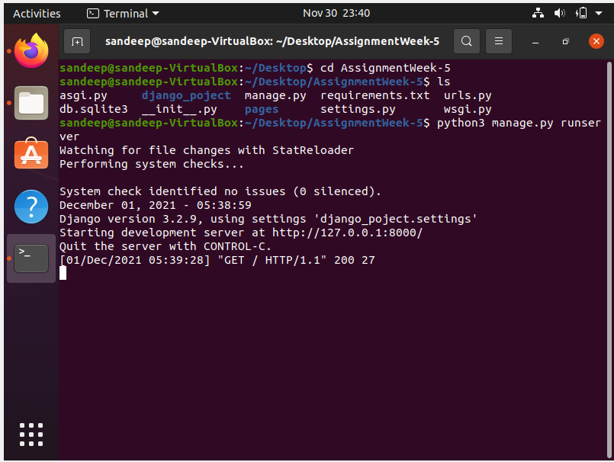

**Step 5:Copy and paste the url in browser which is obtained from the step 4 and the output will be displayed as shown in below screenshot.**

