**Installation, Operation and Uninstallation Instructions**

**Installation:**

**There is an installation package which needs to be imported into IIS for the CreditCheckService to be installed. Please follow the instructions and you should be ready at the end of it.**

**Pre-requisites:**

The CreditCheckService is created using **ASP.NET MVC, .NET 4.5 and SQL Compact database** as database. Please ensure you have **ASP.NET 4 or higher, .NET 4.5 or higher, MS SQL Compact database and IIS** is present in the test system.

1. **IIS:** If you do not have IIS, you could add IIS.

If you are using a Windows Server type of machine, you could add IIS from ‘Server Manager’. Open Server Manager. Click on ‘Roles’. On the right hand pane click ‘Add Roles’. This should run a wizard. Progress through the wizard and Choose Web Server (IIS) and ASP.NET before completing the wizard.

If you are using a Windows client machine like Windows 7, you can add ISS from Control Panel->Programs->Click ‘Turn Windows features on or off’. In the Windows Features dialog box, click ‘Internet InformationServices’ and then click OK. Make sure to choose/select Application development Features -> ASP.Net in the wizard.

1. **Web Deployment Tool :** You will need Web Deployment Tool to import the install package into IIS. Download and install from: <https://technet.microsoft.com/en-us/library/dd569059(v=ws.10).aspx>. Choose ‘Complete’ installation in the installation wizard.

Make sure in IIS, in the ‘Application Pools’, at least one of the application pools is set to .Net Framework to v4.0.

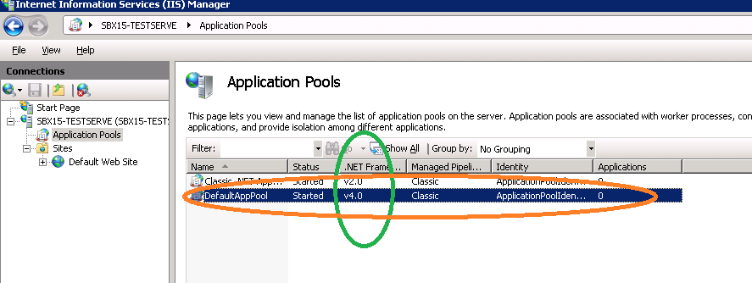

If for example say for Application Pool ‘DefaultAppPool’, the .Net Framework version is 2.0, double-click it and it will then display the following dialog. Change the .Net version to 4.0 and press OK. Make sure the Managed Pipeline is ‘Classic’ instead of ‘Integrated’.

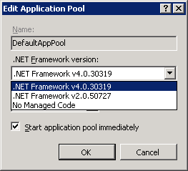

In IIS, go to ‘ISAPI and CGI restriction’ by clicking on your local machine connection in IIS; and then in the right-hand pane, under IIS section, choose ‘ISAPI and CGI Restrictions’. In ‘ISAPI and CGI Restrictions’, check that ASP.NET 4.0 has an entry with ‘Restriction’ set to ‘Allowed’. You can get to

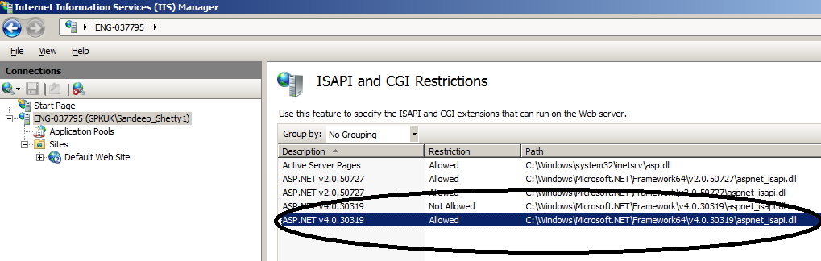

If you do not have an entry for ASP.Net 4.0 add one. On the right-hand pane, right-click and choose ‘Add’. ‘Add ISAPI or CGI Restriction’ dialog is display. Enter the appropriate data. In the ‘ISAPI or CGI Path’, choose the path where the aspnet_isapi.dll lies. Select ‘Allow extension path to execute’. This will set the ‘restriction’ to allowed. Click ‘OK’ to finish.

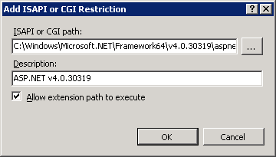

1. **Microsoft SQL Compact database:** You will need Microsoft SQL Compact database to access the database. If you do not have it in the system, you can download it from:

<https://www.microsoft.com/en-gb/download/details.aspx?id=17876>.

Download the 32bit or 64 bit version as per your machine and then install it.

**Installation of the CreditCheckService:**

Go to IIS.

Go to Start->run . Type “IIS”. The search should find the “Internet Information Services Manager”. Select to open it.

In IIS., go to your local machine -> Sites-> Default Web Site.

Right click on it and choose Deploy->Import Application (Refer figure below). This should bring up the import application package wizard. If you do not see deploy you will have to install ‘web deployment tool’ as mentioned above.

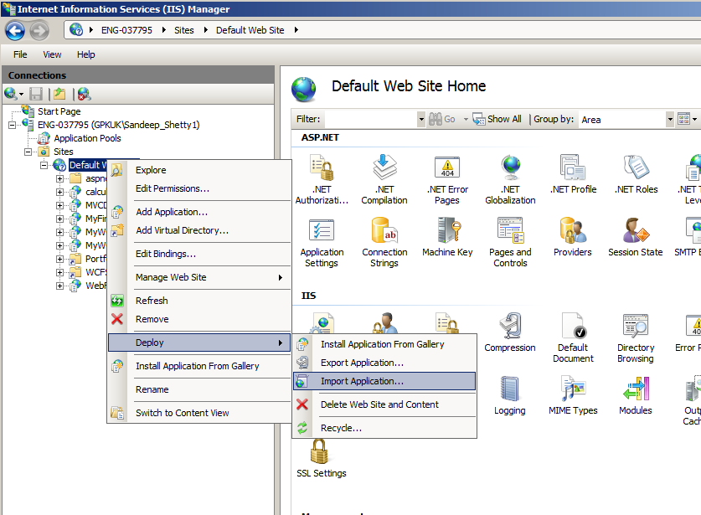

Import Application package wizard:

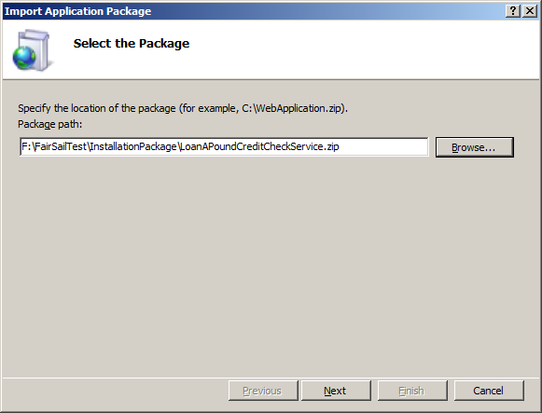

In the first screen (see figure above), Type the path of the package (.zip). It should be in the FairSailTest\InstallationPackage folder. Press ‘Next’. You will get the following screen.

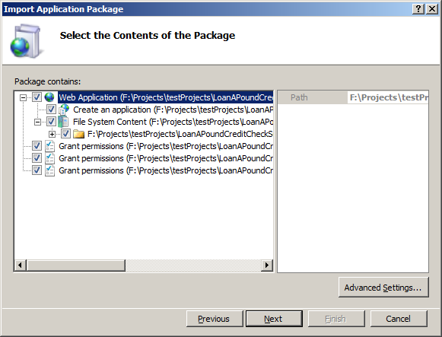

Ensure all check boxes are selected. Press Next. It should bring up the ‘Enter Application Package Information’ page.

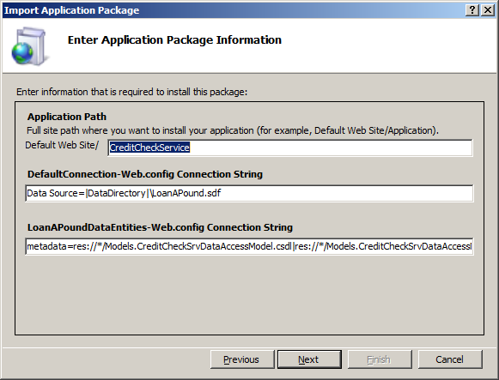

This screen shows the default website to identify the Credit Check service. You can change it but do remember it as you will need it to launch the service. Let us assume to be CreditCheckService as in the figure.

Also note that the database is local in the data directory, the connection string is set and the web.config file is updated. No need to change any of this. Press next.

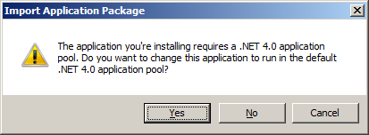

You may get this dialog to say do you want to run in the .NET 4.0 pool. If you get this dialog, press ‘Yes’. Pressing ‘No’ may not complete the installation.

Press ‘Finish’ in the ‘Installation Progress and Summary’ page to finish the installation.

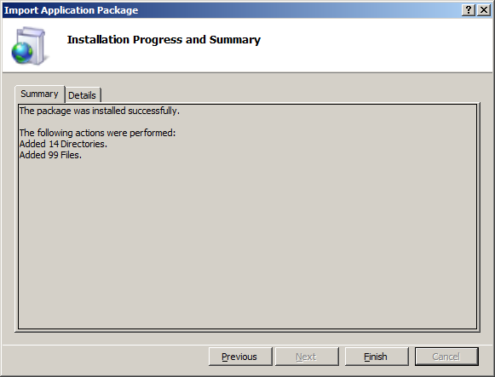

**Operation:**

Launch IE or any browser.

**Type** [**http://localhost/CreditCheckService/Applicants**](http://localhost/CreditCheckService/Applicants) **. This should bring you to this page.**

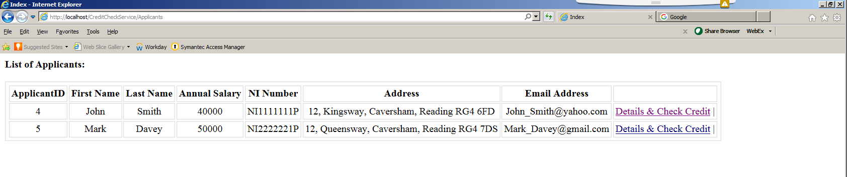

The first screen shows all the applicants details. I have preloaded 2 Applicants and hence we see two. There is a ‘Details & Check Credit” link on each of the applicants. Click any link and that should take you to the page which will display the details of the applicant. For example sake let us say you click the link for ApplicantID 2 i.e..John, then you should see the following screen.

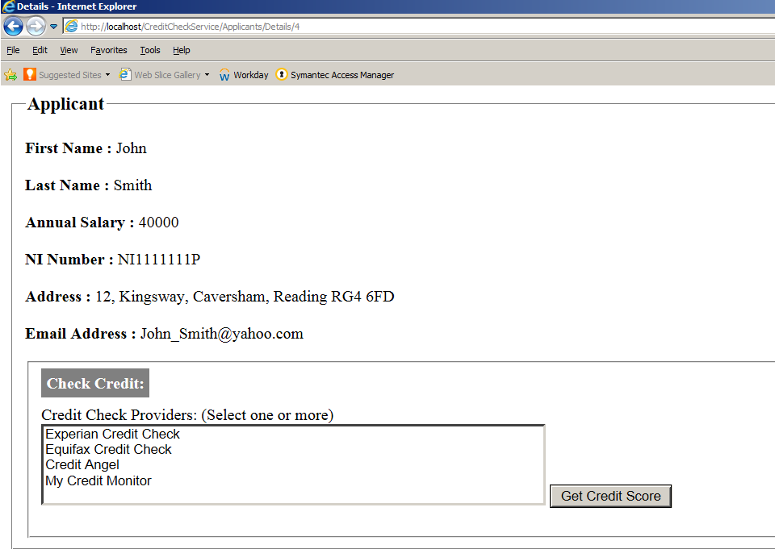

The ‘Check Credit’ section displays all the third party Credit Score providers. This is a multi-select list box. Select one or many or all and press on the ‘Get Credit Score’ button.

Let us say for example sake you selected all the providers and pressed the ‘Get Credit Score’ button. This should bring up the next screen.

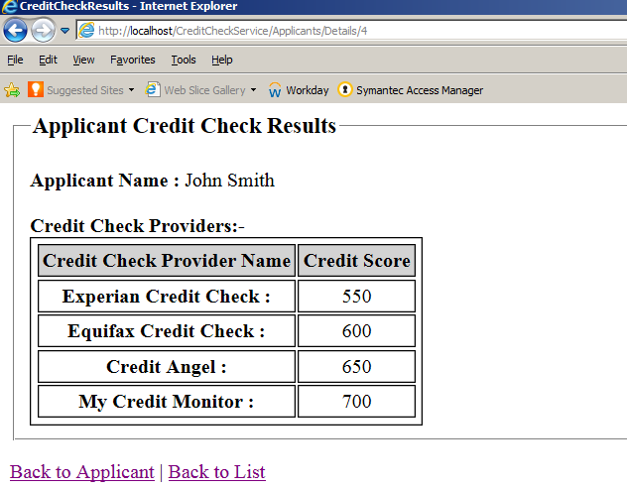

**Uninstallation:**

Go to IIS. Go to your machine->’Default Web Site’->CreditCheckService. Right click on it and choose Deploy->’Delete Application and Content’.

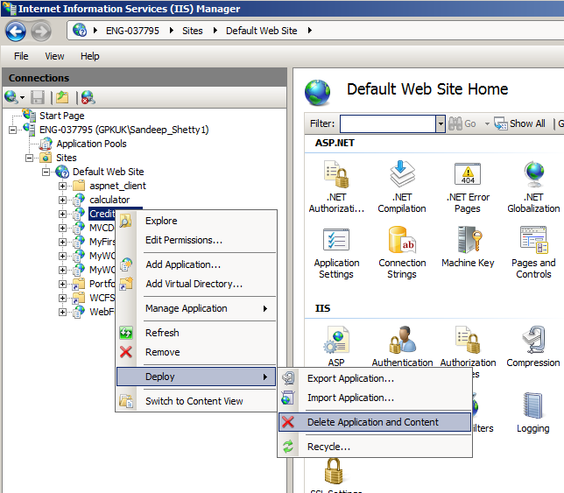

Once you have done you will get a confirmation dialog.

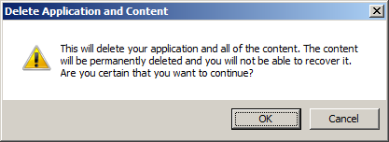

Press ‘OK’.

You should have uninstalled successfully.