**Object Model**

The Credit check service uses the **factory pattern** to determine which third part credit score/check service to use. It implements a standard interface so that the caller need not know which credit check/score provider to return. More credit check providers can be added without disturbing the core system. One or more credit check/score services can be called on at any time.

As a service/data access layer, the CreditCheckService uses Entity Framework. This handles the database operations.

The main Code modules:

Class factory and CreditCheckService core code: **LoanAPoundCreditCheckService\Code**

Models: **LoanAPoundCreditCheckService\Models**

Tests: **LoanAPoundCreditCheckService.Tests**

**CreditCheckProcessor** is the main class which is called from the Controller and which contains the core code for getting the credit score from one or many credit check providers.

***Factory Pattern for selecting the Credit Check Provider:***

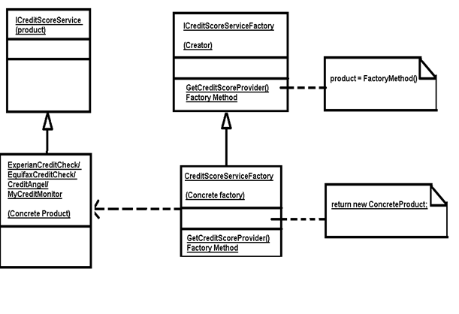

**Interface ICreditScoreService (Product – as per Factory pattern)**

int GetCreditScore();

The interface ICreditScoreService contains just one method – GetCreditScore(). This is the blue print for any existing or new third party Credit score provider which the LoanAPound credit check service may use.

Each third party credit score provider may have a different method to provide the service. So we will need a specialised class which will be responsible to get the credit score from any provider. This specialised class will be derived from ICreditScoreService and will have the specialised logic inside the standard interface function GetCreditScore. So irrespective of the third part credit score provider, a call to GetCreditScore() will get the credit score. The specific class to be instantiated and which GetCreditScore will be called will be determined by the derived classes of ICreditScoreService as per the factory pattern.

In my application I have implemented 4 classes which cater to 4 credit score providers namely

*CreditAngel, EquifaxCreditCheck ExperianCreditCheck and MyCreditMonitor.* ***(Concrete Product as per Factory pattern)***

**Interface ICreditScoreServiceFactory (Creator – as per factory pattern)**

ICreditScoreService GetCreditScoreProvider (int id);

The interface ICreditScoreServiceFactory is an interface which serves as the blue print for the factory class to create concrete products. It contains the method GetCreditScoreProvider().

**CreditScoreServiceFactory (Concrete factory as per factory pattern)**

This class implements the ICreditScoreServicefactory. This class determines which concrete class i.e. which Credit score provider class to create. It creates the appropriate class and returns it.

**CreditCheckProcessor**

This is the crux of the credit check service.

This class takes input as applicantid and a list of selected credit Score provider IDs.

This class has the following methods.

GetCreditCheckResults() – this method is kind of the director for the class. This method does the initial validation. Then it calls GetCheckScoreByCreditCheckProvider() to get a dictionary object which contains the mapping of credit check provider id and the corresponding credit score it has given the applicant

For eg

For say applicant A the dictionary object will have

Credit Score Provider1 <-> 550

Credit Score Provider2 <-> 600

Credit Score Provider3 <-> 650

It then calls FillApplicantCreditCheckResults() to fill the ApplicantCreditCheckResults class object so that it can be returned to the view for displaying the Applicant details, the selected credit score providers and the credit score given by the credit score provider for the applicant.

GetCheckScoreByCreditCheckProvider() – This function gets the ‘third part credit score provider‘ specific class object which will get the credit score. For that it calls *CreditCheckServiceFactory:GetCreditScoreProvider().* Once it gets the class object it calls the GetCreditScore() on that class object to get the credit score.

***Other Objects…***

**Applicant**

int ApplicantID

string ApplicantFirstName

string ApplicantLastName

float AnnualSalary

string NI_Number

string Address

string Email

*Description*: This will have all the information about the Applicant. Email address is included so that the loan engine can email the applicant about the progress of their application/s.

**Application**

int ApplicationID

int ApplicantID

float DepositOffered

float PropertyValue

int Term

int ApplicationStatus

*Description*: This will have all the information about the Application made. It will have the ApplicantID as the foreign key. Application is related to Applicant by ‘Many to 1’ relation. One applicant can have many Applications depending on deposit offered and property value etc..

The ApplicationStatus will show the progress of the application and can have values such as ‘In Queue’, ‘Credit Check Done’, ‘Awaiting Decision’ etc.. The underwriter can use the ApplicationStatus to see the queue. Also Applicant can see the progress of their applications.

The PropertyValue – DepositOffered will give the loan amount requested.

**ApplicantCreditCheckScore**

int CreditCheckTransactionID

int ApplicantID

int CreditCheckProviderID

int CreditScore

*Description*: This will have information about the credit score done by a credit score provider for an Applicant. One Applicant can have just many credit score depending on the credit check provider..i.e. each credit check provider according to their ranges can provide a different score for the same applicant. One Credit Providers can provide many credit scores for different applicants. For an applicant, the Underwriter will use this object model to check the various credit score from the credit check providers.

**CreditCheckProviders**

int CreditCheckProviderID

string Name

string Path

Description: This will have all the information about the Credit Check provider.

The ‘Path’ will give the information about how to access the credit check service. For eg. The path can have the dll name of the third party credit check provider service, or it can be a url to the service etc…

**Loans**

LoanID

LoanProvider

Term

BorrowingRate

MaxLoanAmount

LoanType

*Description*: This will have all the information about the Loan which is available.

**Roles**

int RoleID

string Role

*Description:* This will have information about the roles. The roles could be Applicant who can see his/her applications online, Admin who fills the details or the Underwriter who makes the decision about the loans after seeing the credit score.

**Users**

int UserID

int RoleID

string username

string password

*Description:* This will have information to users of the LoanAPound system. The userid and the ApplicantID for an applicant will be the same.

**ApplicantCreditCheckResults**

int ApplicantID;

string ApplicantName;

Dictionary<string, int> CreditScoresByCreditCheckProvider;

*Description:* This model is sent to the view for displaying the credit scores obtained from the selected credit check providers for an applicant.

**ApplicantCreditCheckView**

Applicant applicant

IEnumerable<string> SelectedCreditCheckProvider

IEnumerable<SelectListItem> CreditCheckProviders

*Description:* This model is sent to the view for displaying the Applicant and the Credit Check providers available in the LoanAPound system.