Install Lustre File System
Sample host configuration
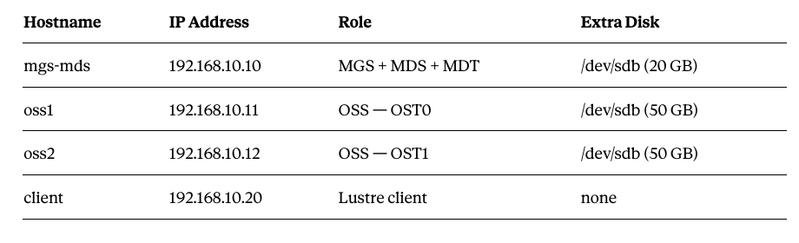
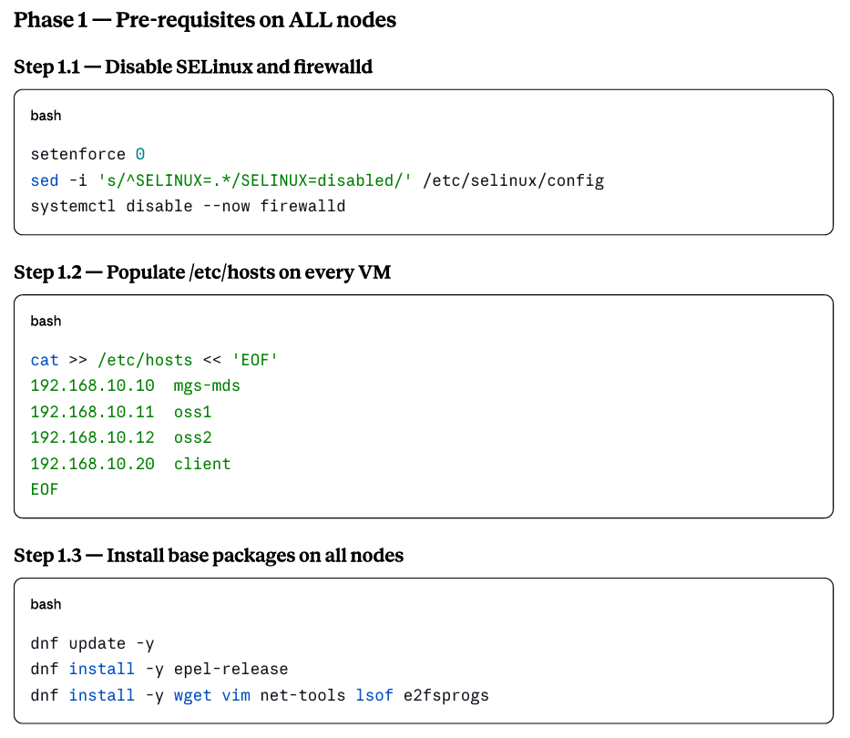

sudo dnf update -y
sudo dnf install epel-release -y
sudo dnf install -y wget vim net-tools lsof e2fsprogs
sudo dnf config-manager --set-enabled crb
sudo dnf clean all
sudo dnf makecache
Add Whamcloud Server Repository
sudo vi /etc/yum.repos.d/lustre-server.repo
Add following lines.
[lustre-server]
name=Lustre Server 2.17.0 - el9.7
baseurl=https://downloads.whamcloud.com/public/lustre/lustre-2.17.0/el9.7/server/
gpgcheck=0
enabled=1

[e2fsprogs-wc]
name=Whamcloud e2fsprogs
baseurl=https://downloads.whamcloud.com/public/e2fsprogs/latest/el9/
gpgcheck=0
enabled=1

Save the file.

sudo dnf install -y kernel kernel-core kernel-modules kernel-devel
wget https://downloads.whamcloud.com/public/lustre/lustre-2.17.0/el9.7/server/RPMS/x86_64/kernel-5.14.0-611.13.1_lustre.el9.x86_64.rpm
sudo yum localinstall kernel-5.14.0-611.13.1_lustre.el9.x86_64.rpm -y
Verify the lustre packed kernel is loaded.
sudo rpm -qa kernel --qf '%{VERSION}-%{RELEASE}.%{ARCH}\n' | grep lustre
sudo dnf install -y lustre kmod-lustre kmod-lustre-osd-ldiskfs lustre-osd-ldiskfs-mount e2fsprogs
sudo grubby --set-default /boot/vmlinuz-5.14.0-611.13.1_lustre.el9.x86_64
sudo grub2-mkconfig -o /boot/grub2/grub.cfg
sudo init 6
After reboot verify the kernel loaded by using
uname –r
sudo vi /etc/modprobe/lnet.conf
Type following line.
options lnet networks=tcp0(ens160)
Save file.
sudo ip link show
sudo modprobe lnet
sudo lctl network up
sudo lctl list_nids
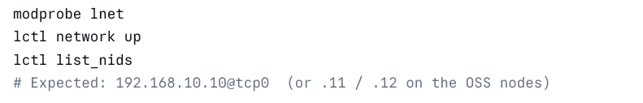

sudo lsblk
sudo mkfs.lustre --fsname=lustrefs --mgs --mdt --index=0 --servicenode=192.168.80.10@tcp /dev/nvme0n2
sudo mkdir /mnt/mgs
sudo mount -t lustre /dev/nvme0n2 /mnt/mgs
sudo lctl dl

sudo lsblk
sudo mkfs.lustre --fsname=lustrefs --ost --index=0 --mgsnode=192.168.80.10@tcp --servicenode=192.168.80.11@tcp /dev/nvme0n2
sudo mkdir -p /mnt/ost0
sudo mount -t lustre /dev/nvme0n2 /mnt/ost0
Perform similar steps on the OST2 node.
sudo lsblk
sudo mkfs.lustre --fsname=lustrefs --ost --index=0 --mgsnode=192.168.80.10@tcp --servicenode=192.168.80.12@tcp /dev/nvme0n2
sudo mkdir -p /mnt/ost1
sudo mount -t lustre /dev/nvme0n2 /mnt/ost1
On the MGS/MDS node run following command to verify
lctl dl | grep OST


sudo update –y
sudo dnf install epel-release
sudo dnf config-manager --set-enabled crb
sudo vi /etc/yum.repos.d/lustre-client.repo
Add following lines.
[lustre-client]
name=Lustre Client
baseurl=https://downloads.whamcloud.com/public/lustre/lustre-2.17.0/el9.7/client/
gpgcheck=1
gpgkey=https://whamcloud.comRPM-GPG-KEY-Lustre
enabled=1
Save the file.
sudo dnf clean all
sudo dnf makecache
sudo dnf install kernel-devel-$(uname -r) kernel-headers-$(uname -r) dkms libmount-devel zlib-devel openssl-devel gcc make flex bison –y
sudo dnf install libyaml-devel –y
sudo dnf install --nogpgcheck lustre-client-dkms lustre-client –y
sudo vi /etc/modprobe/lnet.conf
Type following line.
options lnet networks=tcp0(ens160)
Save file.
sudo ip link show
sudo modprobe lnet
sudo lctl network up
sudo lctl list_nids
sudo mkdir -p /mnt/lustre
sudo mount -t lustre 192.168.80.10@tcp:/lustrefs /mnt/lustre
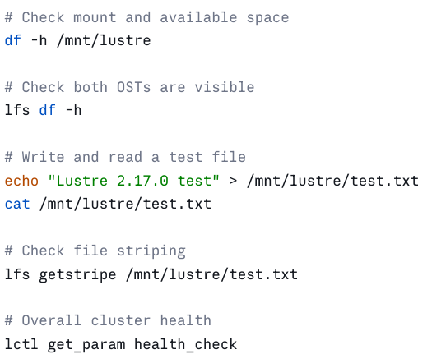
To make sure that Lustre networking loads automatically on boot,

sudo cat <<'EOF' > /etc/sysconfig/modules/lustre.modules
#!/bin/sh
# Automatically load Lustre Networking on boot
/sbin/modprobe lnet >/dev/null 2>&1
/sbin/modprobe lustre >/dev/null 2>&1
EOF

sudo chmod +x /etc/sysconfig/modules/lustre.modules
sudo nano /etc/modprobe.d/lustre.conf
options lnet networks="tcp(ens160)"
sudo systemctl enable lnet
sudo reboot

After reboot check with
sudo lnetctl net show or sudo lsmod | grep lnet

