**DEPARTMENT OF ELECTRONICS AND COMMUNICATION ENGINEERING**



PROJECT ON WORKING OF PUBLIC TELEPHONE

Submitted by:

Y S V SANDEEP (15EC156)

O SRIMAN (15EC136)

**Submitted to:**

**KALPANA G BHAT**

**E&C DEPT.**

**Objective of the Project:**

The Main Objective of the project is working of PAYPHONE.

**Introduction:**

A **PAYPHONE** is typically a coin-operated public telephone, often located in a telephone booth or a privacy hood, by billing the credit used by the Caller. Lifting the Phone and then dialling the desired connection telephone number connects the call. An equipment usage fee may be charged as additional units, minutes or tariff fee to the collect. Payphones are often found in public places.

**List of components:**

Hex-Digit Displays,

7-Segment Displays,

Counters, Registers,

Buttons, Splitters,

Clock & Logic Gates.

**Circuit :**

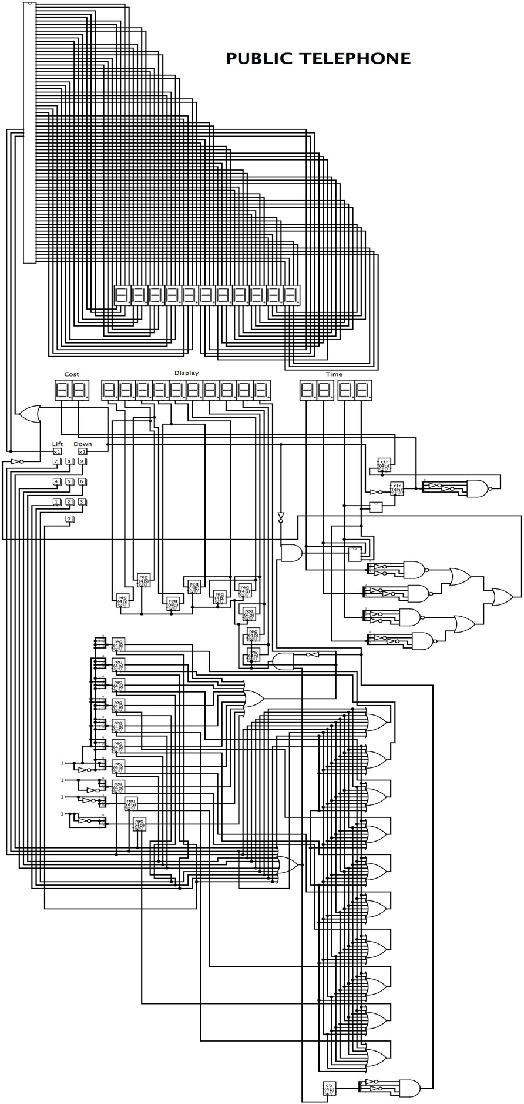**Main Circuit**

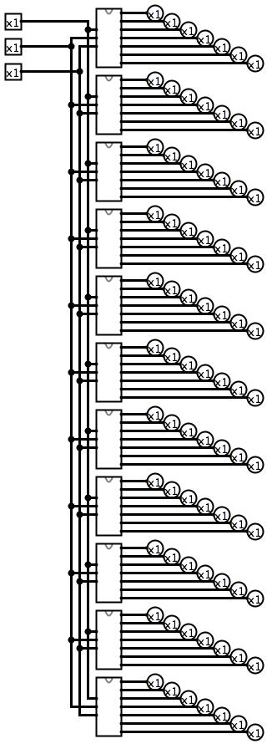 **Display Circuit**

**Detailed Explanation:**

Firstly, the caller lifts the payphone. Then the display gets activated and a message “Dial No.” is displayed on the 7-Segment Displays.

Then the Caller dials the desired no. through the number buttons provided and gets connected to the call. The call gets connected only after dialling 10 numbers. After dialling the number, the Timer and the Cost Calculator get activated and displays the on-going time and the cost on the hex-digit displays respectively.

The caller can cut the call anytime by making the Down input HIGH or the call gets cut automatically after an Hour. After the calls gets disconnected, “Thanq” message is displayed on the 7-Segment Displays.

**Merits of the design:**

**Indispensable part of life:** It was the invention of telephone which really opened the way for communication revolution. Nowadays it has become an indispensable part of commercial, industrial and domestic life.

**Communication with distant person:**People can communicate to distant people and get instant feedback instant over telephone. For example, a person in India can talk with another person in the United Kingdom over telephone.

**Saves time and energy:** A telephone serves us like an honest servant in all the fields. It saves our valuable time and energy to great extent.

**Security:** In big cities a telephone has its own utility in terms of safety and security. You may call police if there is some need for them.

**Healthy relationships:** Telephone encourages regular voice-communication between friends. It helps keep up healthy relationships with friends.

**Low cost:** The cost of voice-communication over telephone and mobile-phones has reduced significantly in the last few years. Thus, even common people can make full use of tele-communication technology.

**Demerits of Design:**

1. The caller won’t be able to talk more than an Hour.
2. The circuit is too lengthy which leaves us difficulty to correct it if anything goes wrong.

**List of References:**

Class Notes, Internet.