Create mysql database emp

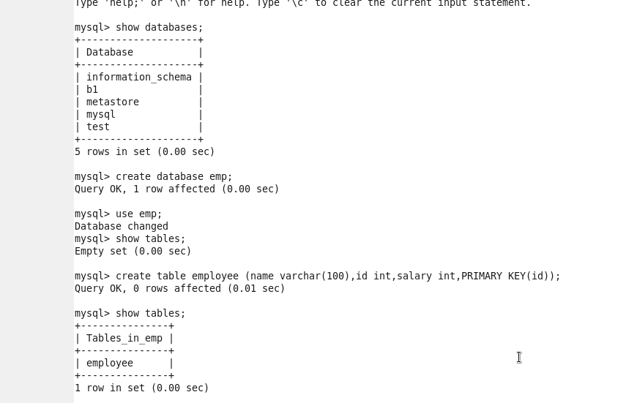

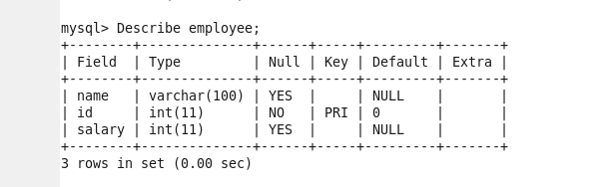

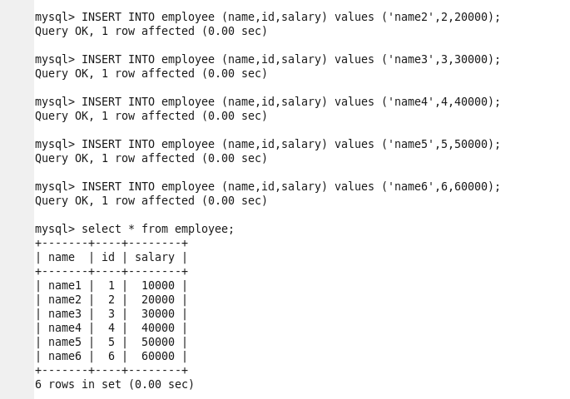



Hbase shell

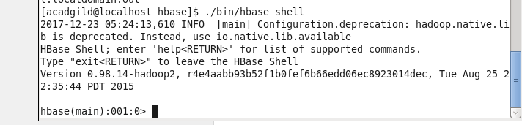

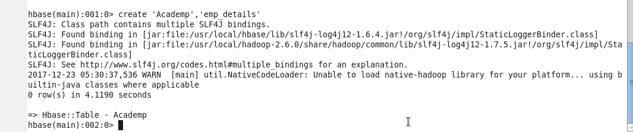

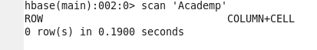

Import from mysql



Scan Hbase table

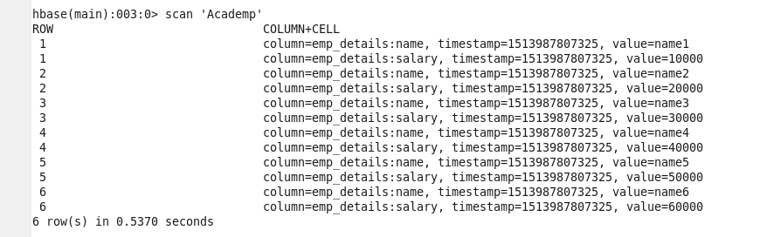

Values are imported successfully

2) Export from Hbase to mysql using sqoop:

Create db

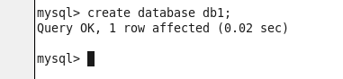

Create table abcd

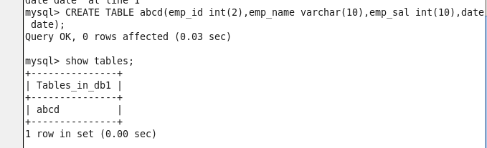

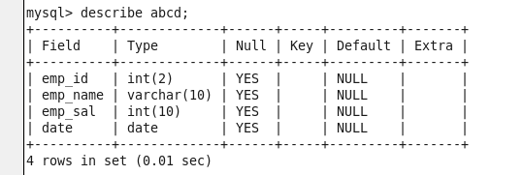

Upload data file to hdfs directory

Create directory in hdfs

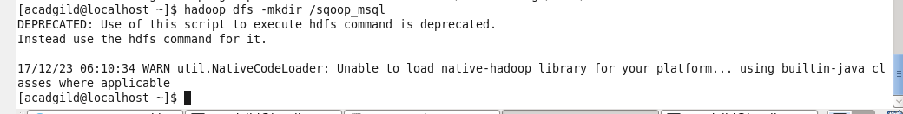

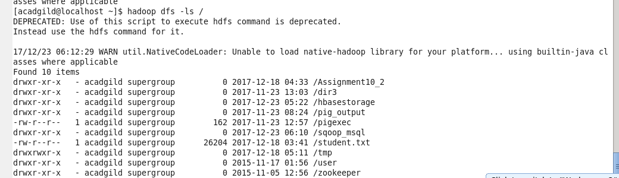

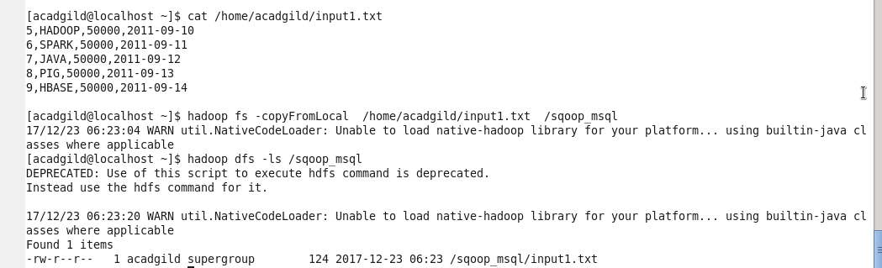

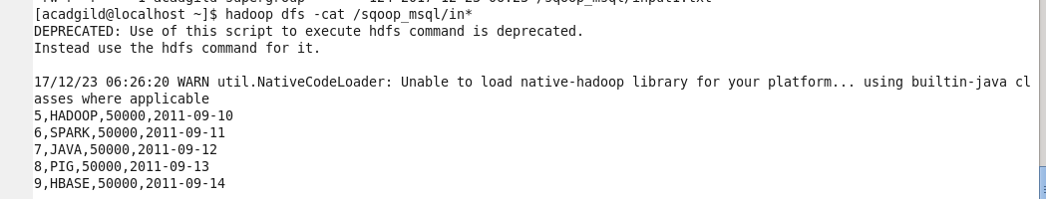

Run sqoop export command



