Assignment 11.2

1. Created a dataset employee.txt
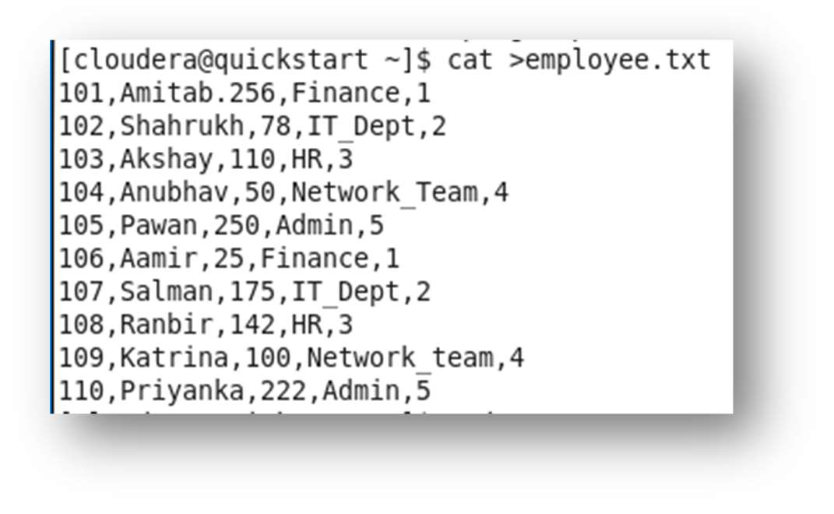

2. Started MySQL commands and enter the MySQL shell. Created the database sumona
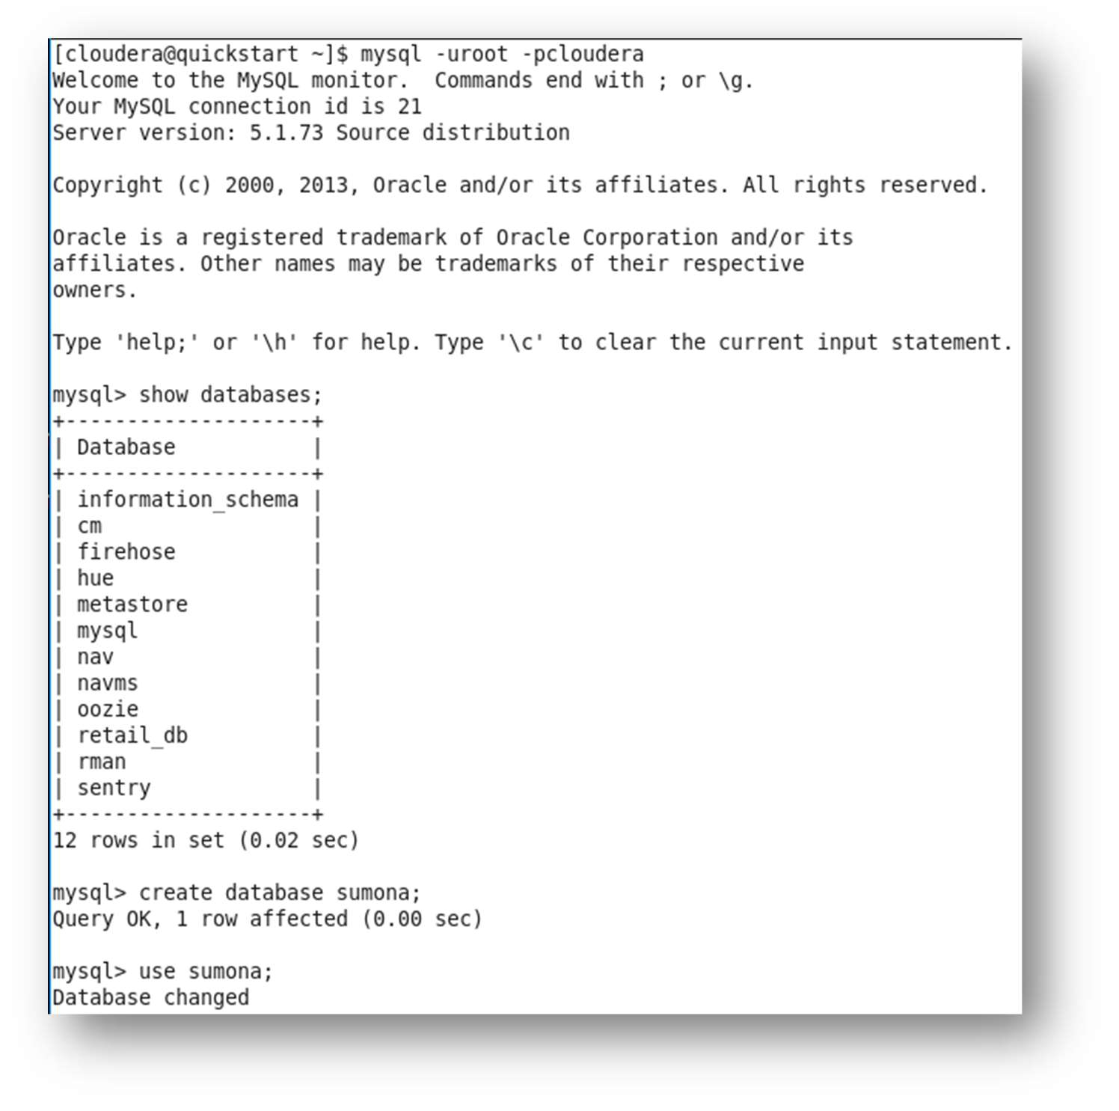

3. Created the table employee and loaded the values into MySQL

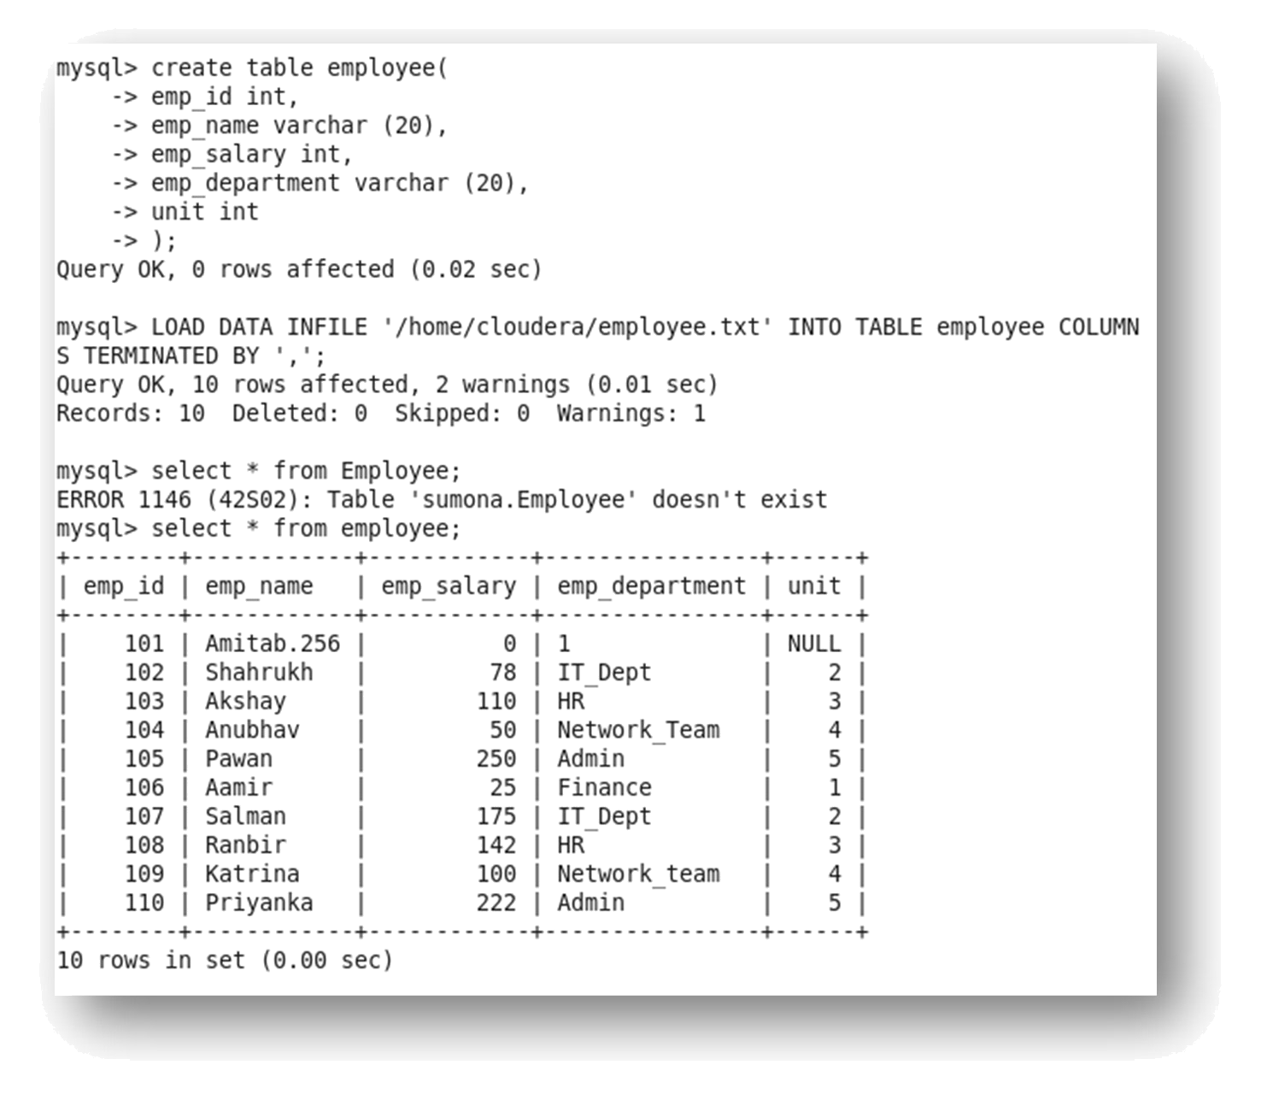

- Since the data is present in table of MySQL and Sqoop is up and running, import the data into HIVE using the command

sqoop import --connect jdbc:mysql://localhost/sumona --username root --password cloudera -- table employee -m1 --target-dir /sqoopouthive --hive-import;
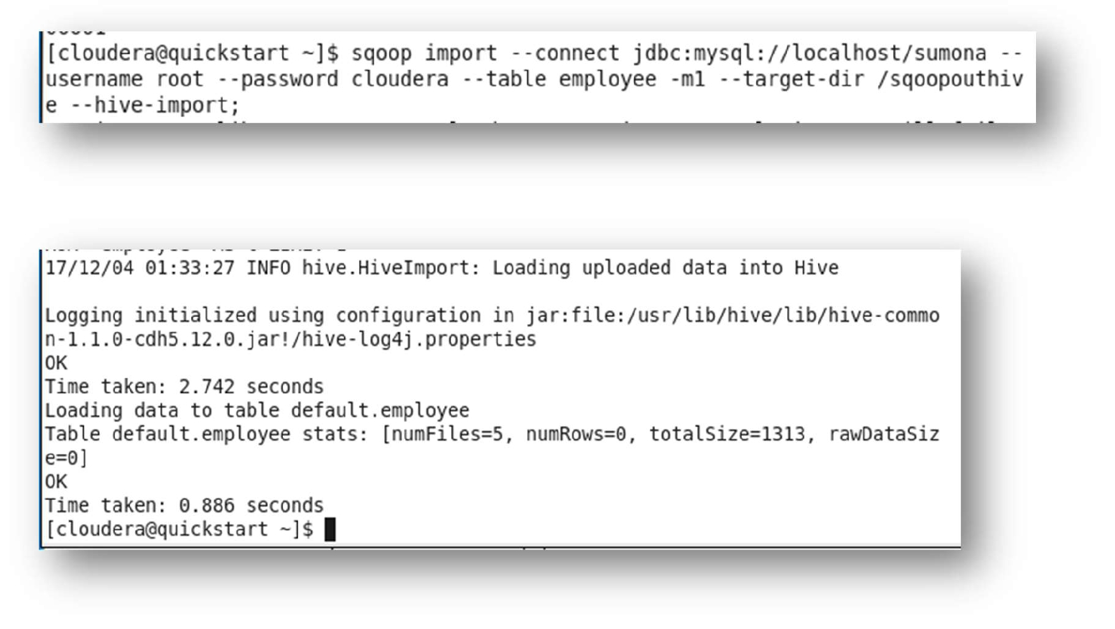
Let us now check the table in HIVE.
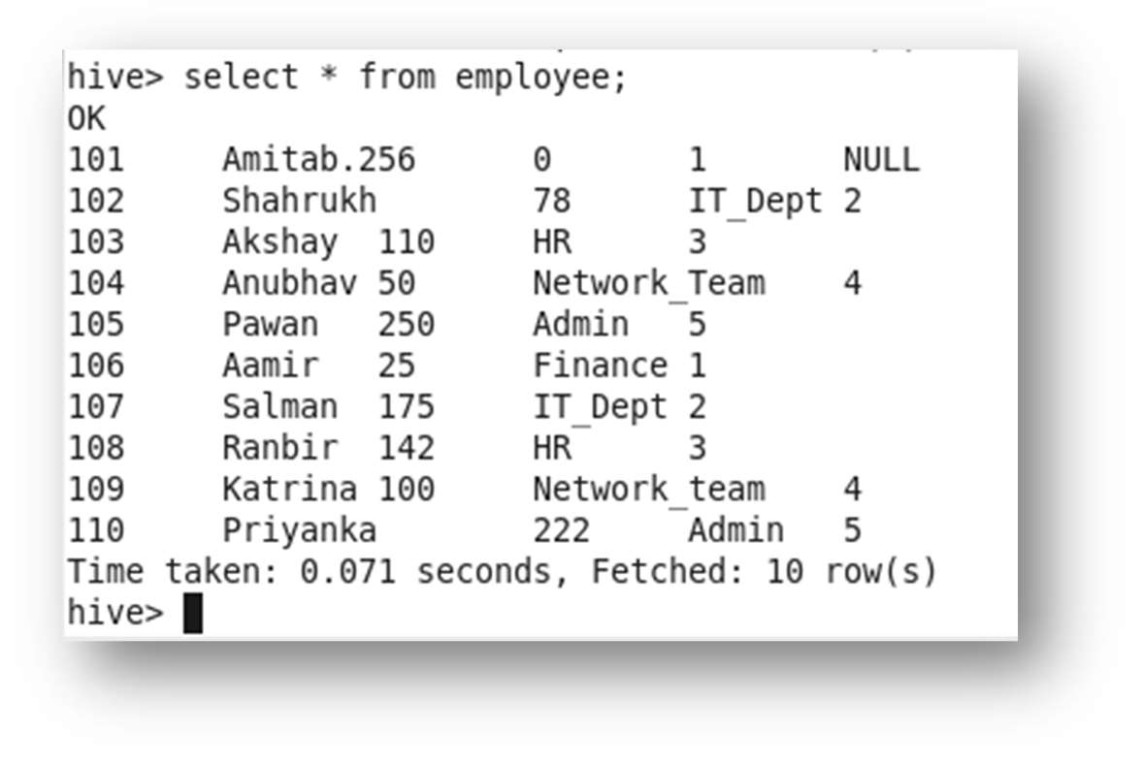

5. Inserted new values to the table employee.
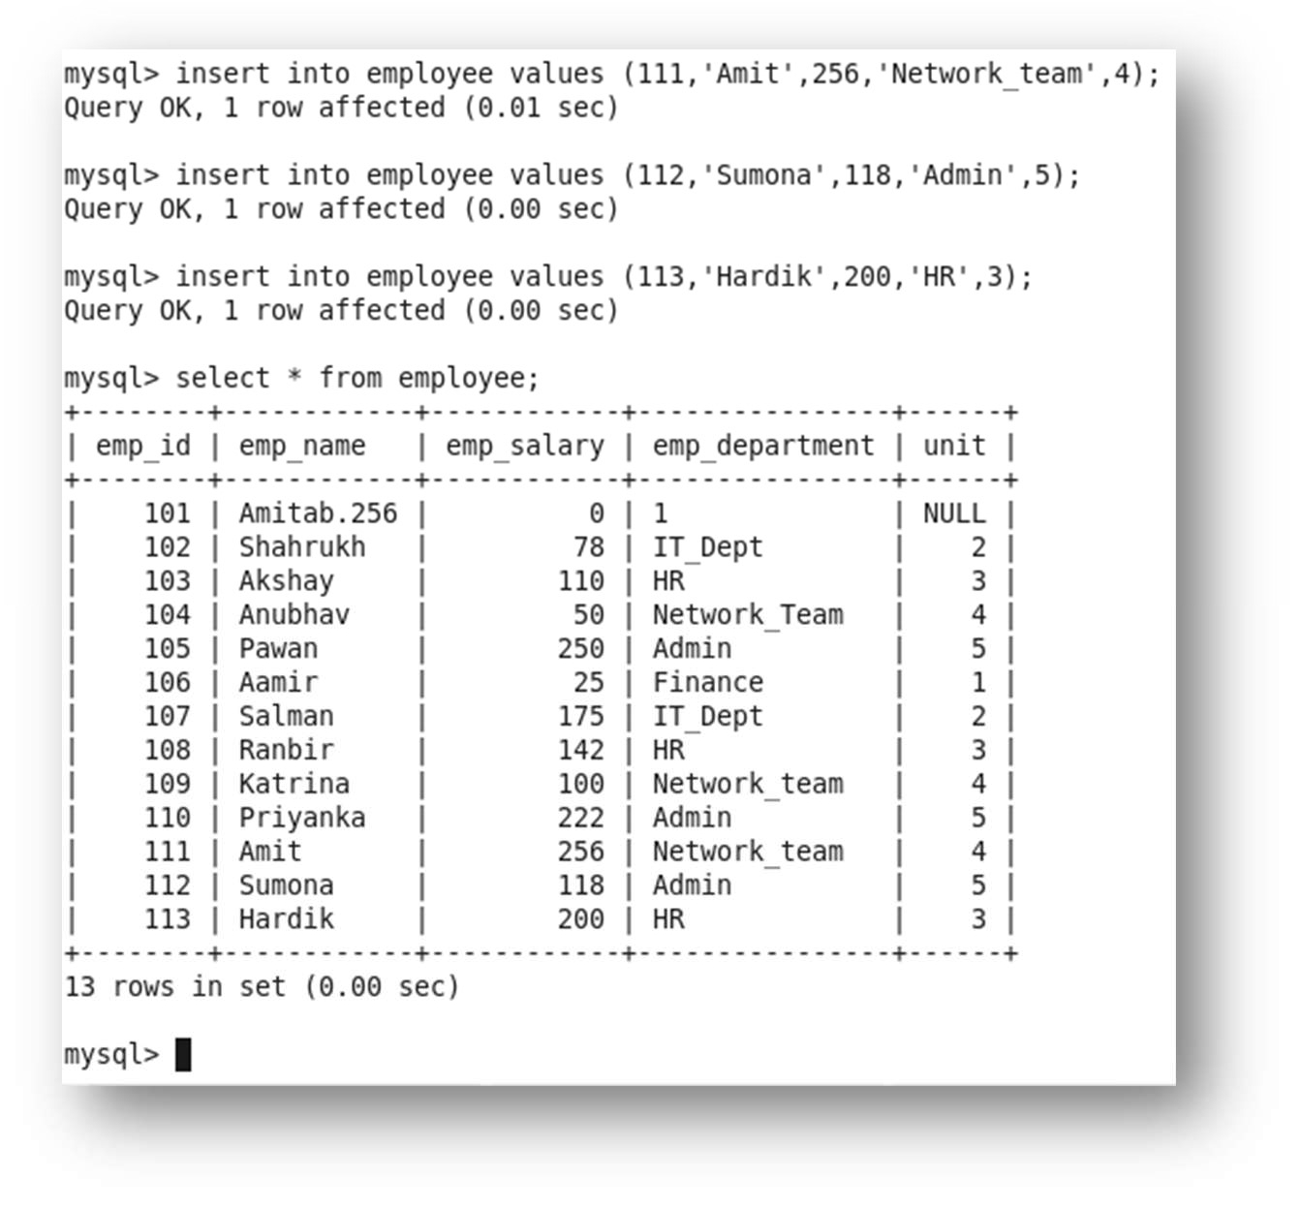

- After inserting the new values in the table in MySQL shell, we shall import the updated values into HIVE by using the INCREMENTAL command

sqoop import --connect jdbc:mysql://localhost/sumona --username root -password cloudera --

table employee --check-column emp_id --incremental append --last-value 110 -m1 --target-dir

/sqoopouthive –hive-import;
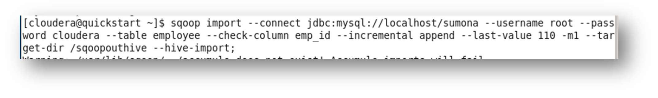

In this command we are updating the new values by comparing the existing values of the table with the column emp_id.
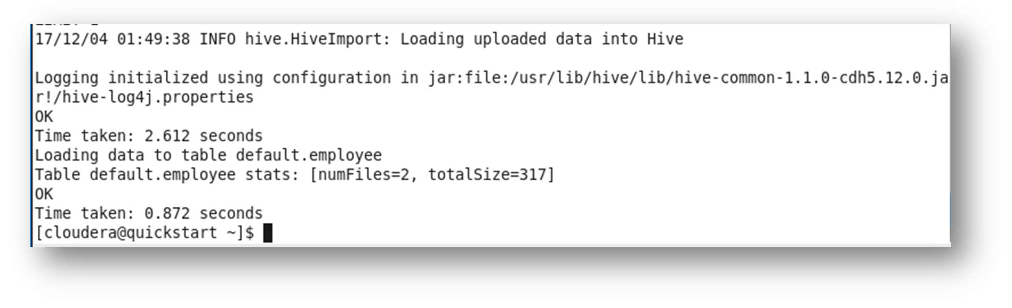

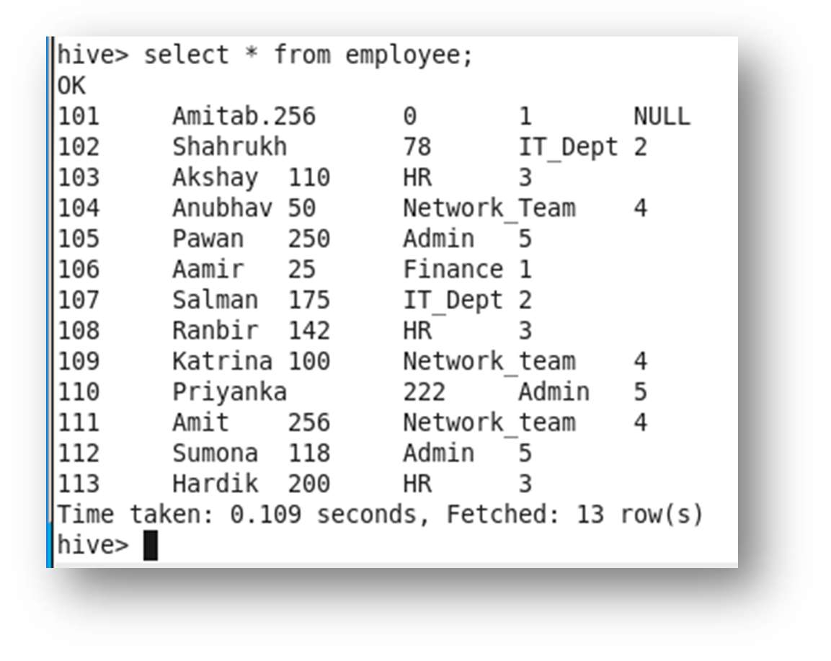
Now as you can see the new values have been updated into the HIVE table.

