1. Write a simple program to show inheritance in scala.

Code:

class Corporate { // Corporate defined salary

  var salary = 20000.00

}

class Employee extends Corporate { // Employee Bonus which extends corporate

  var allowance = 10000.00

  var totalsalary = allowance+salary

  println("Total salary is :"+totalsalary)

}

object main {

  def main (args:Array[String]) {

    new Employee

  }

}

Output:

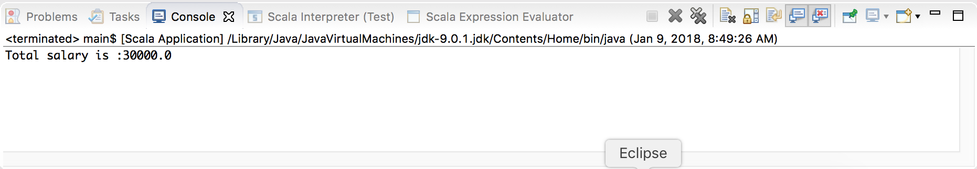

1. Write a simple program to show multiple inheritance in scala.

Code:

class Corporate { // Corporate defined salary

  var salary = 20000.00

}

class HRDivision extends Corporate { // HRDivision Bonus which extends Corporate

  var bonus = 10000.00

}

class Employee extends HRDivision { // Employee class joining HR division

  println(" Salary of the Employee is : "+salary)

  println(" Bonus of the Employee is : "+bonus)

}

object main {

  def main (args:Array[String]) {

    new Employee

  }

}

Output:

