3.Write a partial function to add three numbers in which one number is constant and two

numbers can be passed as inputs and define another method which can take the partial

function as input and squares the result.

Code:

class PartialFunc {

def squareFunc(n: Int) { // function to square a number

   println("Square: " + n * n)

   }

def adder(m: Int, n: Int, p: Int) = m + n + p // function to add three numbers

def partialFunc(x:Int,y:Int) { // Partial function to add two numbers with constant and square it

val add = adder( _: Int,20, _: Int)

println("------------------------")

println("Addition: "+add(x, y))

squareFunc(add(x, y))

println("------------------------")

}

}

object PartialFunc_Task3 {

def main(args: Array[String]) {

  println("Enter First Number")

  var x: Int = scala.io.StdIn.readLine().toInt;

  println("Enter Second Number")

  var y: Int = scala.io.StdIn.readLine().toInt;

  println( "Constant number is 20")

  new PartialFunc().partialFunc(x, y) }

}

Output:

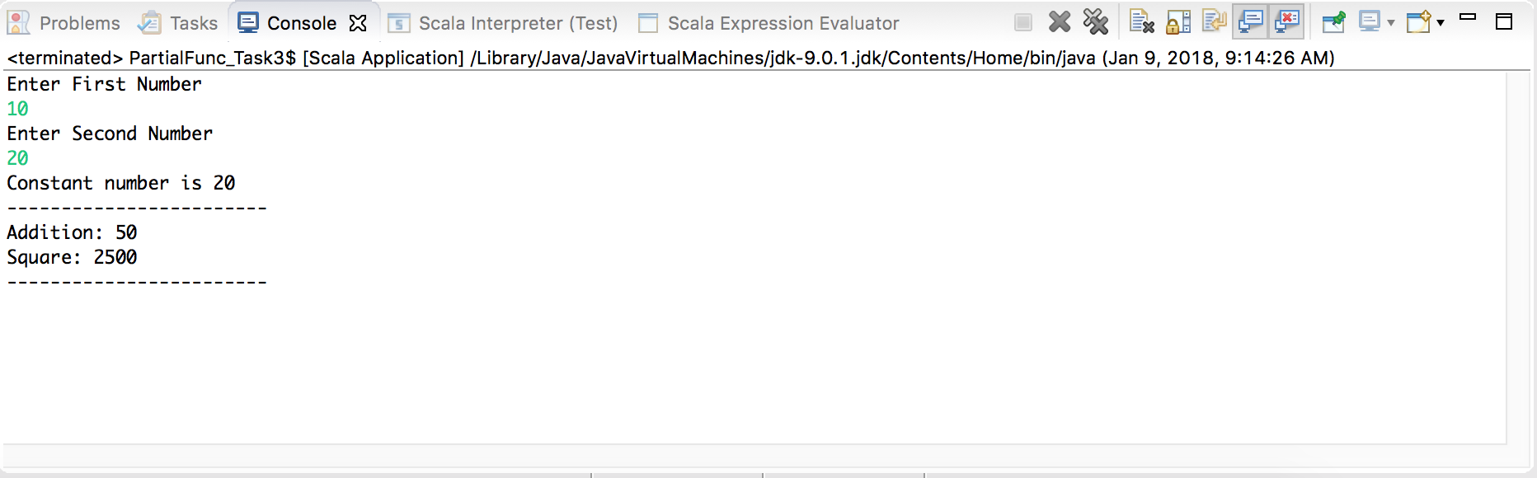

4.Write a program to print the prices of 4 courses of Acadgild: Android-12999,Big Data

Development-17999,Big Data Development-17999,Spark-19999 using match and add a

default condition if the user enters any other course.

Code:

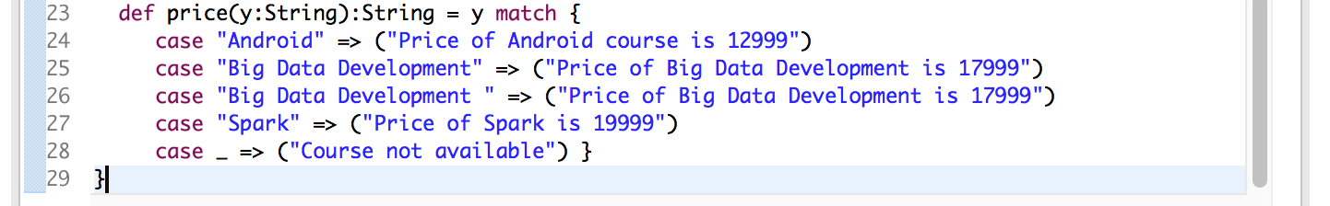

Output

